INDIAN INSTITUTE OF TECHNOLOGY, KHARAGPUR
Date 17.02.2012 FN Time: 2 Hrs. Full Marks : 78
Spring Semester: 2012 Department: Computer Science and Engineering
Sub. No: CS 60002 Sub. Name: Distributed Systems
Q1.
- What do you mean by safety and liveness in the context of sliding window protocol?
Answer:
Safety: if (out_{p}[i]!=undef) then out_{p}[i]=in_{q}[i]; if (out_{q}[i]!=undef) then out_{q}[i]=in_{p}[i]
Liveness: for any value of k>0 at some point of time out_{p}[k] and out_{q}[k] will be defined.

- Lets assume two processes p and q are exchanging information between themselves using sliding window protocol. Constraint for the protocols are lp=2 and lq=2. Comment on the following configurations’ feasibility. (a_{p} is the minimum index of sending window of process p and s_{p} is the minimum index of expected word for process p.) 3+4x3=15

Case i)
in_{p}
a_{p}
out_{p}
s_{p}
Answer: According to the sliding window protocol, s_{p} –l_{q} should be <= a_{p} , value of s_{p} =6,
l_{q} =2, so s_{p} –l_{q} =4, which is greater than a_{p} which is equal to 3

Case ii)
in_{p}
a_{p}
out_{p}
s_{p}
Answer: According to the sliding window protocol, s_{p}+l_{p} should be >= a_{p} , which is violated
in this case.

Case iii)
out_{p}
s_{p}
out_{q}
s_{q}

Answer: According to the sliding window protocol, s_{q}-l_{p} should be <= s_{p} , which is violated
in this case.

Case iv)
in_{p}
a_{p}
in_{q}
a_{q}
Answer: According to the sliding window protocol, a_{q}+l_{p} should be >= a_{p} , which is violated
in this case.

Q2.
- Discuss the actions taken by different node when channel from node N5 to N6 becomes down (Fig.1) in Netchange algorithm.

Answer: Node N5 will receive a message <fail, N6>. Receiving this message N5 will exclude N6 from its neighbour list and initiate Recompute procedure for all nodes in the network. Node N6 will receive <fail,N5> message and take similar actions.

- Also discuss (Fig. 1) the actions taken by different nodes when it is up.

Answer: Node N5 will receive <repair,N6> message. Receiving this message N5 will include N6 in its neighbour list. N5 will modify its ndis value to 7 as the expected distance from any node in the network to node N6 and will send its own distance from all other nodes to N6. Receiving table from N5, N6 will recomputed its distance from other nodes in the network.
N6 will also receive <repair,N5> and will take similar actions as N5.

- Discuss the importance of channel FIFO property in netchange algorithm with an example.

Answer: Assume that node x1 sends 2 messages msg1 and msg2 in order to x2. Node x2 receives msg2 first and then it receives msg1. So after processing both the messages, table of x2 will reflect the effect of msg1 where it was expected to reflect the effect of msg2 as it is the latest table sent by node x1.

- Does Toueg’s routing need sequencing in selecting pivot? How does it make improvement from the simple version of the algorithm?
Answer: Yes, Toueg’s routing needs sequencing in selecting pivot.
Instead of broadcasting routing table of a node, table is sent only to those nodes where this table can make difference. At every pivot round, every node construct a rooted tree keeping itself as root. This tree includes only those nodes which can be reached in less than infinite time from the root. To construct this tree light weight messages are passed. After construction of tree, actual routing table is passed only to the nodes in the tree. This procedure makes improvement by stopping broadcast of the routing table and hence reducing total bytes routed in network.
4+4+2+5=15
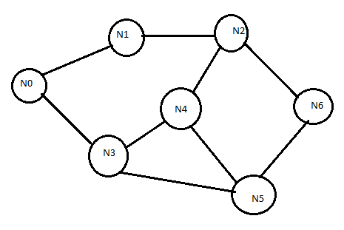
Fig.1

Q3.
- Discuss the constraints to design a deadlock free buffer graph controller for Destination based scheme, Hop-So-Far scheme, Acyclic Orientation Cover
- Discuss the constraints for Forward count and Forward-state controller
- Prove that there is a deadlock free controller for a tree network which uses only two buffers per node.
Answer: Refer Gerard Tel book. 6+4+5=15
Q4.
- Some processes are running concurrently and processes use logical vector clock. T_{a} denotes the vector clock time stamp of some event a and T_{b} denotes the vector clock time stamp of some event b. If T_{a}<T_{b} then prove that a→b.

Answer: Let us assume that event a and event b are parallel. However, for two parallel events there must be some i and j for which T_{a}[i]>T_{b}[i] and T_{a}[j]<T_{b}[j]. If we can find such i and j then we can not say that T_{a}<T_{b.} So either a→b is true or b→a is true. However, as T_{a}<T_{b ,}b→a is not possible.
- Process p1, p2, p3 communicate among themselves and use vector clock. Consider Send and Receive as event and assign the timestamps of event a, b, c , d, e, f, g, h, i, j
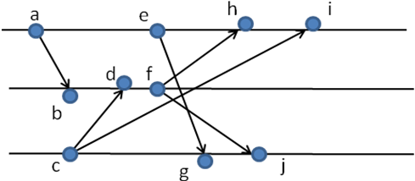
P1
P2
P3
Answer: T_{a}=[1,0,0], T_{b}=[1,1,0], T_{c}=[0,0,1], T_{d}=[1,2,1], T_{e}=[2,0,0], _{Tf}=[1,3,1], T_{g}=[2,0,2], T_{h}=[3,3,1], T_{i}=[4,3,1], T_{j}=[2,3,3]
- Define consistent global state and strongly consistent global state.
Answer: refer to singhal shivratri book
- Show that the given timestamp is not possible in Birman-Schipher-Stephenson’s protocol
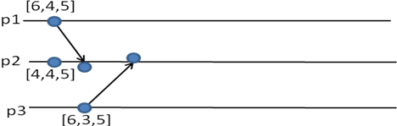
5+3+3+4=15
Answer: Lets denote send event of process p1 is a, and send event of process p3 is b. Local clock of p1 during event a is 6. As every event is broadcasted in Birman-Schipher-Stephenson protocol, so message of broadcasting a, reached to process c either before event b or after event b. But, as b reflects the time 6 as p1’s clock so the broadcast message must be received before event b, hence, a->b. In similar logic, we can prove that broadcast event of b must be received before event a, hwnce, b->a. However, at the same time a->b or b->a is not possible.

Q5.
- There are three processes in a system with process id p1, p2 and p3. a, b, c, d are request for entering Critical Section (CS) in a system which follows Lamport’s mutual exclusion strategy. Write down the input queue of CS request at p1, p2 and p3 when they are about to enter CS.
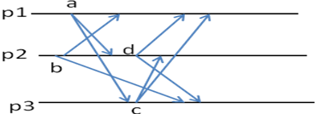
Answer: P2 made two requests for critical section b and d. It implies that b must be served before request d is initiated. Acknowledgement of b from p3 will be sent after event c as the request itself is received after event c. Due to the FIFO property of the channel, acknowledgement from p3 will reach P2 after d. So CS for P2 corresponding to the request b can not be served before event d as it will not receive acknowledgement from all processes. So process p2 can not send another critical section request before its previous request is satisfied. So the scenario depicted here is not a feasible scenario.
- Why FIFO property of channel is important in Lamport’s mutual exclusion scheme and why FIFO property is not required in Ricarta Agarawal’s scheme?

Answer: When a process receives acknowledgement from all other processes, due to FIFO property of channel it is ensured that the process must received other’s CS request (that is any CS request by other process sent before acknowledgement can not be in transit) if it is sent before the acknowledgement.
In, Ricarta Agarwala a process say p1 acknowledges p2 CS request if P1 does not have any CS request or p2’s request time stamp is larger than p1’s request time stamp. So when a process receives acknowledgement, it is sure that it can enter CS.

- In Lamport’s mutual exclusion strategy clock used in i^{th} process is <tsi, i>, where tsi is the time stamp and i is the process identifier. Discuss the importance of process identifier in clock. Let’s assume now clock is denoted as <i, tsi>. What will be the effect?

Answer: Process id is used for total ordering. If clock is represented as <i,tsi>, process with higher id will get priority over other processes.

- Prove that nodes do not suffer with starvation in Suzuki Kasami’s scheme for mutual exclusion.
Answer: refer to singhal shivratri book

- Assume that node 1 holds the token and is executing its critical section. Node 10, node 8, node 3, node 6 request for critical section at 0, 2T, 3T, 4T time instant, where T is the message delay from one node to its neighbour node. No further request for critical section is generated. Node 1 releases critical section at 5T instant. Show how the token is passed to the requesting nodes with sequence of modified trees and message queue in nodes. 4+4+2+3+5=18

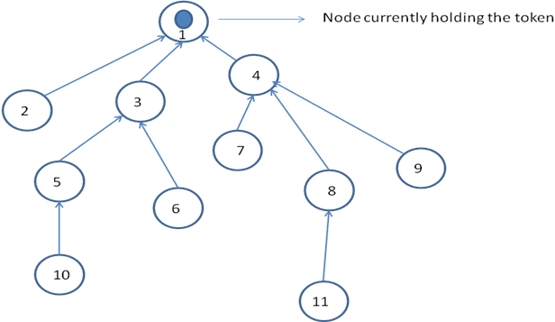
Answer: refer to singhal shivratri book

