INDIAN INSTITUTE OF TECHNOLOGY, KHARAGPUR
Department: Computer Science and Engineering
Spring Semester: 2012
Date Time Full Marks: 95
Sub. No: CS60002 Sub. Name: Distributed Systems

Answer as much as you can

Q1. There are n systems each with a unique identity. Every system generates a random number which may not be unique across n systems.
- Design a distributed wave algorithm for computing sum of random numbers generated by all the systems.
- Describe your algorithm with an example i.e. dry run your algorithm with an example assuming n = 5.
- Find the message complexity of your algorithm.
4+3+3=10

Q2. Show the message passing in each phase of Hirschberg-Sinclair algorithm for leader election with an example of ring of size 8. Find out the run time and message complexity of Hirschberg-Sinclair algorithm for leader election.
4+4=8

Q3.
- Analyse the time and message complexity of classical distributed DFS algorithm based on purely traversal algorithm.
- How Awerbuch’s algorithm makes improvement on time complexity?
- Let’s say a node U upon receiving the token sends vis (visited) message to all its neighbours. V is a neighbour of U and has received the vis message. On response V sends ack message. On receiving token will V send any vis message to U? Justify your answer.
- How Cidon’s algorithm makes improvement on time complexity over Awerbuch’s algorithm.
- In Cidon’s algorithm, suppose a node U upon receiving the token sends vis message to all its neighbours. V is one of the neighbours of U. However, V received the token message before the vis message from U. Will it result anything inconsistent? Justify your answer.

4+3+2+3+3=15

Q4.
- Prove that there is a unique Minimum Spanning Tree (MST) if all edge weights are unique.

- Assume that a single transaction is distributed over n sites. Show that using 2 phase commit protocol, either all sites commit or all sites abort the transaction.
3+5=8

Q5. A WFG of processes is shown in the figure (Fig. 1). Number inside the circle represents process identifier and p signifies the number of resources needed to reduce. Node 1 initiates a deadlock detection using global state collection and termination detection algorithm. Does process 1 find itself in deadlocked state? Show different message flow in termination detection algorithm.

Please note the following assumptions. Node 1 initiates flood message at timestamp 1. Node 3 and 4 receive first flood message from node 1. Node 6 and 7 receive first flood message from node 2. Node 4 was blocked when it received flood message from node 6. Node 3 was blocked when it received flood message from node 8.
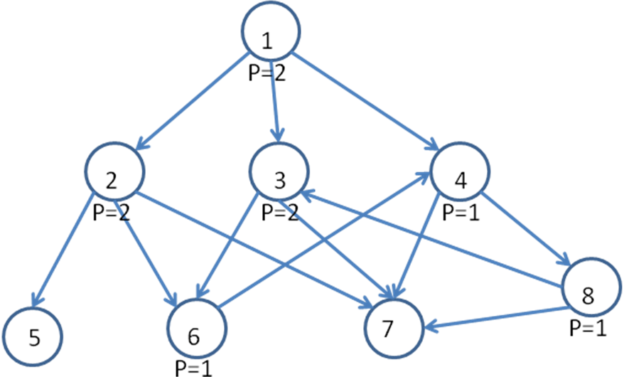
Fig. 1
7

Q6.a) Discuss the Dijkstra’s self-stabilization algorithm for mutual exclusion for a ring network with an example.
- Assume that a set of clocks connected as a chain network. This clock starts at 0 and wrap back again after 2. All the clocks run at same phase, however, due to some error they may be out of phase. Describe a self-stabilization algorithm for this system.
5+5=10
Q7. Assume that processes involved in agreement may have byzantine failure. Answer the following questions.
- Let us assume that f processes are faulty among n processes. Prove that if n<=3f, then it is not possible to reach agreement.
- There are four processes which are involved in an agreement problem. Show that using Lamport-Shoastak-Pease algorithm they will reach to an agreement if there is exactly one faulty process. (Hint: You have to consider two cases)
- Prove that a network with n nodes can reach to a consensus using Phase-King algorithm in f+1 rounds when maximum number of faults (f) in network is <n/4.
4+6+5=15
Q8. A WFG is shown in the figure (Fig. 2). Assume N0 initiates a deadlock detection using Chandy et al.’s diffusion computation based algorithm. Will N0 find itself deadlocked? Show request and reply messages in different steps.
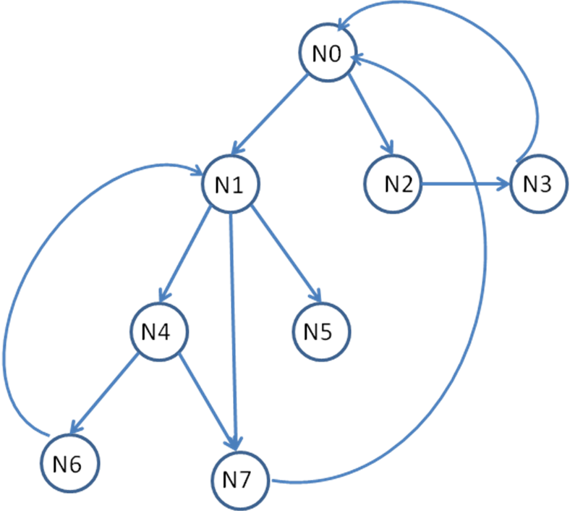

Fig. 2

5
Q9. A WFG of process p1, p2 and p3 is shown in figure (Fig. 3).
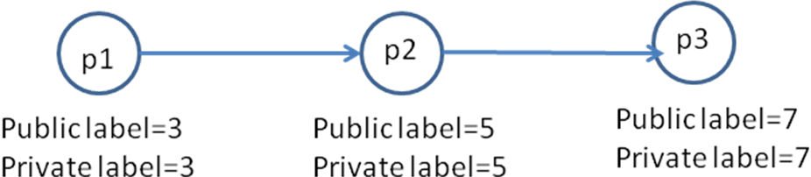
Fig. 3

Before p3 releases resources to p2, p3 requires some resources held by p1 and their WFG gets modified as shown below in Fig. 4.

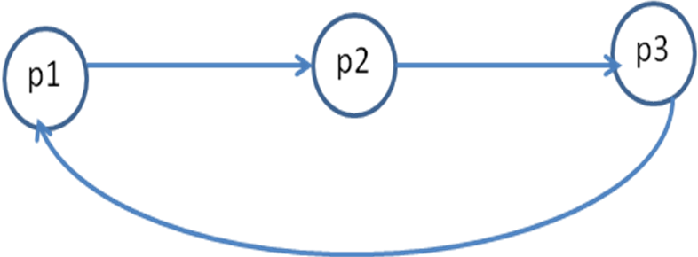
Fig. 4

If a deadlock detection algorithm using Mitchell-Merritt is initiated on this network then show changes of public and private labels of different processes. Which process will abort to break the deadlock?
5

Q10. A chord ring is given in Fig. 5. Answer the following questions.
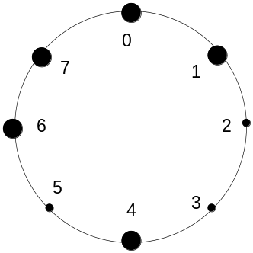
Fig. 5

- Construct the finger table for the node 0, 1, 4, 6, 7 (assume that node identifier consists of 3 bits).
- Place the file having key values 0, 2, 3, 4, 5, 6
- Show the visited nodes and intermediate steps when one search for a file having key value 6 and one has started the search from node 0.
- Show the effect of a node joining with node value 3.
- What will happen when node 6 leaves the network?
2.5+1+2.5+3+3=12

Marks
- 4+3+3=10
- 4+4=8
- 4+3+2+3+3=15
- 3+5=8
- 7
- 5+5=10
- 4+6+5=15
- 5
- 5
- 2.5+1+2.5+3+3=12

