- (i) In distributed balanced sliding window protocol two processes p and q are exchanging packets between themselves. discuss scenarios when following conditions are true [S_{p} is the index of next expected packet from process Q in process P, a_{p} is the index of lowest number word for which process P has not received any acknowledgement (implicit) yet from process Q, l_{p} and l_{q} are non negative constant where l_{p}+l_{q}>1]
  - S_{p} – l_{q} = a_{p}
  - a_{p} = s_{q}
  - s_{q} = a_{p} + l_{p}
Answer: Let us assume that l_{p} = l_{q} =3
Initially a_{p}=a_{q}=s_{p}=s_{q}=0
Condition (b): It is true at initial settings.
Condition (a): Lets assume that process Q sends 3 packets (0, 1 and 2) (a_{q} <i< s_{q} + l_{q}) and process P has not sent any packet yet. a_{p} and s_{p} will be modified according to the below formulae
a_{p}:=max(a_{p},i- l_{q} +1) so after receiving packet 0, 1 and 2 value of a_{p} will remain at 0
s_{p}:=min(j | out_{p}[j]=udef) After receiving all 3 packets will become 3. So at this point, condition (a) is true.

Condition c: Instead of Q if process P sends 3 packets then condition (c) will be true.
(ii) Answer following questions regarding mutual exclusion
  - Provide an example to show that Maekawa’s mutual exclusion algorithm is not a deadlock free mutual exclusion algorithm.
Answer:
Lets assume there are three sites S_{i}, S_{j} and S_{k}. Also suppose that
R_{i}∩R_{j}={Sij}
R_{i}∩R_{k}={S_{ik}}
R_{k}∩R_{j}={S_{kj}}
Now all three sites are competing for entering critical section. Assume S_{i} holds S_{ij} resource, S_{j} holds resource S_{kj} and S_{k} holds resource S_{ik}. So all the sites are in deadlock.
  - Build a valid request set for Maekawa’s algorithm of 7 processes.
Answer:
R₁={1, 2, 3}
R₄={1, 4, 5}
R₆={1, 6, 7}
R₂={2, 4, 6}
R₅={2, 5, 7}
R₇={3, 4, 7}
R₃={3, 5, 6}

2+2 + 2+ 2+3=11

- Answer the following questions from deadlock free packet switching
  - If an acyclic orientation cover for P of size B exists, then there exists a Deadlock Free Controller with only B buffers at each node.
Answer:
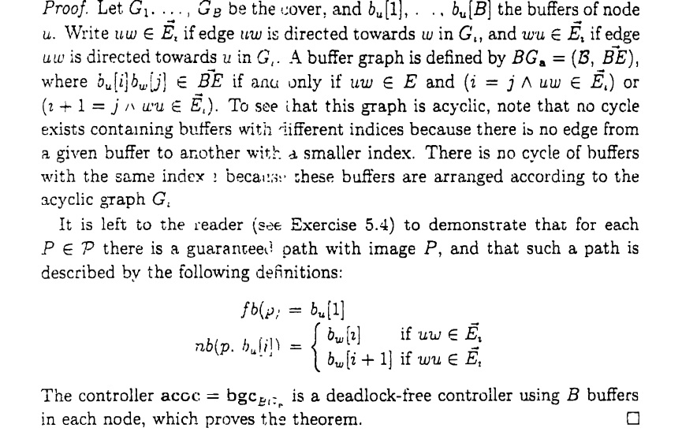

  - Find acyclic covers for the following network.


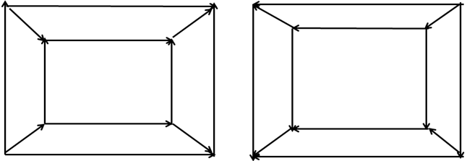

3+3=6

- Consider the following CHORD ring and answer the following questions
- Assume that hash key of a file is mapped to 7. Also assume that a search for the same file is inititated from node 1. During the search of the file a number of nodes and few entries of finger tables of those nodes will be examined. Populate a table in sequence of visit with format given below.
Visit id | Node id | Finger table index | Comments
1 | 1 | 0 (assuming staring from index 0) | It is to check if its successor (node 3) is also successor of 7  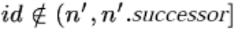  (in find_predecessor)
2 | 1 | 2 | Node 0 is the finger entry and It is not predecessor of 7  In closest_preceeding_finger
3 | 1 | 1 | Node 3 is the finger entry and It is predecessor of 7
4 | 3 | 0 | To find successor of node 3

- Assume a new node is being inserted with hash value 6 and bootstrapping node is node 1. Write down actions taken by existing node and new joinee node. Draw current ring with updated finger tables.
4+6=10
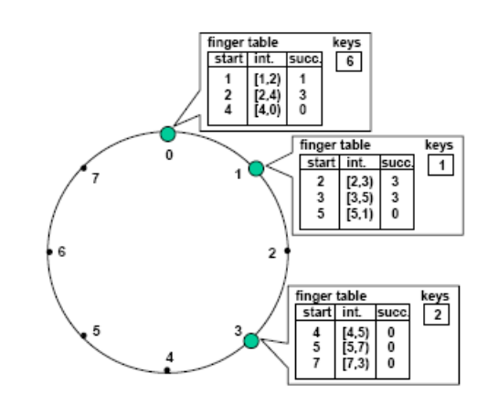
Answer:
New joinee node has to build its own finger table also need to move files to the new node for which new node is the successor (files corresponding to id 4, 5 and 6). Any existing node says x has to update its i^{th} entry of finger table if new node is successor of (x+2^{i}).
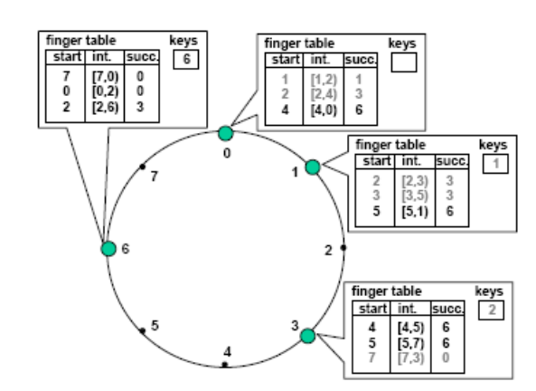
- Answer following questions from self stabilization

- Let us assume a system of n clocks in a chain ticking at the same rate. Each clock is 3-valued, i,e it ticks as 0, 1, 2, 0, 1, 2… A configuration is valid when all clocks are in same phase. A failure may arbitrarily alter the clock phases. The clocks phases need to be stabilized, i.e. they need to return to the same phase. Design a set of rules for this.
Answer:
repeat
R1. ∃j: j∈ N(i) :: c[j] = c[i] +1 mod 3 à
c[i] := c[i] + 2 mod 3
R2. ∀j: j∈N(i) :: c[j] ≠ c[i] +1 mod 3 à
c[i] := c[i] + 1 mod 3
forever

- Show changes of clock value till stabilization with a system with 5 clocks with initial configuration {0 2 1 0 1}.
Answer:
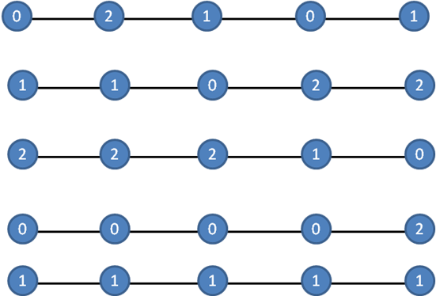
4+3=7

- Answer following questions from leader election algorithms
- Is leader election possible in a ring in which all but one processor has the same identifier? Give Proof.
Ans: Yes, it is possible, since one of the processors has an id which is different from every other processors id. We can propose different algorithms to choose the process with different id as the leader. One possible algorithm is algorithm 1. We assume no failures happen.

Algorithm 1: Leader election

1: To start election
2: send (election, my ID) to the left and right processors in the ring
3: When receiving message (election,id) from both left and right neighbors
4: if my ID is not equal to any of my two neighbors id then
5: I am selected as the leader
6: send (elected,my ID) to my right neighbor
7: end if
8: (elected,id) is forwarded clockwise in the ring until it comes back to leader (to inform every processor which processor is the leader)

- Modify the LeLann & Chang-Robert’s algorithm for leader election to elect 2 leaders in a unidirectional ring (two processes with the highest IDs, use minimum buffers).
Ans: To start an election, a process sends a message < election > with its ID appended. Each node that receives this message appends its ID to it. Once the election message reaches the initiator after going through the circle, the top two nodes (nodes with the highest and second highest IDs ) are selected, and a message < choose : highest1; highest2 > is sent with the initiator's ID appended to it. Each node that receives this message appends its ID again. When this message reaches the initiator, if the appended ID list contains the top two nodes, then the election is successful and ends. Otherwise, a new election is initiated.

- Write a code-snippet to explain extinction of waves in echo algorithm (only needed part).
Ans:
var cawp: process init udef ; // Currently active wave
recp: integer init 0; // No of 〈 tok, , cawp〉received
lrecp: integer init 0; // No of 〈 ldr, , .. 〉received

begin if p is initiator then
begin cawp= p ;

forall q ∈ Neighp
do send 〈 tok, , p 〉 to q ;
end ;
while lrecp< #Neighp
do
begin receive msg from q ;
if msg = 〈 ldr, , r〉 then

begin if lrecp = 0 then
//Do corresponding action
else // message is a 〈 tok, , r〉 message
begin if r < cawp then // Reinitialize the algorithm
//Do corresponding Action
end
// If r > cawp then the message is ignored – extinction
end
end
end

- Prove that, leader election problem and minimum spanning tree problem are of same order of magnitude in terms of complexity.
Ans:
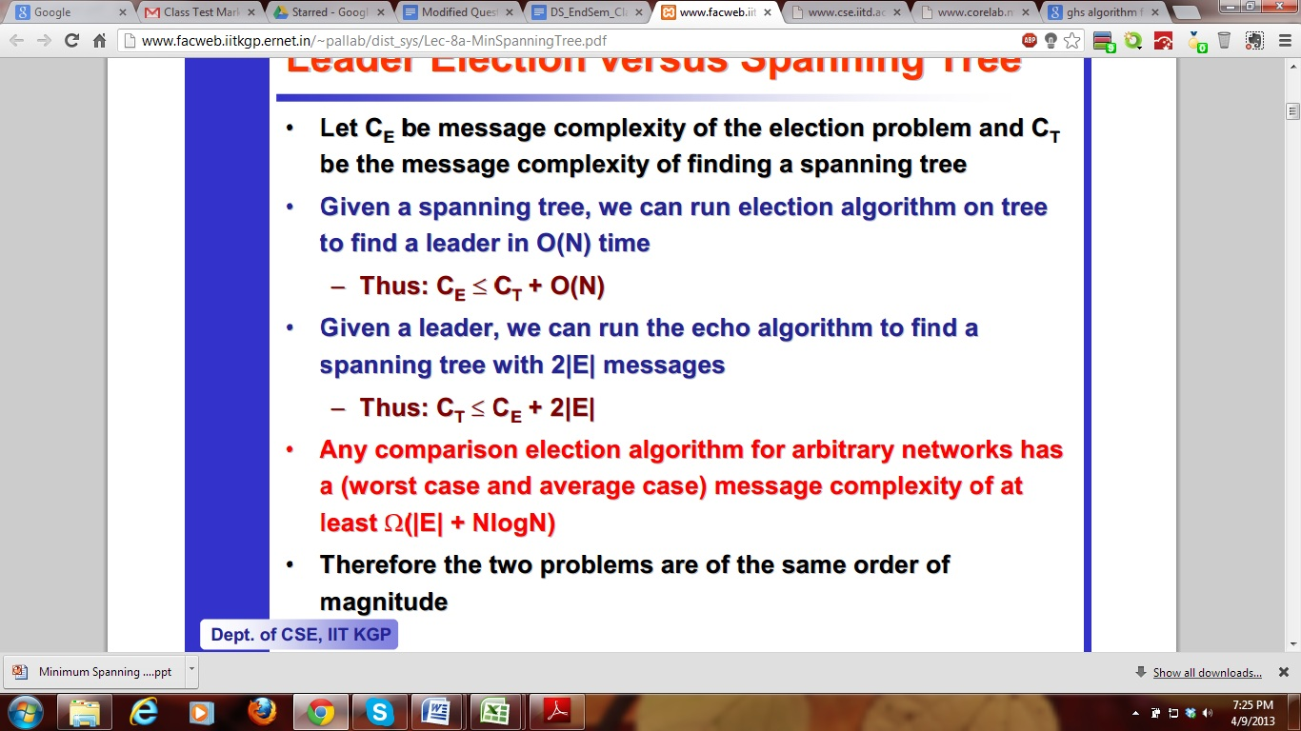
2 + 3 + 3 +4 = 12

- In the GHS algorithm, let’s say there are two fragments F1 and F2 with level L1 and L2. Let P be a node belonging to fragment F1 issues a connect request to node Q belonging to fragment F2. Please answer the following questions for L1<L2.
- Is the connection request from P to Q always accepted immediately? If not what are the conditions?
Ans: Yes
- Q issues an initiate message if the connection request is accepted. What are the parameters of the initiate message?
Ans:
<level of F2(L2),name of Fragment (F2), state of Q >

- Let’s assume PQ is the minimum outgoing edge from fragment F2. What would be the value of state parameter sent along initiate message? Justify your answer.
Ans: Find
As PQ is the edge with minimum weight from fragment F2, a test message would be sent through PQ edge. However, receiving the test message fragment F1 will not send any reply back as L1<L2. So state of node Q will remain Find.
- If PQ is not minimum outgoing edge for fragment F2 then what would be the value of state parameter sent from Q to P? Justify your answer.
Ans: Find/Found depending on Q’s state.
1+1+2+2 = 6
- Consider the following algorithm for failure detection among n processes. Each process picks k other processes at random and sends heartbeat messages to each of those processes. If a process P_{i} receives a heartbeat message from process P_{j}, it will expect further heartbeats to arrive from P_{j} at regular intervals. If they stop, after some timeout, P_{i} declares P_{j} as failed process and broadcasts this to all of the other processes. Suppose m random processes fail at once. What is the probability that not all failures will be detected? You have to clearly state the scenario when detection would not be possible.
5
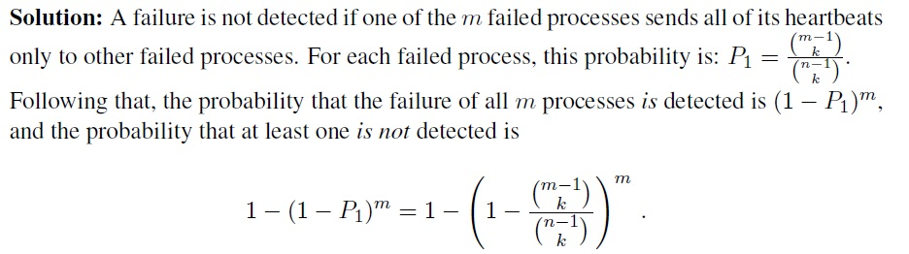
- Answer following questions
  - Assume Probe1 and Probe2 both are initiated by process p1. Fill in the probe messages that are passed, in the Chandy-Misra-Haas Algorithm.
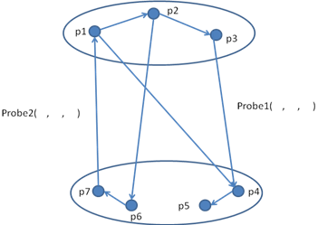

Ans: Probe1 (1,3,4) ,Probe2 (1,7,1)

  - Given Path pushing and Edge chasing algorithms - how is one better than the other in terms of message size?
Ans:
Edge chasing is better because probes are shorter and fixed length than Path pushing where each site sends its local WFG to all the neighbouring sites. This is continued until one site has sufficient information about the global WFG to declare a deadlock or establish that deadlock is absent
  - Derive the upper bound on number of messages exchanged in Chandy-Misra-Haas algorithm (AND model)(Edge chasing) for m processes and n sites. What is the delay in detecting a deadlock?
Ans:
m(n-1)/2
One probe message per deadlock detection initiation is sent along every edge of the WFG which connects processes on 2 different sites.

Delay in deadlock detection is O(n).
2 + 2 + 3 (2+1) =7

- Answer following questions from agreement protocol
  - Prove with an example that in Byzantine General’s Problem with m faulty generals, no solution is possible if total number of generals n < 3m+1(Show with n = 3,m=1)
Ans:
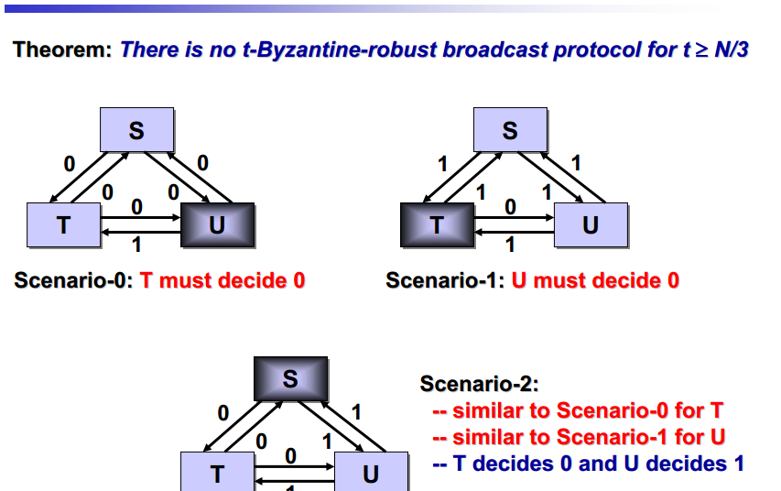
  - In Phase king algorithm,
    - Prove that if king of phase k is non-faulty then at the end of phase k, all non faulty processors have same preference.
    - How many rounds are required to come into consensus if there are at most f faulty processors?
    - What is the message complexity? Justify.
    - Prove that if they reach consensus once, they will stick to the consensus arrived.

Ans:
b-i)
Let p_{i} and p_{j} be non-faulty
Case 1: p_{i} and p_{j} both use p_{k} 's tie‐breaker. Since p_{k} is non-faulty, they both have same preference.
Case 2: p_{i} uses its majority value v and p_{j} uses king’s tie breaker. Then p_{i} receives more than n/2 + f preferences for v. So p_{k} receives more than n/2 preferences for v. So p_{k}’s tie breaker is v.
Case 3: p_{i} and p_{j} both use their own majority values. Suppose p_{i} 's majority value is v. Then p_{i} receives more than n/2 preferences for v. So p_{j} receives more than n/2 preferences for v. So p_{j}’s majority value is v.

b-ii) (f+1) rounds

b-iii)
O(n²f) messages, each of size log|V|. Each process sends message to all other processes. n(n-1) messages + another n-1 messages in the second round of each phase. There are f+1 phase.
(f+1)(n+1)(n-1) = O(n²f)

b-iV)
Every processor receives at least n − f copies of v in the first round of phase k n − f > n/2 + f since n > 4f, so all processors prefer v at the end of phase k Then again at the beginning of next phase, all non-faulty processors prefer v and thus every processor receives at least n-f copies of v in the first round of the next phase. This keeps continuing for all the subsequent phases until all f+1 phases have been completed.

3 + 3 + 1 + 2 + 2 =11

