Answer as much as you can

Question 1
For each of the following, indicate whether the item describes
- a MODEL or technique for generating graphs,
- a mathematical PROPERTY of the entire graph, or
- NEITHER.
(Write either MODEL, PROPERTY, or NEITHER next to each item.)
- G(n, p)
- Small diameter
- Context
- Chromatic number
- The PageRank algorithm
- Preferential attachment
- Heavy-tailed distribution of degree
- Bag of words
- Connected
- Acyclic
- Bacon number
- Tree
[0.5×12=6]

Question 2

In this question, we describe the launch of Pennster, a hypothetical online social network much like the Friendster and Orkut systems. We ask questions about what the network is like at different steps. In this system, people are nodes and the mutual relationship of "Penn-friendship" is the only kind of link. Accepting an invitation to join Pennster is one way to create a "Penn-friendship" link between yourself and the person who invited you. Once on the system, you can offer Penn-friendship to another person who is already on Pennster. Accepting an offer of Penn-friendship (when both parties are already on the system) is the only other way to add a link of Penn-friendship. A person can unilaterally "un-Penn-friend" any Penn-friend, which removes the link that connects them. Assume invitees are part of the network.
- Kilian launches Pennster and is the only Penn-friend on the system.
- Kilian invites Michael and Nick.
- Nick accepts the invitation from Kilian.
- Michael accepts the invitation from Kilian.
- Michael invites Duncan to join Pennster.
- Nick invites Malcolm to join Pennster.
- Malcolm accepts the invitation from Nick.
- Kilian and Nick get into an argument and Nick un-Penn-friends Kilian.
- Malcolm offers Penn-Frienship to Michael.
- Michael accepts the offer from Malcolm.
- Kilian invites Thomas.
- Thomas accepts the invitation from Kilian.
- Duncan accepts the offer from Michael.
- Malcolm accuses Michael of misreading his book and un-Penn-friends him.
The following questions refer to Pennster and the sequence of 14 events listed above.
- If the Pennster graph is disconnected at any point, write the number of each step in which the graph becomes disconnected. If it is always connected, write "ALWAYS CONNECTED."
- Write Kilian's degree after each of the 14 steps above. Your answer will be a sequence of 14 numbers.
- Whose friends are most well connected after all the 14 steps?
- Which two nodes are structurally most equivalent after all the 14 steps?
- Is there any 2-clique in the graph after all the 14 steps?
- After the last step, 14, consider all paths of finite length. Pick the shortest path between each pair of nodes. What is the maximum shortest path (the maximum number of links that must be traversed to get between any pair of nodes)? Write all of the people who lie along the path in order (including the people on the ends of it).
- What is the probability that if two nodes are chosen uniformly at random (after all the 14 steps) from the network they have a “Penn-friendship”. [2+2+2+2+1+2+2=13]

Question 3

Consider a network in which person A has ten friends, the ten friends of person A each have ten friends, and those ten friends each have ten friends. There are no other people in this network other than those mentioned. Assume that people cannot be their own friends.
- What is the largest number of people who could possibly be in such a network? Describe the structure of this network.
- What is the smallest number? Describe the structure of the network.
[3+3=6]

Question 4
Consider this graph that represents a miniature World Wide Web, with vertices representing pages and edges representing hyperlinks:
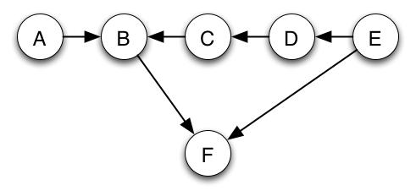
- Which node will have the highest PageRank?
- Add a node G that has two links, one leading to C and one leading to A. Will the PageRank of node G be HIGHER than, LOWER than, or the SAME as B? Justify with arguments.
- Does adding the node G, INCREASE, DECREASE or NOT AFFECT the rank of node F? Justify with arguments.
- After G is added, how many directed cycles does the graph have?
[1+2+2+1=6]

Question 5

- Consider the G(n, m) model of random graphs, with the settings n=5 and m a function of n, specifically m=(0.4)*n. Draw any specific graph that could be generated by this model.

- Consider the figure given below

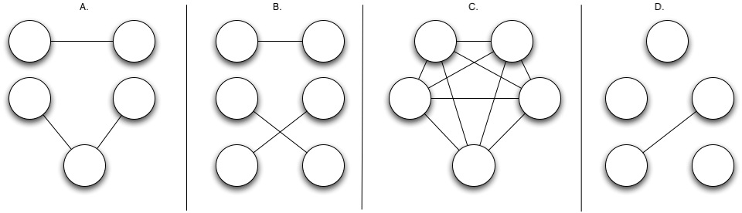

- Which one of the four graphs shown above is most likely to have been generated by a G(n, p) model with n=5 and p=0.3? Why?
- Which of the graphs (if any) could not possibly have been generated by such a model? Why?
[2+2+2=6]

Question 6
For each of the following graph generation models, write which of the following attributes the model has, in expectation: HEAVY-TAILED degree distribution, SMALL DIAMETER, and high CLUSTERING. (You can just write "HEAVY-TAILED", "SMALL DIAMETER", and/or "CLUSTERING" as is appropriate.) If the model has more than one attribute, write all of the appropriate terms. If the model has none of the attributes, write "NONE." A "HEAVY-TAILED" distribution is a probability distribution with infinite variance.
- Erdos-Renyi model
- Preferential attachment
- Small-world model
- Connect nodes 1 through 10 in a clique, then draw an edge from 10 to 11; then connect nodes 11 though 20 in a clique, then draw an edge from 20 to 21; and continue the process for each additional 10 nodes.
[1+1+1+2=5]

Question 7

Consider the two "small worlds" network generation models -- the rewiring model (rewiring probability = α) of Watts, and the model of Kleinberg in which vertices lie on a grid, and a vertex is connected to all others within grid distance p, as well as having q "long distance" connections. A vertex at grid distance d has probability proportional to 1/d^{r} of being chosen as a long-distance connection, for some r > 0.

- Discuss how the Erdös-Renyí model can be approximated in both the rewiring model (parameter: α) and Kleinberg's model (parameters: p, q, d and r). What settings of the parameters of each model realize this approximation? Briefly justify your answer.
- Point out a difference between the two models in terms of their long-distance connections.
- Derive an expression for the clustering coefficient of the network formed by Watt’s model. [4+2+8=14]

Question 8

Let F_{n} represent the general term of the Fibonacci series 1, 1, 2, 3, 5, 8,..... The generating function for this sequence is given by
∞
G₀(x) =∑ F_{n}x^{n}
_{n=1}

Show that the above generating function really encodes the terms of the Fibonacci series. Further show that G₀(x) = x/(1-x-x²)
[8]

Question 9

It can be shown (from Yule Distribution), that for a power-law for integer variables the following holds:

p(k) = C B(k, α) = C (Γ(k) Γ(α)/ Γ (k+ α))

where C is a normalizing constant and Γ(x) is the standard Γ-function with the property Γ(x+1) = x Γ(x).
₁
Consider the integral I(a, b) = ∫ u^{a-1}(1-u)^{b-1}du
₀

Show, using integration by parts, that for a>1 and b>0,

I(a, b) = (^{a-1}/_{b})I(a-1,b+1)

Hence, by the repeated use of the above formula show that for k integer,
₁
B(k, α) = ∫ u^{k-1}(1-u)^{α-1}du
⁰
Further show that C = α – 1, given ∑p(k) = 1
Also show that,
∑kp(k) = ^{α – 1}/ _{α – 2}

If y = k(1-u), then show that in the thermodynamical limits,

p(k) = (α – 1) Γ(α)k^{- α}
[10]

****************************BEST OF LUCK*****************************

