SOLUTIONS TO ASSIGNMENT 3

Question 3:

Using G_{n,p} as in the previous question, show that there exists a constant c such that if p ≥ c/n then the probability that G is 3-colorable goes to zero in the thermodynamic limits

Solution 3:

Number of triangle possible in a graph G_{n,p} = ^{n}C₃
Probability that number of triangles possible = p³
Expected number of triangles in a graph G_{n,p} = ^{n}C₃. p³ [1]

Substituting, p = c / n, in the equation 1, we get
P_{triangle} = ^{n}C₃. p³ = 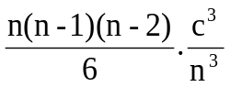 = 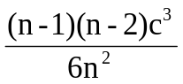 [2]
Now, in the thermodynamic limit, the graph will not be 3-colorable any more if there exists a triangle in the graph. In other words, if for some real value of c, the probability of triangle being present becomes 1 at 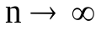, then we can say that there exist a constant c such that for 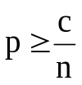, the probability that the graph G_{n,p} is 3-colorable goes to zero in the thermodynamic limits. Therefore to find if real value of c exists we solve for c taking P_{triangle} = 1.
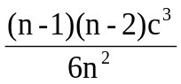= P_{triangle} = 1 [3]
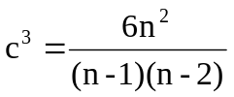 [4]
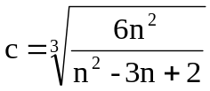 [5]
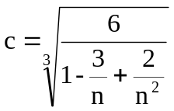 [6]
At thermodynamic limit 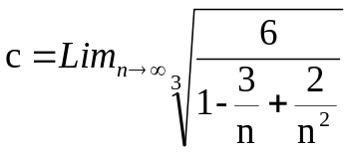 = 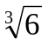1.81712
Therefore we can say that for 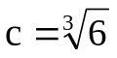, the graph G_{n,p} with is 3-colorable goes to zero in the thermodynamic limits.

Question 4:
In the Erdos-Renyi random graph model, the probability that a node has a degree k is given by:
p_{k} = ^{n}C_{k}p^{k}(1-p)^{n-k}
where n is the number of nodes in the graph. Show that in the thermodynamical limits,
p_{k =} z^{k}e^{-z}/k!
where z=n(p-1).

Solution 4:
We have the probability of a node in the random to have degree k as

p_{k} = ^{n}C_{k}p^{k}(1-p)^{n-k} [7]
Therefore, using generating functions degree distribution is as follows:
G(0) = 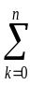^{n}C_{k} p^{k} (1-p)^{n-k} x^{k} [8]
G(0) = 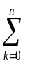^{n}C_{k (}px)^{k} (1-p)^{n-k} [9]
Using Binomial Equation, G(0) = [ px + (1-p) ]^{n} [10]
G(0) = [ 1- p(1-x) ]^{n} [11]
Now for a random graph Gn,p , we know that number of edges = ^{n}C₂ . p
Number of degrees = 2 . ^{n}C₂ . p = n . z , where z = average degree of nodes in the graph. Therefore z = (n-1).pn.p for very large values of n
Substituting this in equation 11, we get
G(0) =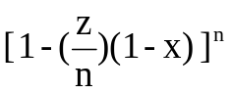 [12]
At the thermodynamic limit, we can do the following
G(0) = 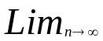[1- (z/n)(1-x) ]^{n} [13]
G(0) = e^{-z(1-x)} [14]
Just to confirm the validity of the derivation, z = G₀´(1) = z.e^{-z(1-x)}|_{x=0} = z
We know that
p_{k} = 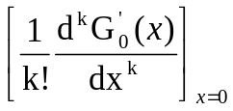 [15]
p_{k} = 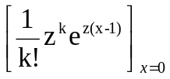 [16]
p_{k} = 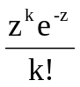 [17]

