Assignments on Community analysis

1.
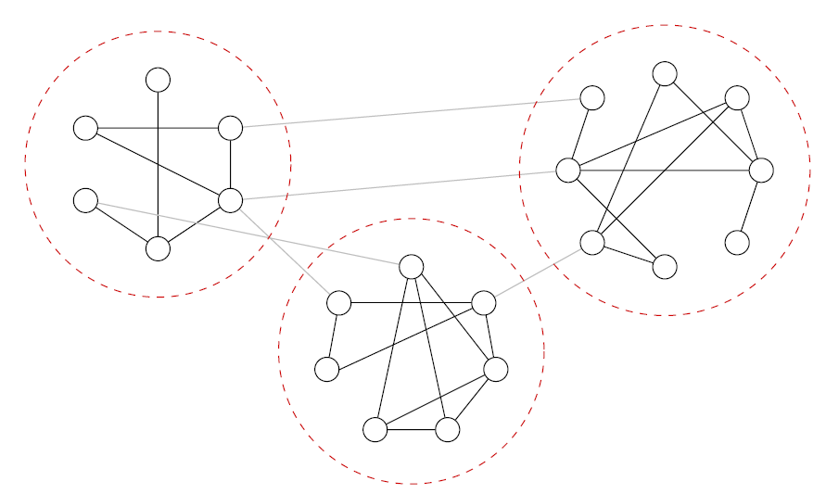

Fig 1
(a) Find the edge betweenness of individual edges of Fig 1 using Newman Girvan shortest path algorithm. Choose any arbitrary source. Show the individual steps.
(b) Repeat the calculation to find edge betweenness using random walker based approach.

2. a. Define community structure in the directed network. Can we directly apply the Kernighan Lin algorithm for the directed network? Justify.
b. If not, then suitably modify the algorithm so that it becomes applicable for the directed network.
c. Demonstrate the algorithm for Fig 2.

3. a. Classical Kernighan Lin algorithm detects two communities in a network. Modify the algorithm so that it can detect three communities in the network.
(One possible approach is the recursive application of classical Kernighan Lin which detects the 3 communities in two steps. In the first step, detect two communities. In the second step, split one of them into two. But modify the Kernighan Lin algorithm so that it can detect three communities in a single step.)
b. Demonstrate the algorithm for the network in Fig 1. You can reduce the size of the network in order to simplify the calculation. However, keep the three community structure of the network intact and distinctly mark the difference of the modified algorithm with the classical algorithm.

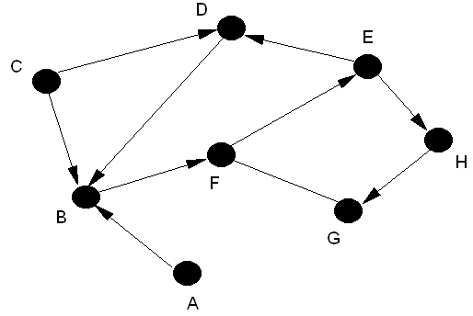

Fig 2
4. Find the rank of the individual nodes of Fig 2 using HITS algorithm. Assume that Fig 2 represents a WWW network where A, B.....H are the web pages.

5.
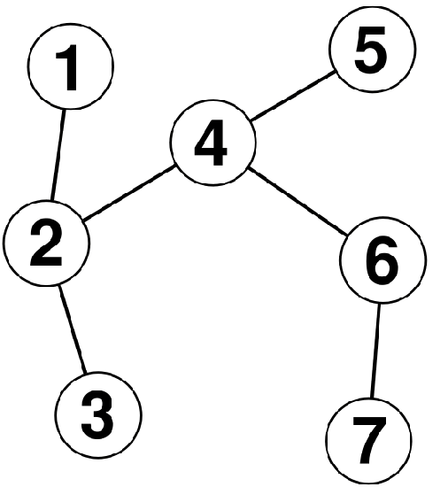
Fig 3

Find the communities of the above network (Fig 3) using
- Wu Huberman’s algorithm
- Radicchi algorithm
Show and explain each step of the algorithm in details.

6. a. How can we measure the shortest path edge betweenness in a weighted graph?
b. Modify the Newman Girvan shortest path betweenness algorithm so that it becomes applicable to the weighted graph.
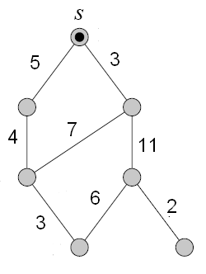
Fig. 4

c. Illustrate the modified algorithm for Fig. 4 to find the betweenness centrality of different edges. In the calculation, clearly mark the difference between the unweighted algorithm with the weighted one.
d. Newman Girvan shortest path betweenness algorithm follows BFS in order to discover the nodes in the network. Can we replace the BFS by the DFS? Justify with logic.

7.a. In the traditional Radichhi algorithm, the graph is given as the input and the betweenness centrality of the edge is calculated by ‘counting’ the number of triangles. In this problem, we specify the input in the following way. Instead of specifying the graph G(V,E), we provide the degree and the clustering coefficient of the individual node of the graph. Can you modify the Radichhi’s algorithm in order to calculate the betweenness centrality of individual edge (at least approximately).
b. Modify the expression for the Radichhi algorithm so that it works for the
i. weighted network
ii. directed network
8. Can we use the random walk based betweenness centrality measurement technique for directed graph? Justify. Make suitable corrections in the existing calculation so that it can be applied to directed network.

