INDIAN INSTITUTE OF TECHNOLOGY, KHARAGPUR
Date 27.02.09 AN Time: 2 Hrs. No. of Students: 43
Spring Semester: 2008 Department: Computer Science and Engineering
Sub. No: CS 60078 Sub. Name: Complex Network Theory
Answer as much as you can

- For the graph in Fig. 1, determine the following:
(a) The average degree.
(b) The degree distribution P(k).
(c) The clustering coefficient C_{i} for each node.
(d) The degree distribution when
i) node 5 is removed
ii) nodes 7 and 8 are removed
(f) Radicchi coefficient of each edge (Hint: Radicchi coefficient is based upon the number of triangles an edge is part of) 0.5 + 1 + 2 + (0.5 + 0.5) + 2.5 = 7

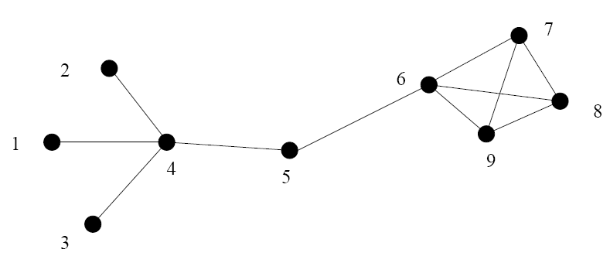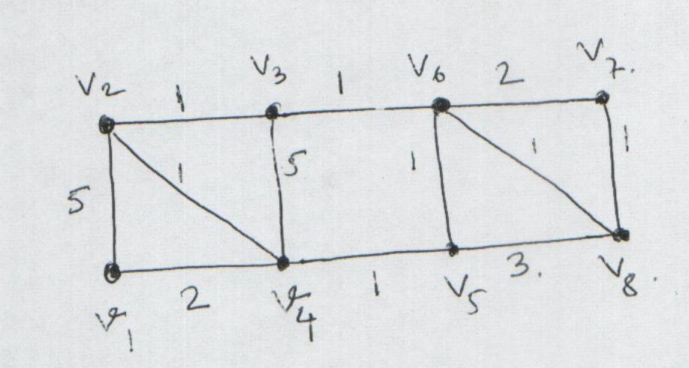
Fig. 1 Fig. 2

- Give one example each of a simple unweighted graph with 4 nodes that satisfies the following conditions. You can specify the graph by drawing the nodes and edges, or describing it verbally (e.g., “a ring with 4 nodes”). If no such graph is possible, you should explain why so, otherwise no explanation is required. Note that by “eigenvalue of the graph” we mean “eigenvalue of the adjacency matrix of the graph”.
  - Undirected and connected graph such that at least one of the eigenvalues is 0.
  - Undirected and connected graph such that none of the eigenvalues is 0.
  - Undirected and connected graph such that the eigenvalues are 1, 1, 0 and 0.
  - Directed graph for which there are exactly two nodes with eigenvector centrality 0 and two nodes with non-zero eigenvector centrality.
  - Undirected and connected graph where all the nodes have the same degree centrality but at least two of them have different eigenvector centralities.
1x5 = 5

- Consider the following modified modern version of the Milgram Experiment: Everybody in a web social network (such as Facebook or Orkut) have been given a unique id (e.g., the login name) and asked to send this id as a token message to all their friends. Once everybody receives the token messages from their friends they are then supposed to send all the received messages again to their friends. After these two rounds of message passing, everybody is awarded a social status based on the total number of messages received by that person in the two rounds.
Assume that the web social network is represented as an undirected and unweighted network G with no self loops. Let A be the corresponding adjacency matrix. Further assume that G’ represents a network where the nodes are same as that of G, but an edge from node u to v has a weight w if there are w messages with id of u that is received by v during the modified Milgram experiment. Let A’ be the adjacency matrix of G’.
  - Show that for all i and j, A’[i][j] = A’[j][i] (i.e., G’ is symmetric).
  - Show that for all i, A’[i][i] is the degree of the node i in the graph G.
  - Show that the status assigned to a node according to the modified Milgram experiment is equal to its weighted degree in G’.
  - Express the matrix A’ in terms of A. (Hint: first try to define A’[i][j] in terms of the entries of A).
  - Give an example of a network G to show that it is not necessary that the node with highest degree in G also has the highest status according to the modified Milgram experiment.
  - How are the eigenvalues of A related to that of A’? Do they have the same eigenvectors?
1 + 1 + 1 + 1.5 + 1.5 + 1.5 = 7.5

- Prove that a planar graph of n vertices (n ≥ 4) has at least four vertices with degree five or less.
- Let e be an edge appearing an odd number of times in a closed walk W. Prove that W contains the edges of a cycle through e.
- In a finite size scale free networks with degree distribution p(k) = k^{-γ} and size N, find the maximum degree of the network. 2.5 x 3 = 7.5

- Given a infinitely large network whose degree distribution is given by p_{k} = c. e^{-k},
- State the value of the constant c.
- State whether such network will form giant component.
- What will be the average degree of the network
- What will be the average number of second neighbours?
- What will be the diameter of the network? 1 + 2.5 + 1 + 1.5 + 2 = 8

- Given the weighted network (Fig. 2), and given the initial partition as A⁰ = <v₂,v₃,v₆,v₇> and B⁰ = <v₁,v₄,v₅,v₈>, apply Keringham Lin Algorithm to partition it. Show in detail the steps of the algorithm and the partitions obtained after first and the second pass of the algorithm. 5

