DISCRETE STRUCTURES
ASSIGNMENT 4

- Let 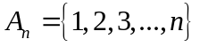. Let the total number of partitions of 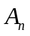 denoted by the nth Bell number 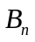. Let 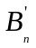 denote the total number of partitions of for which any pair of consecutive integers (i, i + 1) does not belong to the same subset of a partition. Prove that 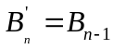 for all n > 1.
- Solve the following recurrence relation to find the explicit formula for the sequence 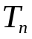:
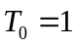,
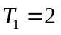,
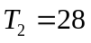,
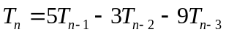 for all 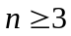.
- Let k belong to Z+, 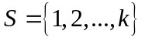 and 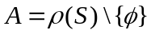, where 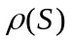 denotes the power set of S, and denotes the empty set. In other words the set A comprises of all non-empty subsets of 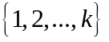. For each 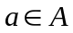 denote by min(a) the smallest element of a (notice here that a is a set). Define a relation on A as follows: 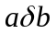 if and only if min(a) = min(b). Prove that is a reflexive, symmetric and transitive relation on A.
- For the following recurrence relation, find a closed form equivalent expression.
L(1) = 3,
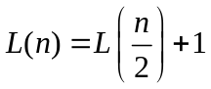 where n is a positive integral power of 2.
- 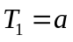,
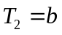,
,
Solve the above recurrence relation to obtain an explicit formula for 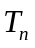. Conclude that 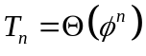, where is the golden ratio.
- Find a recurrence relation for the number of bit strings of length n that have three consecutive 0s. Use this relation to find the number of such bit strings of length 7.
- The number f(n) of steps required to solve the ‘Chinese rings puzzle’ with n rings satisfy f(1) = and
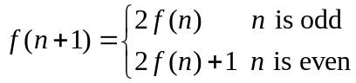
Prove that f(n+2) = f(n+1) + 2f(n) + 1, hence or otherwise find a formula for f(n).

