DISCRETE STRUCTURES
ASSIGNMENT 2

- a). For , we have
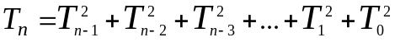
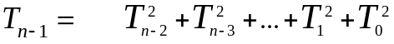
so that 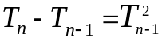
i.e. 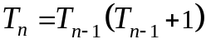
b). [Induction on n] 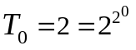. So assume 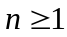 and that 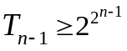.
The recurrence implies 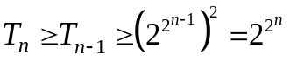
c). [Induction on n] 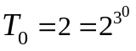 and 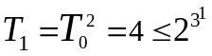, so take and
assume that 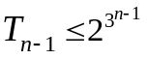. But then by part (a) we have
(since 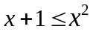 for all 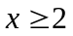) i.e.
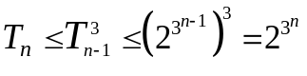.
- [False]. Let P(x) be the predicate “x is even” and Q(x) be predicate “x+1 is even”. The for example 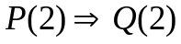 is false and so 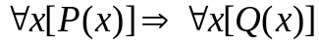 is false. On the other hand 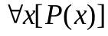 is false since all integers are not even, and so is true.
- a). We proceed using 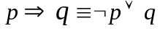
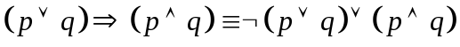
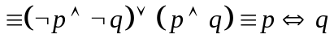
b). 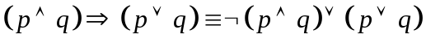
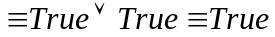
c). 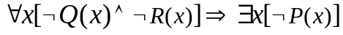
d). “If I attend the lecture, I wake (have woken) up early and do not
have a headache”.
e). “There exist two odd integers the sum of which is an odd integer”.
- We prove by contrapositive. Thus we need to prove that if not both p and q are odd, then their product pq is not odd (i.e. it must be even). Let p = 2k (even) and q = (2l+1) (odd) for some 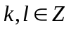. Now the product pq = 2k.(2l+1) = 4kl+2k = 2(2kl+k), which is even. Similarly for the case when both p and q are even, pq is again even. Hence, if not both p and q are odd, then their product pq is not odd.
- We prove by Induction
[Basis] n = 1, 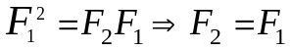
[Induction Step] Let us assume that it is true for k = n-1, i.e.
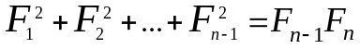, Adding 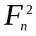 to both the sides we get,
. Hence Proved.
- [Proof by contradiction] Let us assume that the sum of a rational number and irrational number results in an irrational number. Let the rational number be p/q, irrational number be x and the result be a/b. According to our assumption,
p/q + x = a/b, i.e. x = a/b – p/q, i.e. x is rational, which is a contradiction. Hence, our assumption that the sum of a rational number and irrational number is a rational number is wrong.

