DISCRETE STRUCTURES
SOLUTION 4

- Call a partition P of 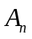 special, if no subset in P contains two consecutive integers. Denote by 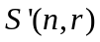 the number of special partitions of containing exactly r non-empty subsets. First I prove by induction on n, that 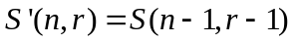 for all 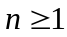 and for all r in the range 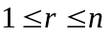. For n = 1 we have 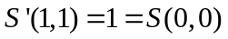 and the induction basis is proved. So take  and , and assume that the claim holds for 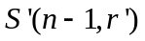 for all legitimate indices 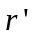. Consider the special partition of 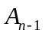 into r-1 non empty subsets. Adding {n} as singleton gives a special partition of . Then consider a special partition of into r non-empty subsets. Adding n to any one the r-1 subsets not containing n-1 yields a special partition of . All special partitions of into r non-empty subsets can be generated in this way. Subsequently:
[by the Induction hypothesis]
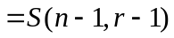[by the recurrence for Stirling numbers]
And the inductive step is established. For it then follows that
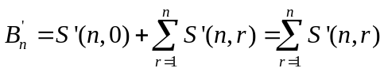 [Since 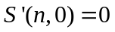]
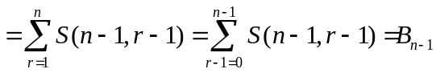
- The characteristic equation is
Therefore, a general solution of the given recurrence is:
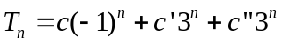
Plugging in the initial values gives:
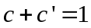,
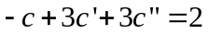,
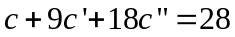
The solution of this system is 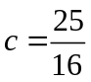, 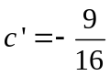, 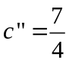. Then we have
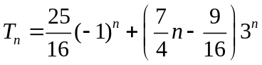.
- We prove all the three properties as follows:
[Reflexive] For any 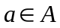 we have min(a) = min(a).
[Symmetric] For any 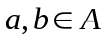, if min(a) = min(b), then min(b) = min(a)
[Transitive] For any 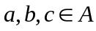, if min(a) = min(b), min(b) = min(c), then min(a) = min(c).
- The proof is as follows:
Given L(1) = 3 and 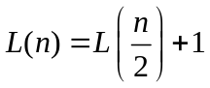
So 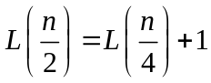
i.e. 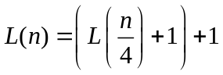
i.e. 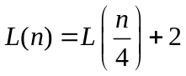
Similarly, 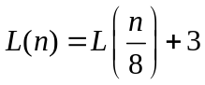 and so on.
In general, 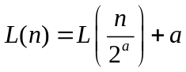 for any positive integer a
Let 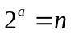, or 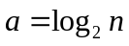
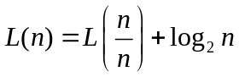
i.e. 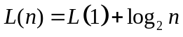
i.e. 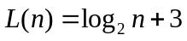.
- The characteristic equation 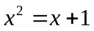 has roots 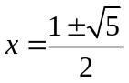. So a particular solution is of the form 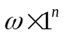. Substitution gives 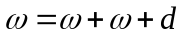, i.e. 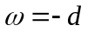. Therefore, a general solution is of the form
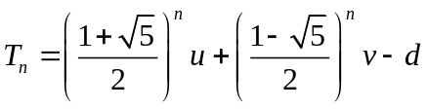
where u, v are constants to be determined from the initial conditions
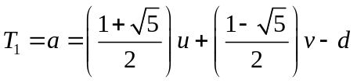,
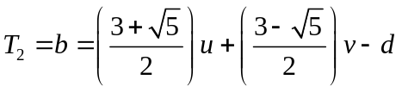
Solving this system gives,
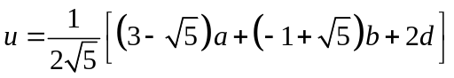
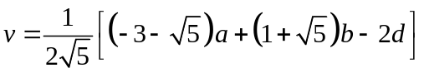
Notice that the exact values of the constants u, v, w are not very important here. It suffices to know the form of the solution. In particular, since a, b, d are positive, it follows that u > 0. Also 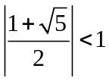. Consequently, 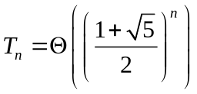.
- Let 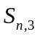 denote the total number of bit strings of length n that have three consecutive 0s. Now we have two possibilities, if 1 occurs on the first place or 0 occurs in the first place. If 1 occurs, then the problem reduces to finding the number of bit strings of length n-1 that have three consecutive 0s i.e. 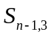 and if 0 occurs in the first place then we look for the 2nd digit. Similarly if 1 occurs in the 2nd digit as well, then we have to solve the relation 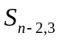, and if again 0 occurs we see the 3rd digit, if 1 occurs here then we solve 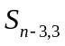 otherwise the remaining n-3 places can be either filled with 1 or 0, giving a total number of ways as 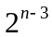 Hence the recurrence relation becomes
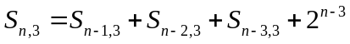
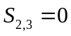, 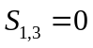, 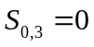
From the above recurrence relation, we get
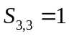
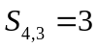
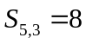
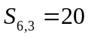
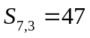
- If n is odd, the f(n+2) = 2f(n+1) + 1 and f(n+1) = 2f(n); if n is even, f(n+2) = 2f(n+1) and f(n+1) = 2f(n) + 1. So the result holds in either case.
This is not a “pure” recurrence relation because of added 1. But if we set g(n) = f(n) + ½, the g(n+1) + 2g(n) = f(n+1) + 2f(n) + 3/2 = g(n+2). The characteristic equation is 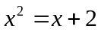, with solutions 2 and -1, so 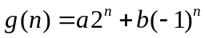. The initial values g(1) = 3/2 and g(2) = 5/2 yield a = 2/3 and b = -1/6. So 

