ASSIGNMENT 5
DISCRETE STRUCTURES

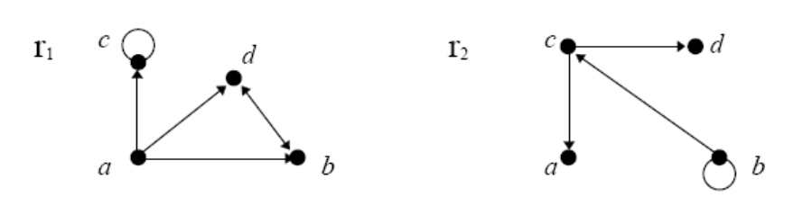
Figure 1

Question 1
- Figure 1 defines two relations on the set {a,b,c,d}. Find the list and matrix representations of those relations.

Solution: R1={(a,d), (b,d), (c,c), (d,b), (a,c), (a,b)} R2={(c,a), (b,b), (b,c), (c,d)}
- A relation on the set {a,b,c,d} is defined by the following list: {(a,c), (c,c), (a,a), (b,b), (c,a), (d,b), (d,a)}. Draw its directed graph
representation.
(c) What is wrong with the following “proof” that every symmetric and transitive relation is reflexive? If (a,b)R then (b,a) R by
symmetry. By transitivity (a,a)R. Therefore R is reflexive.
Solution: Every symmetric & transitive relation need not be reflexive.
Let (a,b) R; (b,a) R (Symmetric)
also (a,b) R, (b,a) R (Transitive)
A={a, b, c} R={(a,b), (b,a), (a,a), (b,b)}
R is both symmetric and transitive but not reflexive.

Question 2
(a) Define the relation r on the set of natural numbers as: r = {(x,y) | ∃ n∈Z: x/y = 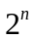}. Here Z is a set of all integers. Prove it is an equivalence relation. How many different equivalence classes are there among [1], [2], [3], and [4], where the brackets denote the equivalence class of the expression inside?
Solution: r = {(x,y) | ∃ n∈Z: x/y = }. Easily prove that the given relation is reflexive, transitive and symmetric.
Thus, r is an equivalence relation.
[1] = R(1) = {(y) | ∃ n∈Z: 1/y = }= {(y) | ∃ n∈Z: x/y = 2^{-n}}= {(y) | ∃ m∈Z: x/y = 2^{m}}
[2] = R(2) = {(y) | ∃ n∈Z: y = 2^{1-n} }= {(y) | ∃ m∈Z: x/y = 2^{m}}
[3] = R(3) = {(y) | ∃ n∈Z: y = 3.}
[4] = R(4) = {(y) | ∃ n∈Z: y = }
R(1)=R(2)=R(4) but R(3) is different. Thus, 2 equivalence classes exist.

(b) On the set of all n × n matrices over R, define A ~ B if there exists an invertible matrix P such that PAP⁻¹ = B. Check that ~ defines an equivalence relation.
Solution: r: A~B if ∃ P: PAP⁻¹=B and P⁻¹ exists. Clearly r is reflexive, symmetric and transitive.

Question 3
Let R be an equivalence relation on a set A. Then A can be written as a union of disjoint sets 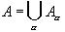with the following properties:
- If a, b are in A then aRb if and only if a and b are in the same set
Solution: Say, a & b do not belong to same set 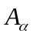. Then b does not belong to R(a). Thus aRb does not hold. So the contrapositive statement would be:- if aRb, iff a & b are in the same set .
- The subsets are non-empty and pairwise disjoint.
Solution: Prove that :- if R(a) R(b), then R(a) R(b) = .
Lets prove the contrapositive statement.

We have, c R(a) R(b). aRc & bRc => aRc & cRb => aRb (transitive).
We also know that, for a,b A (R’s equivalence relation). aRb iff R(a)= R(b) => R(a)= R(b).
Thus if R(a) R(b) , then R(a)= R(b).
So the subsets of (equivalence classes) are non-empty and pair-wise disjoint.
The sets are called equivalence classes.

Question 4

Given that |A| = 24 and an equivalence relation q on A partitions it into three distinct equivalence classes A1, A2, and A3, where |A1| = |A2| = |A3|, what is |q|?
Solution: Given, |A| =24,
After partitioning by the equivalence relation q, we obtain: P={A1, A2, A3}; such that A_{i} intersection A_{j} is a null set. And
A₁ U A₂ U A₃= A. Therefore, |A1|=|A2|=|A3|=8.

Question 5
Consider the set R x R \ {(0,0)} of all points in the plane minus the origin. Define a relation between two points (x,y) and (x’, y’) by saying that they are related if they are lying on the same straight line passing through the origin. Then:
Check that this relation is an equivalence relation and find a graphical representation of all equivalence classes by picking an appropriate member for each class.
Solution:
Given set, (R*R)\ {(0,0)}; then a=(x,y) and b=(x’,y’).
So, aRb iff they lie on the same straight line passing through origin.
y’/Y=x’/X=k (say). So R: {ka | a R², kR-{0}}; Clearly R is reflexive, symmetric and transitive.
Also for a fixed slope, R((x,mx))={k(x,mx) | kR-{0}}. Thus entire set R² \ {(0,0)} can be written as:-
R² \ {(0,0)} = U (_{- 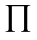/2<tan-1 /}2) R(m_{p}). Individual R(m_{i}) are equivalence classes. Each equivalence class generates a straight line with constant slope and passing through origin.

