DISCRETE STRUCTURES
ASSIGNMENT 1

- Show that if 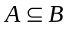 and 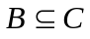, then 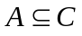.
- List all the subsets of 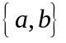.
- The college catering service must decide if the mix of food that is supplied for receptions is appropriate. Of 100 people questioned, 37 say they eat fruits, 33 say they vegetables, 9 say they eat cheese and fruits, 12 eat cheese and vegetables, 10 eat fruits and vegetables, 12 eat only cheese, and 3 report they eat all three offerings. How many people surveyed eat cheese? How many do not eat any of the offerings?
- Prove that 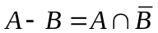.
- Let 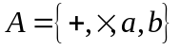. Show that the following expressions are regular over A.
a). 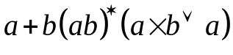.
b). 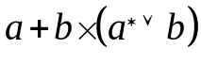.
c). 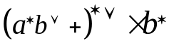.
- If 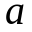and are in 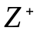, 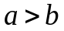 , then 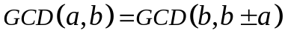.
- Prove that if m and n are relatively prime and mn is a perfect square, then m and n are each perfect squares.
- Let a and b be integers. If p is a prime and 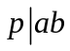, then 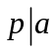 or 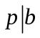.
- Let A and B be matrix. Show that 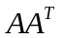 and 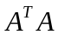 are symmetric.
- Show that if A and B are matrices and , 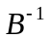 both exist, then 

