DISCRETE STRUCTURES
ASSIGNMENT 2

- Let 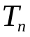 be a sequence of positive integers defined recursively as:
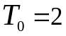
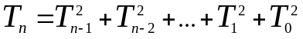 for all 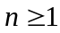
Prove the following assertions. You may use induction on n, whenever necessary
a). 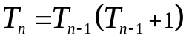 for all 
b). 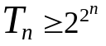 for all 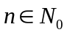
c). 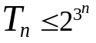 for all
- Let P(x) and Q(x) be predicates involving an integer valued variable x. Prove or disprove 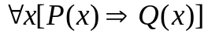 is logically equivalent to 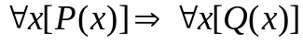.
- Let p, q be prepositions and P(x), Q(x), R(x) be predicates
a). Prove that 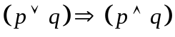 is logically equivalent to 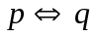. (Hint:
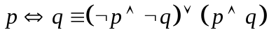
b). Prove that 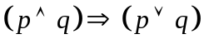 is a tautology.
c). What is the contrapositive of 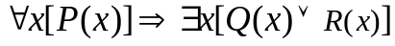.
d). Write in English the converse of the following assertion “If I wake up early, I attend the lecture, unless I have a headache”.
e). Write in English the negation of the following assertion “The sum of any two odd integers is an even integer”. (Hint: Write the sentence in mathematical form and then proceed)
- Prove that if the product of integers p and q is odd, the both p and q must be odd.
- Prove that 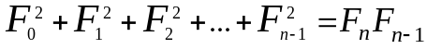 for all 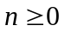 and 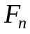 is the nth Fibonacci number.
- Prove that the sum of a rational number and irrational number results in an irrational number.

