1. **What is the project goal? Who will be the end users of your project? What are the tools you are going to use here?**

The demand for LMS has surged after the widespread rise of online education. LMS has made it easier to make education accessible across the globe. The importance of such a system was highlighted especially during COVID-19, where the need for accessing educational opportunities for both teachers and students increased ten folds as people were forced to stay at their homes. But thanks to tools like LMS, it became easier to continue classes despite being unable to attend them physically.

Hence, the goal of our project is to try to build an online learning management system (LMS) similar to the ones existing today to contribute to make learning easier and also try to implement the software design patterns effectively in our project.

The end users for our project will be:

students/learners- who will access educational resources to gain knowledge, test their own performance

teachers/instructors- who will provide educational resources to give knowledge, assess students’ performance

administrators- who will oversee the overall operation of the system, manage users, courses, and performance of the system

Programming languages: HTML, CSS, JavaScript

Frameworks:

Databases: mySQL

Version control: GitHub

1. **Diagrams**

* Class Diagram:

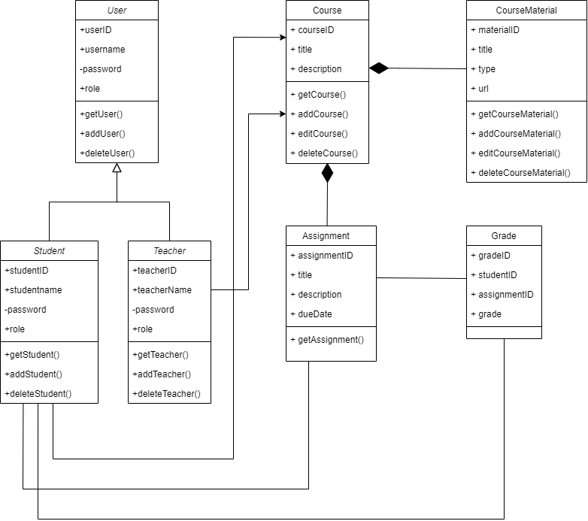

* Use Case Diagram:

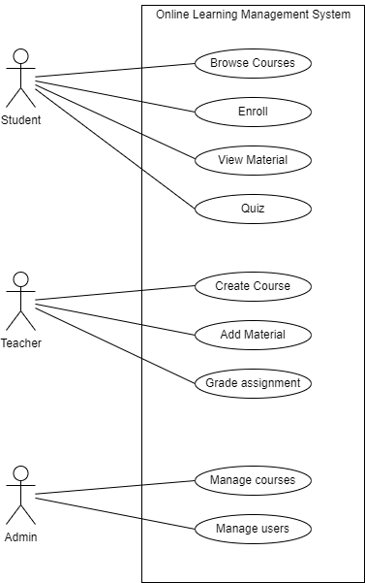

1. **Function requirement/specification and Non-functional requirement/specification.**

* Functional requirements: These are services or functions that the system must provide to meet the needs of its users. In case of our learning management system, the functional requirements are-

1. User authentication: The system should allow users to create a new account or sign-in to an already existing account. The system should verify the type of user signing in to an account, whether it is a student, teacher or admin.
2. Course management: The system should allow instructors to create new courses. The system should allow students to get enrolled in their desired courses. The system should also allow the admin to manage and organize multiple users, courses and other metadata.
3. Content management: The system should allow instructors/teachers to add and manage necessary course materials and resources such as docs, books, videos, links, etc. to each of the courses. The system should allow students to view course materials and modify them such as download necessary resources in order to use them. The system should allow admins to organize and manage both the courses and contents, and multiple users and other metadata.
4. Assessment and Grading: The system should allow instructors/teachers to create assessment tools such as quizzes, assignments, etc. The system should allow students to access and work on these assessment tools.

The system should allow instructors to grade the necessary quizzes and assignments and submit them to students. It should allow the students to view the necessary grades and track their progress.

1. Communication: The system should allow instructors/teachers to post any announcements and allow students to view them. The system should allow a place for both teachers and students to discuss about any particular course. The system should allow admin to manage and check for any unusual activity in the announcements and discussion modules.

* Non-functional requirements: These define or characterize how the system should perform or behave under certain situations. In case of our learning management system (lms), the non-functional requirements include:

1. Performance: The system should respond to actions by users quickly and smoothly, and the system should also support a good number of users without affecting its performance.
2. Usability: The interface of the system application should be user-friendly, making it easier for all types of users to easily navigate through the application.
3. Security: The system should check for authorized and appropriate access for users with different roles (e.g., student, instructor, administrator). User passwords should be stored securely.
4. Reliability: The system should perform regular backups of data to ensure that no data is lost in the event of a system failure. The system should be available at all times especially during peak usage times.