**IMPROVEMENT IN THERMAL CONDUCTIVITY OF GRAPHENE BASED COMPOSITES FOR BETTER THERMAL INTERFACE MATERIALS.**

**Abstract**

Graphene, a planar single sheet of *sp*2-bonded carbon atoms arranged in honeycomb lattice, has a number of its unique properties including extremely high thermal conductivity. Graphene, as filler in nanocomposite, shows promising improvement in thermal conductivity of thermal interface material (TIM) because of its high thermal conductivity and planer geometry. Thermal coupling with base matrix is also strong as compared to the material with high thermal conductivity, CNT. Overall thermal resistance between two interfaces is reduced when highly conductive TIM is used. Experiments have shown significant improvement in heat conduction efficiency using graphene filler for TIM. In this work, we have used silicone oil, a commercially available TIM, as base matrix of the composite. Effects of particle size, aspect ratio, thermal interface resistance and temperature on thermal conductivity of the composite have been observed using Effective Medium Approximation proposed by Nan. The thermal conductivity of graphene filler of different lateral sizes and layers have been approximated using Landauer approach from ballistic to diffusive limit. Composite thermal conductivity varies significantly with the variation of the graphene flake dimension, from nanometer to micrometer range. For SLG-MLG mixture of nanometer to micrometer sized graphene flakes as filler we get thermal conductivity enhancement of around 5000%. Finally using simulation result it is shown that graphene nanocomposite as TIM in desktop or laptop significantly improves heat transfer efficiency.

**Introduction**

We will use effective medium theory proposed by Nan1 to see the variation of a composite thermal conductivity with the inclusion of fillers. In our analysis we have considered filler particles of different sizes separately and also combinations of different sizes. When combinations are used, filler thermal conductivity is not fixed. So, we have to codify EMA of Nan to analyze the effect of combination of different fillers. Here we have calculated total thermal conductivity of composite as $k_{CT}=\sum{\left(F_{i}*k_{ci}\right)}$, where kci is the composite thermal conductivity for filler thermal conductivity Kpi and Fi is the fraction of total volume of fillers with thermal conductivity Kpi. We have seen a linear relationship between composite thermal conductivity and filler volume fraction and between composite thermal conductivity and particle thermal conductivity. So considering a superposition theorem is justifiable.

For nm sized SLG and MLG, theoretical prediction Landauer approach2 from ballistic to diffusive limit by the relation $k_{p}=\frac{\frac{σ}{A}}{\left(\frac{1}{L}+\frac{2}{π}\right)}$ is used for predicting thermal conductivity for different mean free paths. We are considering graphene flakes of square dimension as data for variation of width are not available. Mean free path is comparable to length for lateral sizes of less than 1 μm and it does not affect much on graphene thermal conductivity in this situation. We consider mean free path of SLG, λ=775nm and for MLG(n=3), λ=500nm. For μm sized MLG thermal conductivity we have considered experimental result (considering average width=5μm) for different no. of layers from Balandin et al3.

In Shahil et al.4 from the statistical analysis they established that the composites with ~10-15% of MLG with n≤2, ~50% of FLG with n≤5 are the optimum for maximizing thermal conductivity enhancement(TCE). Based on the optical microscopy and SEM examination, most of the graphene and MLG flakes (~90%) had lateral dimensions in the range L≈50 nm - 0.5 µm. A small fraction of the flakes (~10%), predominantly with n<5, had large lateral sizes L≈2-5 µm.

In our analysis, we will consider silicone oil as a base matrix which has vast uses in commercial TIMs as grease. Though surfactant is used to decrease its surface tension in commercial TIMs, we will not consider it here. Later we will show effect of other base matrixes of different thermal conductivity on the value of composite thermal conductivity. Silicon oil has thermal conductivity of 0.1 Wm-1K-1 . We consider thermal boundary resistance RB=10*10-9 Km2W-1. We will also see how different parameters of filler and composite like volume fraction, filler size, aspect ratio, interfacial resistance etc. affect the composite thermal conductivity with base TIM material silicone oil. We will also see how alignment of filler affects composite thermal conductivity.

**Calculation**

**First we consider lateral size.** We change lateral size of SLG filler from nm to μm and calculate its thermal conductivity using the relation $k_{p}=\frac{\frac{σ}{A}}{\left(\frac{1}{L}+\frac{2}{π}\right)}$ where thermal conductance per unit area is considered as 3.7x109 Wm-2K-1. In figure 1(a) we show composite thermal conductivity of different lateral size of SLG filler with varying filler volume fraction upto 10%. For μm sized SLG a theoretical model proposed in Nika et al5. They have considered different Gruneisen parameters (γLA and γTA). For our analysis we will consider γLA =1.8 and γTA =0.75 and calculate thermal conductivity of SLG of μm size. In figure 1(b) we show composite thermal conductivity of different μm size of SLG filler with varying filler volume fraction upto 10%. Now we will consider composites where graphene flakes of both nm and μm sized length is present. We can consider 3 samples having graphene-MLG with different lateral sizes in line with the proposition of Shahil et al. about size, layer and percentage of graphene filler.

Sample 1 consists of

1. 10% SLG with average length L=100 nm,
2. 75% MLG (n=3) with average lateral size L=300nm,
3. 15% MLG(n=3) with lateral size L=5 μm.

Sample 2 consists of

1. 10% SLG with average length L=100 nm,
2. 70% MLG (n=3) with average lateral size L=300nm,
3. 20% MLG(n=3) with average lateral size L=5 μm.

Sample 3 consists of

1. 10% SLG with average length L=100 nm,
2. 65% MLG (n=3) with average lateral size L=300nm,
3. 25% MLG(n=3) with lateral size L=5 μm.

For lateral size 5µm MLG(n=3) thermal conductivity is 2200 W/mK. In figure 1(c) we show composite thermal conductivity of different mixture sample consisting of both μm and nm size graphene filler with varying filler volume fraction upto 10%.

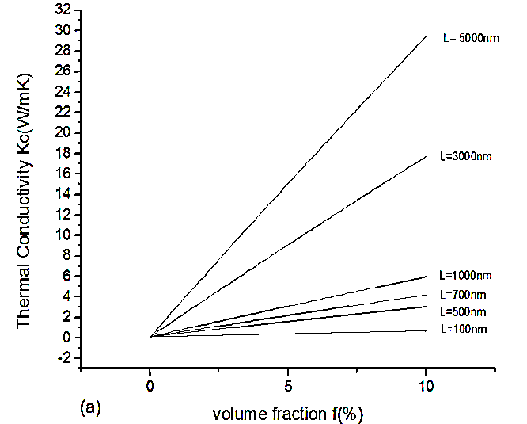 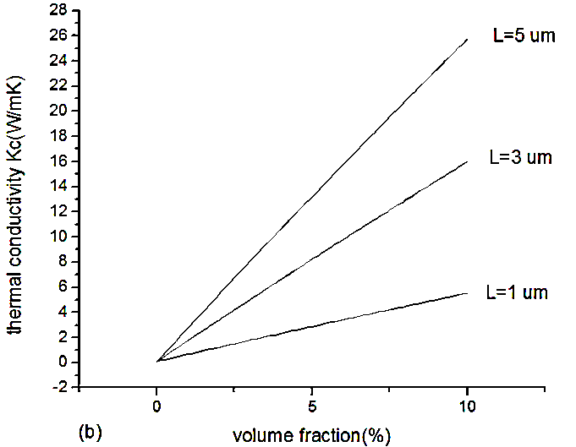

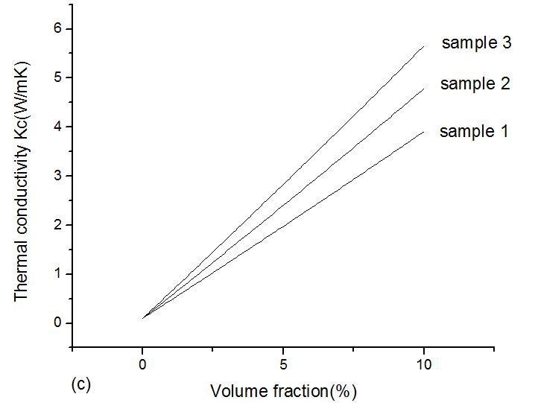

Figure1: Composite thermal conductivity versus filler volume fraction upto 10%. (a) different lateral size of SLG changing from nm to µm using thermal conductance method, (b) different µm lateral size of SLG considering thermal conductivity of filler from the theoretical model proposed in Nika et al. (c) different mixture sample consisting of both μm and nm size graphene filler.

**Second we consider aspect ratio effect.** We will observe impact of aspect ratio over two different lateral size of graphene filler particle. Though thermal conductivity of filler changes with aspect ratio but for simplicity we consider fixed thermal conductivity. First we consider lateral size SLG 500nm in figure 2(a) and then 5µm in figure 2(b).

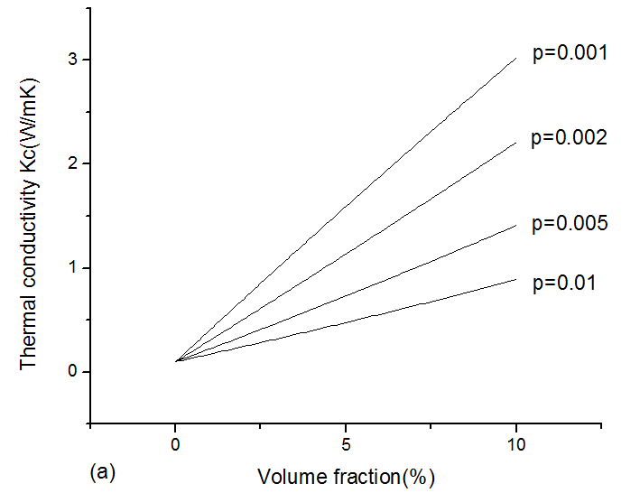 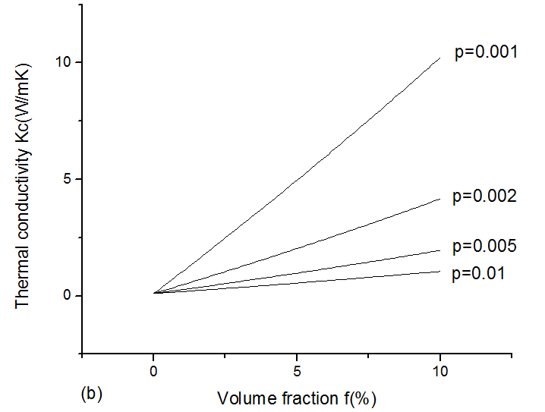

Figure 2: Composite thermal conductivity versus filler volume fraction upto 10%. Variation of aspect ratio for lateral size of SLG filler (a)500nm and (b)5µm is shown.

To investigate effect of thermal boundary resistance between filler and base material, variation of base material thermal conductivity and alignment of graphene filler we consider a sample consists of

1. 10% SLG with average length L=100 nm,
2. 70% MLG (n=3) with average lateral size L=300nm,
3. 20% MLG(n=3) with average lateral size L=5 μm.

**Third we see effect of thermal boundary resistance between filler and base material.** We have taken four values of R as 1*10-9 m2KW-1, 5*10-9 m2KW-1, 10*10-9 m2KW-1 and 20*10-9 m2KW-1. The result is shown in figure 3.

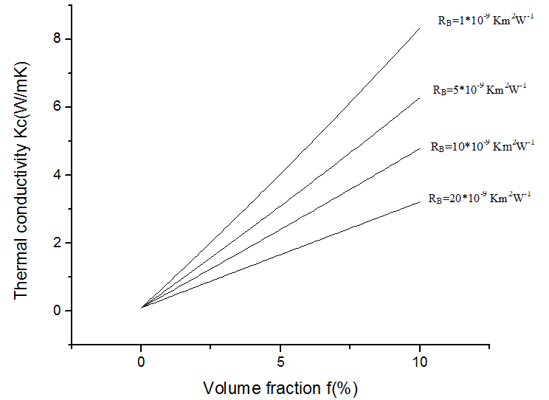

Figure 3: Composite thermal conductivity versus filler volume fraction upto 10%. Variation of thermal boundary resistances.

**Fourth we see effect of variation of base material thermal conductivity.** For analysis, we vary matrix thermal conductivity as km= 0.10, 0.2, 0.3, 0.4 and 0.5 Wm-1K-1. In figure 4 for different matrix thermal conductivity we get the composite thermal conductivity variation like this:

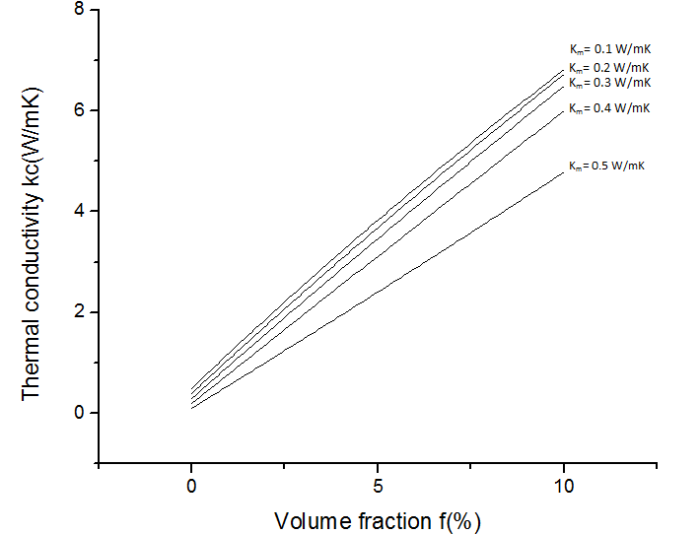

Figure 4: Composite thermal conductivity versus filler volume fraction upto 10%. Variation of base material thermal conductivities has been observed.

**Fifth we see the effect of alignment of graphene filler**. We can see the effect of composite thermal conductivity for particles oriented in the heat transport direction. For this case, we have used EMA equation of Nan for aligned continuous fiber oriented in the heat transport direction. The composite thermal conductivity for completely oriented and randomly oriented for a graphene-MLG filler combination is shown in the figure 5.

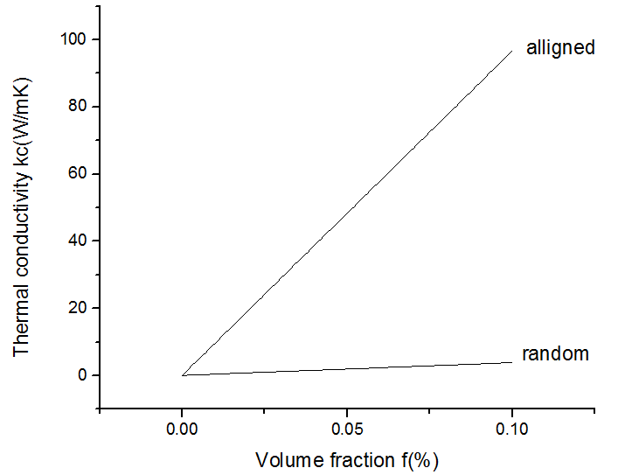

Figure 5: Composite thermal conductivity variation for filler upto 10% have been observed for both randomly oriented and perfectly aligned graphene particle.

**Result Analysis**

In **figure 1(a)** we see that composite thermal conductivity increases proportionally with graphene flake size. For 100 nm lateral sized length, composite thermal conductivity is around 0.52W m-1K-1 and for 5 μm lateral sized length, composite thermal conductivity is around 28.5 W m-1K-1 for 10% volume fraction. So enhancement is 420% and 27500% respectively.

In **figure 1(b)** composite thermal conductivity continues to increase with lateral size. For μm sized flakes composite thermal conductivity increases in a large amount. For 1μm lateral sized length, composite thermal conductivity is around 5.54 W m-1K-1 at 10% volume fraction while for 5μm lateral sized length, composite thermal conductivity becomes around 25.75 W m-1K-1. Here enhancement is 5440% and 25650% respectively. This huge enhancement is predicted by EMA because of the very small aspect ratio (for 5 μm p=H/L =0.00007) and large length. In practical application, other physical considerations will affect and composite thermal conductivity may not be so large.

In **figure 1(c)** we see that for 10% volume fraction of particle, composite thermal conductivity becomes 3.9103 Wm-1K-1, 4.7840 Wm-1K-1 and 5.6577 Wm-1K-1 respectively. Thermal conductivity enhancement is correspondingly 3810%, 4684% and 5557%.

Here we can see that with the increase of graphene flakes of μm range, composite thermal conductivity increases as an effect of higher thermal conductivity for large lateral sized graphene. But we also need to consider that large lateral sized fillers tend to change the properties of TIMs. So, without changing necessary properties of thermal interface materials larger lateral sized flake will lead to higher composite thermal conductivity. Again a maximum value of volume fraction of fillers has to be identified which will ensure highest composite thermal conductivity maintaining other TIM characteristics.

In **figure 2** it is clear that, with the increase of layer number, composite thermal conductivity drops. Here, with the increase of layer number, graphene thermal conductivity drops; so both the effects – particle thermal conductivity and its size (aspect ratio) make impact on composite thermal conductivity. But graphene size effect is more dominant for change in composite thermal conductivity than its conductivity.

In **figure 3** for thermal interface resistance variation from 1x10-9 to 20x 10-9m2KW-1, composite thermal conductivity of the sample drops from 8.054 to 3.12 Wm-1K-1 for 10% inclusion of fillers. We can see a very significant change of composite thermal conductivity with interfacial thermal resistance.

In **figure 4** we see composite thermal conductivity of the composition increases with base matrix but difference in the change of composite thermal conductivity is more significant for lower matrix thermal conductivity values. As base matrix kB moves to higher values composite thermal conductivity difference from the previous stage becomes less prominent gradually.

In **figure 5** we see there is a huge difference of k for two cases. Composite thermal conductivity increases approximately 17 times greater for completely oriented particles comparing randomly oriented particles. For completely oriented particles in the heat propagation direction, all particles contribute to transfer heat in a particular direction. So, thermal conductivity increases in a large amount.

**Comparison of Performance of TIMs with a Simplified Model of High Power Package and Heat Sink:**

A typical configuration for a high power microprocessor or ASIC (Application-Specific Integrated Circuit) package attached to a heat sink is depicted in Figure 1a. Finite element analysis was conducted on a simplified solid model of the package and board as depicted in Figure 1b, using a commercial software tool COMSOL Multiphysics 3.5. The model represents only the chip-to-heat sink thermal path. Regarding the heat sink, only its base is explicitly represented in the model.

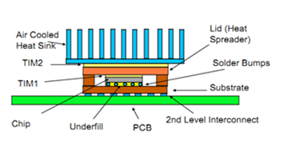 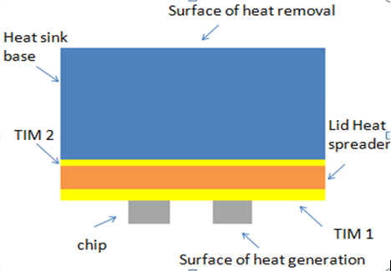

(b)

(a)

Figure 6: Diagrams of high power package attached to a heat sink. (a) a typical system application; (b) simplified geometry as represented in the model.(figure courtesy- Electronics Cooling, Volume-16, Number-4, Winter 2010).

Important features of the high power package include-

* The fin structure is accounted for by the use of an effective heat transfer coefficient applied to the top surface of the heat sink base.
* All other surfaces are assumed to be adiabatic.
* This analysis ignores the presence of a secondary heat flow path to the ambient air through the PCB. This path is usually negligible for high-power packages because of the very low thermal resistance of the primary path to air via the heat sink.

Following table lists the specific dimensions and material properties assumed for the package and heat sink for Finite Element Analysis. We consider four equal sized chips uniformly placed over the PCB.

Table 1 : Specific dimensions and material properties assumed for the package and heat sink for Finite Element Analysis.

|  |  |  |  |  |  |
| --- | --- | --- | --- | --- | --- |
| Layer No | Component | Thickness  (mm) | Length*Width  (mm)*(mm) | Material | Thermal Conductivity (W mK-1) |
| 1 | Die | 0.5 | 15*15 | Si | 111 |
| 2 | TIM 1 | 0.1 | 100*100 |  |  |
| 3 | Lid | 0.5 | 100*100 | Cu | 390 |
| 4 | TIM2 | 0.05 | 100*100 |  |  |
| 5 | Heat Sink Base | 6 | 100*100 | Cu | 390 |

Power of 80 W is uniformly distributed in the volume of 15mm*15mm*0.5mm of every chip. For the outer boundary of heat base sink,heat transfer coefficient h considered 2000 W/m2-K. External and ambient temperature both are considered as 0⁰ C.

Thermal conductivity of silicone oil is 0.1 WmK-1. For a particular graphene-MLG sample we have got composite thermal conductivity as 5.8 WmK-1. Thus heat transfer efficiency between microprocessor and heat sink base increases considerably.

To compare how heat transfer efficiency depends on TIM material we have considered four cases. They are:

* Case 1: silicone oil as TIM 1 and TIM 2.
* Case 2: Silicone oil as TIM 1 and Silicone oil-graphene nanocomposite as TIM 2.
* Case 3: Silicone oil-graphene nanocomposite as TIM 1 and silicone oil as TIM 2.
* Case 4: Silicone oil-graphene nanocomposite as TIM 1 and TIM 2.

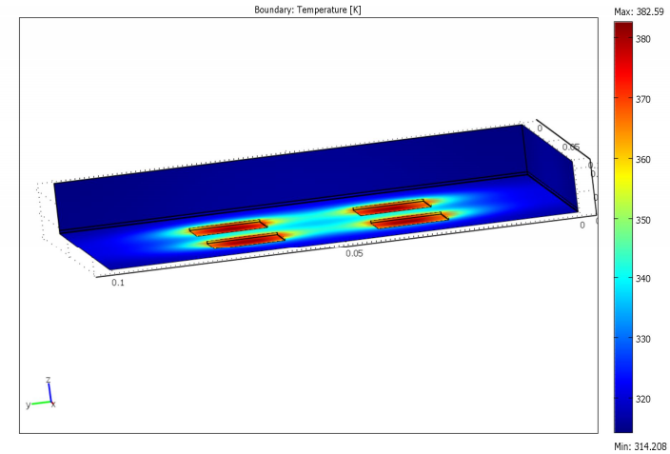

Figure 7 : Finite Element Analysis output figure for case 3. Here, we use silicone oil-graphene nanocomposite as TIM 1 and silicone oil as TIM 2.

Following table compares heat transfer efficiency between above cases.

Table 2 : Input values of thermal conductivity of TIM1 and TIM2 and Output maximum temperature for performance analysis.

|  |  |  |  |  |
| --- | --- | --- | --- | --- |
| **Case no.** | **Thermal Conductivity of TIM 1(Wm-1K-1)** | **Thermal Conductivity of TIM 2(Wm-1K-1)** | **Max temp/Die temp. (K)** | **Comment** |
| 1 | 0.1 | 0.1 | Max: 702K |  |
| 2 | 0.1 | 5.8 | Max: 657K | Maximum temperature decreased |
| 3 | 5.8 | 0.1 | Max: 382K | Maximum temperature further decreased |
| 4 | 5.8 | 5.8 | Max: 333K | Maximum temperature is the least among four cases. |

**Observation:**

It is beneficial to put high thermal conductivity TIM material near the chip. It is also observed that higher the value of thermal conductivity higher the heat transfer efficiency of the package.

**Conclusion**

The demand of next generation IC technology is thermal interface materials with high thermal conductivity. Inclusion of filler particles with high thermal conductivity on matrices can increase composite thermal conductivity significantly which can be used as TIMs. Higher thermal conductivity, plane geometry, better thermal coupling thermal stability of graphene etc. have initiated promising future of graphene as fillers in TIMs. In our analysis, we have considered silicone oil as our main base matrix which has vast uses as TIMs and graphene-MLG as fillers to form a composite and used EMA model proposed by Nan to see composite thermal conductivity variation for different parameters.

Our calculation of thermal conductivity for graphene-MLG silicone elastomer composite or other composites by EMA proposed by Nan derives some aspects. With the increase of lateral size of fillers (graphene), composite thermal conductivity increases. Though we have used different relations or source of data for thermal conductivity of nanometer and micrometer sized graphene, we have got a gradual increase in composite thermal conductivity from nm to μm sized graphene fillers. Considering different samples we have got thermal conductivity enhancement of around 4000% to 5700% for 10% volume of fillers. For larger lateral sizes, the enhancement predicted by EMA increases but in practical situation, there will be a limit for the enhancement.

One of the reasons of anomalous enhancement of thermal conductivity of graphene-MLG based composites is the very small aspect ratio of graphene fillers. It is also pronounced in EMA of Nan as significant changes in composite thermal conductivity are seen for small change in aspect ratio. With the increase of no. of layers, aspect ratio ($p=H/L$) decreases for a particular lateral size. Graphene thermal conductivity also decreases with layers i.e. with the increase of aspect ratios. But in thermal conductivity calculation by EMA, aspect ratio change has more dominant effect in composite thermal conductivity than the particle thermal conductivity.

Interface resistance plays a major role in composite thermal conductivity and EMA model also indicates very large change in composite thermal conductivity with the variation of interface resistance. So interface resistance of the composite needs to be low and graphene based polymers are superior in regarding this case as these polymer composites have low interface resistance due to good coupling of graphene with base materials.

Change of base matrix thermal conductivity does not make very significant impact on composite thermal conductivity as seen by EMA model. But matrix- particle coupling needs to be considered in real situation that can separate matrices according to their superiority for TIM application. Particle orientation also makes a huge impact on composite thermal conductivity as seen by the EMA model and it will be a worth to try to change the orientation in composite materials.

In the last part of our analysis we have made a simple model of high power package to see the effect of TIMs of higher thermal conductivity over low thermal conductivity. We have observed that for high thermal conductivity of TIMs heat propagation becomes better and maximum temperature of the system reduces. This indicates clearly the importance of TIMs with high thermal conductivity.

**Reference:**

1. Ce-Wen Nan, R. Birringer, David R. Clarke, H. Gleiter “Effective thermal conductivity of particulate composites with interfacial thermal resistance”

2. Eric Pop, Vikas Varshney and Ajit K. Roy,DECEMBER 2012. Thermal properties of graphene: Fundamentals and applications.MRS BULLETIN 37

3. S. Ghosh, W. Bao, D.L. Nika, S. Subrina, E.P. Pokatilov, C.N. Lau and A.A. Balandin, UC-Riverside, 2009 Dimensional crossover of thermal transport in few-layer graphene materials

4. M. F. Shahil and Alexander A. Balandin , Graphene-Based Nanocomposites as Highly Efficient Thermal Interface Materials.

5. Nika. Lattice thermal conductivity of graphene ﬂakes: Comparison with bulk graphite.