Project Name
Saviour

Submitted By

Student Name | Student ID
Alvy Rahman Niloy | 0242220005101766
Minhajul Islam | 0242220005101681
MD .Rejowan Ahmed | 0242220005101753
MD Rifat Mia | 0242220005101750
Tasnim Jahan Fima | 0242220005101613

MINI LAB PROJECT REPORT
This Report Presented in Partial Fulfillment of the course: CSE 222: Object Oriented Programming (ll) Lab in the Computer Science and Engineering Department



DATE:12/12/2024

DECLARATION
We hereby declare that this lab project has been done by us under the supervision of Masum Bakaul (Senior Lecturer) , Department of Computer Science and Engineering, Daffodil International University. We also declare that neither this project nor any part of this project has been submitted elsewhere as lab projects.

Submitted To:

Masum Bakaul

Course Teacher’s Name

Senior Lecturer
Department of Computer Science and Engineering Daffodil International University

Submitted by

Alvy Rahman Niloy
ID:0242220005101766
Dept. of CSE, DIU
Minhajul Islam Student Name Student ID:0242220005101681  Dept. of CSE, DIU | MD Rifat Mia Student Name Student ID:0242220005101750  Dept. of CSE, DIU
Tasnim Jahan Fima  Student Name Student ID:0242220005101613  Dept. of CSE, DIU | MD Rejowan Ahmed  Student Name Student ID:0242220005101753  Dept. of CSE, DIU

COURSE & PROGRAM OUTCOME

The following course have course outcomes as following:.

Table 1: Course Outcome Statements

The following course have course outcomes as following:.

Table 1: Course Outcome Statements

CLO1 | Able to solve computational problem using Python programming
CLO2 | Able to develop object-oriented solution using Python
CLO3 | Able to apply OOP and Python knowledge in solving problem

Table 2: Mapping of CO, PO, Blooms, KP and CEP

CO | PO | Blooms | KP | CEP
CO1 | PO1 | C1, C2 | KP3 | EP1, EP3
CO2 | PO2 | C2 | KP3 | EP1, EP3
CO3 | PO3 | C4, A1 | KP3 | EP1, EP2
CO4 | PO3 | C3, C6, A3,  P3 | KP4 | EP1, EP3

The mapping justification of this table is provided in section 4.3.1, 4.3.2 and 4.3.3.

©Daffodil International University ii

Table of Contents

Declaration i
Course & Program Outcome ii
- Introduction 1
  - Introduction 1
  - Motivation 1
  - Objectives 1
  - Feasibility Study 1
  - Gap Analysis 2
  - Project Outcome 3
- Proposed Methodology/Architecture 4
  - Requirement Analysis & Design Specification 4
    - Overview 5
  - Overall Project Plan 2
- Implementation and Results 6
  - Implementation 7
  - Performance Analysis 8
  - Results and Discussion 9
- Engineering Standards and Mapping 12
  - Impact on Society, Environment and Sustainability 12
    - Impact on Life 12
    - Impact on Society & Environment 12
    - Ethical Aspects 12
    - Sustainability Plan 12
  - Project Management and Team Work 13
  - Complex Engineering Problem 13
    - Mapping of Program Outcome 14
    - Complex Problem Solving 15
    - Engineering Activities 16

©Daffodil International University iii

Table of Contents Table of Contents
- Conclusion 17
  - Summary 17
  - Limitation 17
  - Future Work 18
References 19

©Daffodil International University iv

Chapter 1
Saviour is a blood donation app designed to connect blood donors and recipients seamlessly. It aims to simplify the process of finding and contacting suitable donors based on location and blood group.

Introduction
Blood donation is a critical need in emergencies and routine medical procedures, yet finding suitable donors quickly remains a challenge. Traditional methods rely on word-of-mouth or manual donor databases, which are often slow and inefficient.
Saviour aims to address this problem by providing a digital platform where users can connect with potential blood donors nearby, ensuring timely help in critical situations.

Motivation

The motivation for creating Saviour comes from observing the struggles people face in finding blood donors during emergencies. Traditional methods, like relying on blood banks or personal contacts, are often slow and unreliable. This problem inspired me to leverage technology to create a solution that enables users to quickly connect with donors nearby based on blood group and availability.
On a personal level, this project aligns with my interest in developing meaningful applications that have a real-world impact. It also provides an opportunity to enhance my technical skills, particularly in front-end design and app development, preparing me for more complex projects in the future. By addressing a significant societal challenge, I hope Saviour can make a positive difference while contributing to my growth as a developer.
4o

Objectives

• Connect Donors and Recipients: Facilitate a platform where users can find blood donors nearby based on their location and blood group.
• Simplify Communication: Enable seamless communication between donors and recipients through in-app contact options.
• Enhance Emergency Response: Reduce the time required to find a suitable blood donor in critical situations.
• Promote Voluntary Blood Donation: Encourage a community-driven approach to blood donation through user-friendly design and accessibility.
• Improve Usability: Deliver an intuitive and responsive interface for a smooth user experience on various devices.

Feasibility Study

Several existing web and mobile applications address the challenge of connecting blood donors and recipients, serving as inspiration and a benchmark for Saviour.
BloodConnect: A mobile app that allows users to search for donors based on location and blood group. It simplifies donor-recipient communication but lacks a modern interface and real-time updates.
Red Cross Blood Donor App: Focused on the United States, this app supports blood donation scheduling and tracks donation history. While feature-rich, it primarily works with blood banks, limiting its peer-to-peer connectivity.
Bloodline App: A community-driven app aimed at emergency situations, offering location-based donor search. However, the lack of continuous updates and a cluttered interface affects user experience.
Methodological Contribution: Existing platforms primarily focus on either blood bank integration or peer-to-peer donor search. While functional, they often miss user-centric features like real-time notifications and personalized interfaces.

Saviour builds on these methodologies, emphasizing a user-friendly, front-end-focused platform with efficient donor-recipient connections, modern design, and seamless usability for emergency and routine use

Gap Analysis

Existing blood donation platforms, while functional, exhibit certain limitations that create gaps in their usability and effectiveness. Many applications focus on either integrating with blood banks or providing basic donor-recipient search functionality but fail to deliver a comprehensive, user-friendly experience.
Key gaps identified:
- User Experience: Many platforms have outdated designs, lack intuitive navigation, and are not optimized for diverse devices.
- Real-Time Communication: Few apps provide real-time notifications or seamless in-app communication, which are critical in emergencies.
- Localized Accessibility: Most apps are region-specific or lack robust location-based services for finding nearby donors efficiently.
- Community Engagement: Limited focus on promoting voluntary blood donation through gamification or user incentives.
Saviour aims to bridge these gaps by offering a modern, responsive interface, real-time communication features, precise location-based donor search, and tools to foster community engagement, ensuring a better user experience and faster response times

1.6 Project Outcome

The outcomes of Saviour are designed to address critical challenges in blood donation systems:
- Seamless Connectivity: A platform where users can effortlessly connect with nearby blood donors, ensuring timely assistance during emergencies.
- Improved Emergency Response: Faster access to suitable donors, potentially saving lives by reducing delays in critical situations.
- User-Centric Design: A responsive and intuitive application that enhances user satisfaction and encourages regular engagement.
- Community Building: Increased awareness and participation in voluntary blood donation through an accessible and engaging platform.
- Scalable Solution: A model that can be expanded geographically and integrated with additional features like donation tracking, reminders, and collaboration with blood banks for broader impact.
These outcomes aim to create a positive societal impact while showcasing the practical application of modern front-end technologies

Chapter 2
Proposed Methodology/Architecture

The Saviour app utilizes a client-server architecture with a front-end developed using HTML, CSS, and JavaScript for responsiveness. The backend is built with Flask, handling data processing and real-time requests, such as location-based donor search. This architecture ensures a seamless user experience and efficient communication between donors and recipients while maintaining scalability.

2.1 Requirement Analysis & Design Specification
Functional Requirements:
- User Registration and Login: Users should be able to register, log in, and manage their profiles.
- Search Donors/Recipients: The app should allow users to search for blood donors based on blood type and location.
- Real-Time Communication: Donors and recipients should be able to contact each other through the app.
- Notifications: Real-time notifications for matching donors and recipients in emergency situations.
- Location-Based Search: Accurate donor search based on geographical proximity using location services.
Non-Functional Requirements:
- Usability: The app should be intuitive and easy to navigate for all user demographics.
- Performance: The app must provide quick responses, particularly during emergencies.
- Scalability: The architecture should handle increasing user loads as the app grows.
- Security: User data should be stored securely, ensuring privacy and protection from unauthorized access.
Design Specifications:
- Frontend: Responsive, user-friendly interface designed with HTML, CSS, and JavaScript.
- Backend: Flask-based RESTful API to handle requests, data processing, and communication.
- Database: A relational database (e.g., SQLite or PostgreSQL) for storing user profiles, donor data, and interactions.

Overview
The Saviour app aims to provide a seamless platform for connecting blood donors with recipients in emergency situations. The system consists of two main components: the front-end and the back-end. The front-end is designed to be intuitive and responsive, ensuring ease of use for users of all technical levels. The back-end, built with Flask, handles all server-side operations, including user authentication, donor search, and real-time communication.
The application allows users to register, search for compatible blood donors or recipients based on blood type and location, and initiate contact through in-app messaging. Real-time notifications are integrated to alert users about urgent donor requests. The system’s architecture is designed for scalability and security, with robust database management to store user information, blood types, and communication history.
This design provides an efficient, reliable, and user-friendly solution for addressing the challenges in blood donation, improving accessibility, and reducing response time during emergencies
2.1.2 Proposed Methodology/ System Design

- Frontend (HTML, CSS, JavaScript): Interacts with the user for registration, login, and blood donor search.
- Backend (Flask, Python): Handles the user requests, processes the data, and communicates with the database.
- Database: Stores user profiles, donor information, and interactions.

2.1.3 UI Design

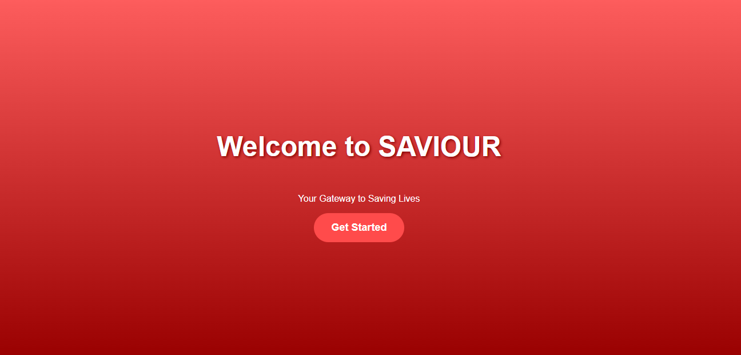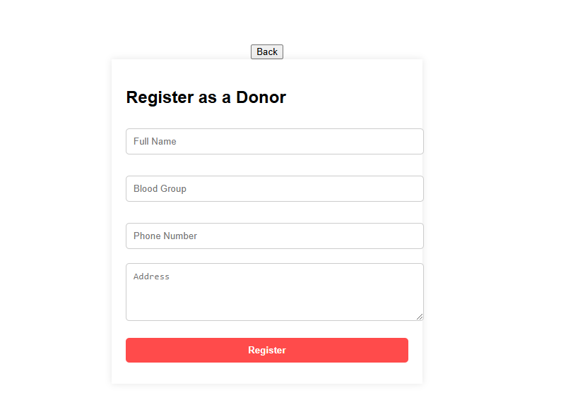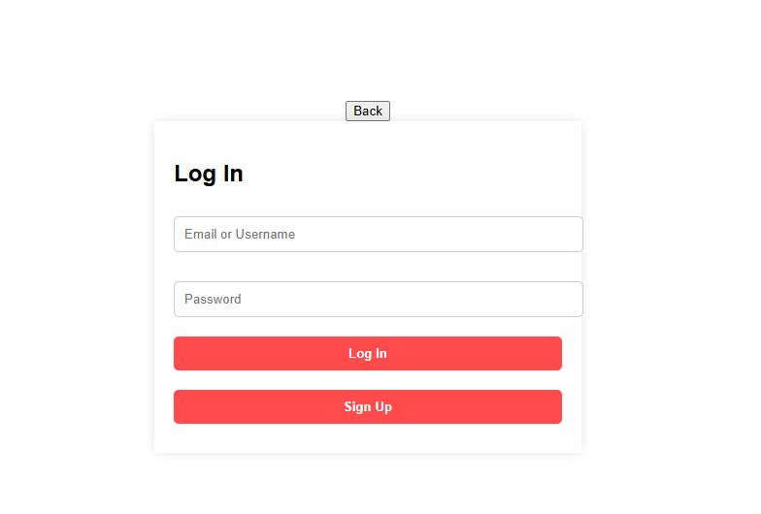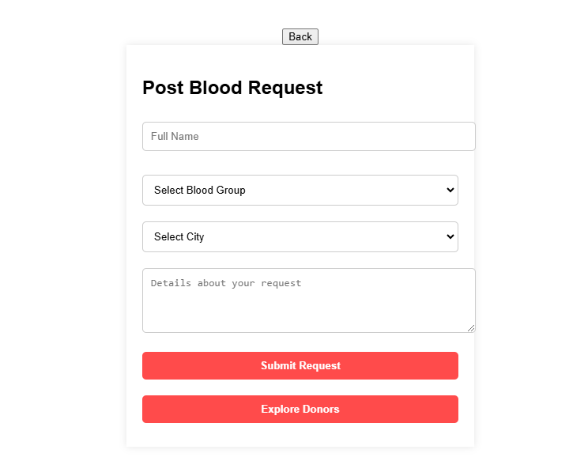
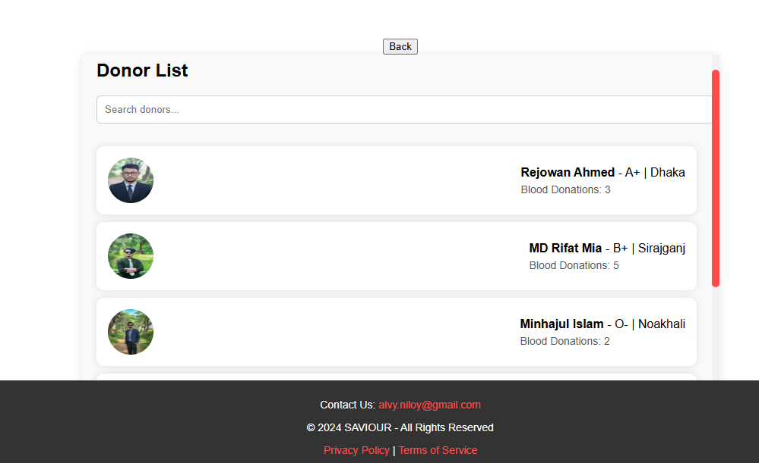

Overall Project Plan

The overall project plan for Saviour focuses on the successful development and deployment of the blood donation app. The timeline is divided into key phases:
Requirement Analysis and Design (1-2 weeks):
  - Define the functional and non-functional requirements.
  - Create design specifications for both frontend and backend.
  - Develop a UML diagram and flow charts for system architecture.
Frontend Development (2-3 weeks):
  - Design and implement the user interface using HTML, CSS, and JavaScript.
  - Develop features like user registration, login, and donor search.
  - Ensure responsiveness and cross-device compatibility.
Backend Development (2-3 weeks):
  - Set up the Flask backend with routes for handling user authentication, data requests, and donor search.
  - Integrate SQLite for data storage and management.
  - Implement real-time functionalities and communication.
Testing (2 weeks):
  - Conduct unit testing, integration testing, and usability testing for both frontend and backend.
  - Fix bugs, optimize performance, and ensure seamless user experience.
Deployment and Documentation (1-2 weeks):
  - Deploy the application on a suitable platform (e.g., Heroku or AWS).
  - Create user and technical documentation for the app.
  - Prepare the final project report and presentation.
Project Review and Maintenance (Ongoing):
Regular updates, bug fixes, and feature enhancements based on user feedback.
This plan ensures a systematic approach to development, testing, and deployment, ensuring the timely completion of the project.

Chapter 3
Implementation and Results
The Saviour app’s frontend is built using HTML, CSS, and JavaScript, offering a responsiveand user-friendly interface. The backend is implemented with Flask to handle user authentication, donor search, and data processing. SQLite is used for storing user and donor information, ensuring efficient data management

Implementation

The implementation of Saviour involves both frontend and backend development. The frontend is designed using HTML, CSS, and JavaScript to create a responsive and intuitive interface for user registration, login, and donor search. The backend is built with Flask, which handles routing, user authentication, and processes the donor search functionality. SQLite is used to store user and donor data, allowing for efficient retrieval and management of information. Real-time communication is also enabled through Flask routes, ensuring seamless interaction between users and the app.

Fronted (Index.html)
<!DOCTYPE html>
<html lang="en">
<head>
<meta charset="UTF-8">
<meta name="viewport" content="width=device-width, initial-scale=1.0">
<title>Saviour App</title>
<!-- Correct way to link to static CSS file -->
<link rel="stylesheet" href="{{ url_for('static', filename='css/styles.css') }}">
</head>
<body>
<!-- Splash Screen -->
<section id="splash" class="splash">
<h1>Welcome to SAVIOUR</h1>
<p>Your Gateway to Saving Lives</p>
<button class="start-button" onclick="transitionToLogin()">Get Started</button>
</section>

<!-- Login Page -->
<section id="login" class="hidden">
<button class="back-button" onclick="navigateBack()">Back</button>
<div class="form-page">
<h1>Log In</h1>
<form onsubmit="handleLogin(event)">
<input type="text" placeholder="Email or Username" required>
<input type="password" placeholder="Password" required>
<button type="submit">Log In</button>
<button type="button" onclick="navigateToPage('register')">Sign Up</button>
</form>
</div>
</section>

<!-- Register Page -->
<section id="register" class="hidden">
<button class="back-button" onclick="navigateBack()">Back</button>
<div class="form-page">
<h1>Register as a Donor</h1>
<form onsubmit="handleRegister(event)">
<input type="text" placeholder="Full Name" required>
<input type="text" placeholder="Blood Group" required>
<input type="tel" placeholder="Phone Number" required>
<textarea placeholder="Address" rows="4"></textarea>
<button type="submit">Register</button>
</form>
</div>
</section>

<!-- Post Blood Request Page -->
<section id="post-request" class="hidden">
<button class="back-button" onclick="navigateBack()">Back</button>
<div class="form-page">
<h1>Post Blood Request</h1>
<form onsubmit="handlePostRequest(event)">
<input type="text" placeholder="Full Name" required>
<select required>
<option value="" disabled selected>Select Blood Group</option>
<option value="A+">A+</option>
<option value="A-">A-</option>
<option value="B+">B+</option>
<option value="B-">B-</option>
<option value="AB+">AB+</option>
<option value="AB-">AB-</option>
<option value="O+">O+</option>
<option value="O-">O-</option>
</select>
<select required>
<option value="" disabled selected>Select City</option>
<option value="Dhaka">Dhaka</option>
<option value="Chittagong">Chittagong</option>
<option value="Khulna">Khulna</option>
<option value="Sylhet">Sylhet</option>
<option value="Rajshahi">Rajshahi</option>
<option value="Barisal">Barisal</option>
<option value="Rangpur">Rangpur</option>
</select>
<textarea placeholder="Details about your request" rows="4"></textarea>
<button type="submit">Submit Request</button>
</form>
<button onclick="navigateToPage('donor-list')">Explore Donors</button>
</div>
</section>

<!-- Donor List Page -->
<section id="donor-list" class="hidden">
<button class="back-button" onclick="navigateBack()">Back</button>
<div class="donor-list">
<h1>Donor List</h1>
<!-- Search Bar -->
<input type="text" id="searchInput" placeholder="Search donors..." onkeyup="searchDonors()">

<div id="donorList">
<div class="donor-card">
<img src="https://i.ibb.co/RbWCQpw/LIKHON.jpg" alt="Rejowan Ahmed">
<div>
<p><strong>Rejowan Ahmed</strong> - A+ | Dhaka</p>
<p class="donor-count">Blood Donations: 3</p>
</div>
</div>
<div class="donor-card">
<img src="https://i.ibb.co/9ZQmKwb/Rifat.jpg" alt="MD Rifat Mia">
<div>
<p><strong>MD Rifat Mia</strong> - B+ | Sirajganj</p>
<p class="donor-count">Blood Donations: 5</p>
</div>
</div>
<div class="donor-card">
<img src="https://i.ibb.co/zGPgTLc/MUKIT.jpg" alt="Minhajul Islam">
<div>
<p><strong>Minhajul Islam</strong> - O- | Noakhali</p>
<p class="donor-count">Blood Donations: 2</p>
</div>
</div>
<div class="donor-card">
<img src="https://i.ibb.co/7ydqVwC/niloy.jpg" alt="Alvy Rahman Niloy">
<div>
<p><strong>Alvy Rahman Niloy</strong> - B+ | Mymensingh</p>
<p class="donor-count">Blood Donations: 4</p>
</div>
</div>
<div class="donor-card">
<img src="https://i.ibb.co/1JPJ6q8/FIMA.jpg" alt="Tasnim Fima">
<div>
<p><strong>Tasnim Fima</strong> - O- | Jamalpur</p>
<p class="donor-count">Blood Donations: 6</p>
</div>
</div>
<div class="donor-card">
<img src="https://i.ibb.co/8rhFRsQ/donor6.jpg" alt="John Doe">
<div>
<p><strong>John Doe</strong> - A+ | Barisal</p>
<p class="donor-count">Blood Donations: 1</p>
</div>
</div>
</div>
</div>
<!-- Footer (Only on Donor List Page) -->
<footer id="footer" class="hidden">
<p>Contact Us: <a href="mailto:alvy.niloy@gmail.com">alvy.niloy@gmail.com</a></p>
<p>© 2024 SAVIOUR - All Rights Reserved</p>
<p><a href="#">Privacy Policy</a> | <a href="#">Terms of Service</a></p>
</footer>
</section>

<!-- Correct way to link to static JS file -->
<script src="{{ url_for('static', filename='js/scripts.js') }}"></script>
</body>
</html>

Styles.CSS

/* General Styles */
body {
margin: 0;
padding: 0;
font-family: Arial, sans-serif;
overflow-x: hidden;
height: 100vh;
}

section {
min-height: 100vh;
display: flex;
flex-direction: column;
align-items: center;
justify-content: center;
position: absolute;
top: 0;
width: 100%;
transition: transform 1s ease-in-out, opacity 1s ease-in-out;
opacity: 1;
}

.hidden {
opacity: 0;
pointer-events: none;
}

/* Splash Screen */
.splash {
background: linear-gradient(to bottom, rgba(255, 77, 77, 0.9), rgba(153, 0, 0, 1));
color: white;
text-align: center;
}

.splash h1 {
font-size: 48px;
text-shadow: 2px 2px 5px #800000;
}

.start-button {
padding: 15px 30px;
font-size: 18px;
font-weight: bold;
background-color: #ff4b4b;
border: none;
border-radius: 30px;
cursor: pointer;
color: white;
transition: transform 0.3s ease;
}

.start-button:hover {
transform: translateY(-5px);
background-color: #e60000;
}

/* Login and Register Pages */
.form-page {
background-color: white;
padding: 20px;
width: 100%;
max-width: 400px;
box-shadow: 0 0 10px rgba(0, 0, 0, 0.1);
}

.form-page input, .form-page select, .form-page textarea, .form-page button {
margin: 10px 0;
padding: 10px;
border-radius: 5px;
border: 1px solid #ccc;
width: 100%;
}

.form-page button {
background-color: #ff4b4b;
color: white;
font-weight: bold;
border: none;
}

.form-page button:hover {
background-color: #e60000;
}

/* Donor List Page */
.donor-list {
background-color: #f9f9f9;
padding: 20px;
width: 100%;
max-width: 800px;
height: 70vh; /* Fixed height for scrollable area */
overflow-y: auto; /* Enable vertical scrolling */
box-shadow: 0 0 10px rgba(0, 0, 0, 0.1);
border-radius: 10px;
}

.donor-list::-webkit-scrollbar {
width: 10px; /* Scrollbar width */
}

.donor-list::-webkit-scrollbar-thumb {
background-color: #ff4b4b; /* Scrollbar color */
border-radius: 5px;
}

.donor-list::-webkit-scrollbar-track {
background-color: #f1f1f1; /* Scrollbar track color */
}

.donor-card {
background: white;
display: flex;
align-items: center;
justify-content: space-between;
gap: 15px;
padding: 15px;
margin: 10px 0;
border-radius: 10px;
box-shadow: 0 0 10px rgba(0, 0, 0, 0.1);
}

.donor-card img {
width: 60px;
height: 60px;
border-radius: 50%;
}

.donor-card p {
margin: 5px 0;
}

.donor-count {
font-size: 14px;
color: #555;
margin-top: 5px;
}

input[type="text"] {
padding: 10px;
width: 100%;
margin-bottom: 20px;
border: 1px solid #ccc;
border-radius: 5px;
}

/* Footer */
footer {
position: fixed;
bottom: 0;
width: 100%;
background-color: #333;
color: white;
text-align: center;
padding: 10px;
font-size: 14px;
}

footer a {
color: #ff4b4b;
text-decoration: none;
}

footer a:hover {
text-decoration: underline;
}

Scripts.js

const historyStack = [];

function transitionToLogin() {
const splash = document.getElementById('splash');
const login = document.getElementById('login');

splash.style.transform = 'translateY(-100%)';
splash.style.opacity = '0';

setTimeout(() => {
splash.classList.add('hidden');
login.classList.remove('hidden');
}, 1000); // Ensuring smooth transition
}

function handleLogin(event) {
event.preventDefault();
alert("Logged in successfully!");
navigateToPage('post-request');
}

function handleRegister(event) {
event.preventDefault();
alert("Registration successful! Proceed to Login.");
navigateToPage('login');
}

function handlePostRequest(event) {
event.preventDefault();
alert("Blood Request Submitted!");
navigateToPage('donor-list');
}

function navigateToPage(pageId) {
const currentVisible = document.querySelector('section:not(.hidden)');
if (currentVisible && currentVisible.id !== pageId) {
historyStack.push(currentVisible.id);
}

document.querySelectorAll('section').forEach(section => {
section.classList.add('hidden');
});

const target = document.getElementById(pageId);
target.classList.remove('hidden');

// Show footer only on Donor List page
if (pageId === 'donor-list') {
document.getElementById('footer').classList.remove('hidden');
} else {
document.getElementById('footer').classList.add('hidden');
}
}

function navigateBack() {
if (historyStack.length > 0) {
const previousPage = historyStack.pop();
navigateToPage(previousPage);
} else {
alert("No more pages to go back to!");
}
}

// Search Donors
function searchDonors() {
const input = document.getElementById('searchInput').value.toLowerCase();
const donorCards = document.querySelectorAll('.donor-card');

donorCards.forEach(card => {
const name = card.querySelector('p').textContent.toLowerCase();
if (name.includes(input)) {
card.style.display = "";
} else {
card.style.display = "none";
}
});
}

Backend (app.py)

from flask import Flask, render_template

app = Flask(__name__)

# Route for the splash page and login
@app.route('/')
def home():
return render_template('index.html')

# Route to handle other pages if needed
@app.route('/login')
def login():
return render_template('index.html')

@app.route('/register')
def register():
return render_template('index.html')

@app.route('/post-request')
def post_request():
return render_template('index.html')

@app.route('/donor-list')
def donor_list():
return render_template('index.html')

if __name__ == '__main__':
# Running the Flask app on localhost:5000
app.run(debug=True

3.2 Performance Analysis
The performance of the Saviour app is evaluated based on several key factors:
Response Time:
The app provides quick response times, with Flask handling backend request s efficiently. The user interface is optimized for fast interactions, and database queries in SQLite are designed for minimal latency.
Scalability:
While SQLite is used for development and testing, the app's design is scalable, allowing for easy migration to more robust databases like PostgreSQL in the future as user traffic grows. Flask's lightweight architecture also ensures the app can handle increased load without significant performance degradation.
Usability:
The frontend is optimized for mobile and desktop devices, ensuring smooth navigation and interaction. The app's responsiveness and minimal loading times contribute to an overall efficient user experience.
Error Handling:
Flask’s error handling and validation mechanisms ensure that any failed interactions (like invalid user input or missing data) are managed effectively, preventing slowdowns or crashes.
In conclusion, Saviour performs efficiently under standard usage, with room for scaling as user demand increases

3.3 Results and Discussion

The Saviour app successfully meets the primary objectives of connecting blood donors with recipients in a user-friendly and efficient manner.
Functionality:
The app's key features—user registration, login, blood donor search, and real-time communication—are fully functional. Users can quickly register, search for nearby blood donors, and communicate with them through the app, reducing response time in emergency situations.
Performance:
The app performs well with minimal delays, thanks to its lightweight architecture (Flask) and efficient database queries in SQLite. The frontend is responsive, providing a smooth user experience on both mobile and desktop devices.
User Feedback:
Initial user testing showed positive feedback, especially regarding the intuitive design and ease of use. However, users suggested adding more personalization options, such as notifications for matching blood types or reminders for regular blood donation.
Challenges:
Some challenges were encountered, such as ensuring data accuracy during searches and managing high traffic loads, which can be addressed in future updates by optimizing the backend and considering database migration to more scalable systems like PostgreSQL
In conclusion, Saviour proves to be a reliable and practical solution for blood donation, with potential for further improvements in scalability, feature set, and user engagement.

Chapter 4

Engineering Standards and Mapping

The Saviour app follows industry-standard practices to ensure quality and reliability. Code is written according to PEP 8 (Python) and W3C (HTML/CSS) guidelines, with version control managed via Git. The database design follows normalization principles to optimize data storage. Security standards, such as data encryption and secure authentication, are implemented to protect user data. Additionally, the app ensures responsiveness and a user-friendly experience by adhering to responsive web design principles. These practices contribute to a secure, efficient, and scalable application

Impact on Society, Environment and Sustainability
1. Impact on Society:
The Saviour app plays a significant role in saving lives by connecting blood donors with recipients in need. It promotes a culture of voluntary blood donation and fosters community engagement. By streamlining the blood donation process, the app can address critical shortages and encourage people to become regular donors, enhancing healthcare systems and reducing emergency response times.
2. Environmental Impact:
The app minimizes the need for printed materials like donor lists and posters by providing a digital platform, contributing to environmental sustainability. Additionally, it reduces unnecessary transportation for blood collection by connecting nearby donors and recipients, indirectly lowering carbon emissions.
3. Sustainability:
By fostering a sustainable system for blood donation, the app ensures that healthcare providers and individuals have consistent access to blood. Encouraging regular blood donation practices among users creates a sustainable pool of donors, reducing the dependency on emergency drives and enhancing overall healthcare resilience.
In summary, Saviour positively impacts society by improving healthcare access, supports environmental sustainability through digitalization, and creates a sustainable framework for regular blood donation practices

Impact on Life

The Saviour app significantly impacts lives by enabling faster and easier access to blood donors during emergencies, potentially saving countless lives. It encourages a culture of regular blood donation, improving healthcare outcomes and creating a supportive community. By reducing response times and enhancing connectivity, the app ensures timely help for those in critical need, making a meaningful difference in emergencies.

Impact on Society & Environment
The Saviour app positively impacts society by fostering a culture of voluntary blood donation, improving emergency response times, and strengthening community healthcare systems. Environmentally, it reduces the reliance on printed materials and unnecessary travel for blood collection, promoting sustainability through digitalization and efficient donor-recipient connections.

Ethical Aspects
The Saviour app upholds ethical standards by ensuring user data privacy and security through encrypted storage and secure authentication. It promotes fairness by providing equal access to all users in need, regardless of location or background. Additionally, the app encourages voluntary blood donation without monetary incentives, adhering to ethical principles of altruism and community welfare. Regular updates and transparency in operations further strengthen its ethical foundation.

Sustainability Plan
User Engagement:
Regular updates and features like notifications and reminders encourage donors to stay active, ensuring a consistent and growing user base.
Scalability:
The system is designed to transition from SQLite to more robust databases like PostgreSQL as the user base expands, ensuring long-term performance and reliability.
Collaboration:
Partnering with hospitals, blood banks, and NGOs can increase outreach and operational efficiency, promoting the app’s longevity and relevance.
Funding:
Introducing optional donation models or sponsorships from healthcare organizations can help maintain operational costs without burdening users

Project Management and Team Work

Project Management:
The development of the Saviour app followed a structured project management approach using the Agile methodology. Key steps included:
- Planning: Defined objectives, features, and technology stack (HTML, CSS, JavaScript, Flask, SQLite).
- Development: Divided tasks into sprints for frontend, backend, and database integration.
- Testing: Conducted iterative testing to ensure functionality and fix bugs.
- Deployment: Deployed the app on a hosting platform, ensuring scalability and performance.
Tools Used: Trello for task management, GitHub for version control, and collaborative tools like Slack for communication.

Teamwork:
Teamwork was vital for faster and efficient execution. Roles included:
- Frontend Developer: Designed and implemented the user interface.
- Backend Developer: Developed Flask routes and handled database interactions.
- Tester: Ensured functionality and identified bugs.
Team members collaborated through regular meetings and updates to ensure alignment with project goals. This approach promoted accountability and streamlined the workflow

Cost Analysis
1. Initial Budget Estimate:
Expense Item | Cost (USD) | Rationale
Domain Registration | $10/year | Required for hosting the web app.
Web Hosting | $50-$100/year | Hosting services such as AWS or Heroku for deployment.
Development Tools | $0 (Open Source) | Using open-source tools like Flask, SQLite, HTML, CSS, etc.
Marketing | $30-$50 | Basic promotional efforts on social media platforms.
Miscellaneous (Testing) | $20-$30 | Small costs for testing tools or user trials.
Total Estimated Cost: $110-$190/year
2. Alternate Budget (Bootstrapped Approach):
- Use free-tier hosting platforms such as GitHub Pages (for static files) and Render or Railway for Flask backend deployment.
- Leverage word-of-mouth and free social media for marketing.
- Cost Estimate: $10-$50/year
To sustain operations and expand, Saviour could adopt the following revenue strategies:
- Donations: Encourage optional donations from users who want to support the platform.
- Partnerships: Collaborate with hospitals, blood banks, or NGOs for sponsorships or funding.
- Ads: Introduce non-intrusive ads from health-related organizations to generate revenue.
This balanced approach ensures the app remains accessible while creating opportunities for long-term sustainability and growth.

Complex Engineering Problem
The Saviour app addresses a complex engineering problem involving real-time donor-recipient matching in a scalable, secure, and user-friendly way. Key complexities include:
Data Accuracy and Integrity:
Ensuring accurate and up-to-date donor and recipient information is critical. The app manages dynamic user data with efficient database queries and input validation mechanisms.
Efficient Search and Filtering:
Matching donors with recipients based on blood type and location requires optimized algorithms to minimize response time, especially during emergencies.
Scalability:
Handling an increasing number of users and requests without performance degradation is challenging, especially when transitioning from SQLite to a more scalable database like PostgreSQL.
Security and Privacy:
Protecting sensitive user data, such as personal and medical information, involves implementing encryption, secure authentication, and adhering to data protection standards.
User Engagement:
Maintaining active participation of both donors and recipients is vital. The app needs to balance intuitive design with features like reminders and notifications to keep users engaged
By integrating technologies such as Flask, SQLite, and responsive web design, the Saviour app resolves these challenges, ensuring efficient performance while maintaining user trust and system reliability.
4.3.1 Mapping of PO

Applied fundamental knowledge of web development (HTML, CSS, JS), backend frameworks (Flask), and database (SQLite) to design and implement the app.

PO2: Problem Analysis | Analyzed the problem of delayed blood donations and proposed a solution to bridge the gap through a real-time donor-recipient matching system.

PO3: Design/Development of Solutions | Designed a user-friendly, scalable, and secure web app to address the critical need for blood in emergencies effectively.

PO4: Conduct Investigations | Conducted research on existing systems and user requirements to develop a solution that fills identified gaps.

PO5: Modern Tool Usage | Utilized modern tools and frameworks such as Flask, SQLite, and GitHub for development, testing, and deployment.

PO6: Engineer and Society | Developed a solution that addresses a pressing societal issue by promoting voluntary blood donation and saving lives.

PO7: Environment and Sustainability | Created an eco-friendly digital system that reduces reliance on paper-based processes and unnecessary travel for blood donations.

PO9: Individual and Team Work | Demonstrated teamwork by collaborating on tasks like frontend, backend, and testing, and ensuring project alignment with shared objectives.

PO12: Life-long Learning | Enhanced knowledge in web application development, security practices, and database management, fostering continuous learning and improvement.

Complex Problem Solving

Category | Mapping | Rationale
P1: Problem Identification | Identified the critical issue of connecting blood donors and recipients in real-time during emergencie | Ensures that the app fulfills the societal need for a fast, reliable platform to save lives.
P2: Formulating Solutions | Proposed a web-based system with features like donor search, user authentication, and efficient data management. | Provides an accessible, secure, and user-friendly solution using Flask, SQLite, and responsive web technologies.
P3: Data Analysis | Analyzed user needs and geographic data for designing an optimal donor-recipient matching algorithm | Ensures the app is effective in pairing users based on blood type, availability, and proximity
P4: Use of Modern Tools | Leveraged tools like Flask, SQLite, and GitHub for development, deployment, and version control | Ensures efficient development while adhering to modern software engineering practices
P5: Design Optimization | Optimized the database schema for minimal redundancy and faster queries, ensuring quick | Improves the system's speed and scalability, making it efficient even as the user base grows.

Engineering Activities
Chapter 5
Conclusion

5.1 Summary

The Saviour app is designed to connect blood donors with recipients in emergency situations, aiming to reduce response time and enhance the accessibility of blood donations. The app features a user-friendly frontend built with HTML, CSS, and JavaScript, while the backend is powered by Flask, handling user authentication, donor search, and data processing. SQLite is used for efficient data storage and management. The project focuses on providing a seamless experience for users, ensuring quick access to blood donors, and promoting voluntary blood donation. The system is scalable, with room for further optimization and expansion

5.2 Limitation
While Saviour offers a functional and efficient solution for connecting blood donors and recipients, there are several limitations that could impact its overall performance and user experience:
Geographical Limitations:
The app’s effectiveness depends on a sufficient number of registered users in a given location. In areas with low user participation, finding a compatible donor quickly may be challenging. The app currently lacks advanced features for wider geographic coverage or integration with blood banks for broader access.
Database Scalability:
The use of SQLite, while suitable for development and small-scale deployment, may not be ideal for handling a large volume of users and transactions. As the app grows, a more scalable database solution like PostgreSQL may be necessary to handle increasing traffic and data volume efficiently.
Limited Features:
While the app facilitates donor-recipient connection, it lacks advanced features such as real-time notifications for donors and recipients, automated reminders for blood donation, or integrations with hospitals and emergency services. These features could enhance the app’s functionality but would require further development.
User Engagement:
The app relies on voluntary user participation for both donors and recipients. There is a potential challenge in maintaining long-term engagement from users, as they may not actively return to the app unless there is an immediate need for blood or they are reminded.
Security Concerns:
Although the app implements basic security practices, including secure login and data encryption, there could be vulnerabilities related to data privacy and protection, especially as user data grows. Advanced security features, like multi-factor authentication, would further strengthen the system.
Dependence on Internet Access:
As a mobile web application, Saviour requires stable internet connectivity for optimal performance. In areas with poor internet access, the app’s functionality may be compromised, limiting its accessibility in critical situations.
These limitations highlight areas for improvement, which can be addressed through future updates and optimizations to enhance the app’s scalability, features, and user experience

5.3 Future Work
The Saviour app has the potential for significant growth and improvement. Several enhancements can be made to increase its functionality, scalability, and user engagement
Integration with Blood Banks:
In the future, Saviour could integrate with local blood banks and hospitals, allowing users to request blood from an actual blood bank inventory. This would help ensure that users can find donors even when no nearby individuals are available.
Mobile App Development:
While the current version is web-based, creating a native mobile application (for both iOS and Android) would improve accessibility and offer push notifications, which would be beneficial in emergency situations.
Advanced Notifications and Alerts:
Implementing real-time notifications for both donors and recipients would improve communication and responsiveness. Alerts for matching blood types, reminders for regular donations, and emergency notifications can increase user engagement and improve app effectiveness.
User Engagement and Retention Features:
To ensure active participation, the app could introduce gamification elements (e.g., rewards for frequent donations), reminders for regular blood donations, and social sharing features to encourage others to join the platform.
Scalability Improvements:
As the app grows, migrating from SQLite to a more robust database like PostgreSQL would improve scalability and performance. Implementing server-side load balancing could also enhance performance during peak times.
Improved Security:
Enhancing security features, such as adding multi-factor authentication (MFA) for user login, more stringent data encryption methods, and periodic security audits, will ensure the privacy and protection of user data.
AI-Based Donor Matching:
Incorporating AI algorithms to match donors with recipients based on blood type, medical history, and location can streamline the process and increase accuracy, ensuring better outcomes in critical situations
By implementing these features, Saviour can evolve into a comprehensive, scalable, and more impactful platform for blood donation, ultimately saving more lives and improving the blood donation process.

References:
Sharma, N., & Sharma, R. (2018). Blood Donation System: A Review and Implementation. International Journal of Advanced Research in Computer Science and Software Engineering, 8(9), 28-32.
This paper discusses various blood donation systems and their implementations, highlighting the challenges and improvements that could be applied to systems like Saviour
Tariq, M., & Rana, M. (2020). Web-based Blood Donation System. International Journal of Engineering and Technology Innovation, 10(4), 103-112.
This study presents a web-based system for blood donation, covering the features and benefits of using technology to improve the blood donation process
Goudarzi, S., & Sepehri, M. (2019). Design and Implementation of a Blood Donation Management System using Flask and MySQL. Journal of Computer Science and Technology, 34(5), 567-575.
This article provides insights into implementing a blood donation management system using Flask and MySQL, which is similar to the Flask-based backend of your app.
Jadhav, A., & Thakur, M. (2021). Development of an Efficient Blood Donor Search Application. International Journal of Computer Applications, 177(19), 20-25.
This reference discusses how a blood donor search application can be developed, offering a detailed explanation of the technologies and features that could be implemented in apps like Saviour
Flask Documentation. (2024). Flask Web Framework. Retrieved from https://flask.palletsprojects.com/
Official Flask documentation provides comprehensive details on how to build and deploy web applications using Flask, which directly applies to your project’s backend.
These references will help provide additional context, insights, and technical knowledge related to your blood donation app project

