Title Page 2
Input Data 3
Reservoir Description 3
Layer Parameters Data 3
Well Parameters Data 3
Fluid Parameters Data 4
Layer 1 Correlations 5
Boundary Geometry 5
Layer Boundaries Data 5
Model Parameters 6
Rate Changes 6
Analysis 8
Line Details 9
Local Results 11
Line Details 11
Local Results 12
Type Curve 13

Title Page

Analyst name
Company
Well
Field
Date
Rig Name/Number
Test
Depth Reference - MSL
Gauge Type
Gauge Number
Gauge Depth - Measured
Gauge Depth - Vertical
Producing Formation Top
Producing Formation Bottom
Perforated interval Top
Perforated interval Bottom
Remarks:

Input Data

Reservoir Description

Fluid type :Single-phase Oil
Well orientation :Vertical
Number of wells : 1
Number of layers : 1

Layer Parameters Data

 | Layer 1
Formation thickness (ft) | 23
Average formation porosity | 0.21
Water saturation | 0
Gas saturation | 0
Formation compressibility (psi-1) | 0
Total system compressibility (psi-1) | 8.7200E-006
Layer pressure (psia) | 0
Temperature (deg F) | 0

Well Parameters Data

 | Well 1
Well radius (ft) | 0.4
Distance from observation to active well (ft) | 0
Wellbore storage coefficient (bbl/psi) | 0.016
Storage Amplitude (psi) | 0
Storage Time Constant (hr) | 0
Second Wellbore Storage (bbl/psi) | 0
Time Change for Second Storage (hr) | 0
Well offset - x direction (ft) | 0
Well offset - y direction (ft) | 0

Fluid Parameters Data

 | Layer 1
Oil gravity (API) | 0
Gas gravity (sp grav) | 0
Gas-oil ratio (produced) (scf/STB) | 0
Water cut | 0
Water salinity (ppm) | 0
Check Pressure (psia) | 0
Check Temperature (deg F) | 0
Gas-oil ratio (solution) (scf/STB) | 0
Bubble-point pressure (psia) | 0
Oil density (lb/ft3) | 0
Oil viscosity (cp) | 0.92
Oil formation volume factor (RB/STB) | 1.21
Gas density (lb/ft3) | 0
Gas viscosity (cp) | 0.0
Gas formation volume factor (ft3/scf) | 0
Water density (lb/ft3) | 0
Water viscosity (cp) | 0
Water formation volume factor (RB/STB) | 0
Oil compressibility (psi-1) | 0
Initial Gas compressibility (psi-1) | 0
Water compressibility (psi-1) | 0

Layer 1 Correlations
Not Used

Boundary Geometry

Layer Boundaries Data

Layer 1 Boundary Type : Closed system
L1 Boundary : No-flow
L2 Boundary : No-flow
L3 Boundary : No-flow
L4 Boundary : No-flow

 | Layer 1
L1 (ft) | 0
L2 (ft) | 0
L3 (ft) | 0
L4 (ft) | 0
Drainage area (acres) | 0
Dietz shape factor () | 0

Model Parameters

Layer 1 Model Data
Layer 1 Model Type : Radial homogeneous

 | Layer 1
Permeability (md) | 88.256
Skin factor (Well 1) | 7.694

Rate Changes
Rate Change Data

Time | Pressure | Rate
Hours | psia | STB/day
0 | 6009 | 2500
100 | 2540 | 2500

Analysis

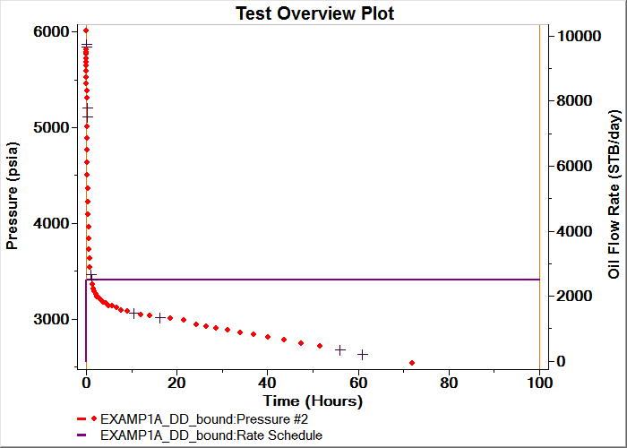
Test Overview Plot

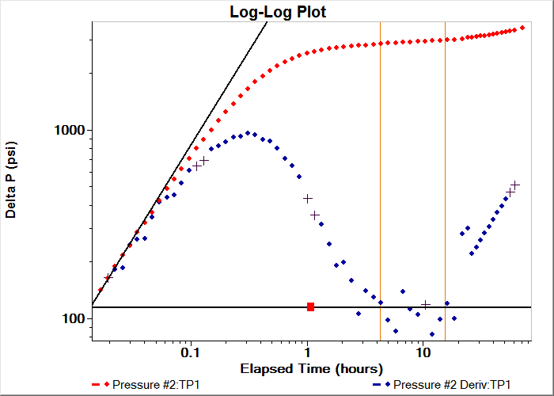
Log-Log Plot:TP1

Line Details
Log-Log Plot Line Details
Line type : Free model line
Slope : Free model line
Intercept : 8315.194
Coefficient of Determination : Not Used
Line type : Free model line
Slope : Free model line
Intercept : 113.677
Coefficient of Determination : Not Used

 | Free model line
Permeability (md) | 75.148
Permeability-thickness (md.ft) | 1728.405
Total mobility (md/cp) | 81.683
Number of Intersections = 0

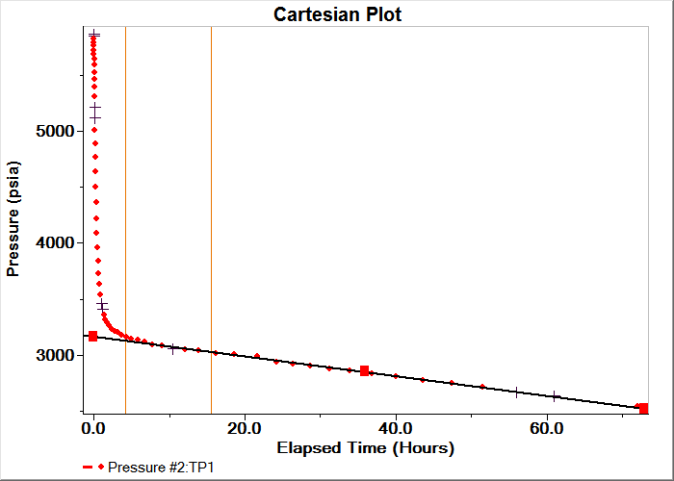
Cartesian Plot:TP1

Local Results

Cartesian Plot Model Results
Radial homogeneous - Closed system
Classic Wellbore Storage

 | Value
Drainage area (acres) | 44.088
Radius of drainage (ft) | 781.862
Oil In Place (STB) | 1.3654E+006
Dietz shape factor | 20.752

Line Details
Cartesian Plot Line Details
Line type : Closed system SSS flow
Slope : Closed system SSS flow
Intercept : 3156.753
Coefficient of Determination : Not Used
Number of Intersections = 0

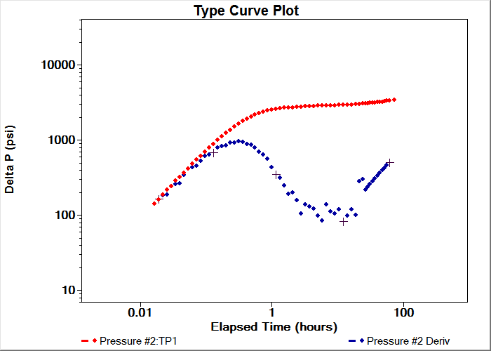
Type Curve Plot:TP1

Local Results

Type Curve Plot Model Results
Radial homogeneous - Closed system
Classic Wellbore Storage

 | Value
Permeability (md) | 88.256
Permeability-thickness (md.ft) | 2029.885
Wellbore storage coefficient (bbl/psi) | 0.016
Dimensionless wellbore storage | 2073.712
Skin factor | 7.694

Type Curve
Type Curve Details

Stage01File Name:C:\Users\mmr\AppData\Roaming\Weatherford\PanSystem\typecurv\radhomog.tch
Axis Type : Td/Cd

 | Stage01
Match point - X | -1.619
Match point - Y | -2.287
Curve Number | 10
Curve Value | 1.0000E+010

