DiaLLM-BD — Prediction Explanation Report
Research prototype only — not a medical diagnosis.
Generated: 2026-08-27 04:00

Result
Lower diabetes risk
Estimated probability: 0.018
Decision threshold: 0.25

Which values influenced this estimate
- height (value: 1.55): -1.535
- age (value: 45.0): -0.933
- glucose (value: 6.93): -0.650
- hypertensive (value: 0): -0.599
- diastolic_bp (value: 81.0): -0.181
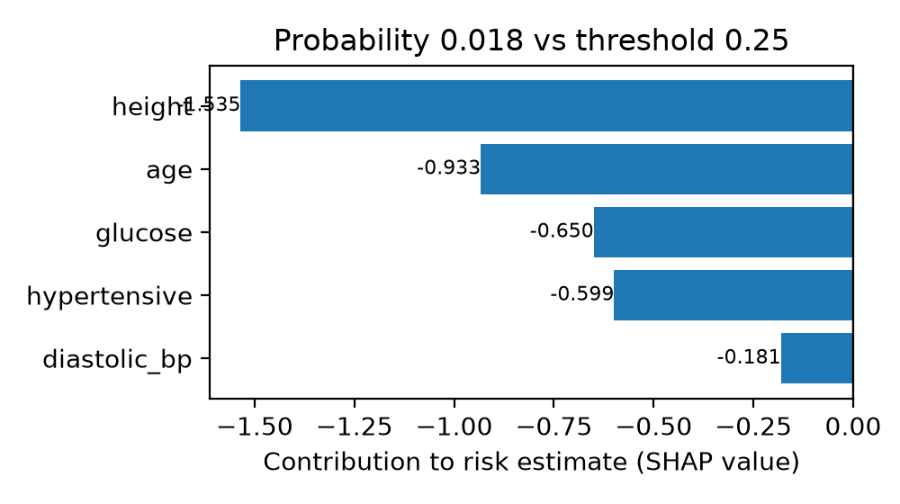

Entered patient information
- age: 45.0
- gender: Female
- pulse_rate: 76.0
- systolic_bp: 130.0
- diastolic_bp: 81.0
- glucose: 6.93
- height: 1.55
- weight: 53.0
- bmi: 21.87
- family_diabetes: 0
- hypertensive: 0
- family_hypertension: 0
- cardiovascular_disease: 0
- stroke: 0

Note
This is an AI-based decision-support output only. A healthcare professional should confirm status using fasting glucose, HbA1c, or an oral glucose tolerance test.

