

Military Institute of Science and Technology

Department of Biomedical Engineering

BME 306: Biomaterials and Biomechanics Sessional

**Experiment 08:** *Experiment on Direct Shear Test of Mild Steel Plate*

**Student ID: 201926033**

Objective:

* To determine the shear strength of metal specimens of different cross-sections
* To ascertain the factors influencing shear strength

Instructions:

* Mention the units in the final results of the calculation

Part A: Results for Steel Plate

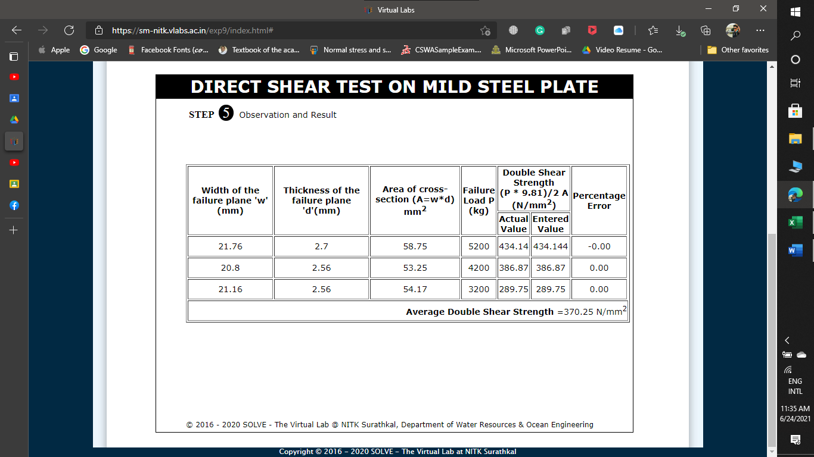

**Fig 1: Observation and Result for Mild Steel Plate**

Part C: Discussion

* State the average shear strength you have obtained in complete sentence.

Answer: The average double shear strength *370.25 N/m $m^{2}$*

* What are the differences between single and double shear?

Answer:

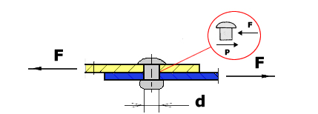Shear stress is a kind of stress that acts parallel or tangential to the surface. Single shear is the shear along one surface only. Double shear is

Figure : SHEAR STRESS (SINGLE SHEAR)

simultaneous shear across two usually parallel planes (as when a rivet passes through three thicknesses of metal). Single

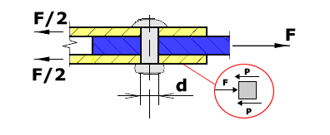shear means a cross section having unbalanced force on its either side and it is ineffective to take that effective load, then it fails in single shear. For double shear an unbalanced load acting on it's both side and whole section is failed is called double or punching shear. shear force required to shear the pin in double shear is twice the shear force required in single shear since side and whole section is failed is called double or punching shear. The average shear stress in the plane for the Single shear is is τave= F/A and for the double stree is τave= F/2A.

Figure :SHEAR STRESS (DOUBLE SHEAR)