THE LONE CAPSULE

1.Main Screen

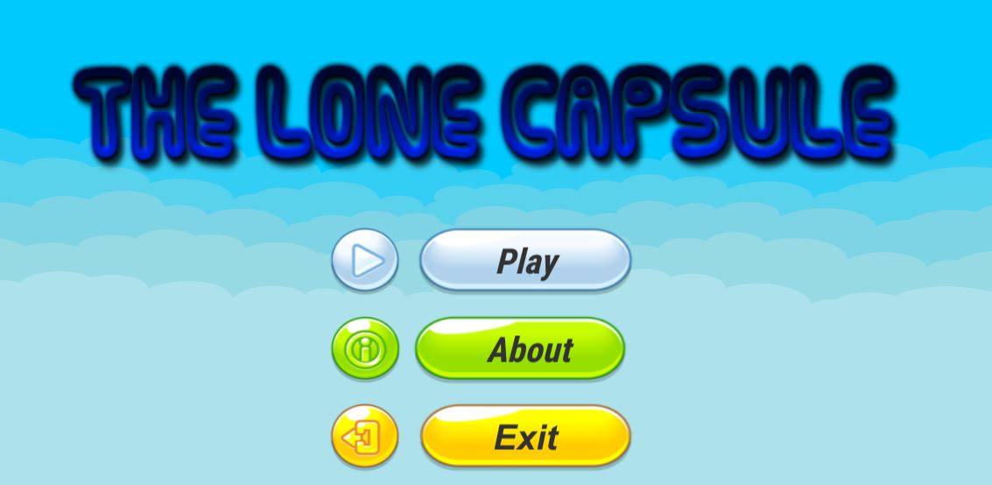

* 1. . Play

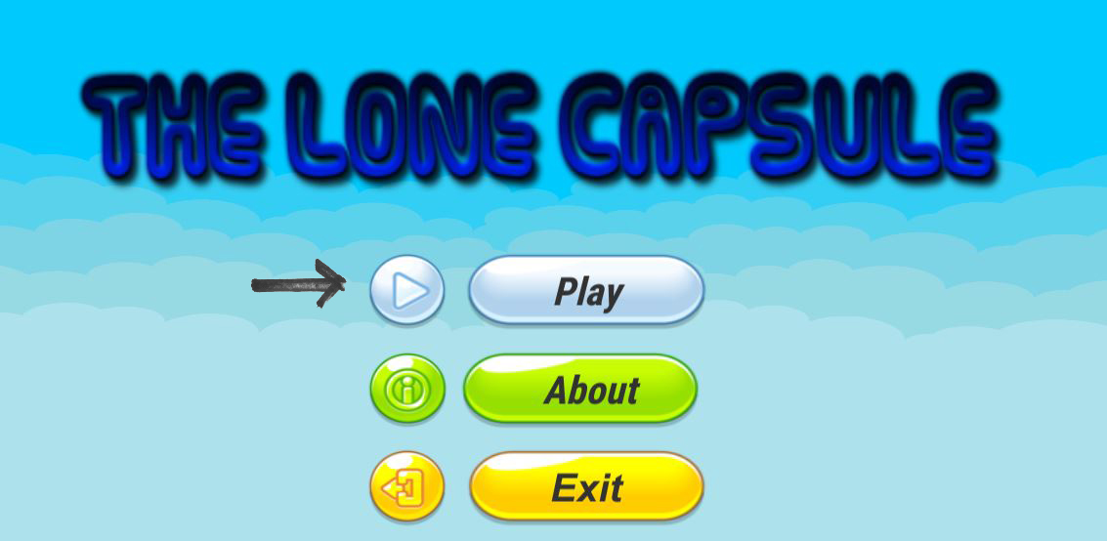

By touching on ‘Play’ button,player can start playing the game

* 1. . About

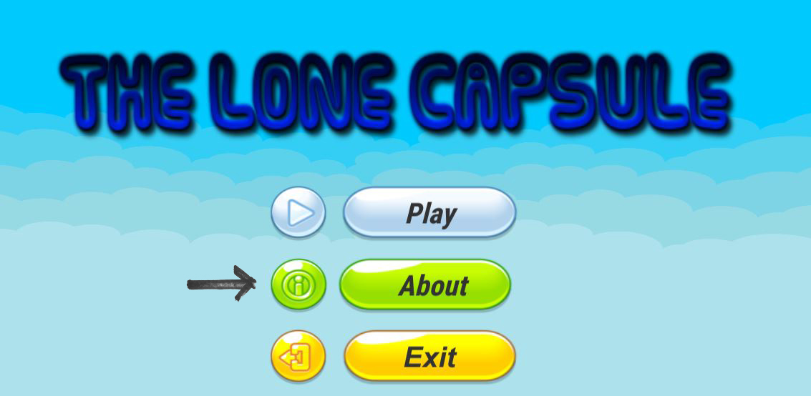

By touching on ‘About’ button,player can know about the game developers.

* 1. . Exit

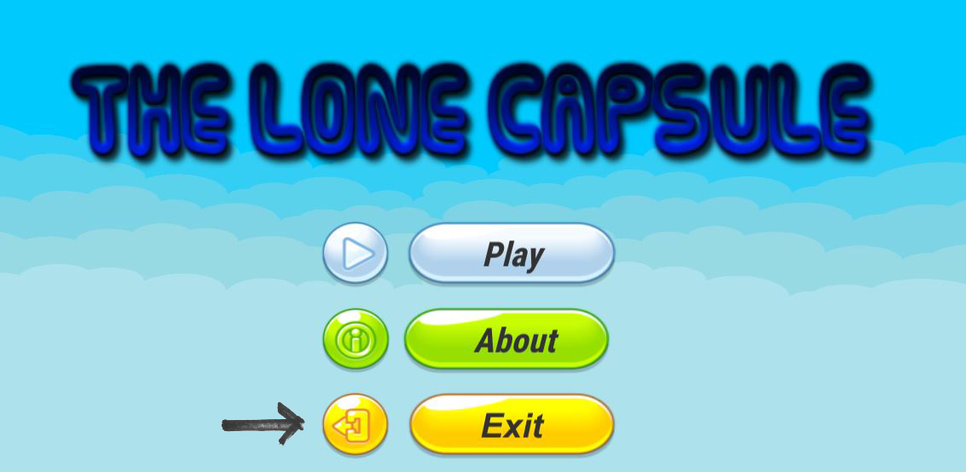

Touching on ‘Exit’ button will ask if player wants to quit the game.

2 . HUD

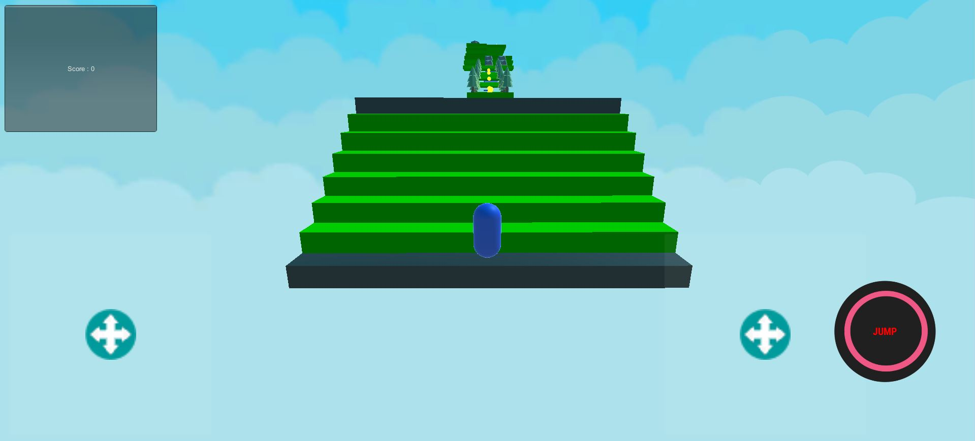

The first level of game with player controller and scoreboard

3. Controls

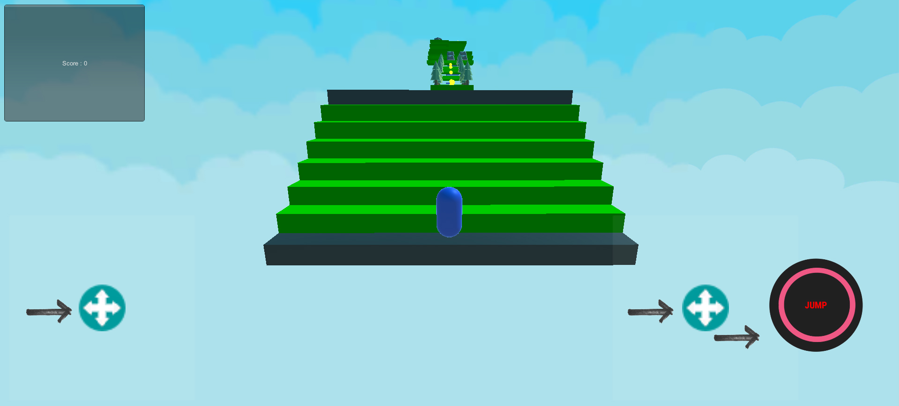

The whole gameplay resolves around player movement stick,camera movement stick

3.1 . Player Movement

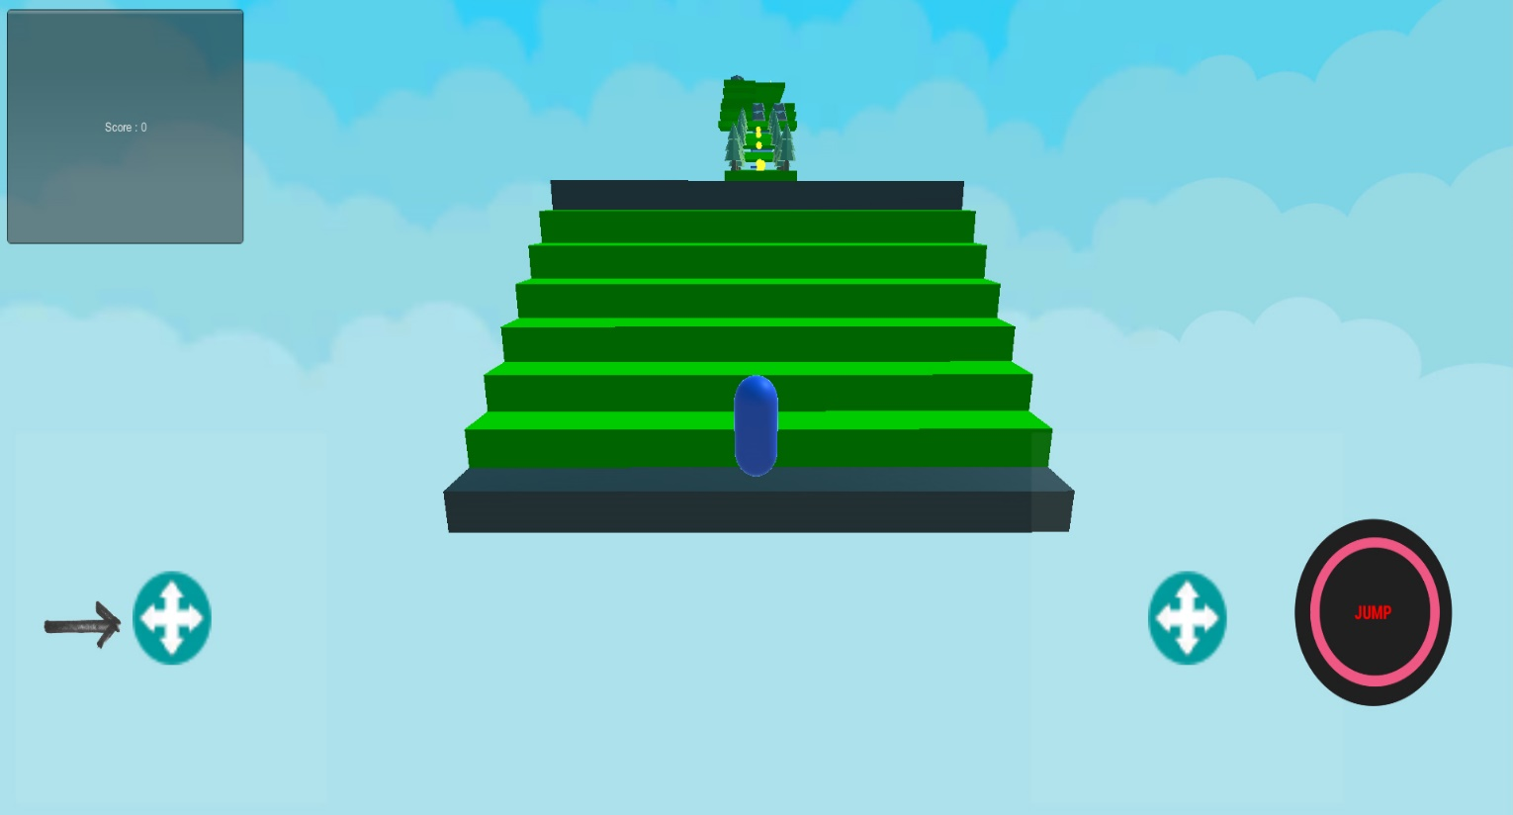

By moving this stick,the game character can be moved in different directions

3.2 . Camera Movement

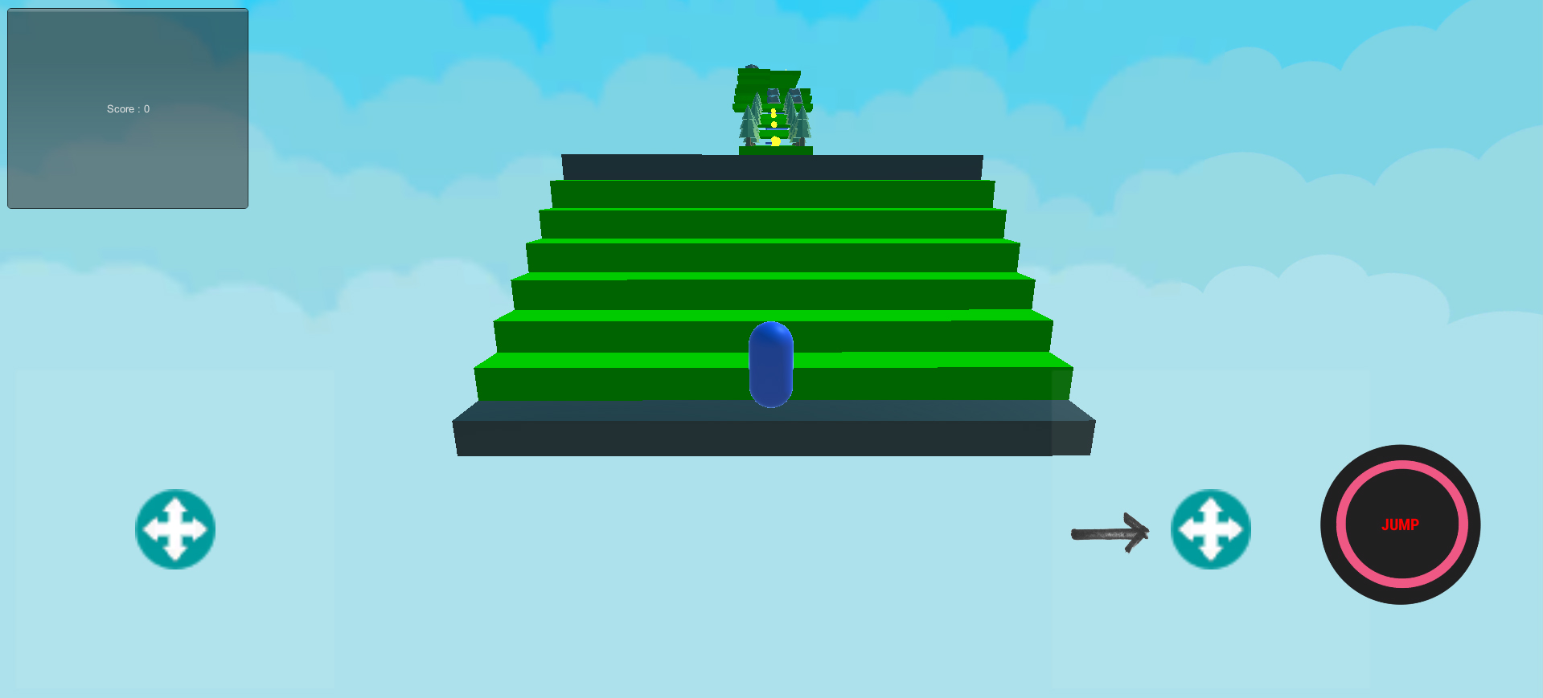

By moving this stick,the camera can be moved up and down for suitable view of the level

3.3 . Jump

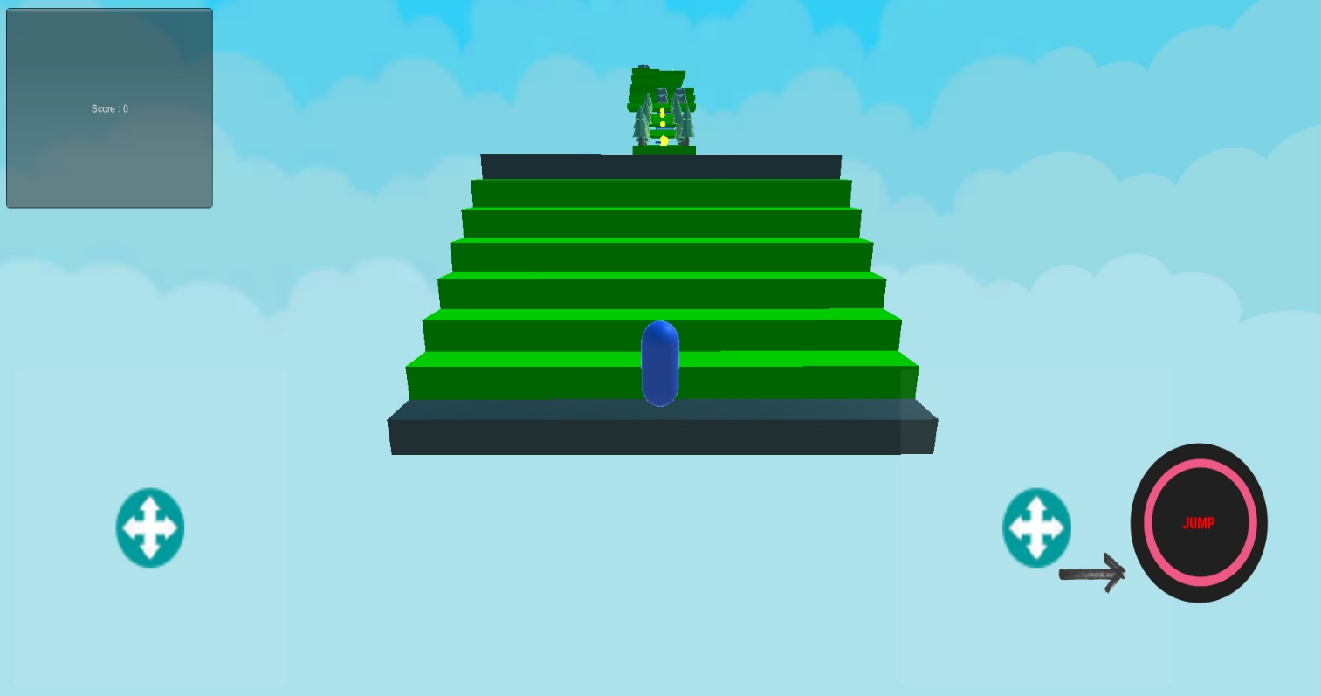

To keep forwarding in the level or for avoiding obstacles the character can be jumped by tapping on the jump button

4. Levels

4.1. Water Elemental Level

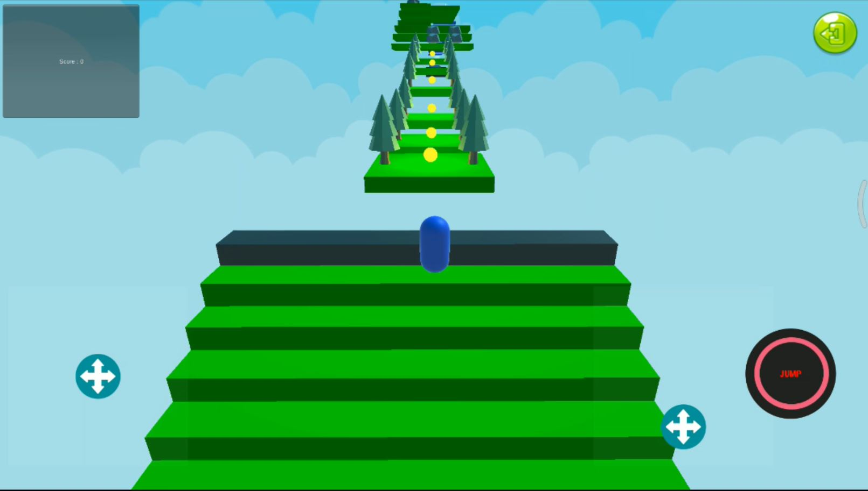

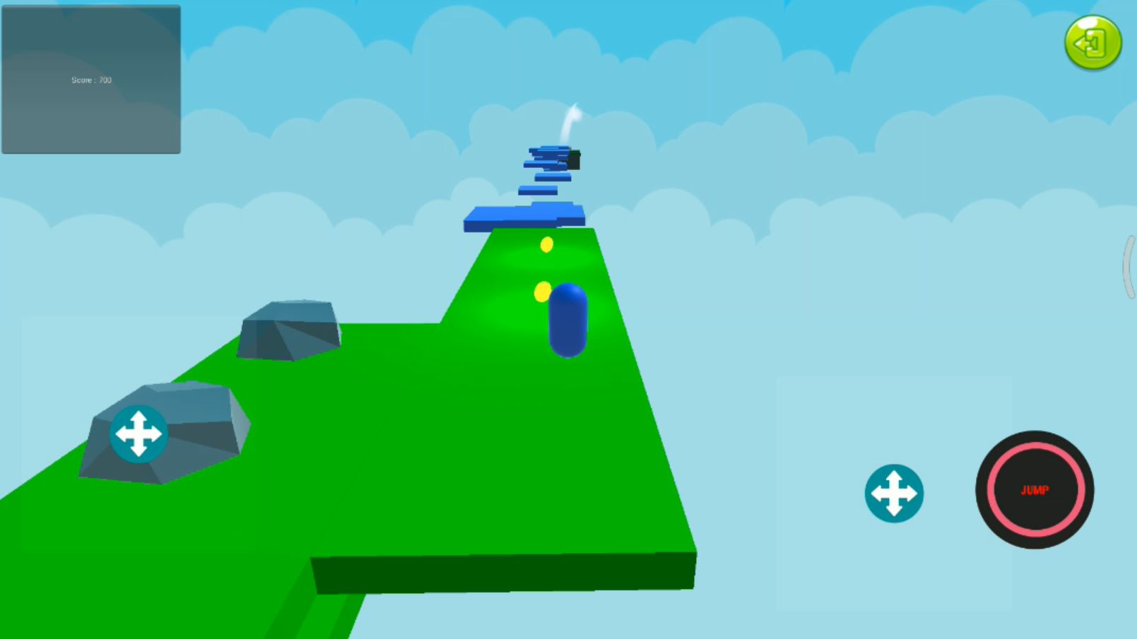

Player will have to collect the water element in the end of this level to proceed to next one.

4.2 . Fire Elemental Level

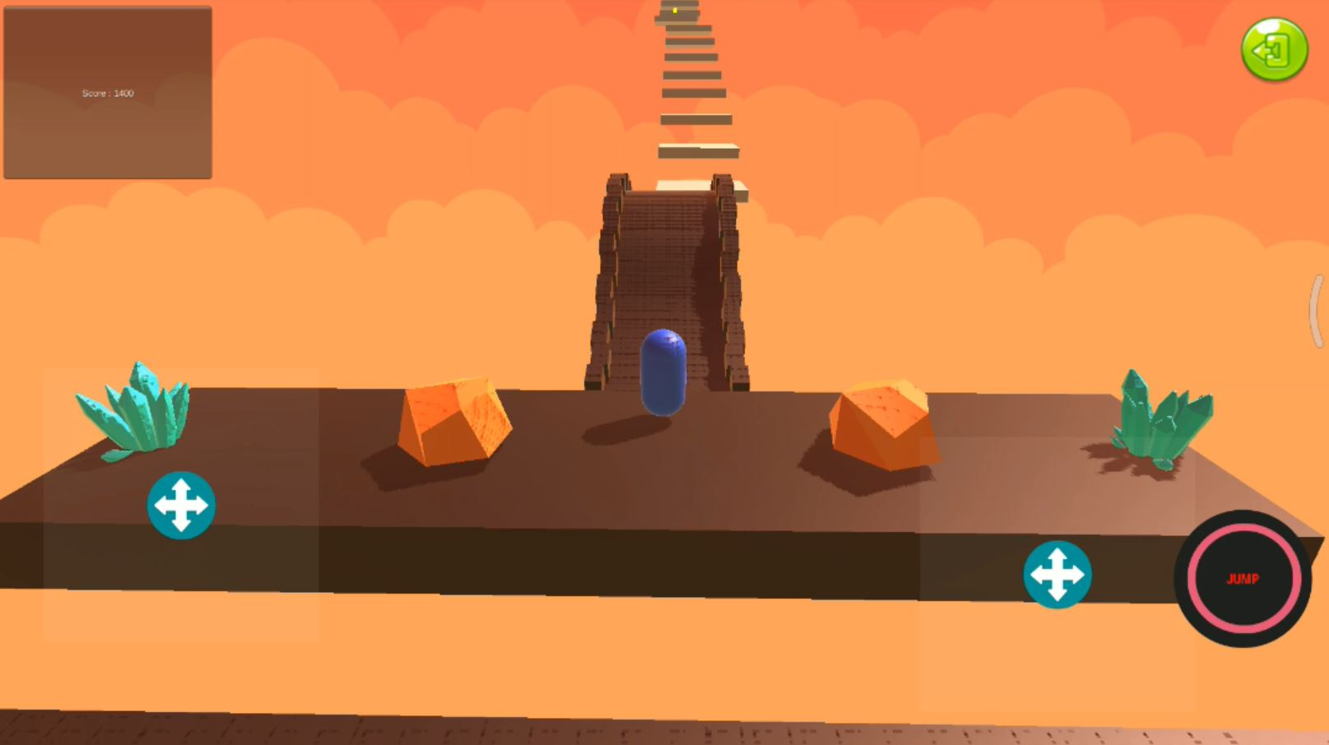

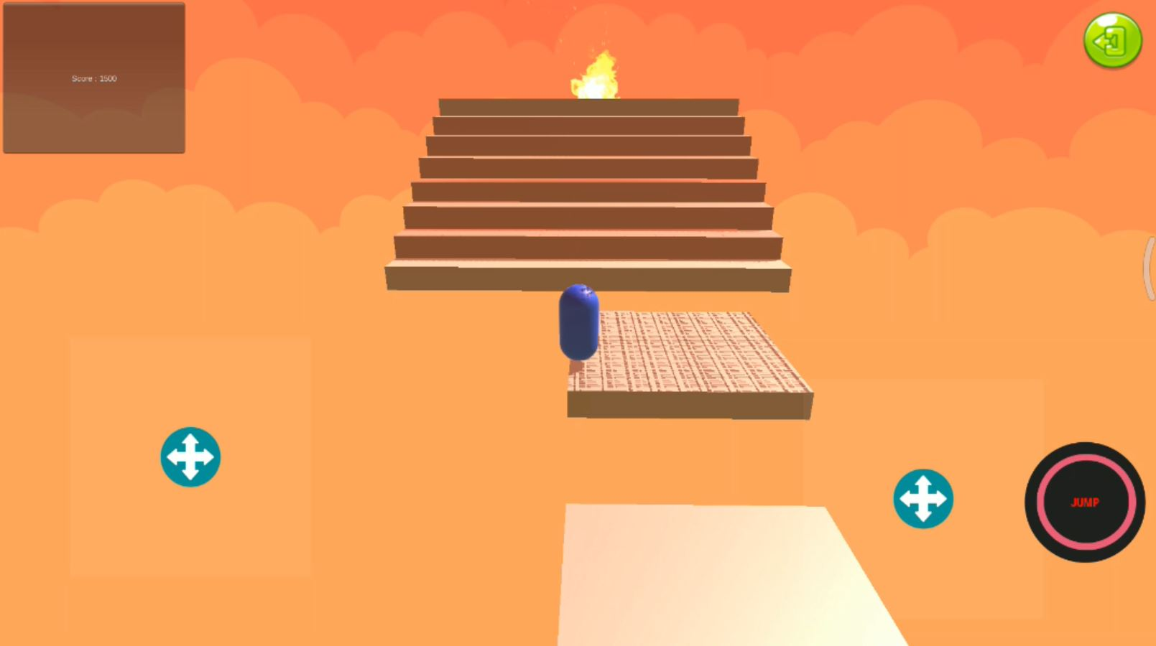

Player will have to collect the fire element in the end of this level to proceed to next one.

4.3. Earth Elemental Level

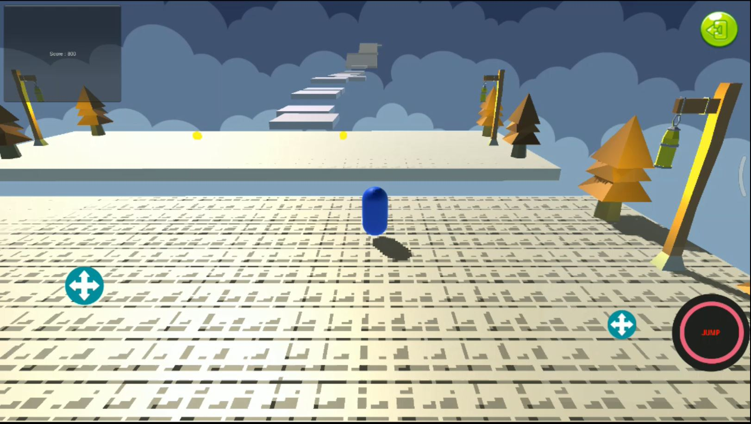

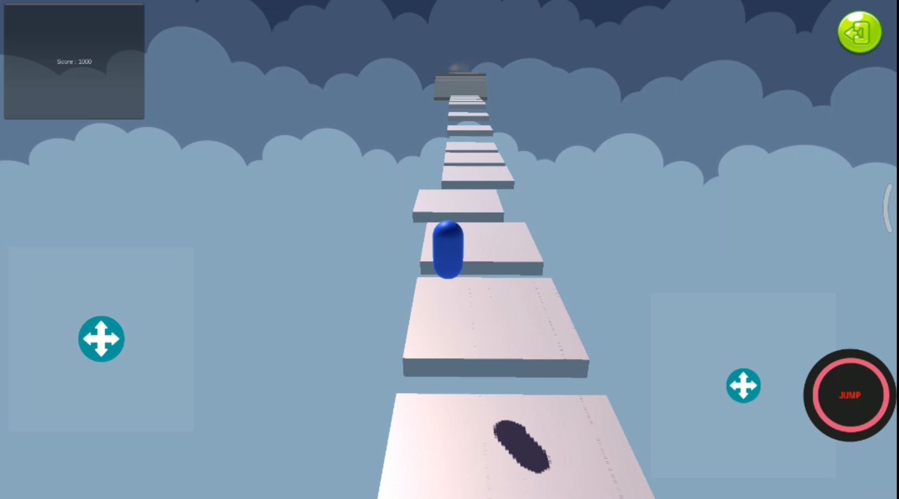

Player will have to collect the earth element in the end of this level finish the .

5. Enemy

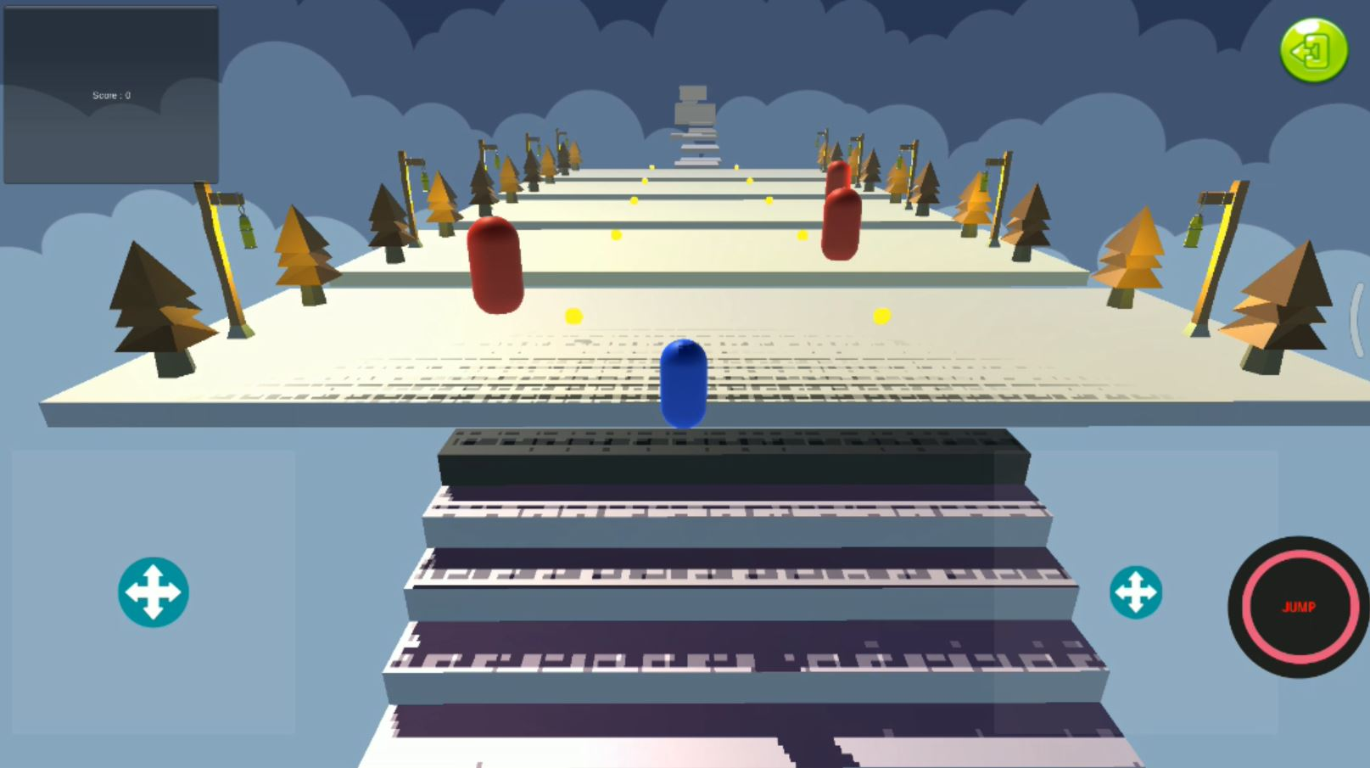

The moving red objects in the level are enemies. Colliding with them will cause respawn from last checkpoint

6. Coins

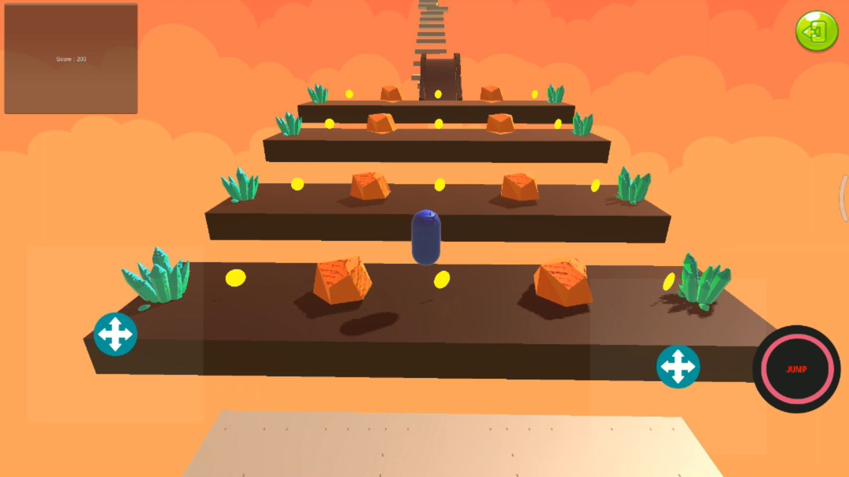

Coins will be scattered around the level.Players can collect them by hovering over them.

7. Scoreboard



Scoreboard is shown on top left corner of the screen.Player can add points to scoreboard by collecting coins

8.Exit to main screen

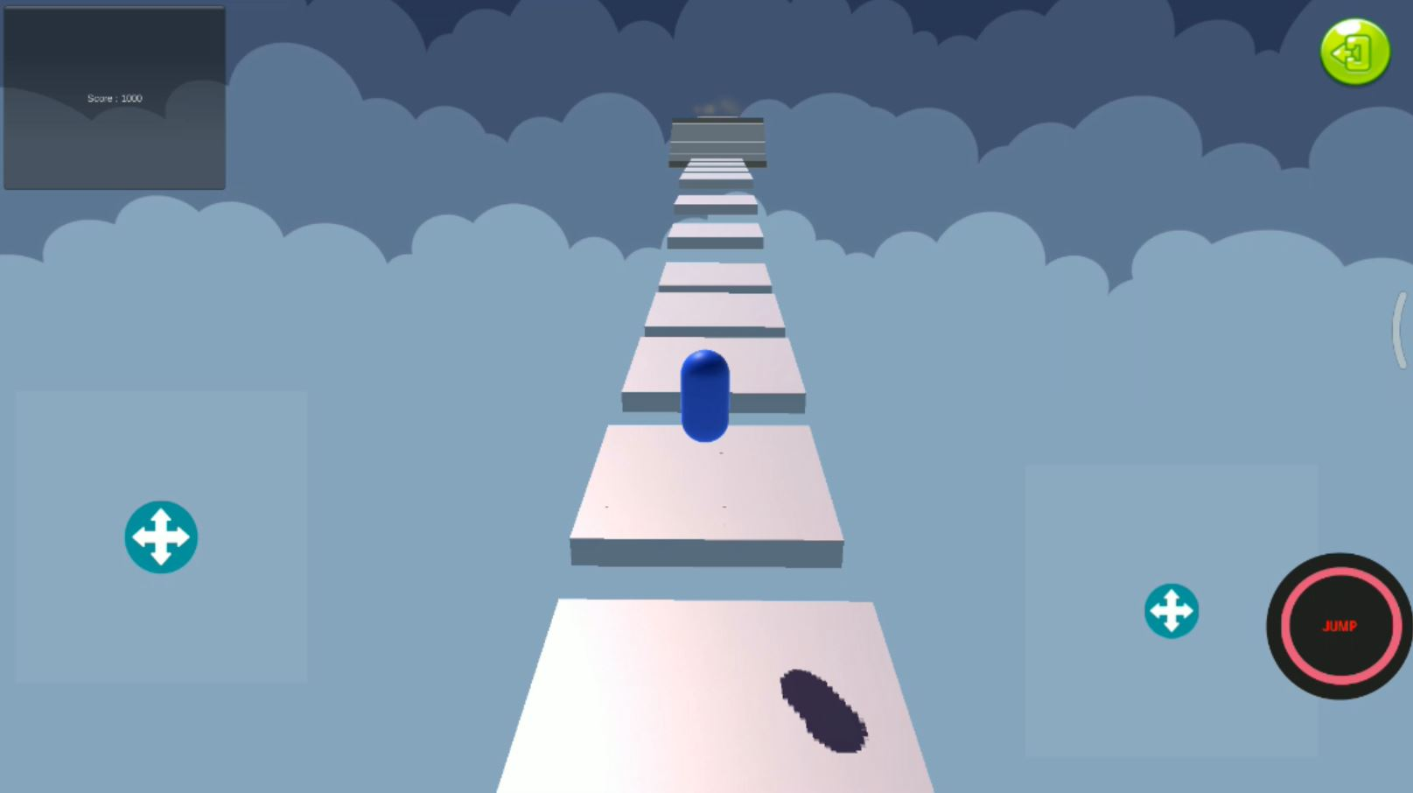

The green button on top right corner of the screen will take back to main screen.