1. Executive Summary
Qué hacer: lo escribes al final, cuando ya tengas todo. 3-4 párrafos resumiendo qué es el honeypot, periodo de captura, y los 2-3 hallazgos más importantes en lenguaje no técnico.

2. Methodology
Qué poner: arquitectura (Cowrie + Wazuh + Docker), periodo de captura exacto, y limitaciones (honeypot de baja interacción, sesgo hacia tráfico automatizado). Puedes linkar tus deployment-*.md en vez de repetir contenido.

3. Statistical Overview
Total events: 6317
Total unique Ips: 38
Volume of Top 5 Ips:
IP | Country | #events
8.210.45.187 | Singapore | 5884
176.53.159.196 | Turkey | 240
130.12.182.110 | Canada | 34
130.12.180.51 | Canada | 20
195.178.110.137 | United Kingdom | 20

Ranking Countries:
Countries | #events
Singapore | 5884
Turkey | 244
Canada | 54
Bulgaria | 36
United Kingdom | 20
China | 19
United States | 16
Japan | 2
Germany | 1

Temporal Distribution:
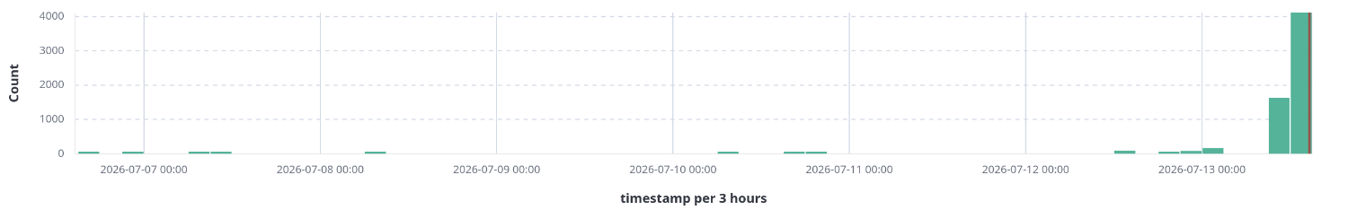
Top 5 Credentials:

Username | Count | Password | Count
root | 2977 | support | 125
support | 125 | admin | 35
admin | 41 | \xef\xbb\xbf------fuck------ | 8
user | 3 | ---fuck_you---- | 4
config | 2 | test | 4

Top 5 Executed Commands

Command | Count
echo -e "\x6F\x6B" | 2942
uname -s -m | 11
ls | 6
exit | 4
pwd | 3

4. Adversary Analysis
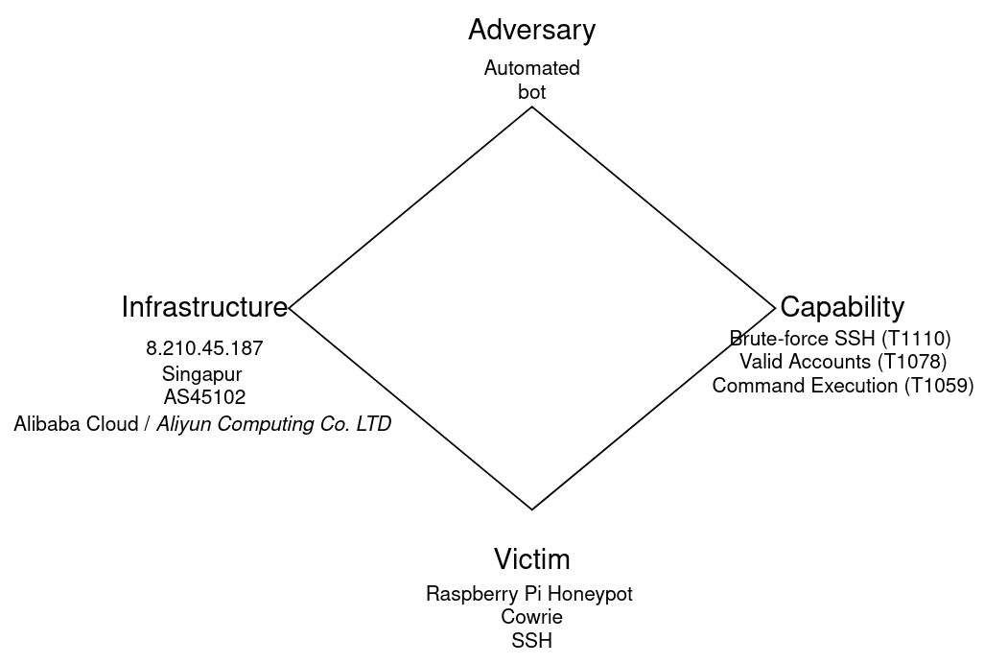

Adversary
Behavioral indicators suggest an automated tool rather than a human operator. Login attempts occurred at intervals of X seconds with minimal variance, and the source issued Y total attempts within Z minutes/hours — a pace inconsistent with manual operation.'] This is consistent with a scripted SSH brute-force tool rather than human-driven activity.
Infrastructure
The source IP resolves to AS45102 (Alibaba Cloud / Aliyun Computing Co. LTD), based in Singapore, a hosting/VPS provider rather than a residential ISP, consistent with disposable infrastructure commonly used for large-scale scanning and brute-force campaigns.
Capability
The adversary attempted [X] total login combinations against the SSH service, of which [Y] succeeded (T1110 – Brute Force; T1078 – Valid Accounts). Successful credentials included: [lista]. Following authentication, the actor repeatedly executed echo -e "\x6F\x6B" ([N] times) — a common shell fingerprinting/sandbox-detection technique used to verify hex-escape interpretation before deploying further payloads (T1059 – Command and Scripting Interpreter). The repetition without adaptation further supports the assessment of unattended, scripted behavior."
Victim
"The target was a low-interaction Cowrie SSH honeypot deployed on a Raspberry Pi, configured with deliberately weak credentials to attract and log brute-force activity."

5. Kill Chain + MITRE ATT&CK Mapping
Qué hacer: coge las sesiones más relevantes y mapea cada fase (Reconnaissance, Initial Access, Execution, etc.) a técnicas ATT&CK concretas (ej: T1110 Brute Force, T1059 Command Execution). Aquí es donde tus tags de MITRE que ya pusiste en Wazuh rinden.

6. Notable Incidents / Case Studies
Qué hacer: elige 2-4 sesiones interesantes (la IP dominante es candidata obligada) y documenta la secuencia completa: credenciales probadas, comandos ejecutados, objetivo probable.

7. Indicators of Compromise (IOCs)
Qué poner: tabla con IPs, hashes de cualquier binario descargado (si Cowrie capturó malware), URLs de staging, user-agents.

8. Detection Rules Developed
Qué hacer: documenta tus reglas custom de Wazuh — qué patrón detectan, por qué las escribiste así, y si dispararon correctamente contra el tráfico real que capturaste.

9. Conclusions & Recommendations
Qué poner: qué aprendiste, qué harías distinto, recomendaciones de hardening genéricas.

10. Appendix
Qué incluir: capturas de dashboards, configs relevantes, referencias externas.

