Page 1 – Basic structure

Titel
  - Subtitle

Heading

Subheading

Subsubheading

Subsubsubheading
A normal paragraph with bold, italic, bold and italic, underlined, strikethrough, ^{superscript}, and _{subscript} text.
A quote
A very important quote
A paragraph containing a hyperlink to GitHub.
A paragraph with a manual line break
within the same paragraph.

Page 2 – Lists and table

Unordered list
- First item
- second item
  - nested item
  - another nested item

Ordered list
- first number
- second number
  - nested number
    - nested nested number

Tables
Heading A | Heading B | Heading C
A1 |  | C1
A2 | B2 | C2

Page 3 – Images and docx exclusive content
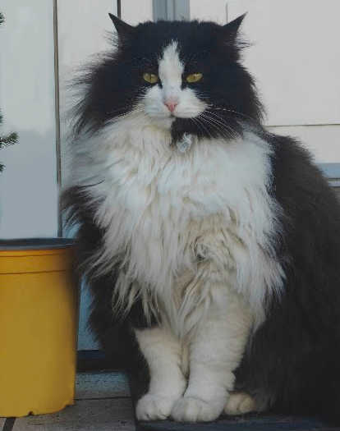

This text is referenced in this footnote
This text is referenced in this endnote

Footnote
Endnote

