# Kvalitet/SPC generelt

## Definisjon/generelt

"Quality is all of the features and characteristics of a product or service that contribute to the satisfaction of a customer's needs (Besterfield, 1986)." (Alemi, Rom, & Eisenstein, 1996, p. 45)

“At its most basic level, statistical quality control is rooted in the graphical and statistical analysis of process data for the purposes of understanding, monitoring, and improving process performance” (James C. Benneyan, 1998a, p. 194)

“once constructed, even the more complex methods discussed in part II of this series' remain relatively easy to interpret” (James C. Benneyan, 1998a, p. 194)

“It should be emphasized, however, that, much like epidemiology, statistical quality control is a broad field, and not all technical issues can possibly be covered in satisfactory depth here” (James C. Benneyan, 1998a, p. 195)

“For example, at least as early as 1916, Frank Gilberth suggested the use of process flow analysis and time and motion studies of hospital system” (James C. Benneyan, 1998a, p. 196)

“The terms statistical process control, statistical quality control, and quality engineering typically are used somewhat interchangeably, broadly defined as the general use of probability theory and various graphical and statistical methods, including quality control charts and other tools, to study and improve processes, process quality, and thus process outcomes” (James C. Benneyan, 1998a, p. 196)

“this also may mean transitioning from a traditional quality-assurance orientation focused largely on inspection, reporting, and regulatory adherence to a quality-improvement orientation focused primarily on process study, continual improvement, and designing better systems” (James C. Benneyan, 1998a, p. 196)

“This broader use of control charts and related methods might be categorized into four more-or-less-sequential phases, corresponding to the objectives of

1. Understanding current process performance;

2. Achieving a consistent level of process quality and performance;

3. Monitoring for process deterioration; and

4. Reducing the (endemic) rate or amount of process variation.” (James C. Benneyan, 1998b, p. 266)

“Perhaps one of the most overlooked phases of SPC is the important initial activity of bringing a process into statistical control.” (James C. Benneyan, 1998b, p. 267)

“Companies throughout the world have used SPC for almost 70 years. There is ample documentation (see “For more information,” page 10) that SPC reduces costs, increases productivity, builds customer loyalty, attracts new customers, and improves employee morale.” (Leavengood & Reeb, 1999a)

“Control charts and process capability analysis are the two primary tools of SPC.” (Leavengood & Reeb, 1999b, p. 2)

“It is widely accepted that the quality of a product/service is generally thought of as the ability to fulfil specific needs, or to conform to, and ideally exceed, customer needs or expectations.” (Antony, Balbontin, & Taner, 2000, p. 242)

“Decision makers often mistakenly attribute positive outcomes to their interventions and negative outcomes to random chance or external events.” (Alemi & Sullivan, 2001, p. 57)

“Shewhart originally worked with manufacturing processes but he and Deming quickly realized that their observation could be applied to any sort of process.” (J. C. Benneyan, Lloyd, & Plsek, 2003, p. 459)

“The use of CCs involves two phases: I and II (see, e.g., Montgomery [56]). In phase I, the researcher collects a set of process data and analyzes them retrospectively, constructing trial control limits in order to determine if the process has been in control over the period of time during which the data were collected. In phase II, the researcher uses the CC in order to monitor the process by comparing the sample statistic for each successive sample as it is drawn from the process to the control limits.” (Sachlas, Bersimis, & Psarakis, 2019, p. 631)

“Statistical process control charts can provide surgeons with early warning of systematic poor performance.” (Jaffray, 2020, p. 1691)

## Effekter av SPC

“One reason offered to explain the prominence of SPC is the positive impact that the deployment of SPC has on quality and costs.” (Rungtusanatham, 2001, p. 654)

“Challenges to and evidence contradicting this message (i.e. the benefits of SPC) tend to be rare. In the few studies that have reported organizational failures at implementing SPC, the failures have typically been attributed not to the ineffectiveness of SPC, the technology, but to the ineffectiveness of the implementation process (e.g. Lightburn and Dale, 1991).” (Rungtusanatham, 2001, p. 654)

“In part, the ineffectiveness of the SPC implementation process results from the näıve perspective that the deployment of SPC is merely a technology issue.” (Rungtusanatham, 2001, p. 654)

“Besides the expected improvements in quality and costs, it appears that the effective implementation and practice of SPC can provide process operators with greater intrinsic rewards and allow them to achieve higher levels of motivation and job satisfaction by making the work that process operators perform more motivating” (Rungtusanatham, 2001, p. 669)

“Research, consistent with sociotechnical systems theory (e.g. Hulin and Roznowski, 1985, p. 56) has shown, time and again, how crucial it is to specify and align both technical and social effects of any intervention so as to maximize the probability of successful implementation and continued sustainability.” (Rungtusanatham, 2001, p. 669)

“Control charts can be used in the daily management of healthcare processes to analyse routinely collected data and reduce ‘‘management by opinion’’, as in the cases of flash sterilisation and laboratory turn around time. Control charts can help policy makers avoid wasted investments in changes that sound good but do not actually deliver” (J. C. Benneyan et al., 2003, p. 463)

“On the basis of these observations, we conclude that although SPC charts may be easy to use even for patients, clinicians or managers without extensive SPC training, they may not be equally simple to construct correctly.” (Thor et al., 2007, p. 390)

“We found more information on SPC benefits and facilitating factors than on limitations and barriers, and this may represent a form of publication bias” (Thor et al., 2007, p. 393)

“we believe that SPC rests on a solid theoretical, statistical foundation and is a highly robust method for analysing process performance.” (Thor et al., 2007, p. 394)

# Prosess

## Definisjon

“A process can be defined **1** as a set of causes and conditions that repeatedly come together to transform inputs into outcomes.” (Nolan & Provost, 1990, p. 70)

“The outcomes include products, services, behavior, or people.” (Nolan & Provost, 1990, p. 70)

“Traditional QC programs emphasize **product** quality control whereas SPC is **process** oriented.” (Leavengood & Reeb, 1999a)

# Variation

## Definisjon/generelt

“The decision is often based on whether we think the variation we observe is indicative of a change or simply random variation that is no different from that which has occurred in the past.” (Nolan & Provost, 1990, p. 70)

“Managers must be able to determine whether the patterns of variation that are observed are indicative of a trend or of random variation that is similar to what has been observed in the past.” (Nolan & Provost, 1990, p. 70)

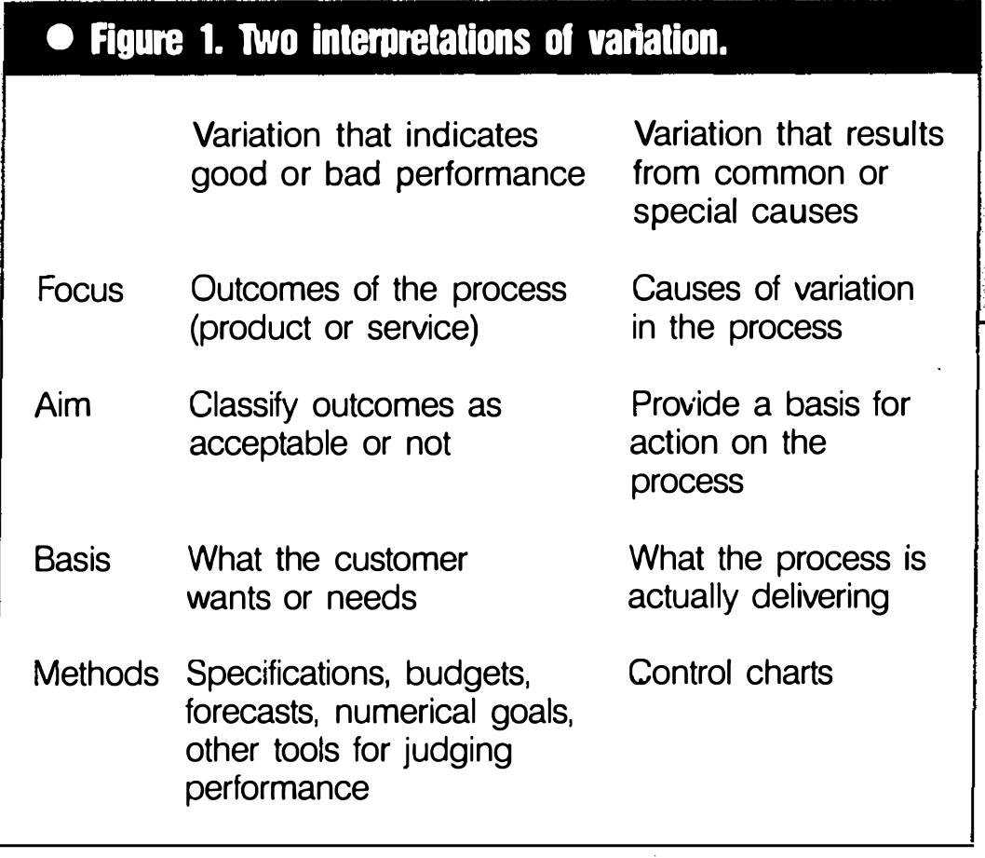

Figur 1: Nolan, Provost - Fig 1 - Two interpretations of variation (Nolan & Provost, 1990, p. 71)

“Variation in outcome is a natural result from any complex biological or production process.” (Plsek, 1992, p. 65)

“It can differentiate common cause variation from special cause variation through the application of several probability-based interpretation rules.” (Amin, 2001, p. 1)

“are based on the probability that the graphical pattern would be very unlikely to occur by chance alone.” (Amin, 2001, p. 2)

## Common causes

“Common causes: those causes that are inherently part of the process (or system) hour after hour, day after day, and affect everyone working in the process.” (Nolan & Provost, 1990, p. 71)

“Control chart practitioners use the phrase "common cause variation" to refer to this natural variation inherent in all processes.” (Plsek, 1992, p. 67)

“The natural variability of a process is defined as the systemic variation inherent as a regular part of the process.” (James C. Benneyan, 1998a, p. 197)

“Just because a factor is a common cause does not mean it is an acceptable or unavoidable cause. For example, a company may find that moisture content of their raw materials ranges from 2% to 16%. If the product is consistently within this range, the variability will be consistent as well. But this doesn’t mean that the company shouldn’t do something to reduce the variability.” (Leavengood & Reeb, 1999b, p. 2)

“Common-cause variation is intrinsic to the process. To decrease common-cause variation, we need to act on the process.” (Mohammed A. Mohammed, Cheng, Rouse, & Marshall, 2001, p. 463)

“As long as all values on the graph fall randomly between the upper and lower control limits, however, we assume that we are simply observing common cause variation.” (J. C. Benneyan et al., 2003, p. 460)

“common cause variation does not necessarily mean the results are acceptable, but only that the process is stable and predictable.” (J. C. Benneyan et al., 2003, p. 462)

## Special causes

“Special causes: those causes that are not part of the process (or system) all of the time or do not affect everyone, but arise because of specific circumstance”s. (Nolan & Provost, 1990, p. 71)

“Similarly, the phrase "special cause variation" is used to refer to unnatural variation due to events or circumstances that are nontypical or not inherent in the normal process.” (Plsek, 1992, p. 67)

“Conversely, observations that have very small probabilities of occurrence based on the regular process usually are presumed to represent special events and deviations from the regular process. Such events suggest that the process or environment fundamentally has changed and are considered to be occurrences of nonsystemic unnatural variability” (James C. Benneyan, 1998a, p. 197)

“Special causes are a signal that something has changed in the process. They disrupt the stable, repeating pattern of variation. Special causes result in inconsistent and unpredictable process performance and must be identified and removed before taking other steps to improve quality.” (Leavengood & Reeb, 1999b, p. 2)

“Special-cause variation is the result of factors extrinsic to the process, and its reduction therefore requires identification of and action on the special causes.” (Mohammed A. Mohammed et al., 2001, p. 463)

“Note that special cause variation can be the result of either a deliberate intervention or an external event over which we have little control.” (J. C. Benneyan et al., 2003, p. 459)

“Når man finner enkeltpunkter utenfor kontrollgrensen i et kontrolldiagram, bør man forsøke å finne årsaken til denne spesielle variasjonen. Ofte finner man ut at datapunktet egentlig ikke hører med til den prosessen diagrammet framstiller, altså at det er noe fremmed for prosessen. Da skal dette datapunktet tas ut og ikke være med i beregningen av senterlinje og kontrollgrenser.” (Nyen, 2009, p. 34)

## Stabil prosess/prosess i kontroll

“A process (or a system) that has only common causes affecting the outcomes is called a stable process or said to be in a state of statistical control.” (Nolan & Provost, 1990, p. 71)

“In a stable process, the cause system for variation remains essentially constant over time. This does not mean that there is no variation in the outcomes of the process, that the variation is small, or that the outcomes meet the requirements set by the customer. A stable process implies only that the variation in the outcomes is predictable within statistically established limits.” (Nolan & Provost, 1990, p. 71)

“The stability of the system does not mean that anyone is happy with the state of affairs, but only that the magnitude of the deficit will be predictable until a fundamental change is made.” (Nolan & Provost, 1990, p. 73)

“Continual adjustment of a stable process, that is, one whose output is dominated by common causes, will increase variation and usually make the performance of the process worse” (Nolan & Provost, 1990, p. 73)

“If a system is stable with respect to a particular measure of performance such as costs, then a fundamental change in the system will be needed to reduce the cost.” (Nolan & Provost, 1990, p. 74)

“Tampering results when action is taken on a process under the assumption that variation is a result of a special cause when, in fact, the variation is a result of common causes.” (Nolan & Provost, 1990, p. 74)

“Tampering (reacting to every data point and overadjusting the process) can be demoralizing to the people who work in the process and can increase the variation. Unfortunately, tampering is widely practiced.” (Plsek, 1992, p. 68)

“The term statistical control most generally refers to the stability and predictability of a process over time. A process that is completely stable and predictable over time exhibits only natural variability, as the regular behavior of the underlying process remains unchanged. Such a process is referred to as being in a state of statistical control” (James C. Benneyan, 1998a, p. 197)

“only if a process is in a state of statistical control can valid probability statements be made about the future predicted performance of the process.” (James C. Benneyan, 1998b, p. 266)

“A process/service is considered to be in a state of statistical control if assignable or special causes of variation (e.g. tool wear, operator error, wrong machine setup, improper raw material, errors in calculations, etc.) are not present in the process (Montgomery, 1991).” (Antony et al., 2000, p. 242)

“even if the process is stable it still may reflect poor quality.” (Fasting & Gisvold, 2003, p. 772)

## Oppsummering

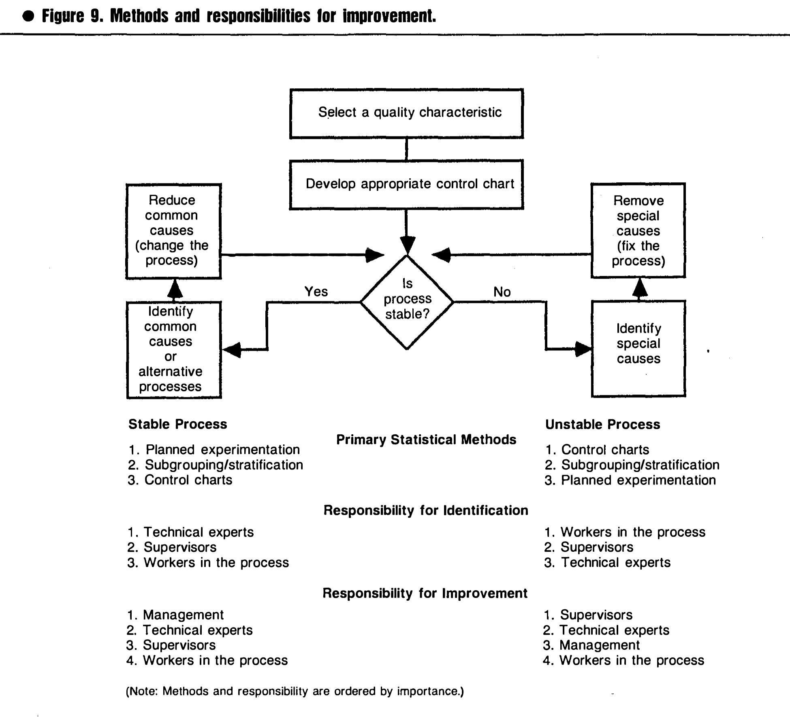

Figur : Nolan, Provost 1990 - fig.9 (Nolan & Provost, 1990, p. 77)

“Central to quality management theory are three simple, but often misunderstood, truths about variation. 1. Variation in outcome is a natural result from any complex process. 2. Therefore, the simple presence of variation is not sufficient evidence to justify concluding that a biological or production process is unstable and in need of special intervention. 3. Furthermore, if we intervene without profound knowledge of the true causes of the variation, we may actually increase the variation.” (Plsek, 1992, p. 65)

Vi forveksler ofte tilstedeværelse av variasjon som varierende kvalitet (Plsek, 1992, p. 65)

“Whether we are looking at an indicator of process quality (the case here); a measurement of volume or cost (e.g., the number of patients seen); or a measure of clinical quality (e.g., c-section rate), it is quite common to look for special reasons when we see high numbers, and to feel good about our efforts when we see low numbers. But while this reaction and analysis is quite common, it is also quite naive ... quite unscientific .. . and potentially quite wrong.” (Plsek, 1992, p. 66)

Common - naturlig, endogen, iboende

Special - unaturlig, eksogen, ytre (Plsek, 1992, p. 67)

“*If the pattern indicates special cause variation,* we should search for and try to eliminate the special causes associated with those few data points.” (Plsek, 1992, p. 69)

“If the pattern indicates common cause variation and we are happy with the overall performance of the process: the best strategy is to do nothing. If we react to the ups and downs in the measurement, we might be tampering and that might make matters worse.” (Plsek, 1992, p. 69)

“If the pattern indicates common cause variation and we are not happy with the overall performance of the process: we must search for and eliminate the common causes associated with all the data points (not just the highs and lows).” (Plsek, 1992, p. 69)

“a key concept within the philosophy of SPC is that unnatural process variation can be reduced or eliminated only by identifying and removing its nonsystemic causes from the regular process (or otherwise suppressing their effect). To improve a process that exhibits only natural variation, however, by definition it is necessary to change fundamentally the regular underlying "common- cause" process.” (James C. Benneyan, 1998a, p. 197)

“In many more realistic scenarios, without the use of statistical methods, it often is difficult to determine intuitively which type of variation (natural versus unnatural) is present and, therefore, which type of process intervention (ie, unique identification or systemwide experimentation) is in order.” (James C. Benneyan, 1998a, p. 198)

# Seriediagram

“Run-diagram er veldig enkelt å konstruere og tolke. Det kan brukes på alle typer prosesser og med alle slags data (målte data, telte data, prosenter, forholdstall osv).” (Nyen, 2009, p. 20)

“Et run er definert som ett eller flere etterfølgende datapunkter på samme siden av medianen. Et run kan altså ha ett eller flere punkter. Punkter som ligger på medianen skal ignoreres.” (Nyen, 2009, p. 20)

“Sandsynligheden for at to på hinanden følgende målinger befinder sig enten over eller under medianen er 0,5 × 0,5 = 0,25. Sandsynligheden for tre på hinanden følgende punkter på samme side er 0,125 osv. Hvis tilstrækkelig mange på hinanden følgende punkter befinder sig på samme side, vil man sige, at sandsynligheden for, at dette er en tilfældighed, er lav. Ofte sættes grænsen ved otte punkter. Sandsynligheden for at dette kan ske ved en tilfældighed et bestemt sted i diagrammet er 0,0039. For et seriediagram med 20 punkter kan denne tilfældighed optræde 20-8 = 12 forskellige steder. Den samlede sandsynlighed for, at der mindst et vilkårligt sted i diagrammet ved en tilfældighed optræder otte eller flere punkter på samme side af medianen, er da 0,047.” (Anhøj & Bjørn, 2009, p. 1766)

“Run charts can show trends or shifts, but analysis ofrun charts is limited because they can miss significant process changes, and they are unreliable in assessing the capability of the process or predicting the future.” (Reynolds, Spencer, Dunaway, Buckingham, & Bartman, 2021, p. 200)

# Kontrolldiagram

## Definisjon/generelt

“The control chart is the means to operationally define the concept of a stable process.” (Nolan & Provost, 1990, p. 71)

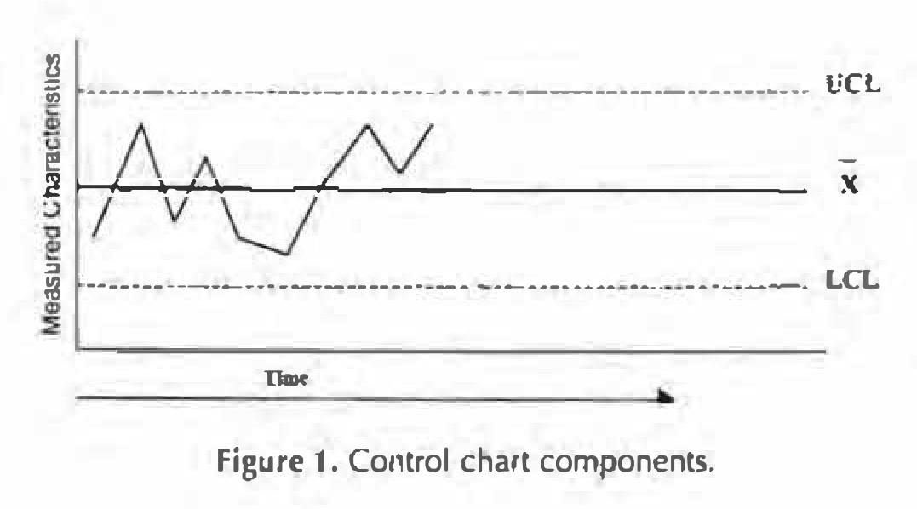

Figur : Komponentnene i et kontrolldiagram (Amin, 2001, p. 2)

“The control chart has three lines: the central line is the mean, and the upper and lower lines are termed control limits. Control limits represent the limits of common-cause variation. A data point that falls outside these control limits (or unusual patterns on the control chart) suggest a special cause.” (Mohammed A. Mohammed et al., 2001, p. 463)

## Egenskaper/forutsetninger

"The control chart, a tool for distinguishing common and special cause variation, is based on the empirical observation that data from a common cause process generates a distinctive and predictable pattern-a pattern that we will generalize here as a "bell-shaped curve." (Plsek, 1992, p. 68)

“We can now summarize this theory, first articulated by Shewhart, as follows: • Measures from any process will display variation. • Individual measurements are unpredictable. (What exactly will the patient's systolic blood pressure be the next time you take it? How long exactly will the next patient wait before being seen in your clinic? How could you possible know?) • BUT .. . if they come from a stable common cause process, the ***group*** of data points will obey a mathematical law (what we are calling a "bell shaped curve).” (Plsek, 1992, p. 68)

“More generally, Shewhart' s original work also referenced Tchebyschev's Inequality, which states that the probability that a variable X should deviate from its mean by more than k times its standard deviation is equal to or less than 1/k2, regardless of the underlying distribution.” (Plsek, 1992, p. 68)

“Small samples are a cause for concern, and when the sample size is less than 30, normality assumptions may not hold.” (Alemi et al., 1996, p. 57)

“Note also that a minimum of at least 25 subgroups of data are recommended in order to conclude that a process is in statistical control” (James C. Benneyan, 1998a, p. 198)

“Control charts are statistical tools and, as such, are based on probability theory. ” (James C. Benneyan, 1998a, p. 200)

“These three probability distributions - binomial, Poisson, and normal - will be familiar to many readers as being among the most common for many practical empirical situations, and the six charts listed above therefore are appropriate for most (but not all) basic applications of SPC.” (James C. Benneyan, 1998a, p. 201)

“Fortunately, from a practical standpoint, X and S charts can be moderately robust to slight departures from their underlying theoretical distributions, with only slight degradation in statistical power and confidence. If the departure is substantial (such as if very significant skewness is suggested by simple histograms or more advanced methods), however, their use can result in greater error. ” (James C. Benneyan, 1998a, p. 210)

“Recall also from part I that a minimum of at least 25 subgroups of data are recommended to conclude that a process is in statistical control” (James C. Benneyan, 1998b, p. 267)

It generally is recommended that there be at least 2 5 data points before constructing a control chart. (Amin, 2001, p. 3)

“The decision about which chart to use primarily rests with the type of data that have been collected and the methods used.” (Amin, 2001, p. 5)

“The ideal number of different samples needed to construct a chart with control limits is generally 20.” (Howard, 2003, p. 10)

“It might be helpful, without causing too much confusion, to mention the work of a mathematician called Tchebyshev. He showed, that if a process is stable, 89% of the time X will fall within the limits: X plus or minus three standard deviations, irrespective of the form of the distribution. The same result holds for control charts in general, not just (X ,R), and provides a mathematical justification of Shewhart's approach” (Howard, 2003, p. 14)

“It is often stated that 20–25 data points are needed on an xmr-chart before the limits are sufficiently ‘‘firmed-up’’ so that if a process is showing common cause variation over these 20–25 data points then we can confidently conclude that it is stable” (M. A. Mohammed, Worthington, & Woodall, 2008, p. 139)

“Et kontroll-diagram bør ha omtrent 20 til 30 datapunkter for å utføre de fire testene som er beskrevet her. Hvis man har færre enn 20 datapunkter, er det større fare for ikke å få med spesielle variasjoner (type-II-feil). Men hvis man finner en spesiell variasjon med færre enn 20 punkter, bør man undersøke den. Med mer enn 30 datapunkter er det økt fare for å finne spesiell variasjon pga tilfeldigheter (type-I-feil).” (Nyen, 2009, p. 26)

“Et robust seriediagram indeholder mellem 20 og 30 målepunkter. Er der færre, stiger risikoen for at overse særlig variation (type 2-fejl). Er der flere, stiger risikoen for at finde særlig variation, selv om processen er stabil (type 1-fejl).” (Anhøj & Bjørn, 2009, p. 1766)

“Det optimale antal målepunkter er 20 – 30” (Lauritsen & Packness, 2010, p. 49)

“Most existing SPC procedures are based on the assumption that a parametric form (e.g., normal) of the process distribution can be specified beforehand. In the literature, it has been demonstrated that their performance is unreliable in cases when the prespecified process distribution is invalid.” (Qiu & Li, 2011, p. 390)

## Kontrollgrenser

“If the normal distribution is used as the model for our common cause variation process, then there is only a 0.27 percent (i.e., 100 percent-99.73 percent) chance of values occurring more than three SDs away from the average. So, if we draw the control limits at three SDs above and below the average, our type I error rate is only 0.27 percent. This level provides a relatively low risk of tampering if we truly have common cause variation. While points that fall more than three SDs from the average can certainly occur, the probability is so small that we instead conclude that special cause variation has occurred.” (Plsek, 1992, pp. 69–70)

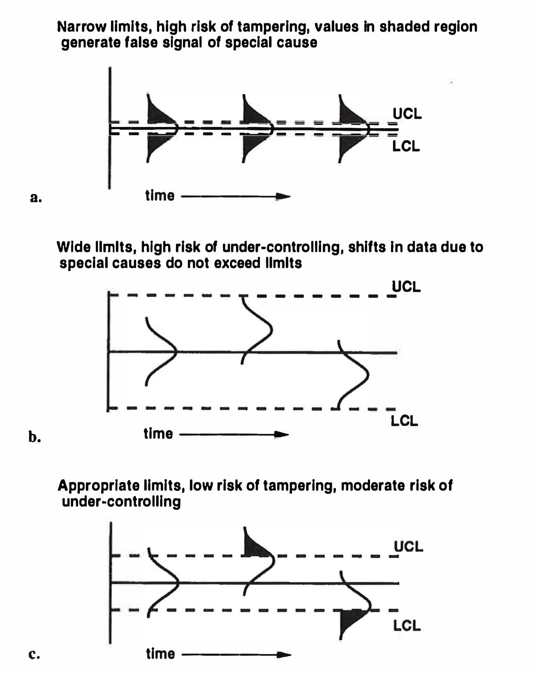

Figur : Plsek 1992 - Fig.3 (Plsek, 1992, p. 70)

“In the end, Shew hart's choice of three SDs was based on consideration of the economic and psychological impact of launching investigations for special cause.” (Plsek, 1992, p. 71)

“there are no standard percentages for the upper and lower control limits and that their determination is a matter of policy for each health care organization.” (Alemi et al., 1996, p. 50)

“In reviewing control charts, it is important to remember that a larger number of cases decreases the value of the standard error of the mean and a smaller number of cases increases the value for the standard error of the mean. As a consequence, when the sample size increases, the *UCL* and *LCL* become closer to each other.” (Alemi et al., 1996, p. 53)

“It is critical to emphasize that a process either is or is not in a state of statistical control, regardless of where control limits arbitrarily or scientifically are placed (and regardless of which specific supplementary rules are used). That is, changing the control limits or rules in no way changes a process from being in statistical control to being out of statistical control, or visa versa, but only changes the power and confidence (sensitivity and specificity) to detect each state.” (James C. Benneyan, 1998b, p. 275)

“**Control limits** are the limits within which the process operates under normal conditions.” (Leavengood & Reeb, 1999b, p. 6)

“**Control limits**

*tell us how far we can expect sample values to stray from the average, given the inherent variability of the process.”* (Leavengood & Reeb, 1999b, p. 6)

“**Control limits vs. specification limits**

It’s common for managers and workers to ask, “Why can’t we simply use the specifications for control limits? Why do we need to bother with control limits based on statistical probabilities when all we really want to know is how much good (within specification) product we’re producing?”

There are two primary reasons never to use specification limits as control limits on a control chart.

**Control limits are used to minimize false alarms.** Unless some significant change has occurred in the process, a sample value beyond a control limit is a statistical rarity and a signal that some special cause (rather than chance or normal variability) is influencing the process. Searching for problems is likely to be profitable.

**Control limits represent what the process *can* do, but specification limits represent what we *want* the process to do.** To be useful for quality control, control limits must be based on what the process can do. Specification limits are usually established by customers or engineers and are not a function of the capabilities of the process. For more detail, see Parts 7, 8, and 9 in this series.” (Leavengood & Reeb, 1999b, p. 8)

“Upper and lower control limits are developed using mathematical formulas that are specific to the type of control chart that is selected to display the data.” (Amin, 2001, p. 2)

“When the limits are set at two standard deviations away from the expected values, then 95% of the values are expected to fall within the limits. There is a 5% chance to erroneously conclude that the system is out of control when in fact *it* is not. When the limits are set three standard deviations away from the expected values, 99.7% of the data are expected to fall win limits. Then the chance of making an erroneous conclusion drops to 0.3%. Tighter limits are chosen when the cost of making an erroneous conclusion is high. Wider limits are chosen when it is important to detect changes in the process, even !f occasionally (5% of time) one makes an erroneous conclusion.” (Alemi & Sullivan, 2001, p. 62)

Shewhart argued that variation from stable processes lies within limits which—combining mathematical theory, empirical evidence, and pragmatism—can be most usefully set at 3 sigma limits from the mean. Some may regard limits of 3 sigma as too wide a range for health care. The use of a narrower range, say 2 sigma, might seem more appealing. But there is a need for caution. First, as shown by the electron data, stable systems can and do produce data beyond 2 sigma limits. (Mohammed A. Mohammed et al., 2001, p. 466)

“In general, regardless of the underlying distribution, almost all data will fall within +/- 3SD of the mean if the underlying distribution is stable—that is, if the process is in statistical control.” (J. C. Benneyan et al., 2003, p. 459)

“A control chart with 25 points using 3SD control limits has a reasonably acceptable overall false positive probability of 1–(0.9973)^25=6.5%, whereas using 2SD limits would produce an unacceptably high overall false positive probability of 1–(0.95)^25=27.7%! The bottom line is that the UCL and LCL are set at 3SD above and below the mean on most common control ”charts (J. C. Benneyan et al., 2003, p. 461)

“Shewhart argued—on the basis of mathematical theory (Tchebysheff theorem) and also on the basis on experience and pragmatism—that stable processes produce variation within limits and that, in the search for economic control of variation, these limits can usefully be set at three-sigma. Several decades of experience in a whole range of application domains, including healthcare, has shown that three-sigma limits are indeed useful. Nevertheless this does not imply that the limits cannot be changed. According to Nelson, the rationale for widening or narrowing the limits is a judgement call in which the costs of looking for special cause variation, when it does not exist, need to balanced against the costs of overlooking such a signal, when it does exist.” (M. A. Mohammed et al., 2008, p. 144)

## Attributter

“Attributes data sometimes also are referred to as discrete data. These types of data represent counts of events that can be grouped into discrete groups such as died versus did not clie, infected versus not infected, had a fall versus did not fall, and had a cesarean section (C-section) versus did not have a Csection. These counts then can be expressed either as a whole number (e.g., number of deaths) or as a rate (e.g., % of patients who died).” (Amin, 2001, pp. 5–6)

### Defect/defectives

“The appropriate chart is selected by first determining if the data points are counts of the number of defects/number of non-conformances or are counts of defectives/non-conforming units (Figure 22). Sometimes it is helpful to ask if the event could happen more than once to the same item. Uthe answer is "yes" (e.g., falls, injuries, number of errors on a dietary tray, etc.), then researchers are counting the number of defects or number of non-conformances. If the answer is "no'' (e.g., deaths, C-section delivery for this pregnancy, etc.), then they are counting defectives or non-conforming units. Additionally. if researchers are comparing an item to a standard and then classifying it as whether it meets the standard or not, then they are counting defectives or non-conforming units (e.g., counting the number of dietary trays that are 100% correct, etc.).” (Amin, 2001, p. 8)

“Attribute data can be further classified into **defectives** or **defects.** The difference between these two is subtle but important. For **defectives** it is possible to count up when a defective event occurred (such as a death) as well as count up the total number of opportunities for the event to occur (such as the total number of patients who had a particular risky procedure). Thus for **defectives** you can calculate a percentage (such as the percentage of deaths). For **defects** on the other hand it is possible to know when a defect event occurred (such as a fall) but you do not know the number of non-defects (such as the number of non-falls). Instead for **defects** you tend to know the opportunity for a non-defect (such as the total number of patient days in hospital). Thus for **defects** you tend to calculate a rate (such as falls per patient day).” (NHS, 2009, p. 14)

### p diagram

“p charts aren’t very sensitive unless samples sizes are very large, the nonconforming rate is high, or both.” (Leavengood & Reeb, 2015b, p. 7)

### np diagram

“The main difference between the np chart and p chart is the rules regarding sample size. For np charts, the sample size of each subgroup must the same.” (Leavengood & Reeb, 2015b, p. 7)

## Variabler

“It is generally advisable to choose variable measurements over attribute, as variable data provide more information and a better estimate of process capability than attribute data.” (Antony et al., 2000, p. 246)

“Variables data sometimes also are referred to as continuous data. These types of data generally represent measurements on a continuous scale that have an infinite number of possible values.” (Amin, 2001, p. 5)

“We have two values to estimate variability; which should we use? Quality control experts recommend using the range if sample size (n) is small (e.g., three to five items), and the standard deviation if sample size varies or is 10 or more. If the sample size is six to nine items, you’re free to choose either measure.” (Leavengood & Reeb, 2015a, p. 6)

### XmR / ImR

“The XmR chart considers the difference in successive values (i.e., moving range) and uses this difference in the calculation of the control limits. The XmR chart differs from some control charts in that it actually consists of two separate graphical displays, a process graph and moving range graph.” (Amin, 2001, p. 6)

“Each data point consists of the same number of subvalues and an X & R chart is the appropriate chart when there are at least two subvalues but not more than 10 subvalues per data point.” (Amin, 2001, p. 6)

“Although the estimation of the process standard deviation (sigma) is based on an underlying normal distribution, it is important to appreciate that the xmr-chart is robust (like other exploratory tools) to departures from the assumption of normality. Thus it is not necessary to ensure that the data behave according to the normal distribution before plotting a control chart.” (M. A. Mohammed et al., 2008, p. 139)

“One characteristic of time-ordered data that should be assessed is independence over time. Independence means that there is no relationship or autocorrelation between successive data points. With positively autocorrelated data, there will be a tendency for high values to follow high values and low values to follow low values, resulting in cyclic behaviour. With negatively autocorrelated data (less common in applications) high values tend to follow low values and vice versa. Wheeler17 shows that even with moderate autocorrelations, the xmr-chart behaves well (ie, the control limits remain similar), but when the correlation is large (eg, with a lag 1 correlation coefficient r.0.6) then the control limits need to be widened by a correction factor.” (M. A. Mohammed et al., 2008, p. 139)

“**Chart for process centering**

This chart is known as the **X-bar** chart and is used to monitor sample averages. The individual measurement values are referred to as the x values, and the average of these values is referred to as x-bar” (Leavengood & Reeb, 2015a, p. 3)

“**Chart for process variability**

This chart is known as either the **R chart** (if the range is used) or **s chart** (if the standard deviation is used)” (Leavengood & Reeb, 2015a, p. 3)

“As we discuss below, the choice of chart to use depends on sample size. If the sample size is three to five items, use the R chart. If the sample size is variable or has more than 10 items, use the s chart.” (Leavengood & Reeb, 2015a, p. 3)

### XS

“Each data point of the X & S chart consists of 11 or more subvalues. Like the X & R chart, each data point is comprised of the same number of subvalues.” (Amin, 2001, pp. 6–7)

## Tolkning/trender

“if no signals of special causes exist, then no outcomes should be considered as deviations from the regular process, regardless of any standards or thresholds imposed by management or some external body.” (James C. Benneyan, 1998a, p. 198)

“each control chart is based mathematically on a particular underlying statistical distribution that is appropriate for its corresponding type of empirical process data” (James C. Benneyan, 1998a, p. 201)

“The identification and removal of sources of this unnatural variation most likely will cause revised estimates of the process mean and variance to be smaller, in turn resulting in tighter control limits and lower center lines on both charts.” (James C. Benneyan, 1998b, p. 267)

Some of the more common control chart interpretation rules apply to the entire chart and include the following:

1. one or more data points above a UCL or below an LCL (Figure 2); this would be due to chance occurrence only 1 in200 times or 0.5% of the time
2. eight or more points in a row that fall on either side of the center line (also known as a run) (Figure 3); this is the equivalent of having a coin toss come up heads eight times in a row and the likelihood of this being due lo chance is 1 in 256 or p < 0.005
3. seven or more consecutive points (if there are 21 or more data points) or six or more consecutive points (if there are less than 21 data points} steadily increasing or decreasing (also know as a trend); two successive points of the same value do not break the rule, however, these successive identical vaJues would be *counted as only one of the six or seven points for the rule (Figure* ***4)***
4. 14 or more consecutive points alternating up and down in a saw-tooth pattern {Figure 5)

(Amin, 2001, p. 2)

“In a statistical analysis, a balance must be struck between the two types of errors that will inevitably be made.

1. Type 1 errors, false alarms in which a process that is in a state of statistical control, is falsely said to be out of control.

2. Type 2 errors, the failure to detect lack of statistical control when it is present.

3. Balancing between type 1 errors and type 2 errors depend upon the purpose of the control chart.” (Hart, Lee, & Robertson, 2003, p. 7)

“a common set of tests for special cause variation is:

1. one point outside the upper or lower control limits;
2. two out of three successive points more than 2SD from the mean on the same side of the centre line;
3. four out of five successive points more than 1SD from the mean on the same side of the centre line;
4. eight successive points on the same side of the centre line;
5. six successive points increasing or decreasing (a trend); or
6. obvious cyclic behaviour”

(J. C. Benneyan et al., 2003, p. 461)

“Testene ble utviklet for industrielle formål hvor hovedhensikten var å unngå ”falsk alarm” som kunne medføre en stengning av hele prosessen. I helsesammenheng kan det hende at man av hensyn til pasienters liv og helse må bruke grensen på 2 sigma (i stedet for 3 sigma) som ”grense for tidlig varsel” eller bruke 7 punkter i stedet for 8 i test 3.” (Nyen, 2009, p. 26)

“A process is said to have a symmetric tolerance if the target value T is set to be the mid-point of the specification interval [LSL, USL], i.e. T =(USL + LSL)/2. In the manufacturing industry cases with asymmetric tolerances (T *not* m) often occur.” (Wu, Pearn, & Kotz, 2009, p. 350)

### Western Electric Tests

“Western Electric Tests," shown below. Using these tests, we conclude that we are observing special cause variation if we see:

• one point more than three SDs beyond the average,

• two out of three successive points more than two SDs beyond the average on one side of the center line,

• four out of five successive points more than one SD beyond the average on one side of the center line,

• eight successive points on one side of the center line, or

• six successive points increasing or decreasing (a trend).” (Plsek, 1992, p. 72)

“the **Western Electric Rules** because they were developed by the Western Electric Company and published in their *Statistical Quality Control Handbook* (1956).” (Leavengood & Reeb, 2015a, p. 14)

“Table 2. Western Electric Rules for interpreting patterns on p charts

**Rule Description**

1 Any point outside of the control limits

2 9 points in a row above or below centerline

3 6 points in a row steadily increasing or decreasing

4 14 points in a row alternating up and down” (Leavengood & Reeb, 2015b, p. 6)

## Spesielle kontrolldiagram

“As an alternative to the standard "Shewhart" type of control charts discussed in this series, which tis illustrated earl et often have low sensitivity to detect small process changes. more sophisticated types of charts also exist that tend to detect smaller process shifts more quickly while still maintaining low false alarm rates”. (James C. Benneyan, 1998b, p. 279)

“Perhaps the most common of these are geometrically weighted moving average (GWMA) and cumulative sum (Cusum) control charts Although beyond the present scope, additional information on the construction, use, interpretation. technical details, and relative performance of GWMA charts (sometimes also referred to as exponentially weighted moving average charts)” (James C. Benneyan, 1998b, p. 279)

### Ikke-parametriske

“Most existing SPC procedures are based on the assumption that a parametric form (e.g., normal) of the process distribution can be specified beforehand. In the literature, it has been demonstrated that their performance is unreliable in cases when the prespecified process distribution is invalid.” (Qiu & Li, 2011, p. 390)

“Numerical studies show that the P-CUSUM chart performs well in all cases considered, compared to its peers. Therefore, this is the nonparametric chart that we recommend for use in practice.” (Qiu & Li, 2011, p. 403)

### CUSUM/EWMA

“the Cusum control chart is based on a sequential sampling method that was devised specifically to detect when a process parameter shifts to a particular value of concern (which ii does very well)” (James C. Benneyan, 1998b, p. 279)

“Cusum charts also often can locale more precisely the time of a process change” (James C. Benneyan, 1998b, p. 279)

“In adifferent way. GWMA charts also explicitly capture past process information in each subgroup. now by monitoring a moving average of all present and past data, giving greater weight to more recent subgroups” (James C. Benneyan, 1998b, p. 279)

“GWMA charts also tend to have advantages when dealing with seasonal data, autocorrelated processes” (James C. Benneyan, 1998b, p. 279)

“Autocorrelation is a phenomenon whereby the preceding observation predicts the next observation. ” (Solodky, Hengang, Jones, Katcher, & Neuhauser, 1998)

However, CUSUM charts require the setting of a target, which is not always possible in clinical medicine, and the technique has not routinely been employed for comparative analysis of variation across health-care providers. Control charts are generally straightforward to produce and easy to interpret. (Mohammed A. Mohammed et al., 2001, p. 467)

“In industrial practice, it has been found useful to distinguish between two phases in the application of control charts.12 In phase I, historical data are used to provide a baseline, assess stability, detect special causes and estimate the parameters that describe the behaviour of the process. Phase II consists of ongoing monitoring with data samples taken successively over time and an assumed underlying probability distribution which is appropriate to the process. Shewhart control charts are highly recommended for phase I whereas cumulative sum (CUSUM) and exponentially weighted moving average (EWMA) charts have been shown to detect smaller process shifts in phase II, although it is generally acknowledged that a combination of charts is likely to be advantageous.” (M. A. Mohammed et al., 2008, p. 137)

“For instance, exponentially weighted moving average (EWMA) control charts (Yeh et al., 2008) and cumulative sum (CUSUM) controls charts (Chang and Gan, 2001) are used to monitor high-yield processes.” (Hossain, Prybutok, Abdullah, & Talukder, 2010, p. 28)

Time-weighted control charts use information from both current and past observations. Themain time-weighted control charts are the cumulative sum(CUSUM) control chart and the Exponentially Weighted Moving Average (EWMA) control chart. (Sachlas et al., 2019, p. 641)

### Risikojustering

“control charts are not typically adjusted for severity of illness. This adjustment is needed because, unlike industrial organizations, hospitals are not able to control all of their inputs and must accept variances in their patients.” (Alemi et al., 1996, p. 45)

“risk-adjusting expected patient outcomes can change our assessments of the relative quality of care offered by a health care organization in different time periods.” (Alemi et al., 1996, p. 45)

“it is important that health care organizations be able to separate the influences of quality of care from those of severity of illness when assessing patient outcomes.” (Alemi et al., 1996, p. 46)

“important differences between their actual and predicted mortality rates which could be attributed to differences in patient risk levels.” (Alemi et al., 1996, p. 46)

“control charts are not typically adjusted for severity of illness.” (Alemi et al., 1996, p. 49)

“One of the primary quality management differences between industrial organizations and hospitals is that industrial organizations are able to control their inputs, while hospitals must accept variances in their inputs (patients).” (Alemi et al., 1996, p. 49)

“since hospitals are not able to control their inputs, they must separate their output variations into those components which are caused by differences in inputs (severity of illness) and those which are caused by differences in processes (quality of care).” (Alemi et al., 1996, p. 49)

“The major problem with this technique is that it assumes that all eight time periods in the study treat patients with the same average severity of illness.” (Alemi et al., 1996, p. 53)

“A regression model which includes all the patient data is used to predict outcomes for each patient.” (Alemi et al., 1996, p. 54)

“Finally, it is important to emphasize taht all standard control charts assume a reasonably homogeneous process (eg, equal likelihoods of an infection, a needlestick, a patient fall, etc). Significantly differing at-risk groups of patients, therefore, should not be combined on the same standard control chart, unless properly adjusted.” (James C. Benneyan, 1998b, p. 280)

“But in health care, the input unit is usually patients and the characteristics of those patients may vary tremendously.” (Alemi & Sullivan, 2001, p. 57)

“There are nine steps involved in constructing a risk-adjusted X-bar chart:

1. check assumptions

2. determine the average of all observations in each time period

3. create a plot of the averages over time

4. calculate and plot expected values using a se­erity adjustment tool

5. calculate the expected average for each time period

6. calculate the standard deviation of the difference between observed and expected values for each time period

7. calculate and plot the control limits

8. interpret the findings

9. distribute the chart and the findings to the people who "own the process"” (Alemi & Sullivan, 2001, p. 59)

“The purpose of risk adjustment is to determine if outcomes have improved beyond what can be expected from the patients' condition.” (Alemi & Sullivan, 2001, p. 61)

“Analysis led to conclusions radically different from an unadjusted chart.” (Alemi & Oliver, 2001, p. 1)

In risk-adjusted control charts, the reference point changes. Instead of comparing the outcomes to historical patterns, outcomes are compared to what could be expected based on patients’ severity of illness on admission. The purpose of the risk-adjusted P-chart is to detect time periods in which care outcomes do not correspond to expectations at admission. (Alemi & Oliver, 2001, p. 2)

“In this facility, the fall risk assessment tool predicted the patient’s likelihood of a fall based on several criteria such as the ability to ambulate, steadiness of gait, presence of certain chronic medical conditions, number of medications, mental status, and history of falls. Logistic regression can be used to regress patient care outcomes on the fall risk factors. Another alternative is to rely on consensus among clinicians regarding the patient’s probability of fall.” (Alemi & Oliver, 2001, p. 3)

1. check assumptions

2. calculate observed rates and plot them

3. calculate expected rates and plot them

4. calculate expected deviation

5. calculate control limits and plot them

6. interpret findings

7. distribute findings (Alemi & Oliver, 2001, p. 3)

“Risk-adjusted control charts enable health care leaders to compare observed and expected outcomes.” (Alemi & Oliver, 2001, p. 9)

“When applied in health care, control charts should be created and interpreted with caution, primarily because health care processes and outcomes often depend on factors (such as the patient’s demographics, severity of illness, or resource availability) that are generally beyond the health care organization’s immediate control.” (Hart et al., 2003, p. 6)

“Risk adjustment is a statistical technique for reducing the effects of confounding factors that a patient may bring to a health care encounter.” (Hart et al., 2003, p. 6)

“This research showed that risk adjustment might either improve or harm the stability or other indications of performance.” (Hart, Robertson, Hart, & Lee, 2004, p. 116)

“It was found empirically that when the proper transformation is applied to continuous data to satisfy the requirements of normality, the risk-adjusted X and s charts can be very effective in eliminating biases that may arise from variation in patient mix over time. The risk-adjusted X and s charts for continuous data may potentially decrease the occurrence of both type I and type II errors when compared to ordinary X and s charts. Therefore, a reduction in the occurrence of both type I and type II errors can be expected while providing the best possible appraisal of the performance of an organization over time.

It must be noted that the effectiveness of riskadjusted 5c and s charts will depend on the proper understanding of the original data, the proper use of transformations if needed, and the validity and reliability of the risk-adjustment process.

When dealing with either attribute or continuous data, not all performance measures are amenable to risk adjustment. If the patient mix is very stable over time, the marginal effect of risk-adjusted control charts may be negligible for outcomes measures.” (Hart et al., 2004, pp. 117–118)

“The risk-adjusted charts have been grouped into three categories: control charts for continuous variables, control charts for attributes (noncontinuous variables), time-weighted control charts.” (Sachlas et al., 2019, p. 630)

“In industrial processes the observations are usually homogeneous in nature. However, in medicine patients can vary greatly with respect to their health and this may affect the outcome.” (Sachlas et al., 2019, p. 631)

“In other words, risk adjustment (RA) is a statistical technique for reducing the effects of confounding factors that a patient may bring to a health care encounter [36].” (Sachlas et al., 2019, p. 632)

“Zeng [90] reviewed the main developments concerning the two basic problems involved in RA: *performance monitoring* establishing risk-adjustment models, which includes identifying the appropriate performance measures to monitor and associated patient risk factors, constructing statistical models that characterize the dependency of the performance measures on the risk factors, and *change detection* based on the established models, which includes estimating baseline parameters of the risk-adjustment models and detecting deviations from them.” (Sachlas et al., 2019, p. 632)

“Alemi et al. [4], in the context of health care assessment, presented a methodology for adjusting control charts for mortality rates to reflect patients’ severity of illness during different time intervals. They demonstrated that risk-adjusting expected patient outcomes can change the assessments of the relative quality of care offered by a health care organization in different time periods.” (Sachlas et al., 2019, p. 634)

“Until to now, RA control charts have been used to monitor the quality performance of medical processes, taking into account only the heterogeneity (i.e., the different characteristics) of patients. However, other factors such as the heterogeneity of physicians (e.g., age, experience, studies), and/or health organizations (e.g size, location), may affect the outcome, and thus should been taken into account.” (Sachlas et al., 2019, p. 653)

“Clearly, if there are variables with major effects on the outcome of interest, some form of risk adjustment is mandatory.” (Jaffray, 2020, p. 1696)

# Prosesskapabilitet

“Reports of the use of control charts where the target rate are based on a single published standard are susceptible to this bias” (Jaffray, 2020, p. 1696)

“The general idea behind a PCI is to compare what the process ‘‘should do’’ with what the process is ‘‘actually doing’’ (Kotz and Lovelace, 1998).” (Wu et al., 2009, p. 340)

## Definisjon/generelt

“if the process remains stable (i.e., under common cause variation only), the daily percentage of customers who have to wait more than five minutes will fluctuate between about 9 percent and about 28 percent (the LCL and UCL), with an average of around 18 percent (the center line). Ths prediction is called the "process capability.” (Plsek, 1992, pp. 71–72)

“In short, process capability analysis allows us to develop simple ratios from which we can compare the performance of our process with specifications.” (Leavengood & Reeb, 1999b, p. 8)

“Once the process stability is achieved, process capability can be improved by reducing common causes of variation (e.g. variation in raw material,,operator emotional conditions, machine performance degradation, gradual changes in ambient temperature, humidity fluctuations etc).” (Antony et al., 2000, p. 242)

“**Stability** reflects how the process is performing; **capability** reflects the customer’s desires for the products. Said another way, stability is related to the “voice of the process” and capability is related to the “voice of the customer.” The two are generally unrelated.” (Leavengood & Reeb, 2015c, p. 2)

“The most common target value used today is the midpoint of the specification limits. This value is often selected as a process target to minimize cost since the chance of a part beyond the specification limit is minimized.” (Kane, 1986, p. 46)

## Histogrammer

“A histogram is a snapshot of the process. It is useful for examining the status (centering and spread) of the process at the time data were collected and for examining the general shape (number of peaks and symmetry) of the distribution.” (Leavengood & Reeb, 1999b, p. 5)

“The simplest and easiest way to assess the capability of a stable process is to plot a histogram of the individual values directly from the control chart. The x-axis of the histogram can show the specification limits and the relationship between the histogram and these limits will portray the capability of a stable process.” (Deleryd, 1999, p. 321)

## Boxplots

“Another way to visualise the process capability is to use boxplots, see [10].” (Deleryd, 1999, p. 321)

## Kapabilitetsindekser

“Process capability analysis compares the variability of a process to specifications. The results are reported as ratios.” (Leavengood & Reeb, 1999b, p. 8)

“The resulting indices are unitless and provide a common, easily understood language for quantifying the performance of a process.” (Kane, 1986, p. 41)

“assumed that the process output is approximately normally distributed and in a state of statistical control.” (Kane, 1986, p. 41)

“The intent of any index is to conveniently summarize information in a more usable form.” (Kane, 1986, p. 49)

“It is recommended that the impact of process distributions be considered before using popular process capability indexes, due to the lack of robustness when departures from normality are encountered.” (English & Taylor, 1993, p. 1621)

“process capability analysis has become widely adopted as the ultimate measure of performance to evaluate the ability of a process to satisfy customers (in the form of specifications).” (English & Taylor, 1993, p. 1621)

“PCA as presented in this work is described as the means of measuring the ability of a process to satisfy a customer's described 'fitness for use' (Juran and Gryna 1980). The common measures of performance used in PCA are based on the ability of the process to satisfy customer specification limits.” (English & Taylor, 1993, p. 1622)

“Can the process produce products that meet specifications, or in other words, is the process capable?” (Deleryd, 1999, p. 319)

“estimates of process capability indices are often treated as exact measures of capability of the process and not as the estimates they actually are.” (Deleryd, 1999, p. 319)

“To receive a numerical measure of the capability, the so-called process capability indices have been developed. These indices represent dimensionless functions of process parameters and product specifications and are designed to provide easily understood numerical values of the performance of the process.” (Deleryd, 1999, p. 321)

“The development of process capability indices has been aimed at receiving a measure of capability that, in the best possible way, detects changes both in the centring and the dispersion of the process, while still having as good statistical properties as possible.” (Deleryd, 1999, p. 322)

“As we understand it, PCls are intended to provide single-number assessments of ability to meet specification limits on quality characteristic(s) of interes”t. (Kotz & Johnson, 2002, p. 3)

“we regard "capability" in the present context, as meaning "possibility of achieving," rather than "actually achieving"-i.e. in the terminology of Kane (1986), "process potential."” (Kotz & Johnson, 2002, p. 5)

### Cp

“Cp has little meaning if the process is significantly off ”target (Leavengood & Reeb, 1999b, p. 8)

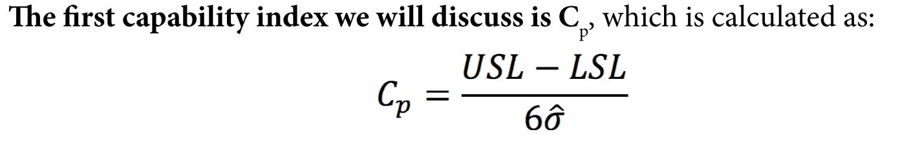

Figur : Cp (Leavengood & Reeb, 2015c, p. 4)

“σ is the process standard deviation and the ^ (hat or caret) symbol over it means “estimate.” Recall that σ is the true standard deviation for a normally distributed variable, and generally the best we can do is estimate it by sampling the process. The value 6 is the total width of process variability (that is, plus and minus three standard deviations). Therefore, Cp is a ratio of the specification width to total process width.” (Leavengood & Reeb, 2015c, p. 4)

“What does this mean? In simple terms, the higher the Cp equal to 1.0 means we are exactly on the specifications.” (Leavengood & Reeb, 2015c, p. 4)

“Cp is less than 1.0 so we know that process variability is too high and, therefore, the process is not capable of meeting the specifications.” (Leavengood & Reeb, 2015c, p. 4)

“Cp is a simple ratio that is relatively easy to calculate. Its primary limitation is that it does not account for process centering relative to the target. Theoretically, a manufacturing process could be centered far away from the target, perhaps even producing 100% defective product. Yet if the process variability were low, Cp would indicate everything was okay.” (Leavengood & Reeb, 2015c, p. 4)

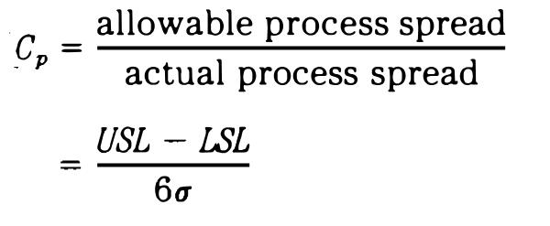

Figur : Formel Cp (Kane, 1986, p. 41)

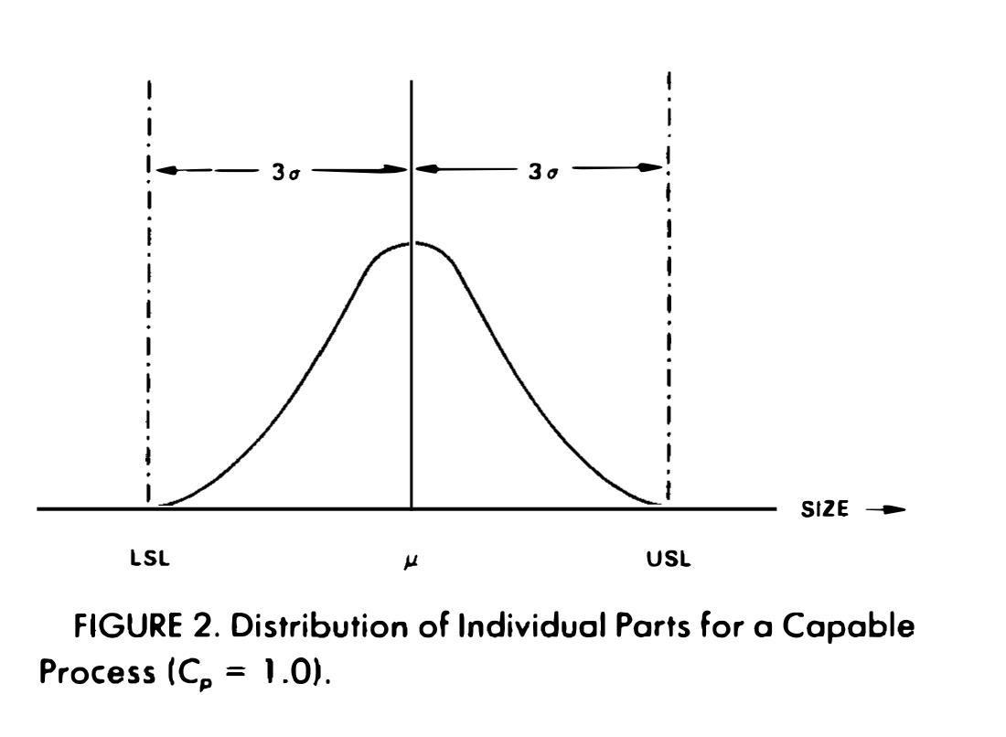

Figur : Cp = 1.0 (Kane, 1986, p. 42)

“Cp = 1.0 is generally not used as a minimally acceptable value.” (Kane, 1986, p. 42)

“A capable process with an underlying stable normal distribution will in theory result in 0.27% of parts beyond the specification limits. The benchmark of 1.0 was chosen to relate Cp to the standard six sigma spread used on control charts”. (Kane, 1986, p. 42)

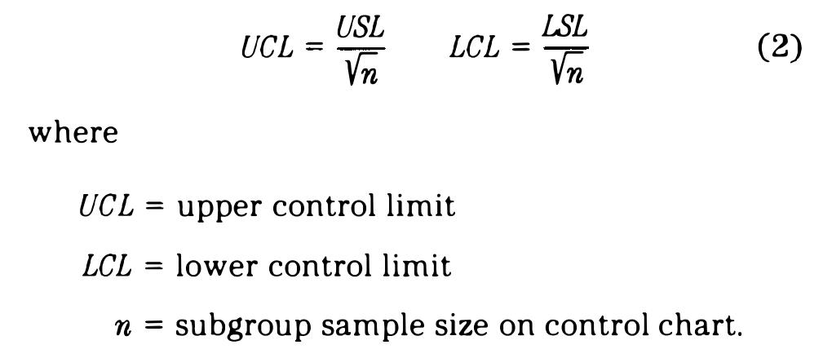

Figur : Hvis en prosess er eksakt kapabel er: (Kane, 1986, p. 42)

“A value of Cp = 1.33 is also often used to qualify machinery since long-term statistical control of a process is generally not established during qualification trials. Using 1.33 gives some assurance that a Cp = 1.0 will be possible when the additional sources of variation are experienced in production processing. It should be noted that it is seemingly more natural to use the traditional indicator” (Kane, 1986, p. 42)

“It is apparent that the GP index measures potential process performance since only the process spread is related to the specification limits” (Kane, 1986, p. 44)

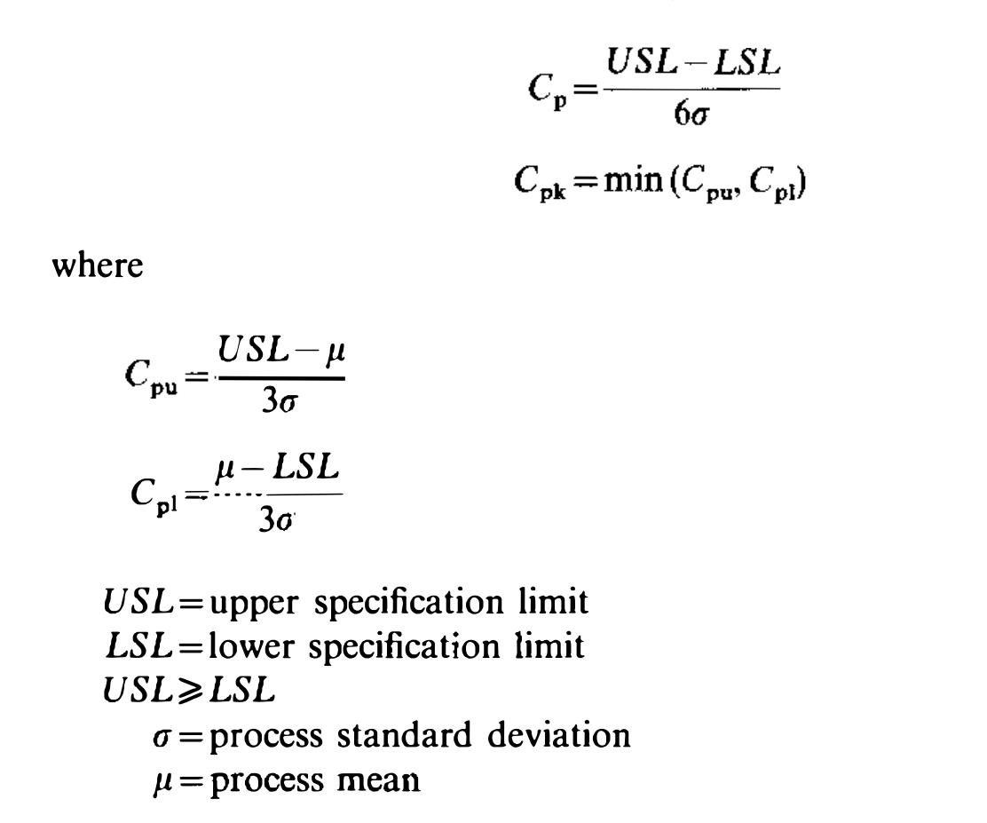

Figur : Formler Cp og Cpk (English & Taylor, 1993, p. 1622)

“As a rule of thumb, if the sample size, *n,* is between 30 and 50, it is reasonable that the use of Cp for process capability is fairly robust to departures from normality.” (English & Taylor, 1993, p. 1631)

“For example, Cp = 1.00 corresponds to %NC = 2700 ppm, and Cp = 1.33 corresponds to %NC = 63 ppm. Thus, the index Cp provides an exact measure of the actual process yield. Since Cp measures the magnitude of process variation. Cp may be viewed as aprocess precision index.” (Pearn, Kotz, & Johnson, 1992, p. 987)

“If for instance Cp = 11 and the process is centred then the proportion of nonconforming items is 0.27%, which often is regarded as “acceptably small”.” (Deleryd, 1999, p. 322)

### Cpk

“There is another process capability index known as Cpk that also accounts for centering.” (Leavengood & Reeb, 1999b, p. 8)

“**To account for process variability and centering relative to the target, we use another process capability index,** Cpk .” (Leavengood & Reeb, 2015c, p. 4)

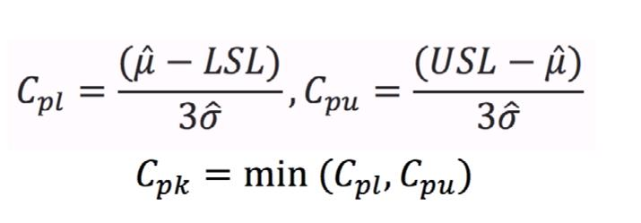

Figur : Cpk (Leavengood & Reeb, 2015c, p. 4)

“Cpk is interpreted much the same as Cp , Below 1.0 is bad and above 1.0 is good. However, Cpk provides a bit more information. If Cpl and Cpu are equal, we know the process is on target. And when the process is on target, Cp and Cpk are equal, we know the are the same.” (Leavengood & Reeb, 2015c, p. 4)

“What if we adjust the process to put it on target? In other words, what if we shift the process center from 6.5% to 6%? Because Cp does not account for prosess centering, it would not be affected. Cpk , however, would increase from 0.45 to 0.60. Remember, Cp and Cpk are the same when a process is on center.” (Leavengood & Reeb, 2015c, p. 5)

“the natural relationship between process potential, quantified by Cp , and process performance, quantified by Cpk” (Kane, 1986, p. 42)

“The Cpk index is related to the GP index, but utilizes the process mean and can be considered a measure of process performance” (Kane, 1986, p. 45)



Figur : Formler Cp og Cpk (English & Taylor, 1993, p. 1622)

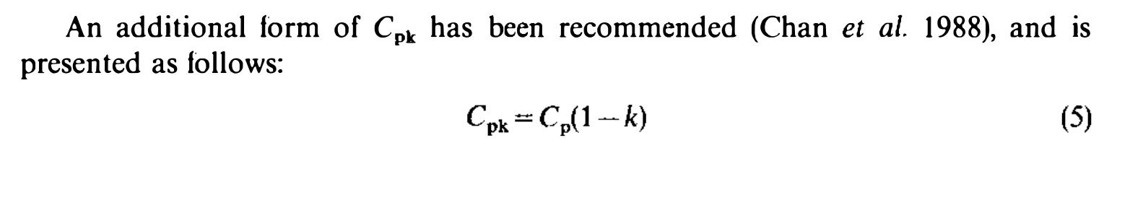

Figur : Alternativ formel for Cpk (English & Taylor, 1993, p. 1622)

In estimating **Cpk** using the alternative form, the parameter *k* is a random variable; therefore, when a process is not centred at the middle of the specification limits, the probability of observing a sample average greater than (or less than) the ***USL(LSL)*** is certainly not zero, and depending on the particular situation, could be significantly greater than zero. Therefore, the alternative form for c.k should be used with caution, realizing that the estimate of random variable *k* may exceed the limitations necessary for equivalence to c., by definition (English & Taylor, 1993, p. 1623)

“The Cpk ratio is more sensitive to departures from normality.” (English & Taylor, 1993, p. 1631)

“The process capability index *Cpk* measures the distance between the expected value of the studied characteristic, *my*, and the nearest specification limit and relates this distance to half the natural process spread, *3sigma*. The process capability index *Cpk is more* useful than *Cp* , from a practitioner’s point of view, since it can be used for characteristics where only one specification limit is relevant.” (Deleryd, 1999, p. 322)

### Cpm

Even though the process capability index *Cpk is* superior to *Cp* it has one disadvantage since it does not account for characteristics with a pre-established target value. To overcome this shortage of Cpk the process capability index Cpm was proposed independently by Hsiang and Taguchi [14] and Chan et al. [15]. (Deleryd, 1999, p. 322)

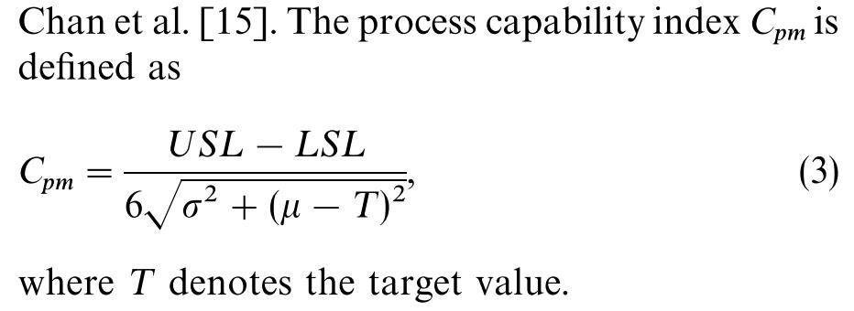

Figur : Cpm (Deleryd, 1999, p. 322)

“A well-known pioneer in the quality control, G. Taguchi, on the other hand, pays special attention on the loss in product’s worth when one of product’s characteristics deviates from the customers’ ideal value T. To take this factor into account, Hsiang and Taguchi (1985) introduced the index Cpm, which was also later proposed independently by Chan et al. (1988). The index is motivated by the idea of squared error loss and this lossbased process capability index Cpm, sometimes called the Taguchi index. The index is geared towards measuring the ability of a process to cluster around the target, and reflects the degrees of process targeting (centering).” (Wu et al., 2009, p. 339)

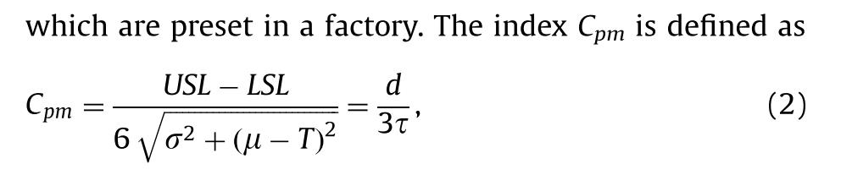

Figur : Cpm (Wu et al., 2009, p. 339)

### Cpmk

“Another version of Cpm which is based on the same idea as the development of Cpk from Cp is introduced by Pearn [16]. This process capability index is called Cpmk...” (Deleryd, 1999, p. 322)

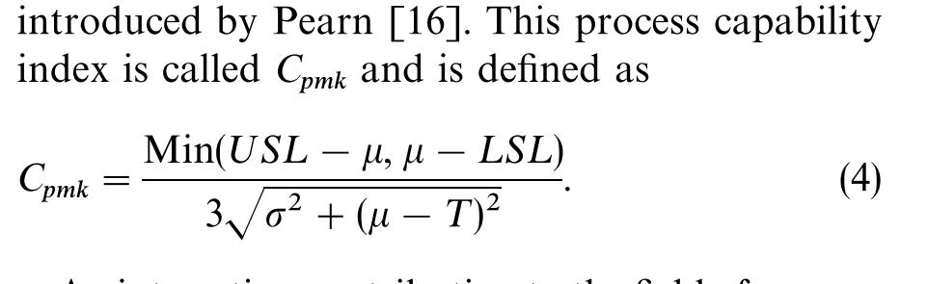

Figur : Cpmk (Deleryd, 1999, p. 322)

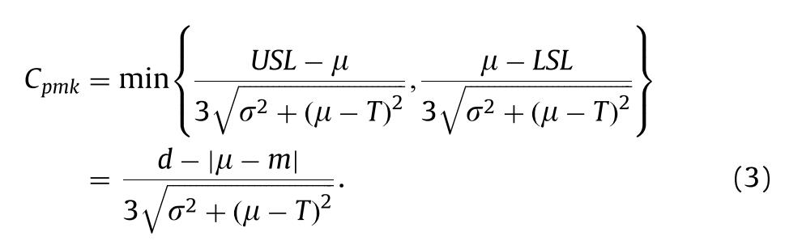

Figur : Cpmk (Wu et al., 2009, p. 339)

### Tolkning/effekt

“if we move from a Cpk of 0.45 to 0.77, what does that mean for the company’s defect rate, costs, and profitability?” (Leavengood & Reeb, 2015c, p. 5)

Experience to date has shown that there are poten­ tial problems in using Cpand *Cpk* on a routine basis. These drawbacks generally stem from users having an incomplete understanding of statistical principles rather than from problems with the indicies. Some of the drawbacks are described below:

(1) *Statistical Control* - There is a tendency to want to knw the capability of a process before statistical control has been established. Capability refers to a quantification of common cause variation and what can be expected from a process in the future.

...

(2) *Sampling Plan* - Clearly, values of the average range R, often used to estimate *sigma,* depend on the sampling plan. Thus, it could be argued that the value of a capability index could be made to change easily by merely changing the sampling plan.

...

(3) *Computation* - It is sometimes difficult to compute *Cp* and *Cpk* on the plant floor...

(4) *Nonnormality* - A variety of processes result in a nonnormal distribution for a charateristic. It is probably reasonable to expect that the capability indicies are somewhat sensitive to departures from normality. Data transformations may be useful to attain approximate normality.

...

(5) *Tool Wear* - ... (Kane, 1986, pp. 48–49)

“*Use* of *Cp* and *Cpk* establishes a common language that is dimensionless and assesses both the potential and actual performance of production processes.” (Kane, 1986, p. 49)

“Perhaps the greatest value of these indices is that their use encourages efforts to prevent production of nonconforming products and they provide a method to monitor continuous improvement on a broad scale.” (Kane, 1986, p. 51)

“ In classical PCA, it is traditionally accepted that a process is capable of meeting specifications if the designated process capability ratio is greater than or equal to one. ” (English & Taylor, 1993, p. 1624)

“The simulation results lead to several observations and conclusions. Specifically, the application of CP and Cpk for process capability analysis when departures from normality are experienced must be made carefully.” (English & Taylor, 1993, p. 1631)

“As demonstrated in Figs l and 3, the distributions of the estimated CP for the nonnormal processes approach that of the normal process as the sample size is increased.” (English & Taylor, 1993, p. 1631)

It is recommended that the analyst be sensitive to the process behaviour before using popular process capability indexes due to the lack of robustness to departures from normality. As a rule of thumb, CP may be used with reasonable assurance when the sample size is large (30-50), but the use of Cpk should be avoided when severe departures from normality are observed. It is also important to note that the processes considered here arc stationary (or in a state of statistical control). If doubt of such a conclusion exists, PCA is invalid. (English & Taylor, 1993, p. 1632)

To answer the question posed in the introduction: “Should they use process capability studies or not?”, the recommendation is “They should!”. But it must be done with care and based on a thorough understanding of how to conduct process capability studies, and the method should be used in symbiosis with other improvement methods, aimed at mastering variation in processes. (Deleryd, 1999, p. 329)

“Considerations of this kind may have played a part in motivating increases in the allowable lower bound for Cp above 1. Values of 1.33, 1.66, and "even 2.00" (Bothe (1999)) are becoming more and more common.” (Kotz & Johnson, 2002, p. 5)

“For example, the value 1 indicates that the process variability (or spread) utilizes the whole width of the specification interval (tolerance band). For an on-target normally distributed process, this would result in about 0.27% (2700 parts per million (ppm)) non-conforming units” (Wu et al., 2009, p. 340)

“The American giant corporation Motorola Inc. introduced their very popular six sigma (6–s) program which is equivalent to a defect rate of 3.4 ppm. This program corresponds to a Cp value of 2.0 or more and a Cpk value of 1.5 or more.” (Wu et al., 2009, p. 355)

### Loss function

“PCA indicates the ability of a process to satisfy customer specification limits, but it is perhaps more interesting to examine the costs associated with process variation. One means of examining these costs is the Taguchi quadratic loss function (Taguchi *et* 1989).” (English & Taylor, 1993, p. 1630)

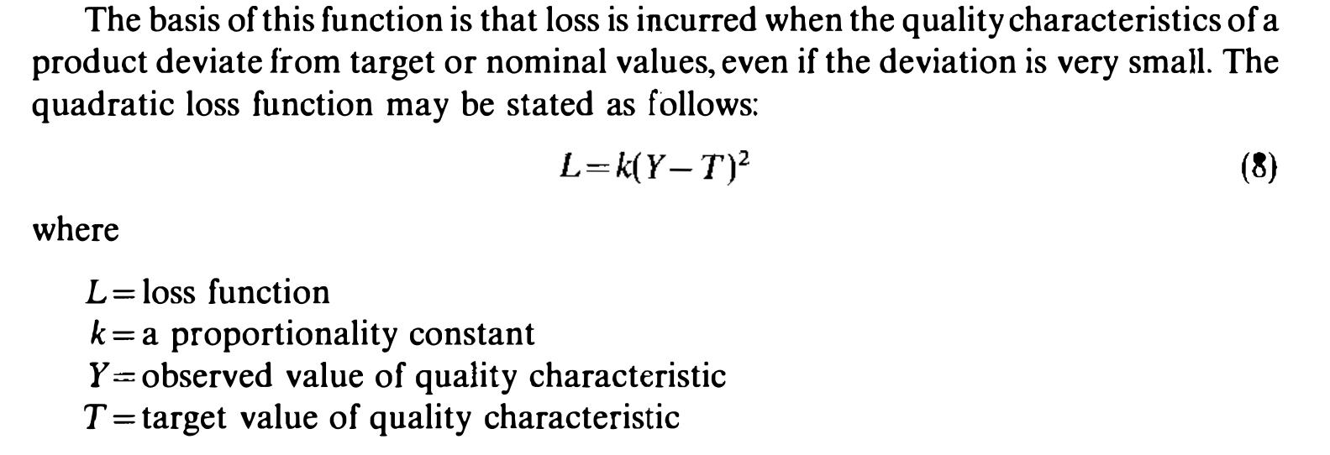

Figur : Loss function (English & Taylor, 1993, p. 1630)

### Ikke-normale data

“When the distribution of a process characteristic is non-normal, Cp and Cpk calculated using conventional methods often lead to erroneous interpretation of the process’s capability.” (Tang & Than, 1999, p. 339)

A widely accepted approach for PCI computation is to use a normal probability plot [13] so that the normality assumption can be verified simultaneously. Analogous to the normal probability plot, where the natural process width is between the 0.135 percentile and the 99.865 percentile, surrogate PCI values may be obtained via suitable probability plots: (Tang & Than, 1999, p. 340)

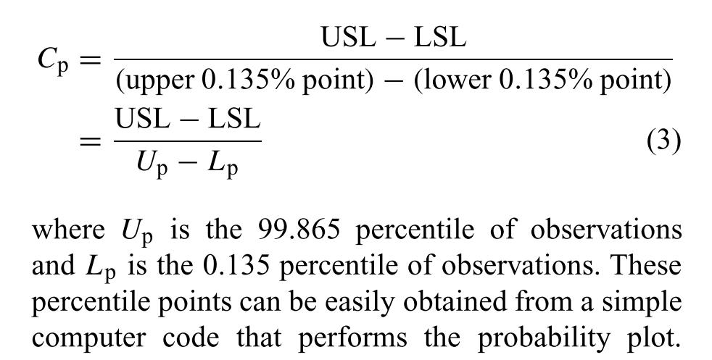

Figur : Surrogat Cp (Tang & Than, 1999, p. 340)

“From Tables 3–6 we observe that the performance of the transformation methods is consistently better than that of the non-transformation methods for all the different underlying non-normal distributions.” (Tang & Than, 1999, p. 346)

“Thus far, transformation methods seem to be adequate for handling non-normal data. The performance of the transformation methods is fairly consistent in terms of accuracy and precision.” (Tang & Than, 1999, p. 347)

“This suggests that transformation methods are not appropriate for small sample sizes.” (Tang & Than, 1999, p. 348)

“This has led us to suggest that the Box–Cox transformation is the preferred method for handling nonnormal data whenever a computer-assisted analysis is available.” (Tang & Than, 1999, p. 350)

“If the normality test shows that the transformed data is normally distributed, then one can apply statistical procedures to the transformed data in order to obtain useful information such as capability index values.” (Swamy, Nagesh, & Wooluru, 2016, p. 9)

# Forbedringsarbeid

“Product consistency is ensured by detecting and eliminating special-cause variation. Longterm quality improvement results from reducing common-cause variation.” (Leavengood & Reeb, 1999a)

“According to Dale (1990), more than 75 percent of suppliers to Ford Motor Company had encountered difficulties in the successful introduction of SPC programmes. There are many reasons for failure:

...

- Lack of management commitment

- Lack of education and training

- Inadequate measuring system

- Lack of knowledge of what to monitor and measure

- Lack of communication between engineers, managers and operators”

NB! >Referansen i sitatet er feil, det skal være Dale et al (1990), se Mendeley (Antony et al., 2000, p. 243)

“However, a recent study carried out by one of the authors of this paper (Mason and Antony, 2000) found that the only thing taught to engineering students within many UK academic institutions in relation to SPC is control charting of processes. Very little, if any, time is spent on management and implementation aspects of SPC.” (Antony et al., 2000, p. 244)

“Goh et al. (1998) recommend a very powerful approach for prioritising processes in complicated production systems prior to implementing SPC. They suggest a preliminary selection of key processes from a larger number of processes based on statistical and technical criticality. This should be followed by the use of a powerful method called analytic hierarchy process (AHP) based on pair-wise comparisons between several factors in deciding the relative criticality of the processes in a hierarchy structure.” (Antony et al., 2000, p. 245)

“Quality characteristics can be any of the following types (Antony and Kaye, 1999):

- smaller-the-better quality characteristics (e.g. tool wear, surface roughness, response time to customer complaints, etc.);

- larger-the-better quality characteristics (e.g. pull strength, life of components, engine efficiency, etc.);

- target-the-best quality characteristics (e.g. dimensions such as diameter, thickness, width, weight, density, etc.);

-attribute quality characteristics (defective/non-defective, good/bad, pass/fail, etc.).” (Antony et al., 2000, p. 245)

“However. in addition to identifying special cause variation, a control chart can be a useful vehicle to evaluate the effectiveness of a change. Thus, when determining the impact of a process change, it may be helpful to maintain the control limits and center line from the old process and continue to plot the new process data points on the control chart.” (Amin, 2001, p. 3)

“In quality improvement, the purpose of data collection and analysis is not to set blame but to assist improvement efforts. The purpose is not to prove but to improve.” (Alemi & Sullivan, 2001, p. 58)

“Interventions in a research study or change ideas in a quality improvement project are deliberate attempts to introduce special causes of variation.” (J. C. Benneyan et al., 2003, p. 459)

“If a different level of performance is wanted in the future, we must intervene and introduce a change in the process—that is, a special cause. If we simply want to sustain the current level of performance, special causes of variation must be prevented or eliminated.” (J. C. Benneyan et al., 2003, p. 459)

“But change does not always mean improvement.” (Thor et al., 2007, p. 387)

“Are we improving? This is a question we should be asking and answering more frequently. Run and control charts are at the heart of this method.” (Neuhauser & Diaz, 2007, p. 79)

“**Testing a process change (looking for a special cause)**

Next plot the post-change data. Using the old control limits and centre line look for a special cause. If you detect a special cause it is a sign that the process has measurably changed.” (NHS, 2009, p. 27)

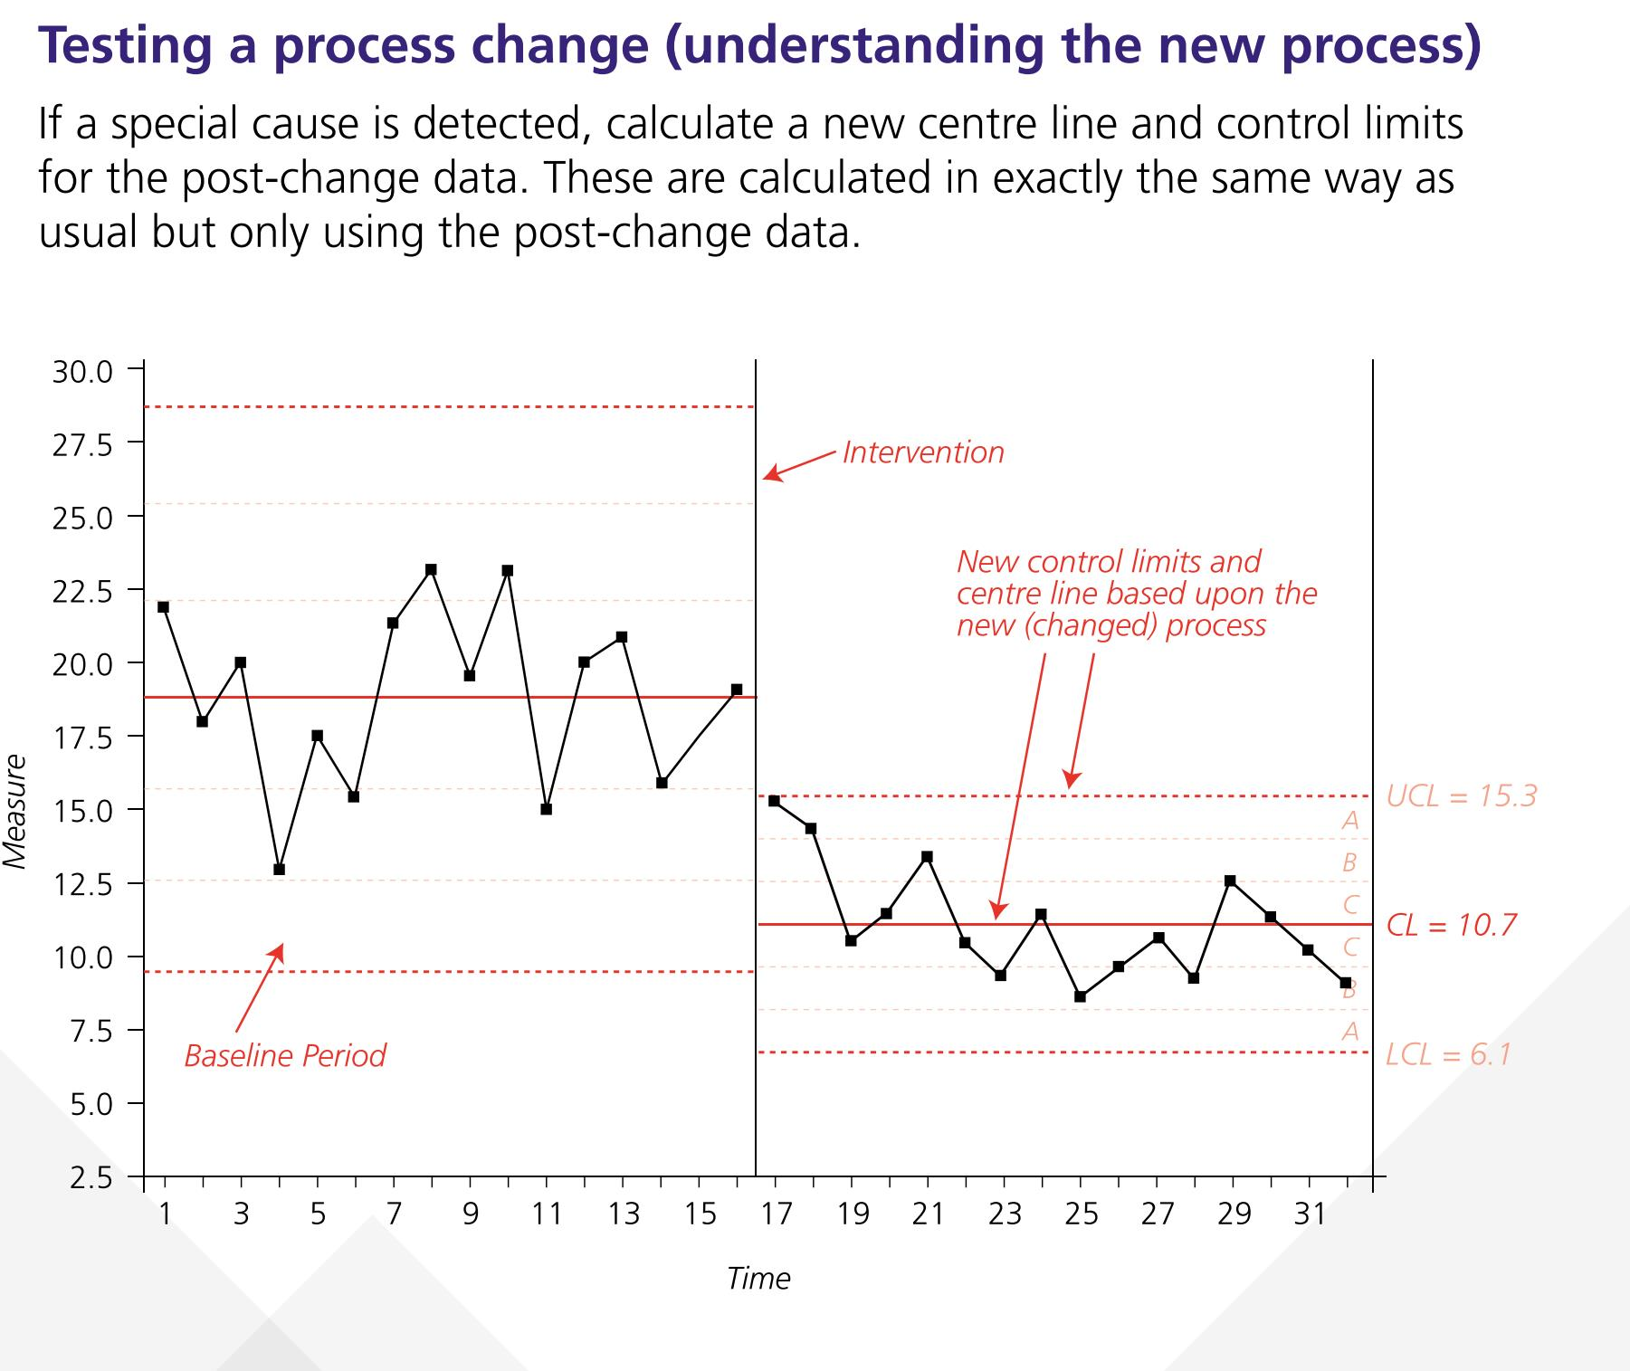

Figur : Prosessendring (NHS, 2009, p. 28)

“Ofte søger man med forbedringstiltag netop at introducere særlig variation i den ønskede retning, f.eks. reduktion af mortalitet. I andre tilfælde er ønsket en stabilisering af den proces, der er målet for forbedringsinitiativet.” (Anhøj & Bjørn, 2009, p. 1767)

“SPC gør det muligt at dokumentere, hvornår en forandring er en forbedring.” (Lauritsen & Packness, 2010, p. 8)

“En indikator er kort defineret: »En målbar variabel, der anvendes til at overvåge og evaluere kvaliteten«. Indikatorer anvendes til at monitorere og evaluere kvaliteten af fx ledelse, kliniske funktioner eller støttefunktioner, der påvirker behandlingsresultatet. Traditionelt har indikatorer været delt i disse typer (eksempel):

• Struktur (fx antal fysioterapeuter i en afdeling eller MR skanning +/-)

• Proces (andel rettidigt fremsendte epikriser)

• Resultat (mortalitet, morbiditet, funktionsstatus, livskvalitet, patienttilfredshed)” (Lauritsen & Packness, 2010, p. 13)

“Regardless of which framework is chosen for a quality improvement project, the measurement of data changes is essential to establish if an intervention leads to change. In addition, quality improvement best practices focus on establishing the baseline performance of a process before formulating and implementing an intervention.” (Reynolds et al., 2021, p. 199)

“The goal with quality improvement is not to see if the data are different after the intervention; it is to see if the data are different because of the intervention.” (Reynolds et al., 2021, pp. 202–203)

“The effort to provide quality products passes through four phases. The first phase is to simply "make a part to print" where inspection is commonly used in go, no-go screening to hopefully ensure that all parts are within the engineering print specification limits. The second phase is the use of control charts to establish the stability of processes. The third phase is to minimize variability to enhance the uniformity of products. The ideas of defect prevention (i.e., preventing nonconforming parts from occurring) and continuous improvement are part of this phase. The fourth phase is to use enhanced process capability to target the means of processes to optimize product function, or more traditionally, to minimize cost (e.g., assembly time). The last phase is no less significant than its predecessors.” (Kane, 1986, p. 46)

## Forutsetninger

“Juran asserts that to be held accountable for minimizing the variation in the outcome of a process, the workers must 1. know what they are supposed to do (that is, have training and guidelines that cover every conceivable situation), 2. know how they are doing (have clear and instantaneous feedback that always alerts them when something has or is about to go wrong), and 3. be able to regulate the process (have complete control over the various people, machines, mate-” (Plsek, 1992, p. 67)

“Deming (1993) states that in his experience 94% of troubles—and therefore the most possibilities for improvement—belong to the system, which is the responsibility of management. The remaining 6% are attributable to special causes (see “Philosophy of SPC,” above), of which production personnel control only a small percentage.” (Leavengood & Reeb, 1999a, p. 8)

“Many people new to SPC are surprised to discover that there’s no direct connection between an in-control process and meeting specifications. Isn’t a stable process a guarantee that we will meet customer expectations? Unfortunately, the answer is no. An in-control process can produce defective product if the process is off-target or if the common-cause variability is too high.” (Leavengood & Reeb, 1999b, p. 8)

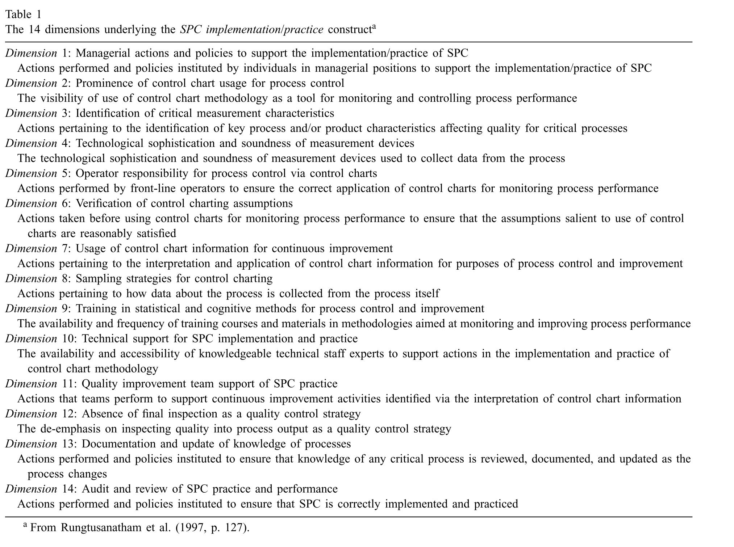

Figur : Dimensions of SPC implementation (Rungtusanatham, 2001, p. 655)

## Pareto

“Pareto analysis, a tool we can use to help decide how and where to begin using SPC.” (Leavengood & Reeb, 2002a)

“Prioritizing quality problems for the company is a good first step. Then, determine which projects will have the highest return on investment and therefore should be the initial focus of quality improvement programs. Pareto analysis enables us to do all this.” (Leavengood & Reeb, 2002a)

“Quality expert J.M. Juran applied the principle to quality control and found that 80% of problems stem from 20% of the possible causes. The numbers 80 and 20 are not meant to be absolutes. The main point, as Juran stated, is that we should focus on the “vital few” problems (those in the 20% category) rather than on the “trivial many” to make the most significant improvements in product quality.” (Leavengood & Reeb, 2002a)

“Pareto charts are the graphical tool used in Pareto analysis. A Pareto chart is a bar chart that displays the relative importance of problems in a format that is very easy to interpret. The most important problem (for example, the one highest in cost, frequency, or some other measurement) is represented by the tallest bar, the next most important problem is represented by the next tallest bar, and so on.” (Leavengood & Reeb, 2002a)

“Frequency, however, is not the only important consideration. Certain types of non-conformities, even if infrequent, may be very costly to scrap or rework. Therefore, Pareto analysis should take into account both cost and frequency.” (Leavengood & Reeb, 2002a)

“Paretoprinsippet er at grovt sett er omlag 20 % av feilene årsak til om lag 80 % av problemene. Hvis man går inn og forbedrer faktorer som har liten innvirkning på totalresultatet, risikerer man å bruke mye ressurser med liten effekt.” (Nyen, 2009, p. 14)

“Pareto diagrammer er ikke i sig selv SPC diagrammer, men kan give vigtig information, når der skal prioriteres ændringer.” (Lauritsen & Packness, 2010, p. 43)

## Flowcharts

“Pareto analysis as a tool to locate the primary causes of nonconformities and therefore where to focus initial efforts. Now we need to know which specific activities in the process cause the nonconformity and which quality characteristic(s) to monitor.” (Leavengood & Reeb, 2002b)

“Cause-and-effect diagrams are commonly used to identify specific activities responsible for causing nonconformities.” (Leavengood & Reeb, 2002b)

“people often are surprised to learn of the differences between the ideal process flow and what actually occurs in the mill.” (Leavengood & Reeb, 2002b)

“If detail is sufficient, flowcharts can help to reveal non-value-added activities such as inspection, rework, redundant steps, movement, unnecessary processing loops, and bottlenecks. From the standpoint of SPC, flowcharts also help to reveal the stages in the process where data may be collected.” (Leavengood & Reeb, 2002b)

“Montgomery suggests several ways to eliminate non-value-added activities.

1. Rearrange the sequence of worksteps.
2. Rearrange the physical location of the operator in the system.
3. Change work methods.
4. Improve supervisio
5. Change the type of equipment used in the process.
6. Redesign forms and documents for more efficient use. ees (flowcharts are goo
7. Improve operator training.”

• Improve supervision. • Identify more clearly the function of the process to all employees • Consolidate process steps. (flowcharts are good visual aids for explaining the process to employees). A ll flh (Fi 2) lk

• Eliminate unnecessary steps.

• Eliminate unnecessary steps. i

• Consolidate process steps. (Leavengood & Reeb, 2002b)

## Cause and effect

“our prior efforts have helped us identify what the problem is and where it might be occurring in the process. We still do not know, however, what to do to solve the problem because we do not know what might be causing the problem.” (Leavengood & Reeb, 2009, p. 1)

“Perhaps most importantly, using a team to develop a CE diagram can help to avoid the all-too-common challenge of pet theories. Pet theories might arise when someone asserts that he or she already knows the cause of a problem.” (Leavengood & Reeb, 2009, p. 2)

## Eksperimenter

“Why not simply tweak the process and see what happens? In fact, companies do this all the time. In an effort to save time and money, manufacturers often test numerous variables at the same time and observe a limited number of results. Without DOE (and statistics), interpreting the results is often challenging, particularly when several variables have been tested. For example, if moisture content, tooling, species, and feed speed were all varied, how could you tell which variable or combination of variables affected the results? If the factors were varied one at a time in several individual experiments, how would you know if certain factors interacted (e.g., one set of tooling works well with one species but not with another)?” (Leavengood & Reeb, 2011, p. 3)

DOE involves the following steps:

1. Objectives

2. Response variables

3. Process variables (factors)

4. Number of replicates

5. Detailed experimental plan

6. Factors to be held constant

7. Post-experiment plans (Leavengood & Reeb, 2011, p. 4)

“Often, the best approach is to rely on employees to guide selection of the factors on the basis of their experiences.” (Leavengood & Reeb, 2011, p. 4)

References

Alemi, F., & Oliver, D. W. (2001). Tutorial in Risk-Adjusted P-charts. *Quality Management in Health Care*, *10*(1), 1–9.

Alemi, F., Rom, W., & Eisenstein, E. (1996). Risk-adjusted control charts for health care assessment. *Annals of Operations Research*, *67*(1), 45–60. https://doi.org/10.1007/BF02187023

Alemi, F., & Sullivan, T. (2001). Tutorial on Risk Adjusted X-Bar Charts: Applicatins to Measurement of Diabetes Control. *Auality Management in Health Care*, *9*(3), 57–65.

Amin, S. G. (2001). Control charts 101: A guide to health care applications. *Quality Management in Health Care*, *9*(3), 1–27. https://doi.org/10.1097/00019514-200109030-00003

Anhøj, J., & Bjørn, B. (2009). Statistisk processtyring i sundhedsvæsenet. *Ugeskr Læger*, *171*(21), 1764–1768.

Antony, J., Balbontin, A., & Taner, T. (2000). Key ingredients for the effective implementation of statistical process control. *Work Study*, *49*(6), 242–247. https://doi.org/10.1108/00438020010343417

Benneyan, J. C. [J. C.], Lloyd, R. C., & Plsek, P. E. [P. E.] (2003). Statistical process control as a tool for research and healthcare improvement. *Quality & Safety in Health Care*, *12*(6), 458–464. https://doi.org/10.1136/qhc.12.6.458

Benneyan, J. C. [James C.] (1998a). Statistical Quality Control Methods in Infection Control and Hospital Epidemiology, Part I: Introduction and Basic Theory. *Infection Control and Hospital Epidemiology*, *19*(3), 194–214. https://doi.org/10.2307/30143442

Benneyan, J. C. [James C.] (1998b). Statistical Quality Control Methods in Infection Control and Hospital Epidemiology, Part II: Chart Use, Statistical Properties, and Research Issues. *Infection Control and Hospital Epidemiology*, *19*(4), 265–283. https://doi.org/10.1017/S0195941700087397

Deleryd, M. (1999). A pragmatic view on process capability studies. *International Journal of Production Economics*, *58*(3), 319–330. https://doi.org/10.1016/S0925-5273(98)00214-X

English, J. R., & Taylor, G. D. (1993). Process capability analysis - a robustness study. *International Journal of Production Research*, *31*(7), 1621–1635.

Fasting, S., & Gisvold, S. E. (2003). Statistical process control methods allow the analysis and improvement of anesthesia care. *Canadian Journal of Anaesthesia = Journal Canadien D'anesthesie*, *50*(8), 767–774. https://doi.org/10.1007/BF03019371

Hart, M. K., Lee, K. Y., & Robertson, J. W. (2003). Application of Attribute Control Charts to Risk-Adjusted Data for Monitoring and Improving Health Care Performance. *Quality Management in Health Care*, *12*(1), 5–19.

Hart, M. K., Robertson, J. W., Hart, R. F., & Lee, K. Y. (2004). Application of Variables Control Charts to Risk-adjusted Time-ordered Healthcare Data. *Quality Management in Health Care*, *13*(2), 99–119.

Hossain, M. M., Prybutok, V. R., Abdullah, A., & Talukder, M. (2010). The development and research tradition of statistical quality control. *International Journal of Productivity and Quality Management*, *5*(1), 21. https://doi.org/10.1504/IJPQM.2010.029505

Howard, D. (2003). *The Basics of Statistical Process Control & Process Behaviour Charting*. Chislehurst. Retrieved from Management-NewStyle website: https://nzbef.org.nz/wp-content/uploads/2019/05/Guide-Statistical-Process-Control.pdf

Jaffray, B. (2020). Am I out of control? The application of statistical process control charts to children's surgery. *Journal of Pediatric Surgery*, *55*(9), 1691–1698. https://doi.org/10.1016/j.jpedsurg.2019.12.027

Kane, V. E. (1986). Process Capability Indices. *Journal of Quality Technology*, *18*(1), 41–52. https://doi.org/10.1080/00224065.1986.11978984

Kotz, S., & Johnson, N. L. (2002). Process Capability Indices—A Review, 1992–2000. *Journal of Quality Technology*, *34*(1), 2–19. https://doi.org/10.1080/00224065.2002.11980119

Lauritsen, J., & Packness, A. (2010). *SPC – Statistisk Proces Kontrol: Introduktion og håndbog. SPC Diagrammer og analyse med brug af EpiData*. Retrieved from Region Syddanmark, Odense Universitetshospital og Center for Kvalitet website: www.centerforkvalitet.dk/spc.

Leavengood, S., & Reeb, J. E. (1999a). *Statistical Process Control: Part 1: An Introduction* (Oregon State University Extension Service (EM 8726)). Retrieved from Oregon State University website: https://catalog.extension.oregonstate.edu/em8726

Leavengood, S., & Reeb, J. E. (1999b). *Statistical Process Control: Part 2: How and Why SPC Works* (Oregon State University Extension Service (EM 8733)). Retrieved from Oregon State University website: https://catalog.extension.oregonstate.edu/em8733

Leavengood, S., & Reeb, J. E. (2002a). *Statistical Process Control: Part 3: Pareto Analysis and Check Sheets* (Oregon State University Extension Service (EM 8771)). Retrieved from Oregon State University website: https://catalog.extension.oregonstate.edu/em8771

Leavengood, S., & Reeb, J. E. (2002b). *Statistical Process Control: Part 4: Flowcharts* (Oregon State University Extension Service (EM 8772)). Retrieved from Oregon State University website: https://catalog.extension.oregonstate.edu/em8772

Leavengood, S., & Reeb, J. E. (2009). *Statistical Process Control: Part 5: Cause-and-Effect Diagrams* (Oregon State University Extension Service (EM 8984)). Retrieved from Oregon State University website: https://catalog.extension.oregonstate.edu/em8984

Leavengood, S., & Reeb, J. E. (2011). *Statistical Process Control: Part 6: Design of Experiments* (Oregon State University Extension Service (EM 9045)). Retrieved from Oregon State University website: https://catalog.extension.oregonstate.edu/em9045

Leavengood, S., & Reeb, J. E. (2015a). *Statistical Process Control: Part 7: Variables Control Charts* (Oregon State University Extension Service (EM 9109)). Retrieved from Oregon State University website: https://catalog.extension.oregonstate.edu/em9109

Leavengood, S., & Reeb, J. E. (2015b). *Statistical Process Control: Part 8: Attributes Control Charts* (Oregon State University Extension Service (EM 9110)). Retrieved from Oregon State University website: https://catalog.extension.oregonstate.edu/em9110

Leavengood, S., & Reeb, J. E. (2015c). *Statistical Process Control: Part 9: Process Capability Analysis* (Oregon State University Extension Service (EM 9111)). Retrieved from Oregon State University website: https://catalog.extension.oregonstate.edu/em9111

Mohammed, M. A. [M. A.], Worthington, P., & Woodall, W. H. (2008). Plotting basic control charts: Tutorial notes for healthcare practitioners. *Quality & Safety in Health Care*, *17*(2), 137–145. https://doi.org/10.1136/qshc.2004.012047

Mohammed, M. A. [Mohammed A.], Cheng, K. K., Rouse, A., & Marshall, T. (2001). Bristol, Shipman, and clinical governance: Shewhart's forgotten lessons. *The Lancet*, *357*(9254), 463–467. https://doi.org/10.1016/S0140-6736(00)04019-8

Neuhauser, D. [D.], & Diaz, M. (2007). Quality improvement research: Are randomised trials necessary? *Quality & Safety in Health Care*, *16*(1), 77–80. https://doi.org/10.1136/qshc.2006.021584

NHS (2009). *A guide to creating and interpreting run and control charts*. Retrieved from NHS Institute for Innovation and Improvement website: https://www.england.nhs.uk/improvement-hub/wp-content/uploads/sites/44/2017/11/A-guide-to-creating-and-interpreting-run-and-control-charts.pdf

Nolan, T., & Provost, L. (1990). Understanding Variation. *Quality Progress*, *23*(5), 70–78.

Nyen, B. (2009). *Forbedringsarbeid og Statistisk Prosesskontroll (SPC)*. Retrieved from Nasjonalt kunnskapssenter for helsetjenesten website: https://www.helsebiblioteket.no/kvalitetsforbedring/kvalitetsmaling/statistisk-prosesskontroll

Pearn, W. L., Kotz, S., & Johnson, N. L. (1992). Distributional and Inferential Properties of Process Capability Indices. *Journal of Quality Technology*, *24*(4), 216–231. https://doi.org/10.1080/00224065.1992.11979403

Plsek, P. E. [Paul E.] (1992). Tutorial. *Quality Management in Health Care*, *1*(1), 65–74. https://doi.org/10.1097/00019514-199223000-00010

Qiu, P., & Li, Z. (2011). On Nonparametric Statistical Process Control of Univariate Processes. *Technometrics*, *53*(4), 390–405. https://doi.org/10.1198/TECH.2011.10005

Reynolds, M. S., Spencer, S. P., Dunaway, A., Buckingham, D., & Bartman, T. (2021). Scientific Approach to Assess if Change Led to Improvement-Methods for Statistical Process Control Analysis in Quality Improvement. *Journal of Emergency Nursing*, *47*(1), 198–205. https://doi.org/10.1016/j.jen.2020.09.002

Rungtusanatham, M. (2001). Beyond improved quality: the motivational effects of statistical process control. *Journal of Operations Management*, *19*(6), 653–673. https://doi.org/10.1016/S0272-6963(01)00070-5

Sachlas, A., Bersimis, S., & Psarakis, S. (2019). Risk-Adjusted Control Charts: Theory, Methods, and Applications in Health. *Statistics in Biosciences*, *11*(3), 630–658. https://doi.org/10.1007/s12561-019-09257-z

Solodky, C., Hengang, C., Jones, P. K., Katcher, W., & Neuhauser, D. [Duncan] (1998). Patients as Partners in Clinical Research: A Proposal for Applying Quality Improvement Methods to Patient Care. *Medical Care*, *36*(8), AS13-AS20.

Swamy, R. R., Nagesh, P., & Wooluru, Y. (2016). Process Capability Indices for Non-Normal Distribution - A Review. In R. Jagadeesh, R. Todalbagi, & G. Srilakshminarayana (Eds.), *Towards Operational Excellence* (pp. 1–13). SDM Research Center for Management Studies (SDM RCMS), SDMIMD.

Tang, L. C., & Than, S. E. (1999). Computing process capability indices for non-normal data: a review and comparative study. *Quality and Reliability Engineering International*, *15*(5), 339–353. https://doi.org/10.1002/(SICI)1099-1638(199909/10)15:5<339::AID-QRE259>3.0.CO;2-A

Thor, J., Lundberg, J., Ask, J., Olsson, J., Carli, C., Härenstam, K. P., & Brommels, M. (2007). Application of statistical process control in healthcare improvement: Systematic review. *Quality & Safety in Health Care*, *16*(5), 387–399. https://doi.org/10.1136/qshc.2006.022194

Wu, C.‑W., Pearn, W. L., & Kotz, S. (2009). An overview of theory and practice on process capability indices for quality assurance. *International Journal of Production Economics*, *117*(2), 338–359. https://doi.org/10.1016/j.ijpe.2008.11.008