Simulation data

Centerline described by
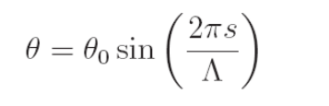

with θ₀ = 10 degrees (low sinuosity) and Λ = 250 m.

****
Flow = 20.0 m³/s
Width = 30.0 m
Valley slope = 0.001134
Initial perturbation velocity = 0.0
Initial curvature = 0.0
Sediment size = 0.2 m (looks high but is the usual thing that using Engelund-Hansen formula requires using high sediment size values to have reasonable friction coefficient). For the valley slope, with sediment size = 0.2 m

Depth = 0.896 m
Velocity =0.744 m/s
Cf = 0.018

and that Cf corresponds, for that depth, to a Manning’s coefficient of 0.042.

****

Method = "Migration coefficient"
Migration coefficient = 0.0000003

****

Duration = 100.0 years
Number iterations = 500

