MATH 252 QUIZ 5 KEY

For problems 1 and 2, use 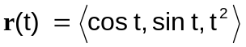 (4 pts each)

1. Find the velocity vector at 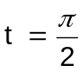.
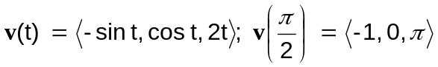

2. Find the acceleration vector at .

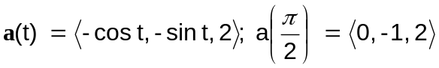

For problems 3 and 4, a projectile is fired at a speed of 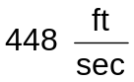 at an angle of 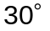 from a tower 512 feet above the ground. (6 pts each)

3. Give the position vector for any time t.

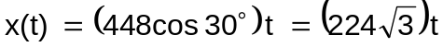
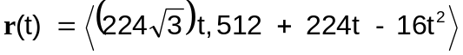

4. How far away will the object strike?

The object will hit the ground when 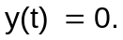
seconds
