MATH 252 QUIZ 5 NAME________________
FALL 2017 ID #_________

Show all work and indicate all solutions on the quiz.

For problems 1 and 2, use 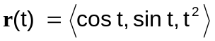 (4 pts each)

1. Find the velocity vector at 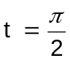.

2. Find the acceleration vector at .

For problems 3 and 4, a projectile is fired at a speed of 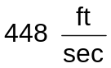 at an angle of 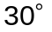 from a tower 512 feet above the ground. (6 pts each)

3. Give the position vector for any time t.

4. How far away will the object strike?

