MATH 252 QUIZ 6 KEY

Use 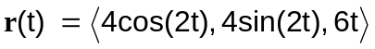 for each problem

1. Find 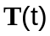 (7 pts)

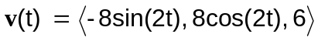
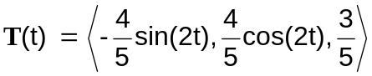

2. Find 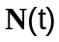 (7 pts)

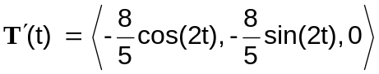
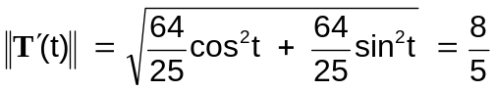
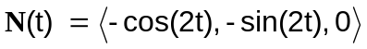

3. Find curvature (6 pts)

