MATH 252 QUIZ 6 NAME________________
FALL 2017 ID #_________

Show all work and indicate all solutions on the quiz.

Use 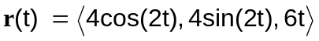 for each problem

1. Find 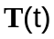 (7 pts)

2. Find 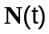 (7 pts)

3. Find curvature (6 pts)

