MATH 252 QUIZ 7 KEY

1. Find the tangential and normal components of acceleration for the curve 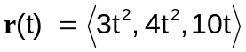 at 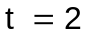 and express in terms of  (20 pts)

