MATH 252 QUIZ 7 NAME________________
FALL 2017 ID #_________

Show all work and indicate all solutions on the quiz.

1. Find the tangential and normal components of acceleration for the curve 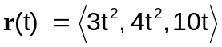 at 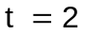 and express in terms of  (20 pts)

