MATH 252 PRACTICE TEST 1 KEY

For problems 1-7 use 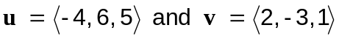 to find each of the following.

1.

2. 

3. 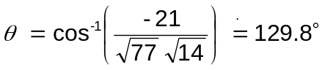

4. 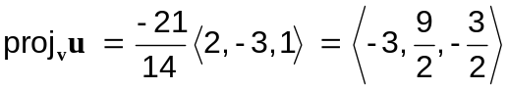

5. 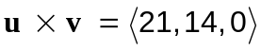

For problems 6-9, use

6. Find an equation of the plane passing through the points

7. Find parametric equations for the line through P and parallel to 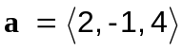

8. Find the distance from the point 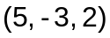 to the plane.

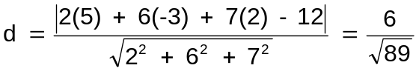

9. Find the area of the parallelogram determined by P, Q and R

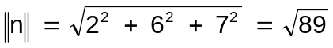

For problems 10-13 identify each surface.

10. 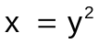 parabolic cylinder

11. 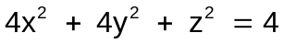 circular ellipsoid

12. 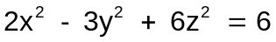 hyperboloid of one sheet

13. 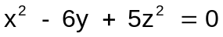 elliptical cone

For problems 14-17, a baseball is thrown from the stands 128 ft above the field at an angle of 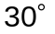 up from the horizontal with an initial speed of 64 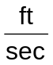.

14.. Give the position vector for any time t.

15. When will the ball strike the ground?

The ball will strike the ground when seconds

16. How far away will the ball strike the ground?

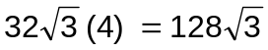 feet

17. What is the speed of the ball when it strikes the ground?

For problems 18-21, use 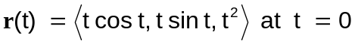

18.

19. Find 

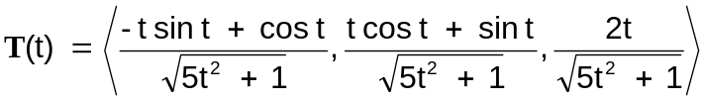
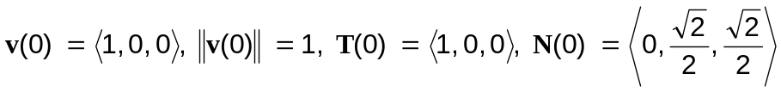

20. Find K; Using 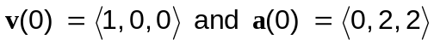
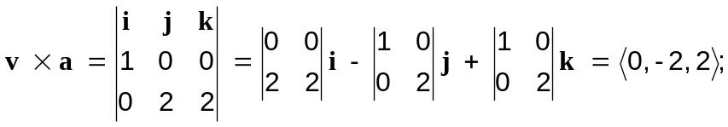
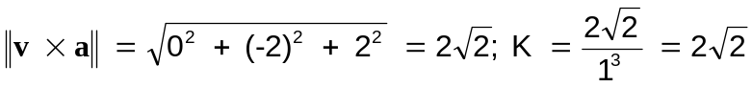

21. Write 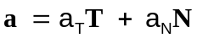 by finding 