MATH 252 PRACTICE TEST 1 FALL 2017

For problems 1-7 use 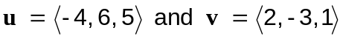 to find each of the following.

1. 

2. Find

3. the angle between 

4. Find 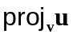

5. Find

For problems 6-9, use

6. Find an equation of the plane passing through the points

7. Find parametric equations for the line through P and parallel to 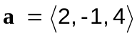

8. Find the distance from the point 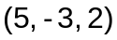 to the plane.

9. Find the area of the parallelogram determined by P, Q and R

For problems 10-13 identify each surface.

10. 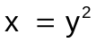

11. 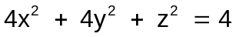

12. 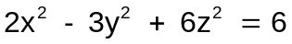

13. 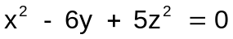
For problems 14-17, a baseball is thrown from the stands 128 feet above the field at an angle of 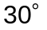 up from the horizontal with an initial speed of 64 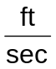.
14.. Give the position vector for any time t.

15. When will the ball strike the ground?

16. How far away will the ball strike the ground?

17. What is the speed of the ball when it strikes the ground?

For problems 18-21, use 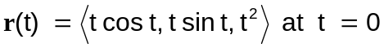

18. Find 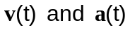

19. Find 

20. Find K

21. Write 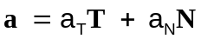 by finding 