**Nils Sommer**

Fabrikstrasse 8, 3012 Bern

nils.sommer@unibe.ch

**Data Science Project**

**SatisMap: Mapping Well-Being in Switzerland**

**Project Report**

**15 June 2023**

# Abstract

The project SatisMap is an interactive web application mapping and displaying various measures of well-being in Switzerland. With the data from the Swiss Household Panel [1], the application displays average levels of well-being in psychological and sociological domains per Canton for the year 2020. Moreover, SatisMap displays the associations of various demographical and well-being variables. This report gives an overview of the data and data models for this project and documents the web-application.

# Table of Contents

**Abstract 1**

**Table of Contents 2**

**1 Project Objectives 3**

**2 Methods 3**

**3 Data 4**

**4 Metadata 6**

**5 Data Quality 6**

**6 Data Flow 6**

**7 Data Model 7**

**8 Risks 8**

**9 Preliminary Studies 9**

**10 Conclusions 11**

**References and Bibliography 12**

# 1 Project Objectives

The goal of this project was to create a web application that lets users interactively view a map of well-being of adults in Switzerland in the year 2020 (SatisMap). The application describes and shows various forms of well-being from psychological (e.g., self-reported life satisfaction, affect, or self-efficacy) and sociological (e.g., education, income, work status domains. On top of descriptively showing average values of these well-being measures per canton, the application variably displays associations of well-being with possible predictors and / or criteria of well-being (e.g., demographics or well-being measures from other domains).

The data used for all these analyses stems from the Swiss Household Panel (SHP) [1]. The SHP is an ongoing panel study that investigates households and individuals since 1998.

The web application SatisMap can be an important asset to get an overview of different domains of well-being in Switzerland. Governments (federal, cantonal, and municipal) can find starting points to initiate actions to promote well-being. SatisMap helps researchers to explore well-being and to build their hypotheses. And finally, SatisMap can be an interesting application to the general populace interested in well-being in Switzerland.

# 2 Methods

SatisMap was created using R software [2] as well as several specific R-packages. To name two of high importance, the packages tmap [3] (used to create maps in R) and shiny [4] (used to create web applications in R) were used. Webhosting of the final application is carried by Shinyapps [5], a basic but scalable hosting service for Shiny applications.

The following statistical analyses were conducted during this project and in the final application. To display overall associations, Spearman-Correlations were used.

Shiny

Github <https://github.com/nilssommer1/SatisMap>

# 3 Data

## 3.1 Data Origin

The data used for this project stems from the SHP [1], retrieved from SWISSUbase [6]. The SHP is “is a household panel study that follows a random sample of households resident in Switzerland over time” and aims to “observe social change, in particular, the dynamics of changing living conditions and social representations in the population of Switzerland” (SHP-Userguide, Page 5) [7]. In the SHP, representative households and their members are regularly interviewed about various topics concerning their daily lives. This includes several measures of the domains of well-being stated above, but also extensive data on demographics, work, finances, and so forth. Currently, 22 Waves of interviews are provided, conducted in consecutive years from 1999 to 2020. In the SHP, the relevant data is divided into 2 master files (describing households and individuals) and 44 annual files (one household and one individual file per wave) [7]. For the SatisMap-application, only the most recent wave of interviews conducted in the year 2020 was used.

In accordance with the license agreement with the SHP [1], the raw data is not to be transmitted to third parties and was therefore stored exclusively on a personal, password protected cloud. No personal information of the participants of the SHP are included in the data and therefore no such data will be included in the final application.

To create maps in R, some basic geospatial data of Switzerland and its cantons is required. This data was retrieved from the Website of the Federal Statistical Office [8].

## 3.2 Metadata & Data Quality

Metadata in great detail (such as in the SHP Userguide [7]) concerning the SHP-data is available at SWISSUbase [7] free of charge, however requiring a license agreement to access it. Metadata concerning calculations and programming of the web application is stored in a GitHub repository [9] and will be publicly available in the form of R-scripts.

To achieve the goals of this project, data needs to be representative for the Swiss Population. Aside from a representative initial Sampling the SHP provides mathematical weights to adjust results for low response rates and high attrition rates [7]. The SHP also conducts primary data cleaning before releasing the data [7].

## 3.3 Data Flow

Figure 4 displays the data flow for this project. Data was initially retrieved from SWISSUbase (SHP data) [6] and the Federal Statistical Office (geospatial data) [8] and was then stored in a personal cloud. These data files were combined to a data frame in R. From there, the web application is created, and the data is analyzed to be displayed as maps according to user input. Users can manipulate the options in the web application and renew the analyses according to their input. The live web-application is hosted by Shinyapps [5].

Ein Bild, das Screenshot, Text, Schrift, Design enthält.

**Figure 4.** Data flow of the project SatisMap.

## 3.5 Preprocessing

In figures 1 to 3, exemplary data is displayed from the most recent wave of interviews conducted in the year 2020. Only adults (16 years or older) are included. In Figure 3, one exemplary measure of well-being, life satisfaction, is depicted.

## 3.6 Data Description

Survey Questions and Response Scales are depicted in Table A1 in the Appendix.

**Table 2.** Sample sizes, means, standard deviations, and questionnaire descriptions of analyzed variables.

|  |  |  |  |
| --- | --- | --- | --- |
| **Categorical Variables** | ***n*** | ***n*0** | ***n*1** |
| Sex | 20839 | 10190 | 10649 |
| Work status | 10601 | 284 | 10238 |
| **Numeric Variables** | ***n*** | ***M*** | ***SD*** |
| Age | 20839 | 48.69 | 19.01 |
| Life Satisfaction | 15399 | 8.12 | 1.42 |
| Satisfaction with relationships (general) | 15327 | 8.22 | 1.50 |
| Happiness with partner | 11863 | 8.65 | 1.47 |
| Satisfaction with health | 15390 | 7.81 | 1.75 |
| Satisfaction with studies | 1337 | 7.53 | 1.69 |
| Satisfaction with finances | 15255 | 7.26 | 2.18 |
| Satisfaction with job | 10218 | 7.95 | 1.54 |
| Satisfaction with free time | 15204 | 7.37 | 2.42 |
| Satisfaction with democracy | 14914 | 6.87 | 1.91 |
| Negative emotions | 15341 | 2.19 | 2.19 |
| Positive emotions | 15343 | 7.05 | 1.87 |
| Women penalized | 15048 | 5.56 | 2.49 |
| Own sex penalized | 15092 | 2.12 | 2.64 |
| Importance of promotion of women | 14912 | 6.34 | 2.79 |
| Education | 17573 | 3.44 | 1.12 |
| Socioeconomic status | 9313 | 6.37 | 2.64 |
| Individual income (year) | 13092 | 72042.32 | 69395.08 |
| Household income (year) | 17246 | 142018.65 | 98399.30 |
| Number of own kids | 15002 | 1.46 | 1.27 |

In figures 1 to 3, exemplary data is displayed from the most recent wave of interviews conducted in the year 2020. Only adults (16 years or older) are included. In Figure 3, one exemplary measure of well-being, life satisfaction, is depicted.

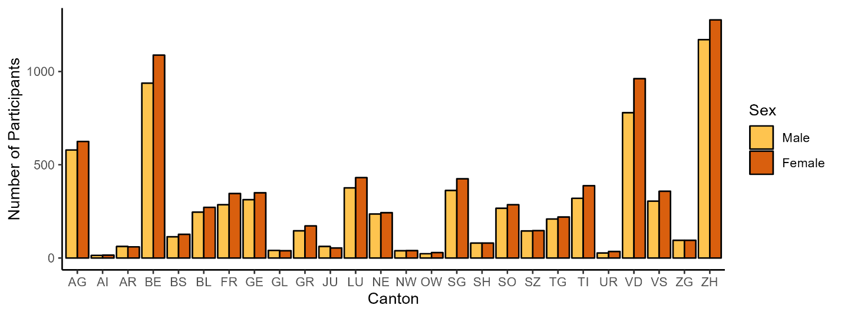

**Figure 1.** Participants by canton and sex.

SHP wave 22 (2020), n = 15399.

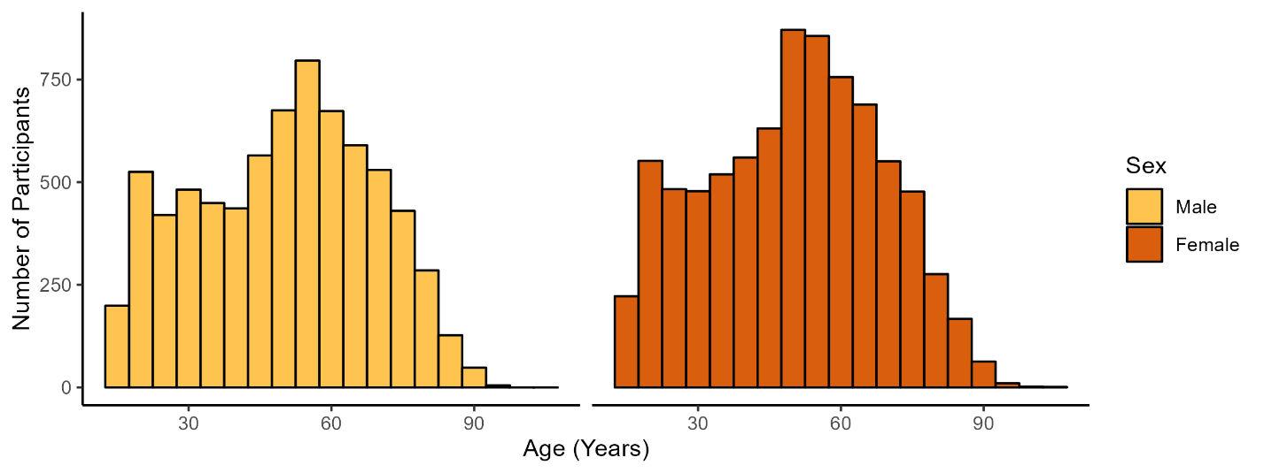

**Figure 2.** Participants by age and sex.

SHP wave 22 (2020), n = 15399.

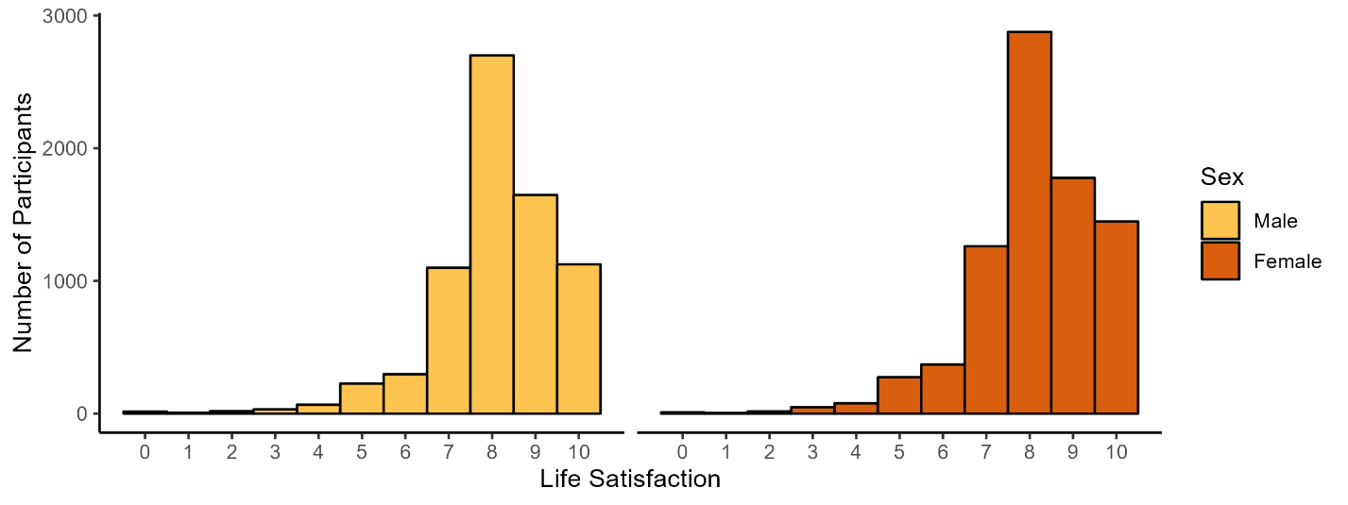

**Figure 3.** Life satisfaction by sex.

SHP wave 22 (2020), n = 15399. Life satisfaction measured globally with one question: ‘In general, how satisfied are you with your life if 0 means "not at all satisfied" and 10 means "completely satisfied"?’

# 4 Documentation of the Web-Application

Preliminary examples for maps depicting well-being in Switzerland using the SHP data and the R-package tmap [3] are displayed below. Guidance for this preliminary programming was found in the book “Geocomputation with R” by Robin Lovelace and colleagues [10].

Figures 7 and 8 depict static maps of life satisfaction in the Swiss cantons for men and women, respectively. Figure 9 depicts a screenshot of an interactive map, based on the static map in figure 7 (life satisfaction of women). It is visually evident that satisfaction levels differ to a high amount between cantons and between men and women (see for example cantons Uri and Nidwalden).

Ein Bild, das Karte enthält.

**Figure 7.** Life satisfaction per canton (men).

SHP wave 22 (2020), n = 7235. Life satisfaction measured globally with one question: ‘In general, how satisfied are you with your life if 0 means "not at all satisfied" and 10 means "completely satisfied"?’

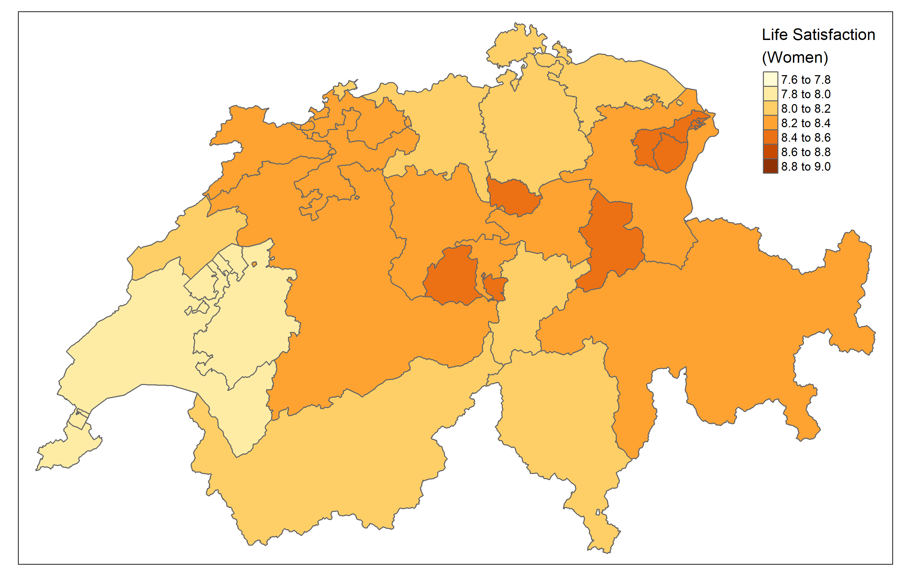

**Figure 8.** Life satisfaction per canton (women).

SHP wave 22 (2020), n = 8164. Life satisfaction measured globally with one question: ‘In general, how satisfied are you with your life if 0 means "not at all satisfied" and 10 means "completely satisfied"?’

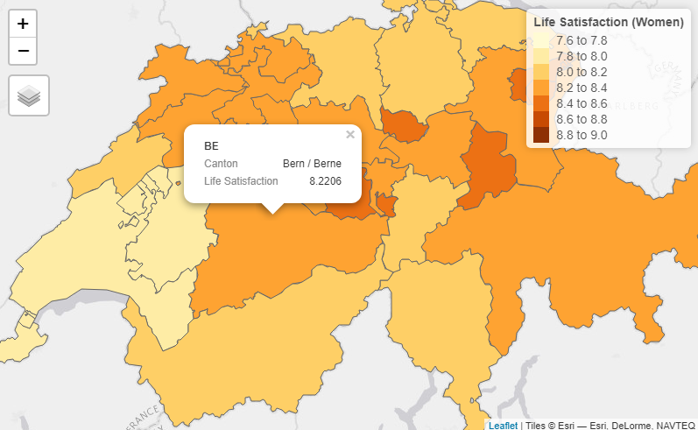

**Figure 9.** Life satisfaction per canton (women).

Screenshot taken from the interactive version of the map in figure 7. Created with tmap [3].

# 5 Conclusion and outlook

The development of SatisMap is still at an early stage, however, the outlined project plan and the preliminary results and graphs look promising. Satismap can be an important asset to explore well-being in Switzerland for governments, researchers, and the general population.

# References and Bibliography

[1] Swiss Household Panel; Lausanne: FORS ([https://forscenter.ch/projekte/swiss-household-panel/](https://forscenter.ch/projekte/swiss-household-panel/?lang=de))

[2] The R Project for Statistical Computing (<https://www.r-project.org/>)

[3] M. Tennekes; tmap: Thematic maps in R; Journal of Statistical Software, 84(6), 1–39; 2018 (doi:10.18637/jss.v084.i06.; <https://r-tmap.github.io/tmap/>)

[4] Shiny; Rstudio (<https://shiny.rstudio.com/>)

[5] Shinyapps; Rstudio (<https://www.shinyapps.io/>)

[6] SWISSUbase; Lausanne: FORS (<https://www.swissubase.ch/en/>)

[7] M. Vorpostel et al.; Swiss Household Panel Userguide (1999-2020), Wave 22, January 2022; Lausanne: FORS; 2021

[8] Generalisierte Gemeindegrenzen: Geodaten; Federal Statistical Office, Switzerland (<https://www.bfs.admin.ch/bfs/en/home/services/geostat/swiss-federal-statistics-geodata/administrative-boundaries/generalized-boundaries-local-regional-authorities.assetdetail.22484210.html>)

[9] GitHub (<https://github.com/>)

[10] R. Lovelace et al.; Geocomputation with R; 2022 (<https://geocompr.robinlovelace.net/references.html>)

# Appendix

**Table A1.** Survey questions and response scales of the analyzed variables.

| **Categorical Variables** | **Survey Question** | **Scale** |
| --- | --- | --- |
| Sex | - | 0 "Male" and 1 "Female" |
| Work status | - | 0 "unemployed" and 1 "occupied" |
| Age | - | Age in years |
| Life satisfaction | In general, how satisfied are you with your life? | From 0 "not at all satisfied" to 10 "completely satisfied" |
| Satisfaction with relationships (general) | How satisfied are you with your personal, social and family relationships? | From 0 "not at all satisfied" to 10 "completely satisfied" |
| Happiness with partner | In general, how happy are you in your current couple relationship? | From 0 "very unhappy" to 10 "very happy" |
| Satisfaction with health | How satisfied are you with your state of health? | From 0 "not at all satisfied" to 10 "completely satisfied" |
| Satisfaction with studies | Can you indicate your degree of satisfaction with the studies you are currently engaged in? | From 0 "not at all satisfied" to 10 "completely satisfied" |
| Satisfaction with finances | Overall how satisfied are you with your financial situation? | From 0 "not at all satisfied" to 10 "completely satisfied" |
| Satisfaction with job | In general, how satisfied are you with your job? | From 0 "not at all satisfied" to 10 "completely satisfied" |
| Satisfaction with free time | How satisfied are you with the amount of free time you have? | From 0 "not at all satisfied" to 10 "completely satisfied" |
| Satisfaction with democracy | Overall, how satisfied are you with the way in which democracy works in our country? | From 0 "not at all satisfied" to 10 "completely satisfied" |
| Negative emotions | Do you often have negative feelings such as having the blues, being desperate, suffering from anxiety or depression | From 0 "never" to 10 "always" |
| Positive emotions | Are you often plenty of strength, energy and optimism? | From 0 "never" to 10 "always" |
| Women penalized | Do you have the feeling that in Switzerland women are penalized compared with men in certain areas? | From 0 "not at all penalized" to 10 "strongly penalized" |
| Own sex penalized | Do you, in your everyday life, feel penalized compared with the opposite sex? | From 0 "not at all penalized" to 10 "strongly penalized" |
| Importance of promotion of women | Are you in favour of Switzerland taking more steps to ensure the promotion of women? | From 0 "not at all in favour" to 10 "totally in favour" |
| Education | *International Standard Classification of Education ISCED 1997* | 0 "Not completed primary (compulsory) education";  1 "Primary or first stage of basic education";  2 "Lower secondary or Second stage of basic education";  3 "Upper secondary education";  4 "Post-secondary education non tertiary (preparation for an institution for higher education)"; 5 "First stage of tertiary education";  6 "Second stage of tertiary education" |
| Socioeconomic status |  | 1 "Routine";  2 "Lower technical";  3 "Lower sales and service";  4 "Lower supervisors and technicians";  5 "Small employers and self-employed (agriculture)";  6 "Small employers and self-employed (non-agriculture)";  7 "Intermediate occupations";  8 "Lower mgrs/professionals, higher supervisory/technicians"; 9 "Large employers, higher mgrs/professionals" |
| Individual income (year) |  | Yearly income in CHF |
| Household income (year) |  | Yearly income in CHF |
| Number of own kids |  | Number of own kids born |