metin içeren bir resim

Açıklama otomatik olarak oluşturuldu



**EE463 STATIC POWER CONVERSION I**

**Homework 2: DC/DC CONVERTERS**

**Team Members:** İrem Bayın 2304145 ; Nilsu Bora 2304186

**Deadline:** 18/01/2023 23:59

**Lecturer:** Assoc. Prof. Ozan Keysan

**Assistant:** Ogün Altun

# INTRODUCTION

In this homework, Buck and Boost converters which are DC/DC converters, will be examined. The continuous current mode, power in the ideal case, and nonidealities in the real world will be examined for both converter types.

# SOLUTIONS

1. **Buck Converter**

**a)**

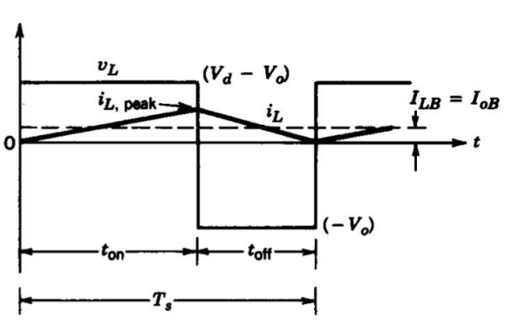

Figure 1: VL and IL graph for transition to the discontinuous current mode

In Figure 1, the boundary output current graph for DCM can be seen.

Since this boundary means that the minimum current, we need to find the lower value. So that input voltage is chosen 12V for the calculation.

**b)**

**c)**

**d)**

**e)**

**f)**

1. **Boost Converter**

**a)**

**b)**

**c)**

**d)**

**e)**

**f)**

**g)**

# CONCLUSION

# APPENDIX