



Essay / Assignment Title: Visualization and Story Telling Using Tableau

Programme title: Visual and Analytical Exploration of Store Sales Data Using Tableau

Name: Nilsu Gungor

Year: 2025

CONTENTS

INTRODUCTION
MATERIALS AND METHODS
RESULTS
DISCUSSION
CONCLUDING REMARKS
BIBLIOGRAPHY

Statement of compliance with academic ethics and the avoidance of plagiarism

I honestly declare that this dissertation is entirely my own work and none of its part has been copied from printed or electronic sources, translated from foreign sources and reproduced from essays of other researchers or students. Wherever I have been based on ideas or other people texts I clearly declare it through the good use of references following academic ethics.
(In the case that is proved that part of the essay does not constitute an original work, but a copy of an already published essay or from another source, the student will be expelled permanently from the postgraduate program).

Name and Surname (Capital letters):

..................................NILSU GUNGOR.....................................................................................................

Date: .........04.............../....10....../........2025.

INTRODUCTION

For this assignment, I will explore and analyze a dataset from a multinational fashion retailer to show sales performance, customer behavior, and product trends. My aim is to identify key insights such as top-selling products, customer segments, and the impact of discounts on sales and also make predictions.
I worked with the Global Fashion Retail Analytics Dataset, which contains two years of simulated sales data from 35 stores across seven countries. This dataset includes information on customers, products, stores, employees, and discounts, which allowes me to create visualizations and dashboards to understand patterns and trends across different regions.

MATERIALS AND METHODS

ABOUT THE DATASET
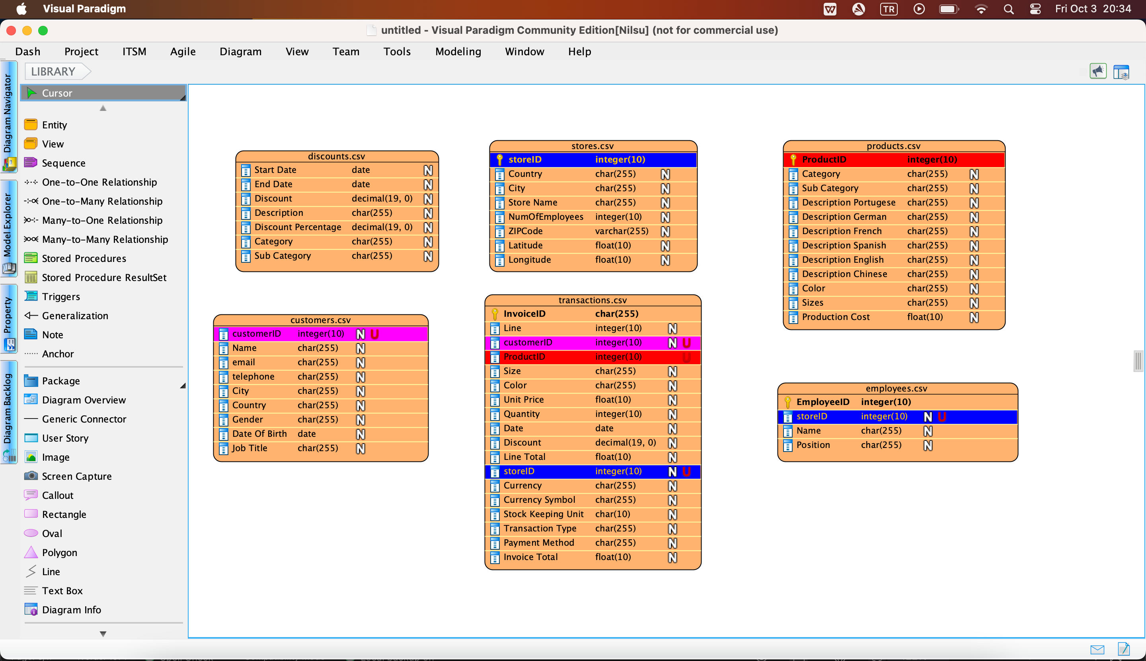

Figure: Chosen Dataset visualized in Visual Paradigm
-I highlighted all the unique keys to see the relationships between different kinds of entities.
The dataset that I chose for this assignment is the Global Fashion Retail Analytics Dataset, which contains two years of semi-simulated sales data for a multinational fashion retailer. It has over 4 million transactions from 35 stores across seven countries and multiple currencies (USD, EUR, CNY, GBP).
It gives us information on customers, products, stores, employees, and discounts. Customer data includes demographics and purchasing behavior, while product data includes category, subcategory, size, and color. Store and employee data allow analysis of performance, and discount information enables studying the effect of promotions on sales.
The dataset is synthetic, that means that all personal information is anonymized for privacy, but it still hints realistic retail patterns. It also has some intentional inconsistencies to make data exploration more realistic.
Basically, this dataset gives us the opportunity to analyze sales trends, customer behavior, product performance, and multi-region comparisons, making it a good choice for building visualizations and dashboards.
Dataset structure:
Dataset has multiple csv files, which are connected to each other with the transactions.csv file because all the unique keys of the other files are already in the transactions.csv file. That is why, this is how I approached making the logical table on Tableau:
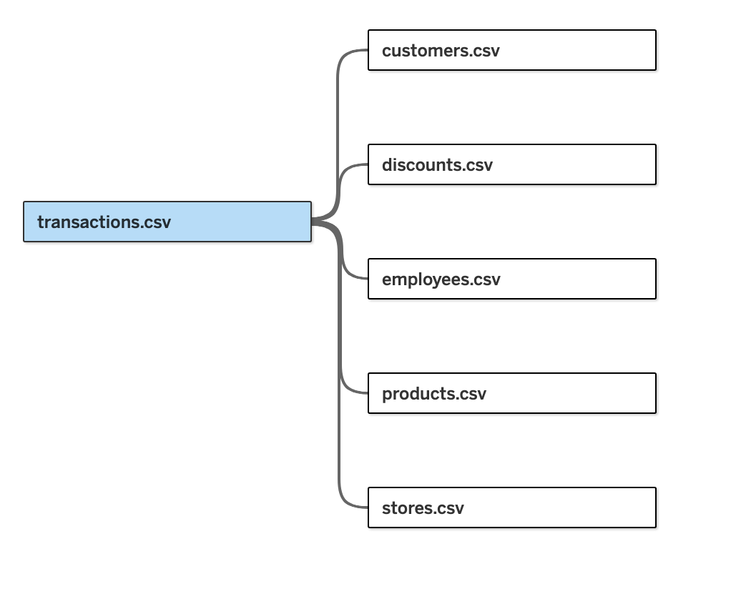
Figure: Tableau Logical Structure of the dataset
I started by looking at the excel sheets of each file to understand the data types. Categorical fields in the dataset are: Category, Sub Category, Color, and Country. Numerical fields are: Line Total, Quantity, and Unit Price. Temporal fields are: Date. Geographical fields are: Store City and Store Country.
While exploring the data, I noticed that some fields had missing values. For example, the Color field had many missing entries. I decided not to remove them for the initial visualizations; instead, I allowed Tableau to display them as NULL values so I could still include all transactions in my analysis.
I also did some basic exploring of the data to understand it better. I looked at summary statistics and checked for outliers in numerical fields. Then, I created some simple Tableau visualizations; bar charts for top-selling categories, histograms for product prices and quantities, line charts to see monthly sales trends, and maps to look at sales across different countries. These helped me notice patterns such as seasonal peaks in sales, which categories sell more, and differences in performance between regions.

RESULTS

INITIAL TABLEAU VISUALIZATIONS
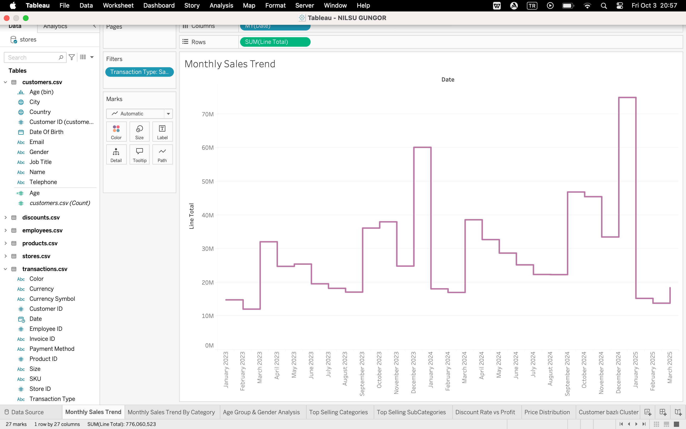
Figure: Monthly Sales Trend
I created a line chart to show the monthly sales trend. I customized the Date and converted it to Month/Year format for this. In the graph, we can clearly see that sales peaked in December in all years. This could be related to Christmas shopping.
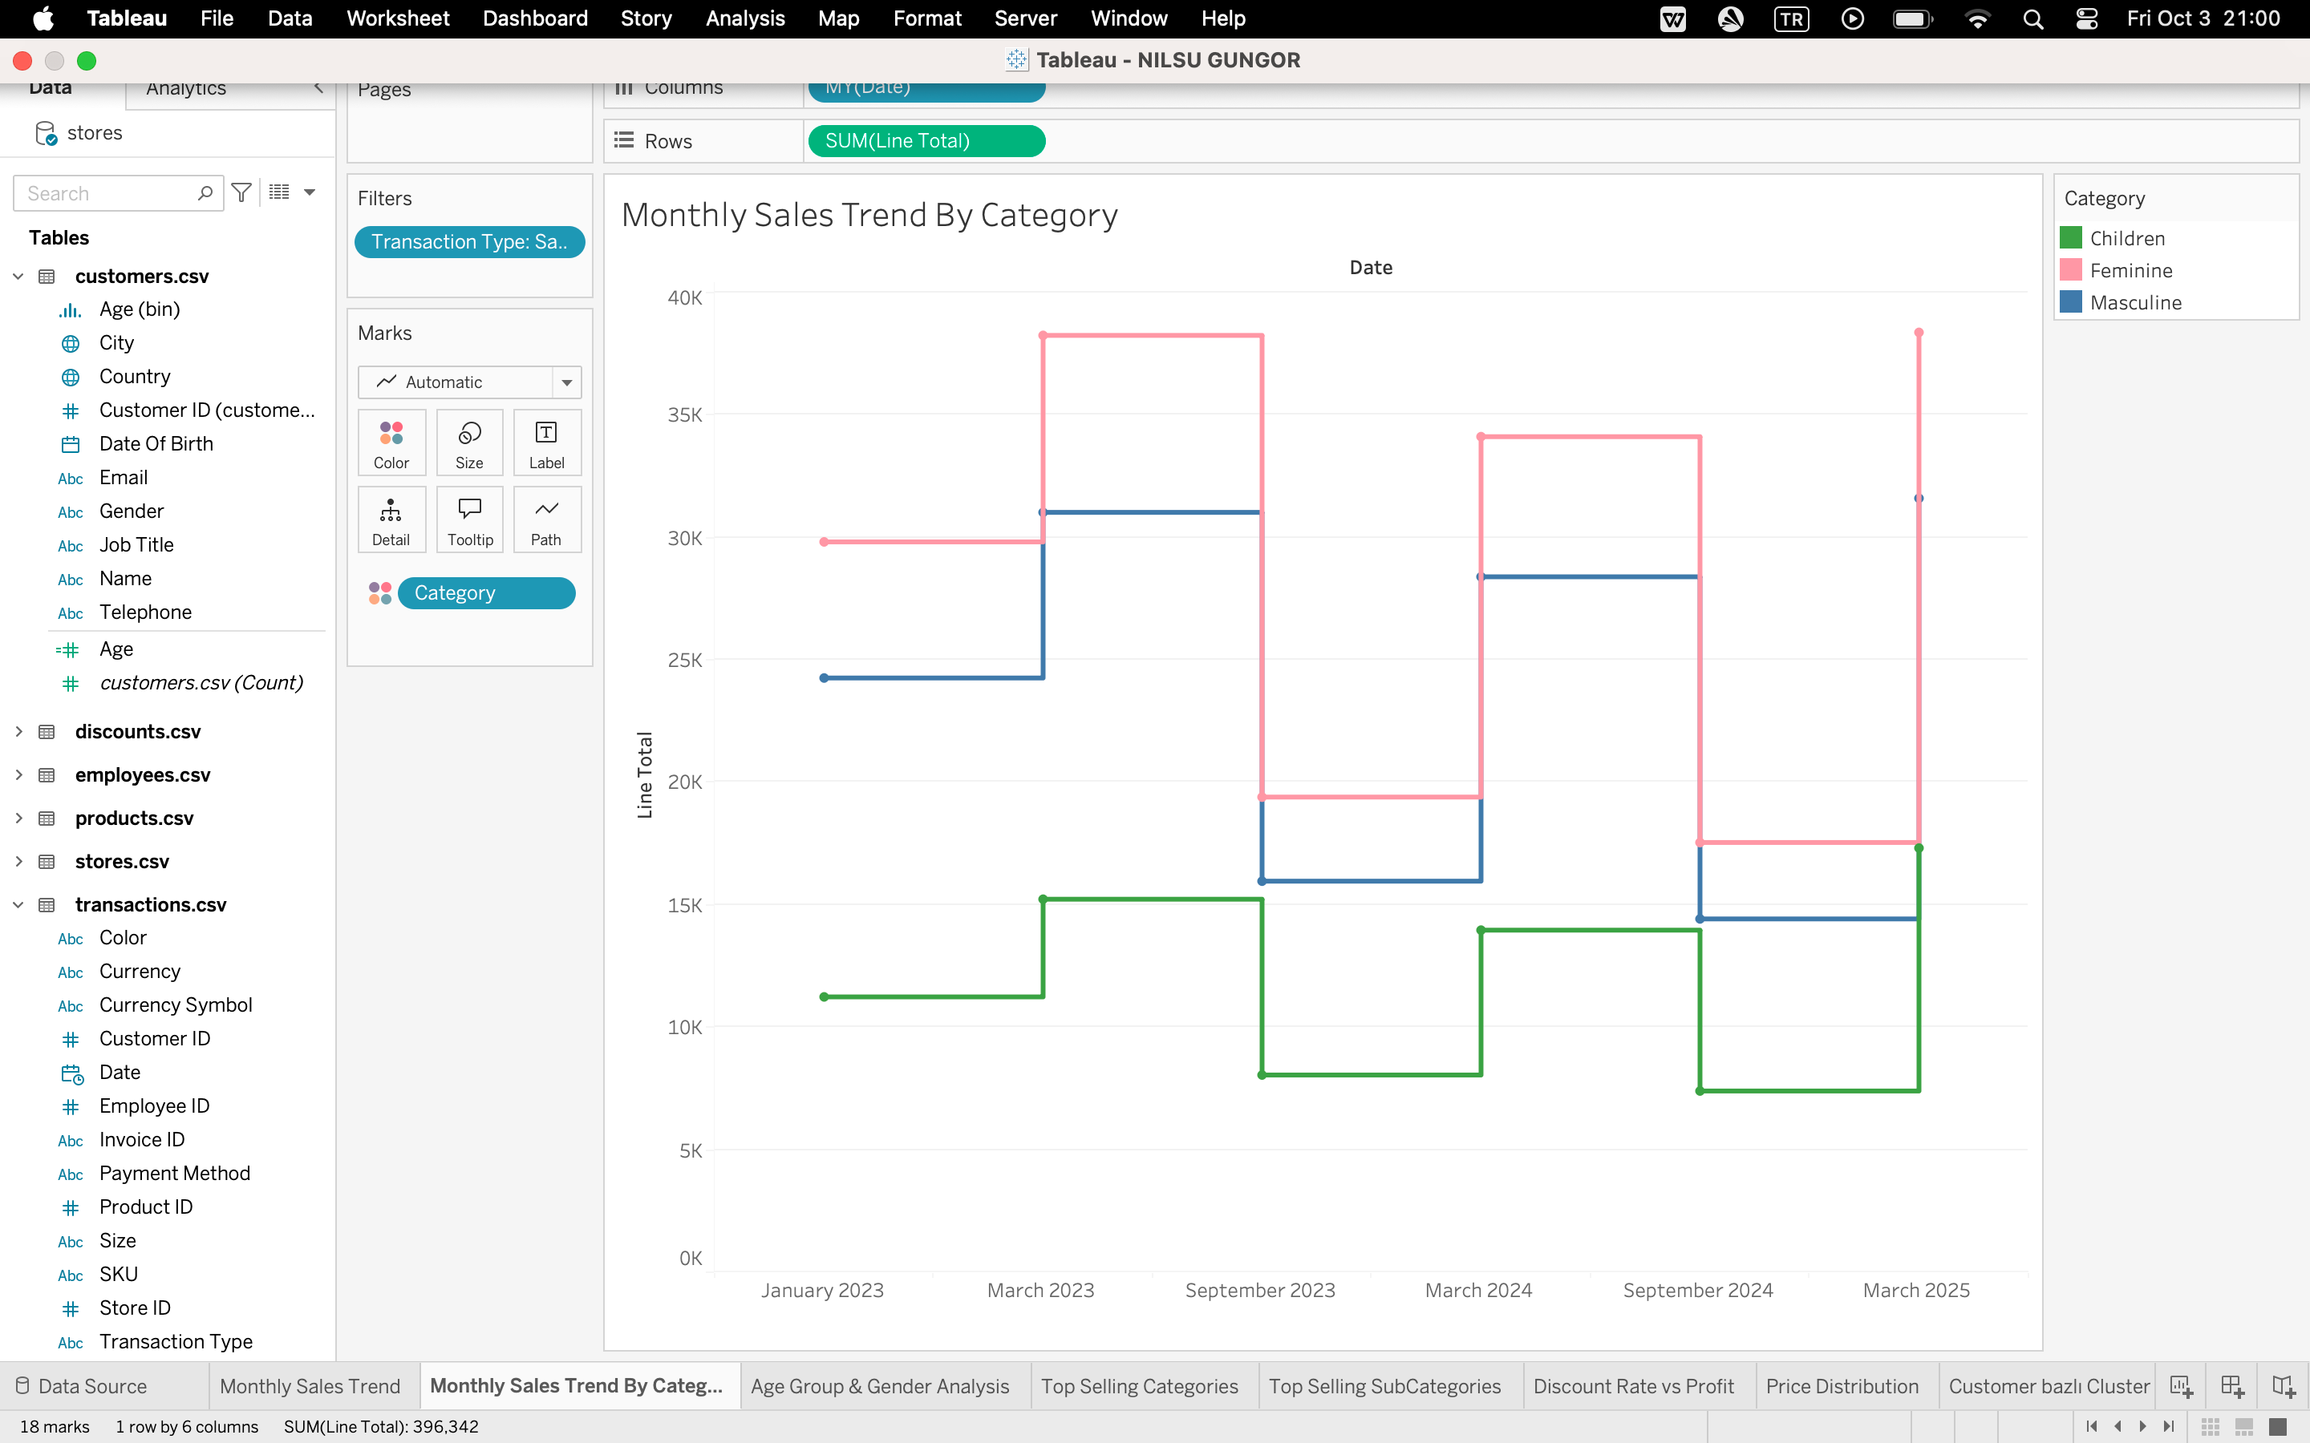
Figure: Monthly Sales Trend by Category
This time, I added Category from products.csv to color section to see which category is sold the most. I added the filter transaction type and filtered out the returns to only see the sales. We can clearly see on this graph that Female products are the ones that are the most sold.
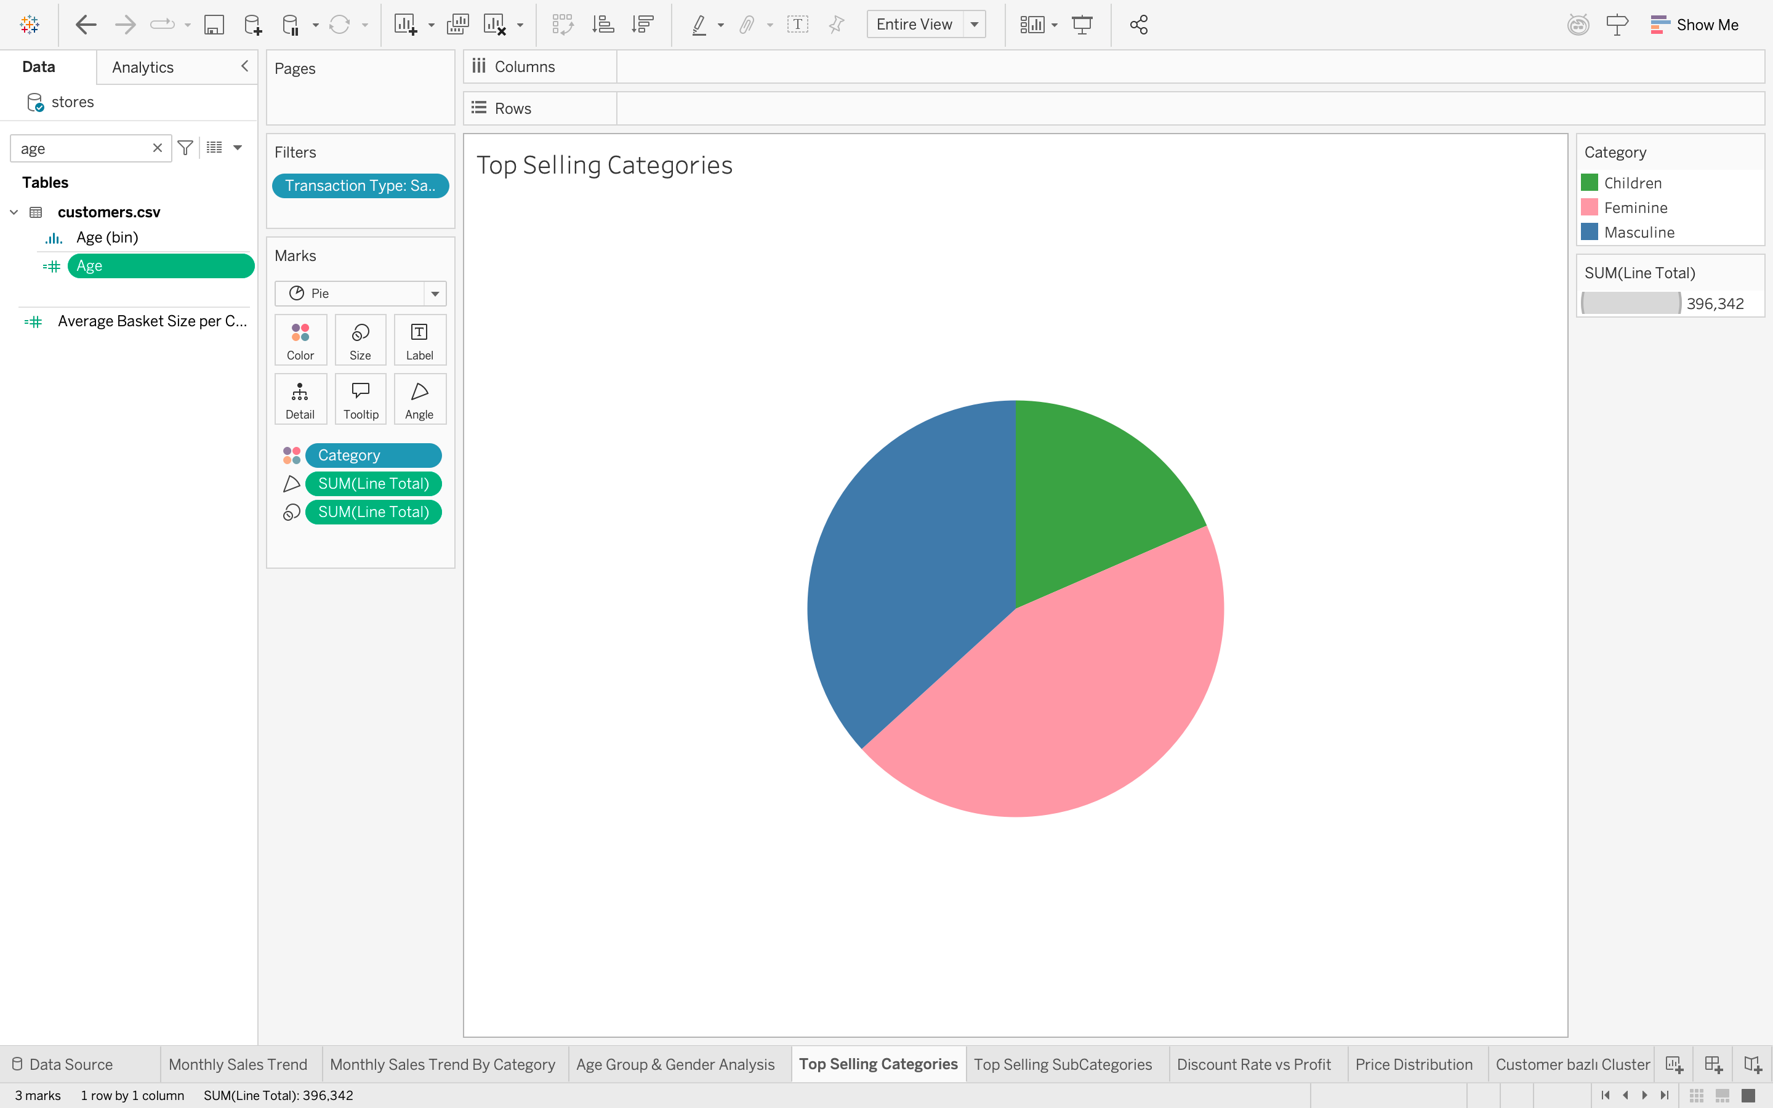
Figure: Pie Chart of the Sales by Category

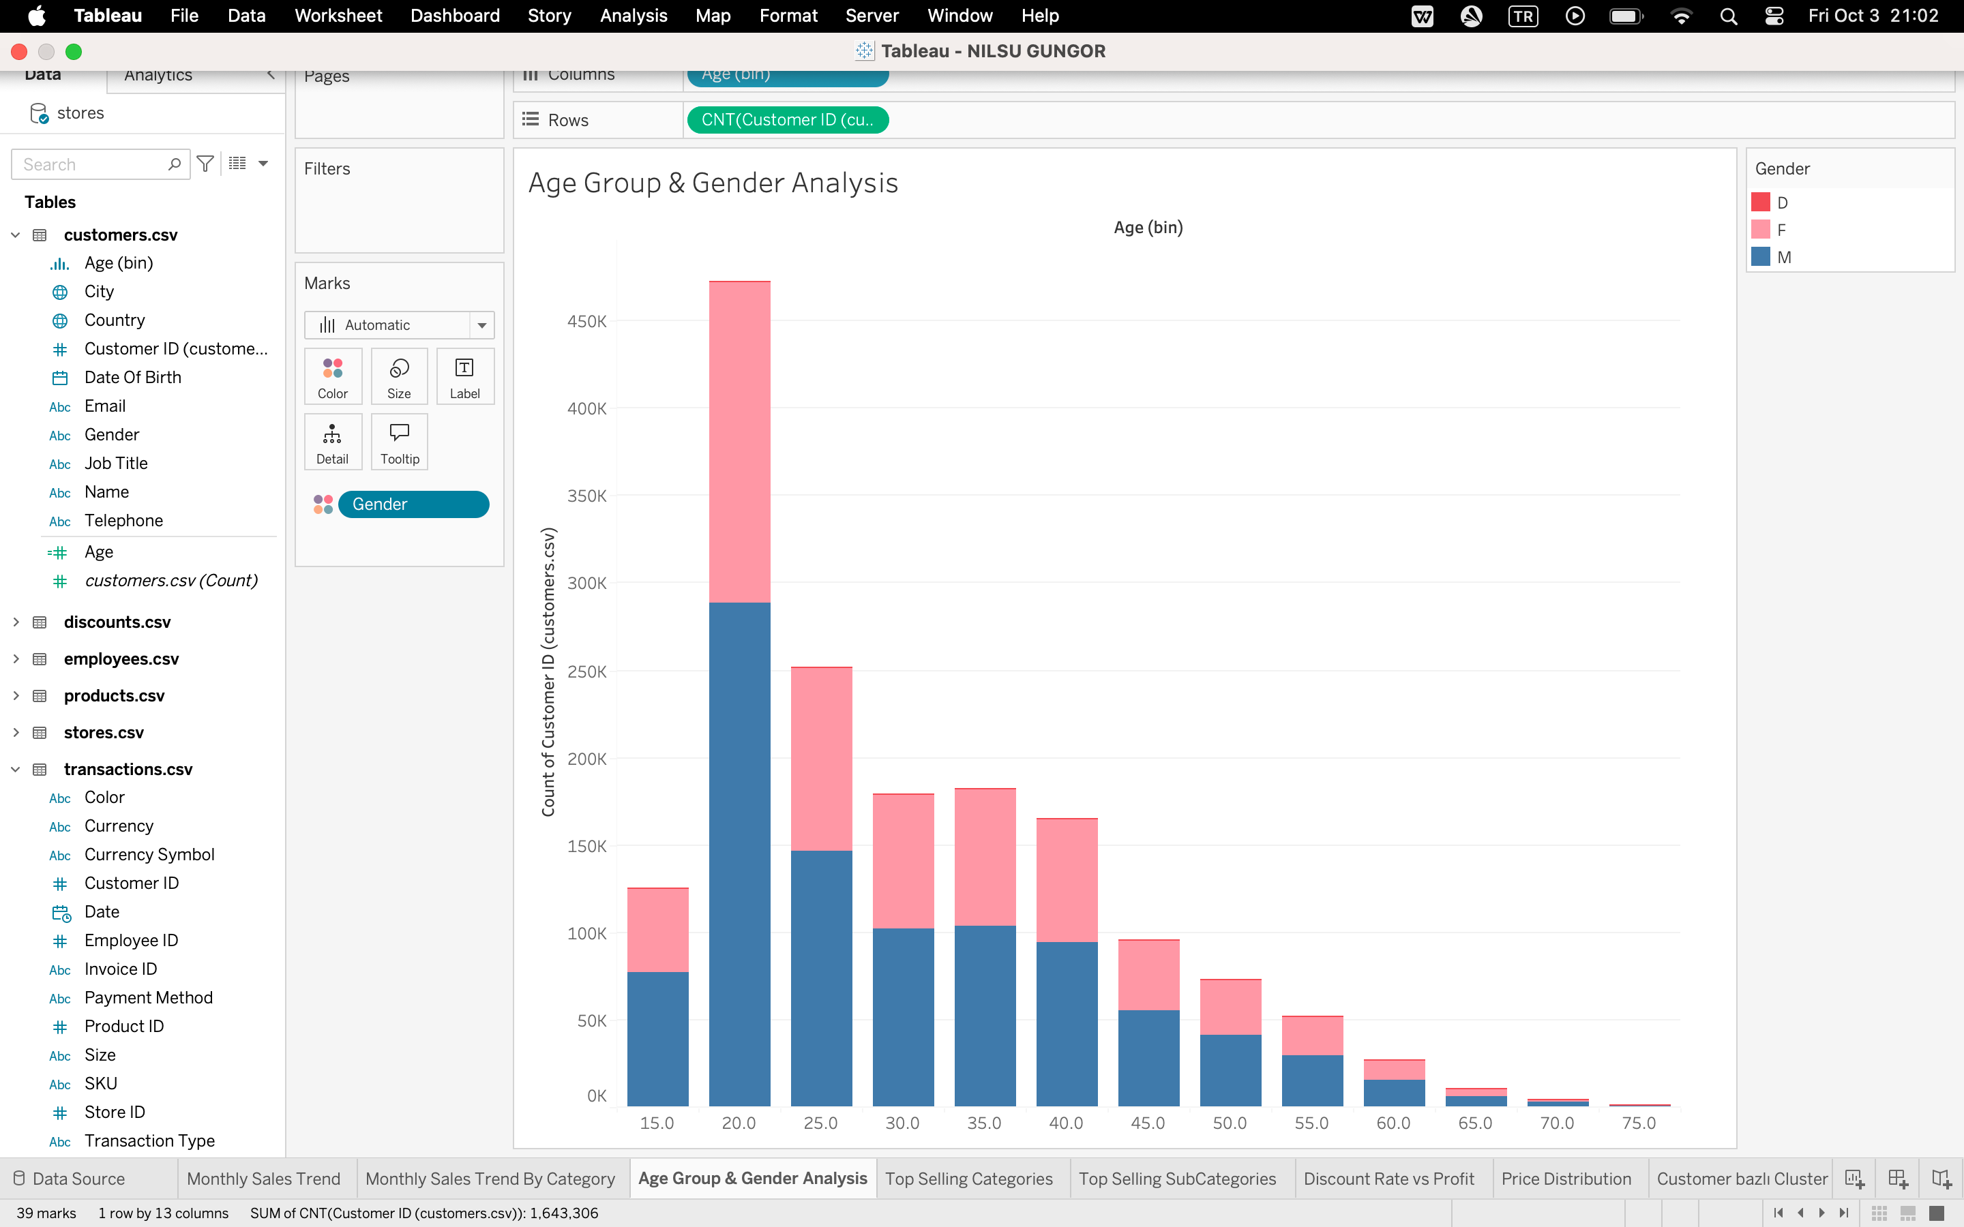
Figure: Age Group & Gender Analysis
This time, I wanted to see who are the buyers in the conjunction with age and gender. I created an age calculated field and used this formula (DATEDIFF('year', [Date Of Birth], TODAY())) to calculate the ages of each customer. Then, I created bins that have the size of five, to see who are our customers. We can clearly see in this graph that ages to 20-30 are our customers, but gender is close.
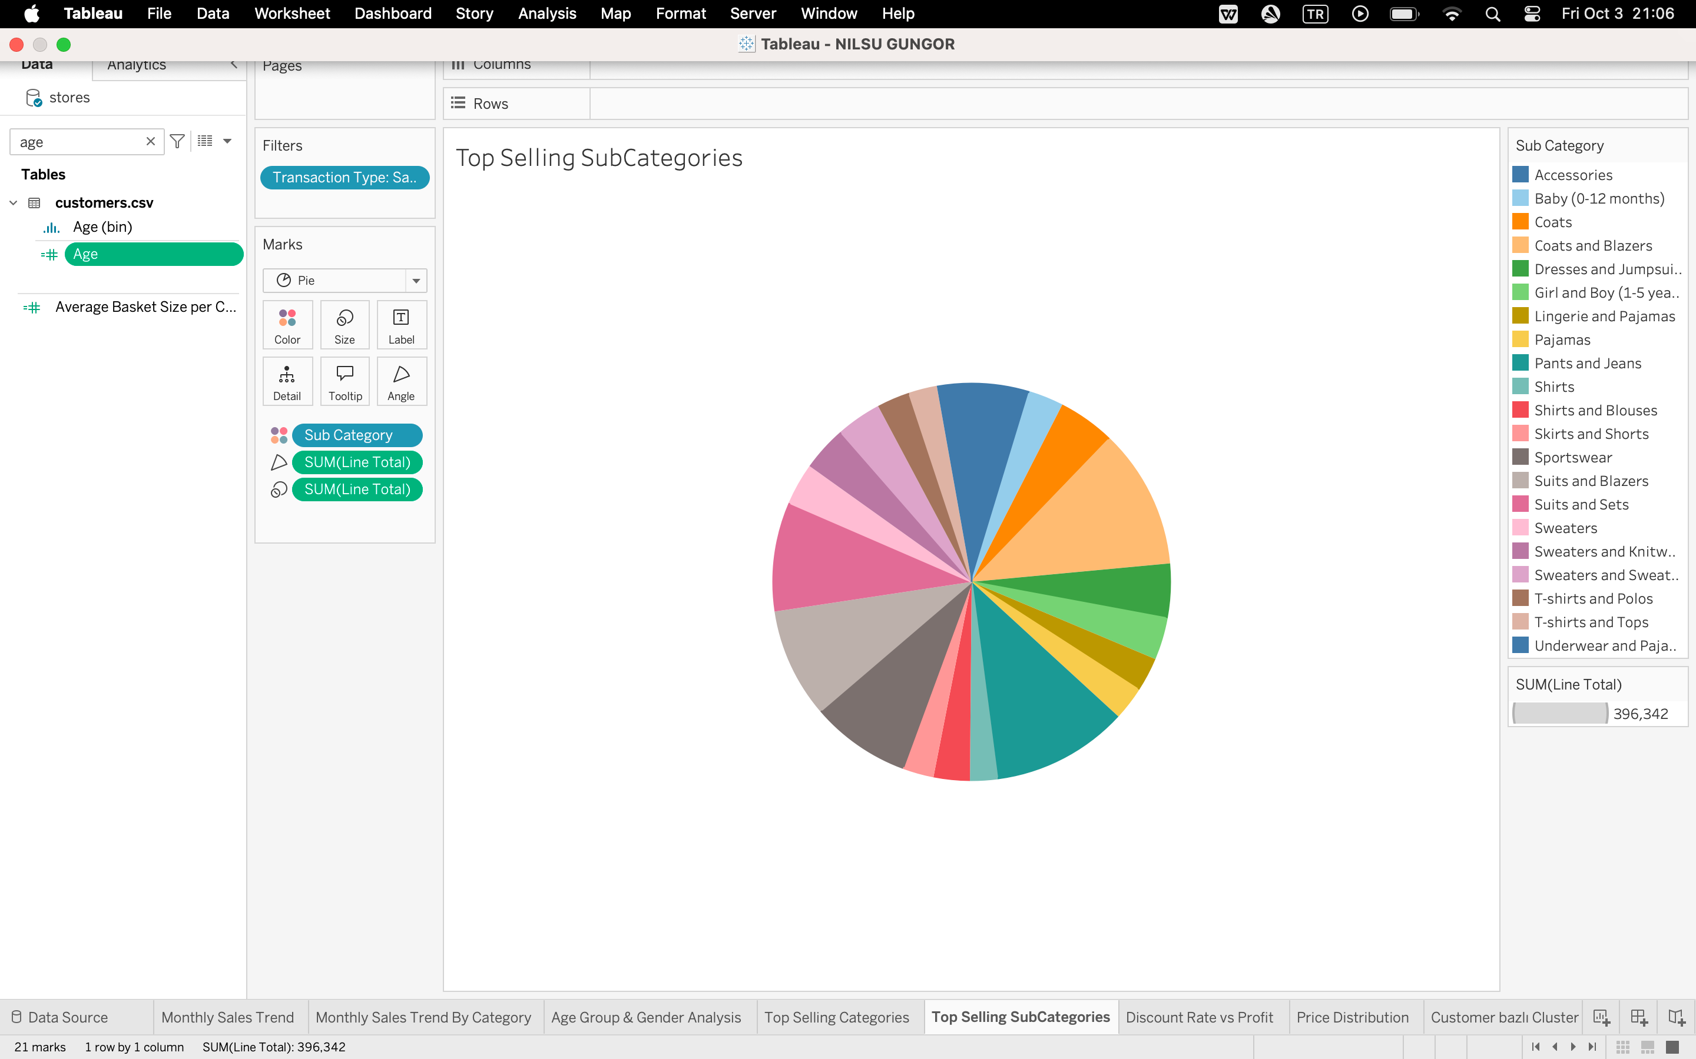
Figure: Top Selling Sub Categories
Next thing I did was to try to see which sub categories sold the most. For this one, I again used transaction type as filter to eliminate the returns and only see the sales, and put Sub Category data to color. Then I used Line Total to see which ones are the ones that sell the most. We can clearly see that Coats and Blazers, Pants and Jeans and Suits and Blazers are the ones that sell the most.

ADVANCED VISUALIZATIONS AND INSIGHTS
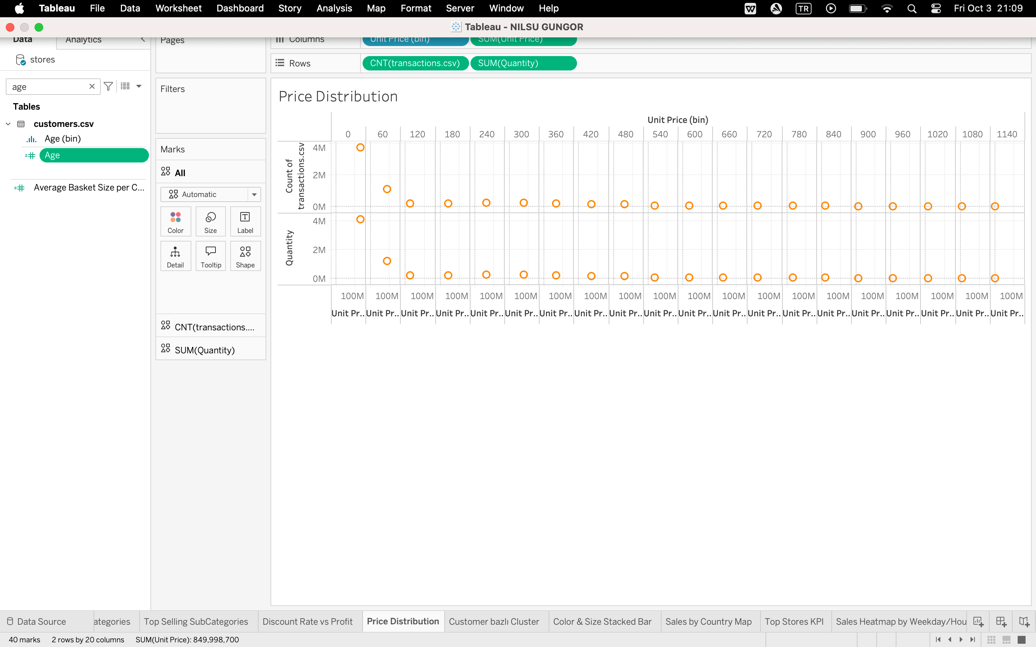
Figure: Price Distribution
Next analysis that I did was to see, which price range our customers bought the most. For this one, I created bins for Unit Price and sized them as 60. In this graph, we can clearly see that after 240 as unit price, customers interest generally decrease.

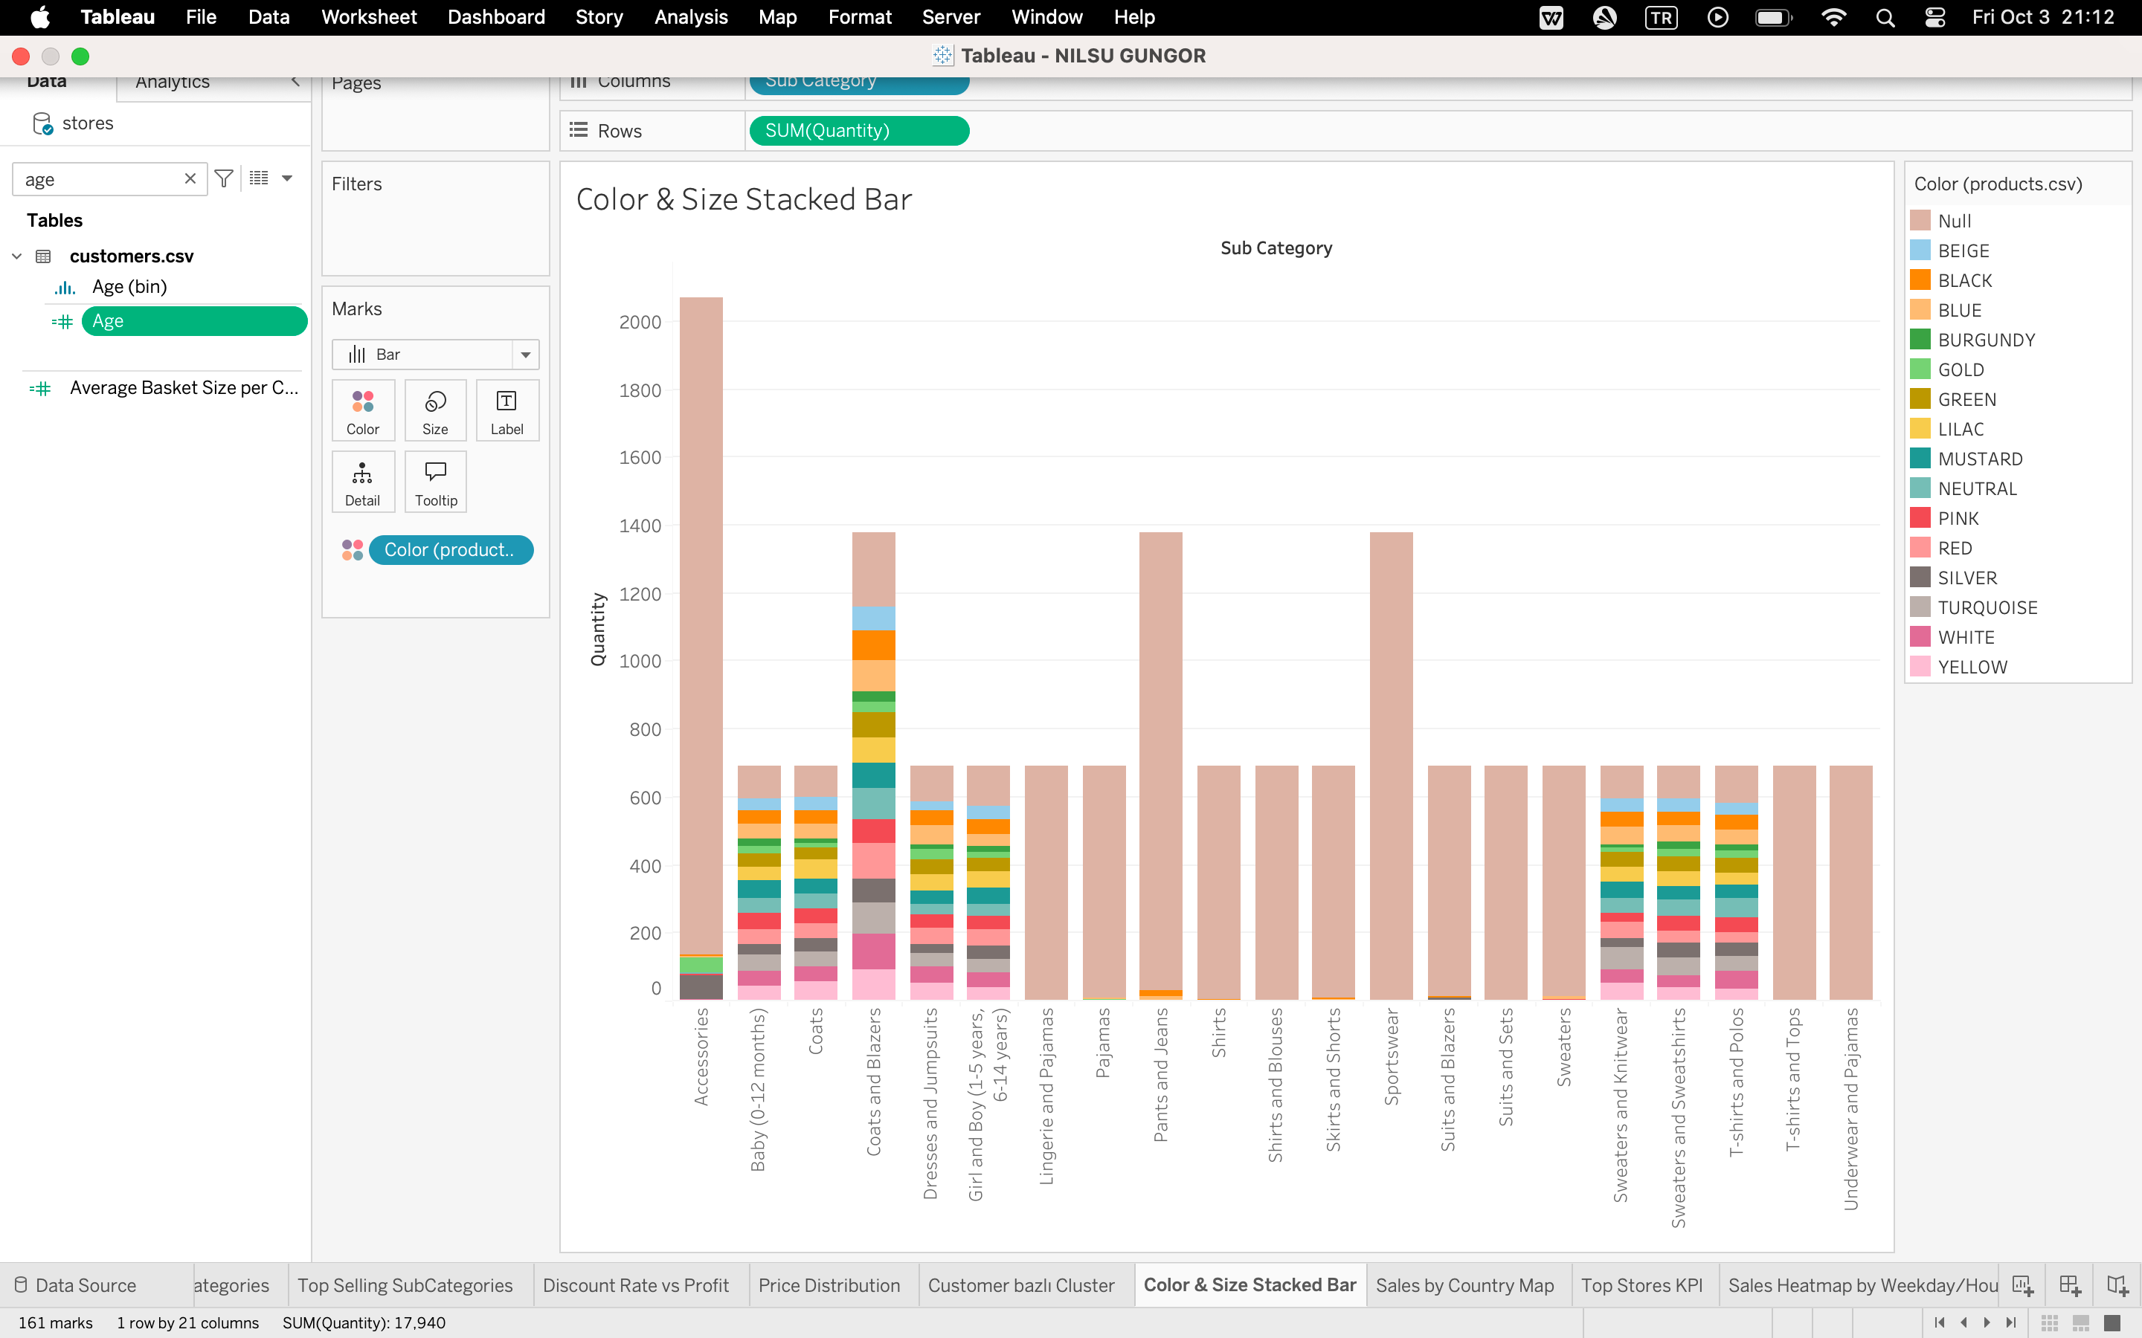
Figure: Color Stacked Bar
Next analysis that I tackled was to see which colors of items were bought the most. To visualize this, I also had to divide everything to categories to see which of the colors belonged to which items. However, there very many missing values for this data, most of the categories were left blank. Even though we don’t have much data on most of them, we can still clearly see that black is the color that is bought the most.
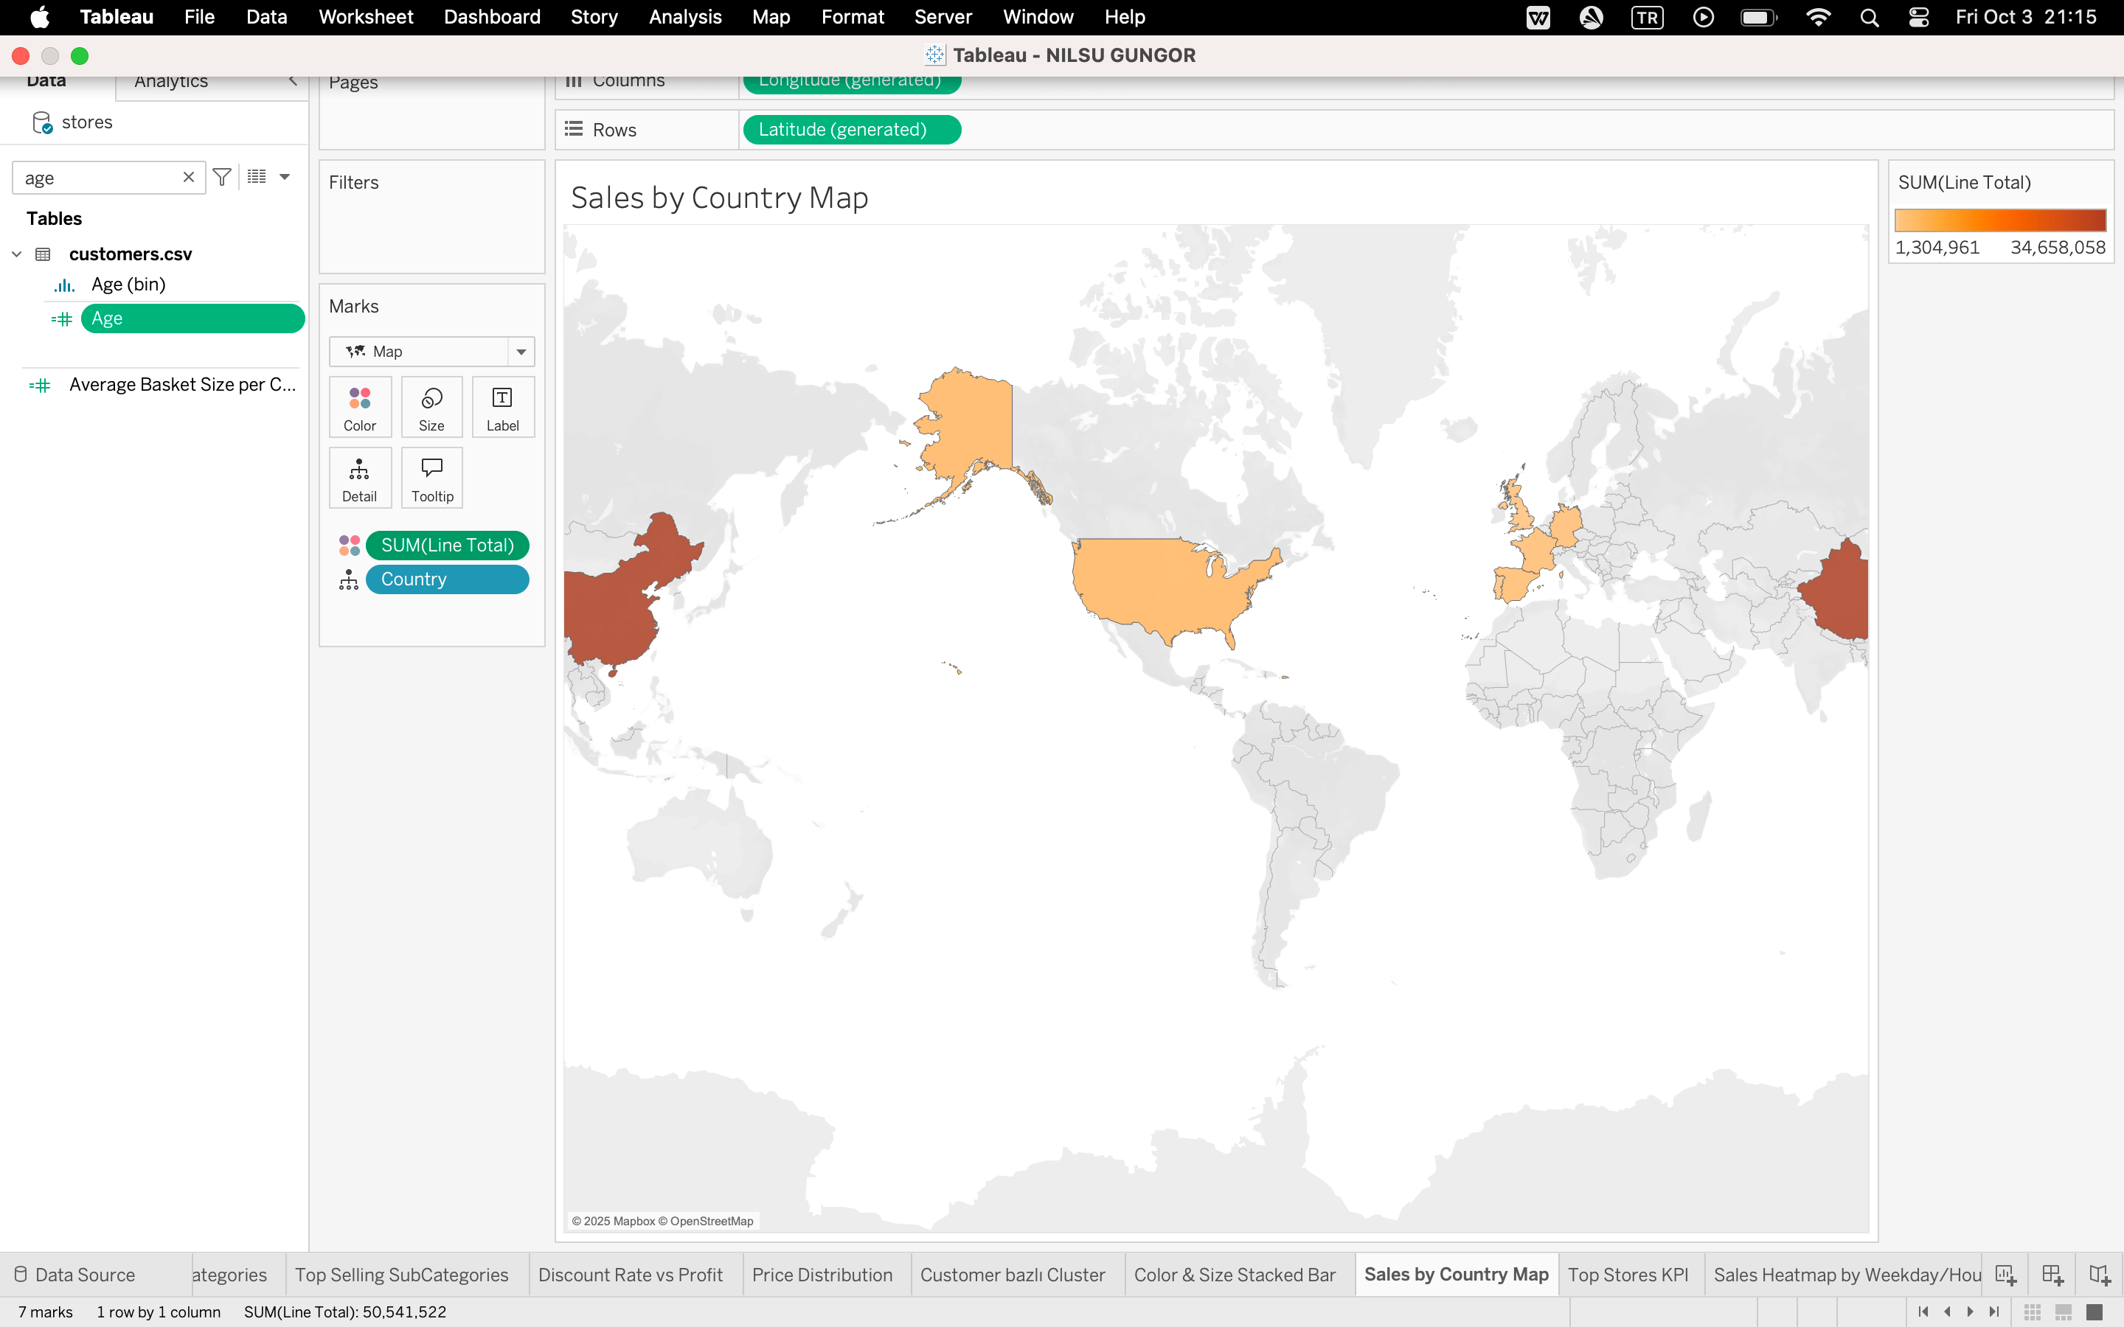
Figure: Sales by Country Map
Next analysis that I did was to see, which countries’ had the most customers. To visualize that I created a heat map on a world map. We can clearly see China has the most customers.
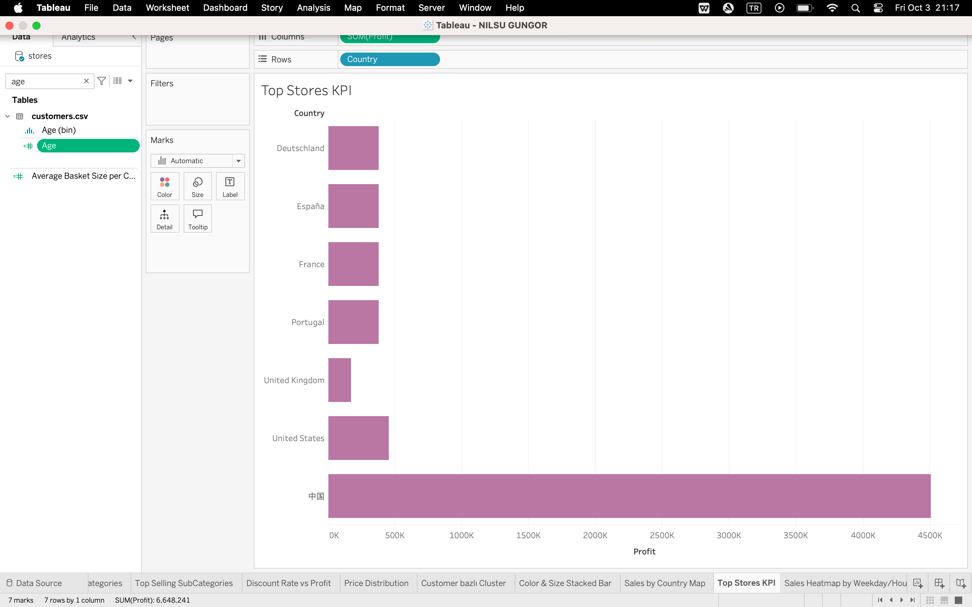
Figure: Top Stores KPI
After doing the previous analysis, I also had to see which country had the most Stores in. It is seen here clearly that China also leads here as well. So it is very natural that they have the most customers.
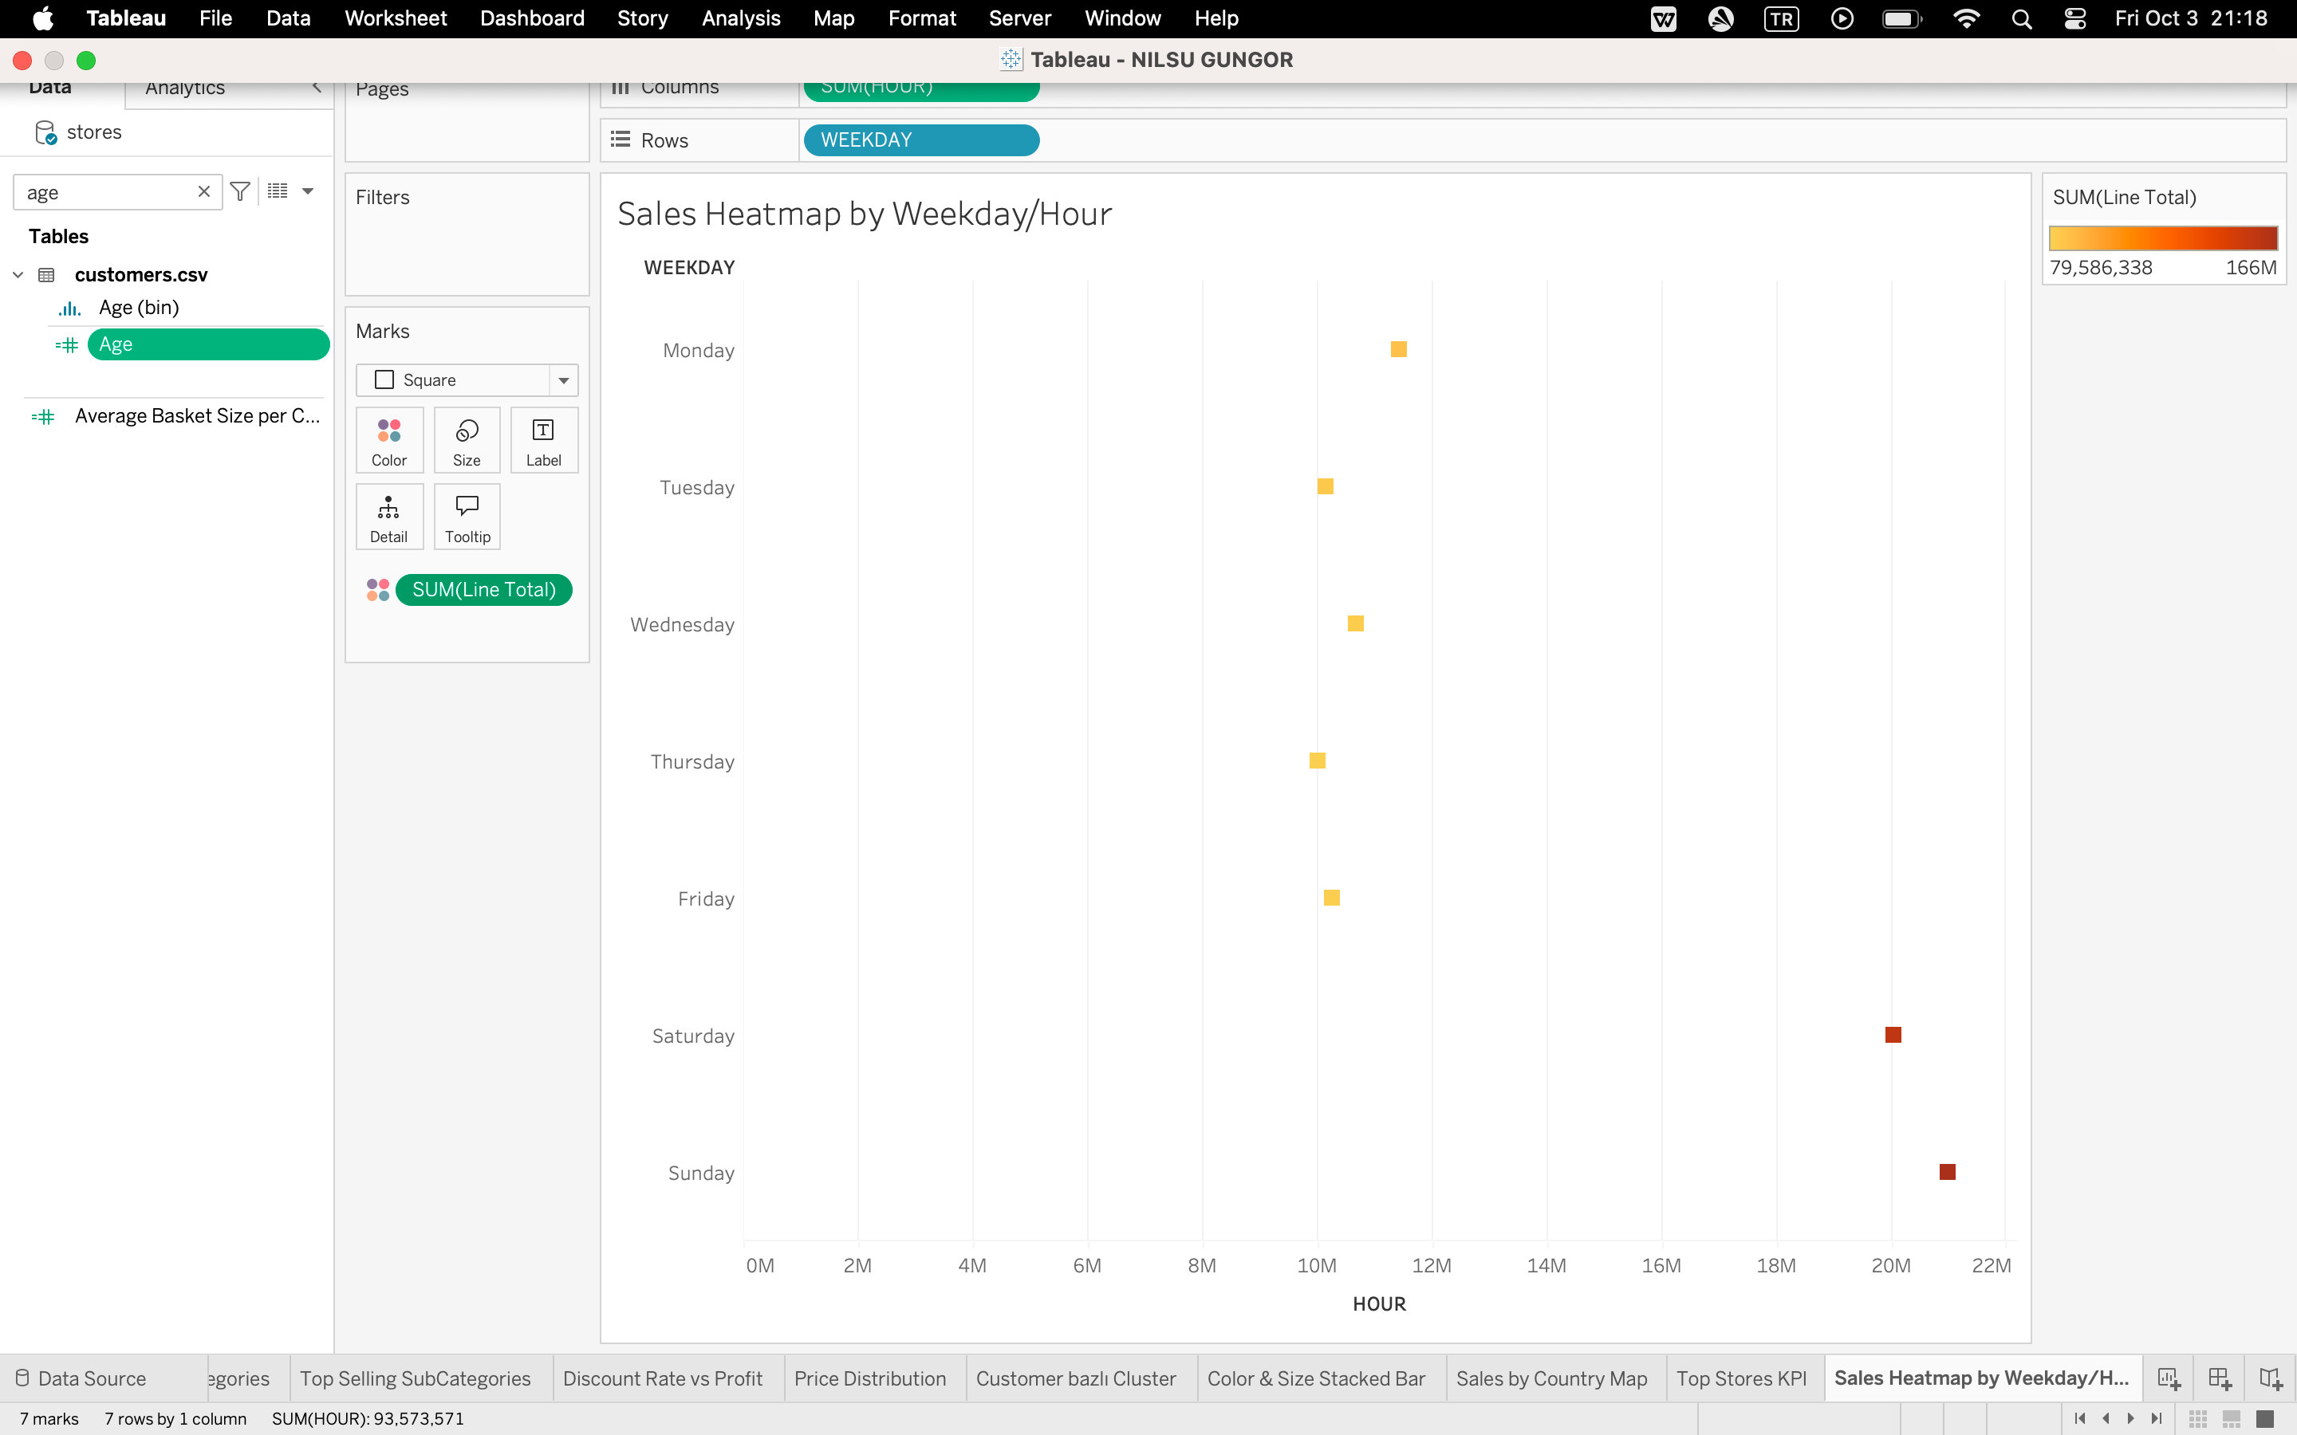
Figure: Sales Heatmap by Weekday/Hour
Next analysis that I did was a heatmap to see which hours and which days sales happened the most. It is seen here that on the weekdays between 10-12, and on the weekends between 19-21 are the busiest hours.

CLUSTER ANALYSIS
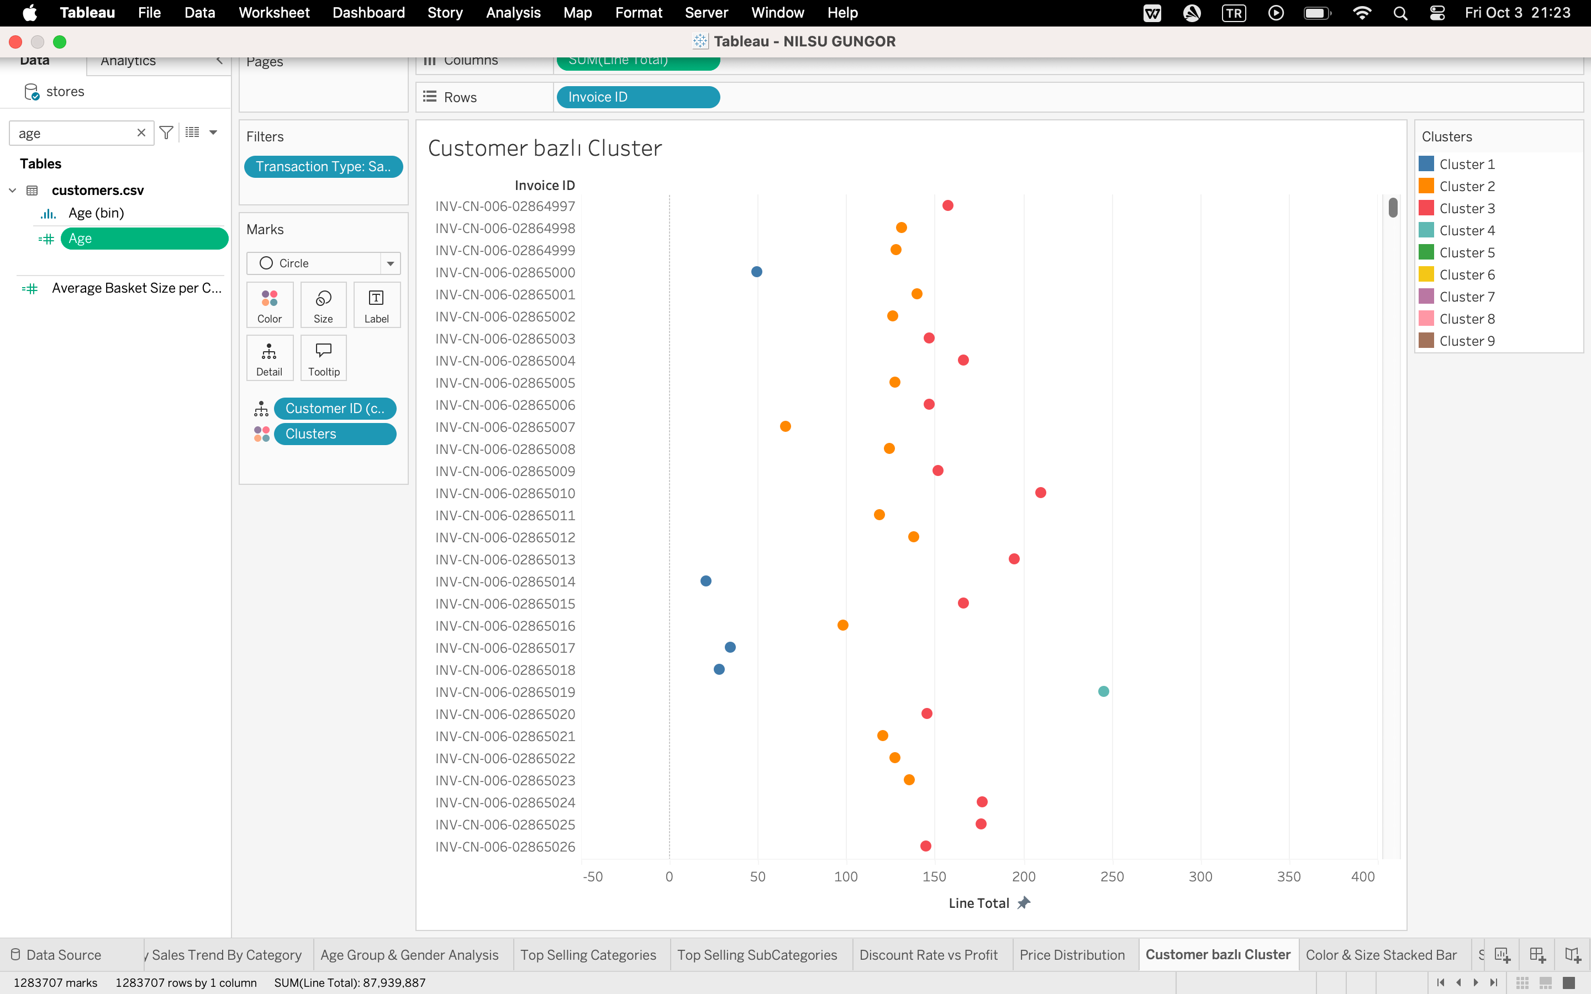
Figure: Customer based cluster
In this analysis, I wanted to see a pattern that, when customers make a purchase what amount of money they spend in one go. For this one, I created 9 clusters to see which range is the most common trend to spend money. As seen clearly here, customers spend the most between the ranges of 150-200, and then 100-150.
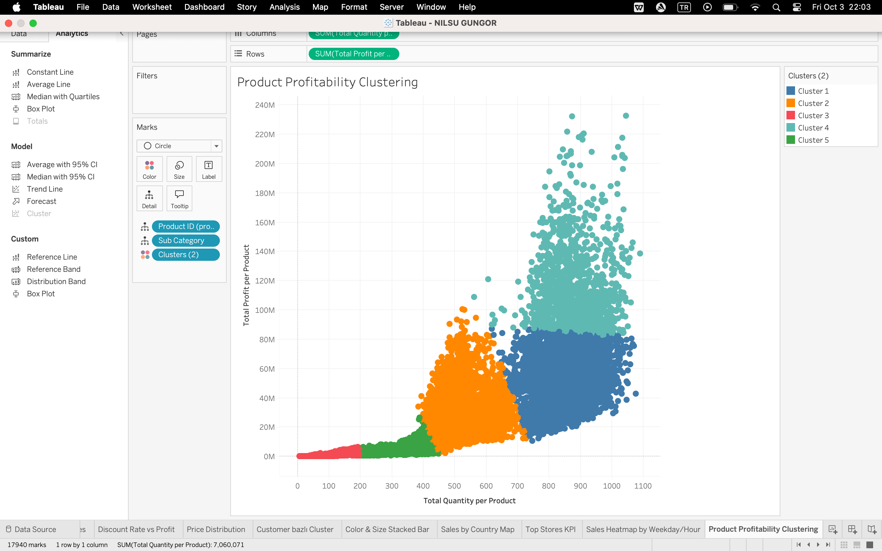
Figure: Product Profitability Clustering
For this one, I created a scatter plot with Total Quantity per Product calculated field on the X-axis and Total Profit per Product calculated field on the Y-axis. I added Product ID and Sub Category to the Detail so that each point represents a unique product and its category. Clustering was applied to identify groups of products based on sales volume and profitability. The analysis revealed star products with high sales and profit, low performers with low sales and profit, and a middle group of average-performing products. The least profit has been from the lowest amount of sales products as well. So we see a strong correlation there.

PREDICTIVE AND EXPLORATORY ANALYTICS

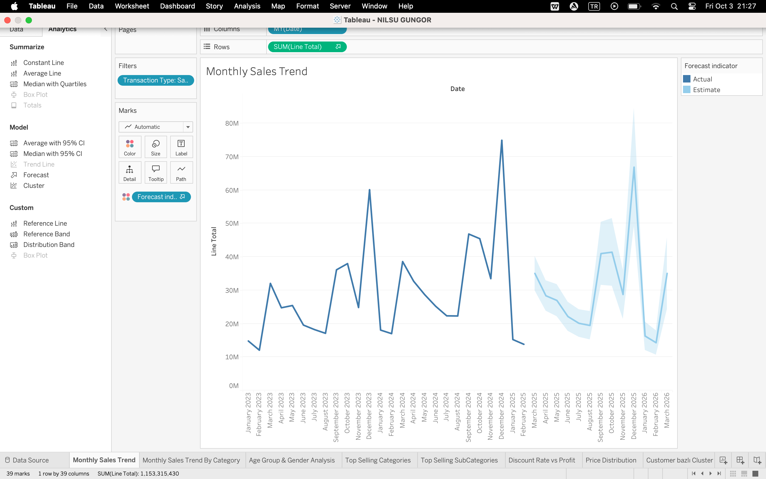
Figure: Monthly Sales Forecast
This time, I used the Forecast feature of Tableau to see the future sales. As seen above, Tableau predicts December sales as peak as well and there is a dip in August, we clearly see a trend here.
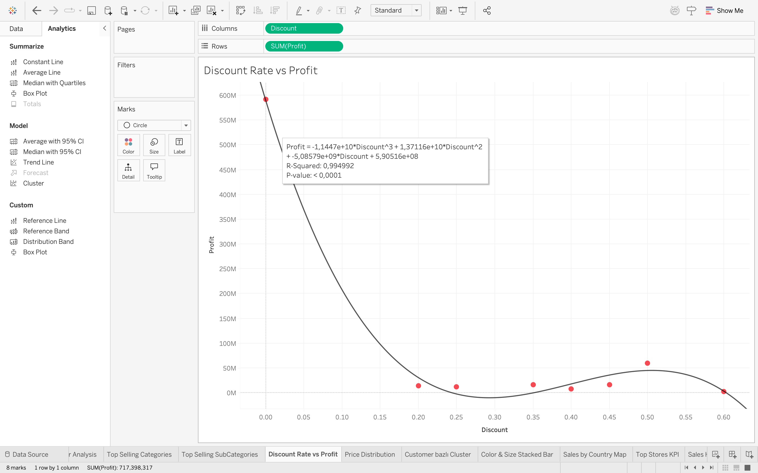
Figure: Discount Rate vs Profit
This time, I used Polynomial Regression in Tableau. As seen above, when we hover over the trend line we can see the R Squared and p value. The more close to 1 R Squared value is, the more it shows that there is a good relationshio between the regression model we used and the actual values. As you can see, when we increase the discount, our profit decreases. So there is a negative relationship between these two data. One thing to consider is that this is simulated data so it is unnatural to have such high R Squared value in real life. This shows the dataset lacking in this field as well.
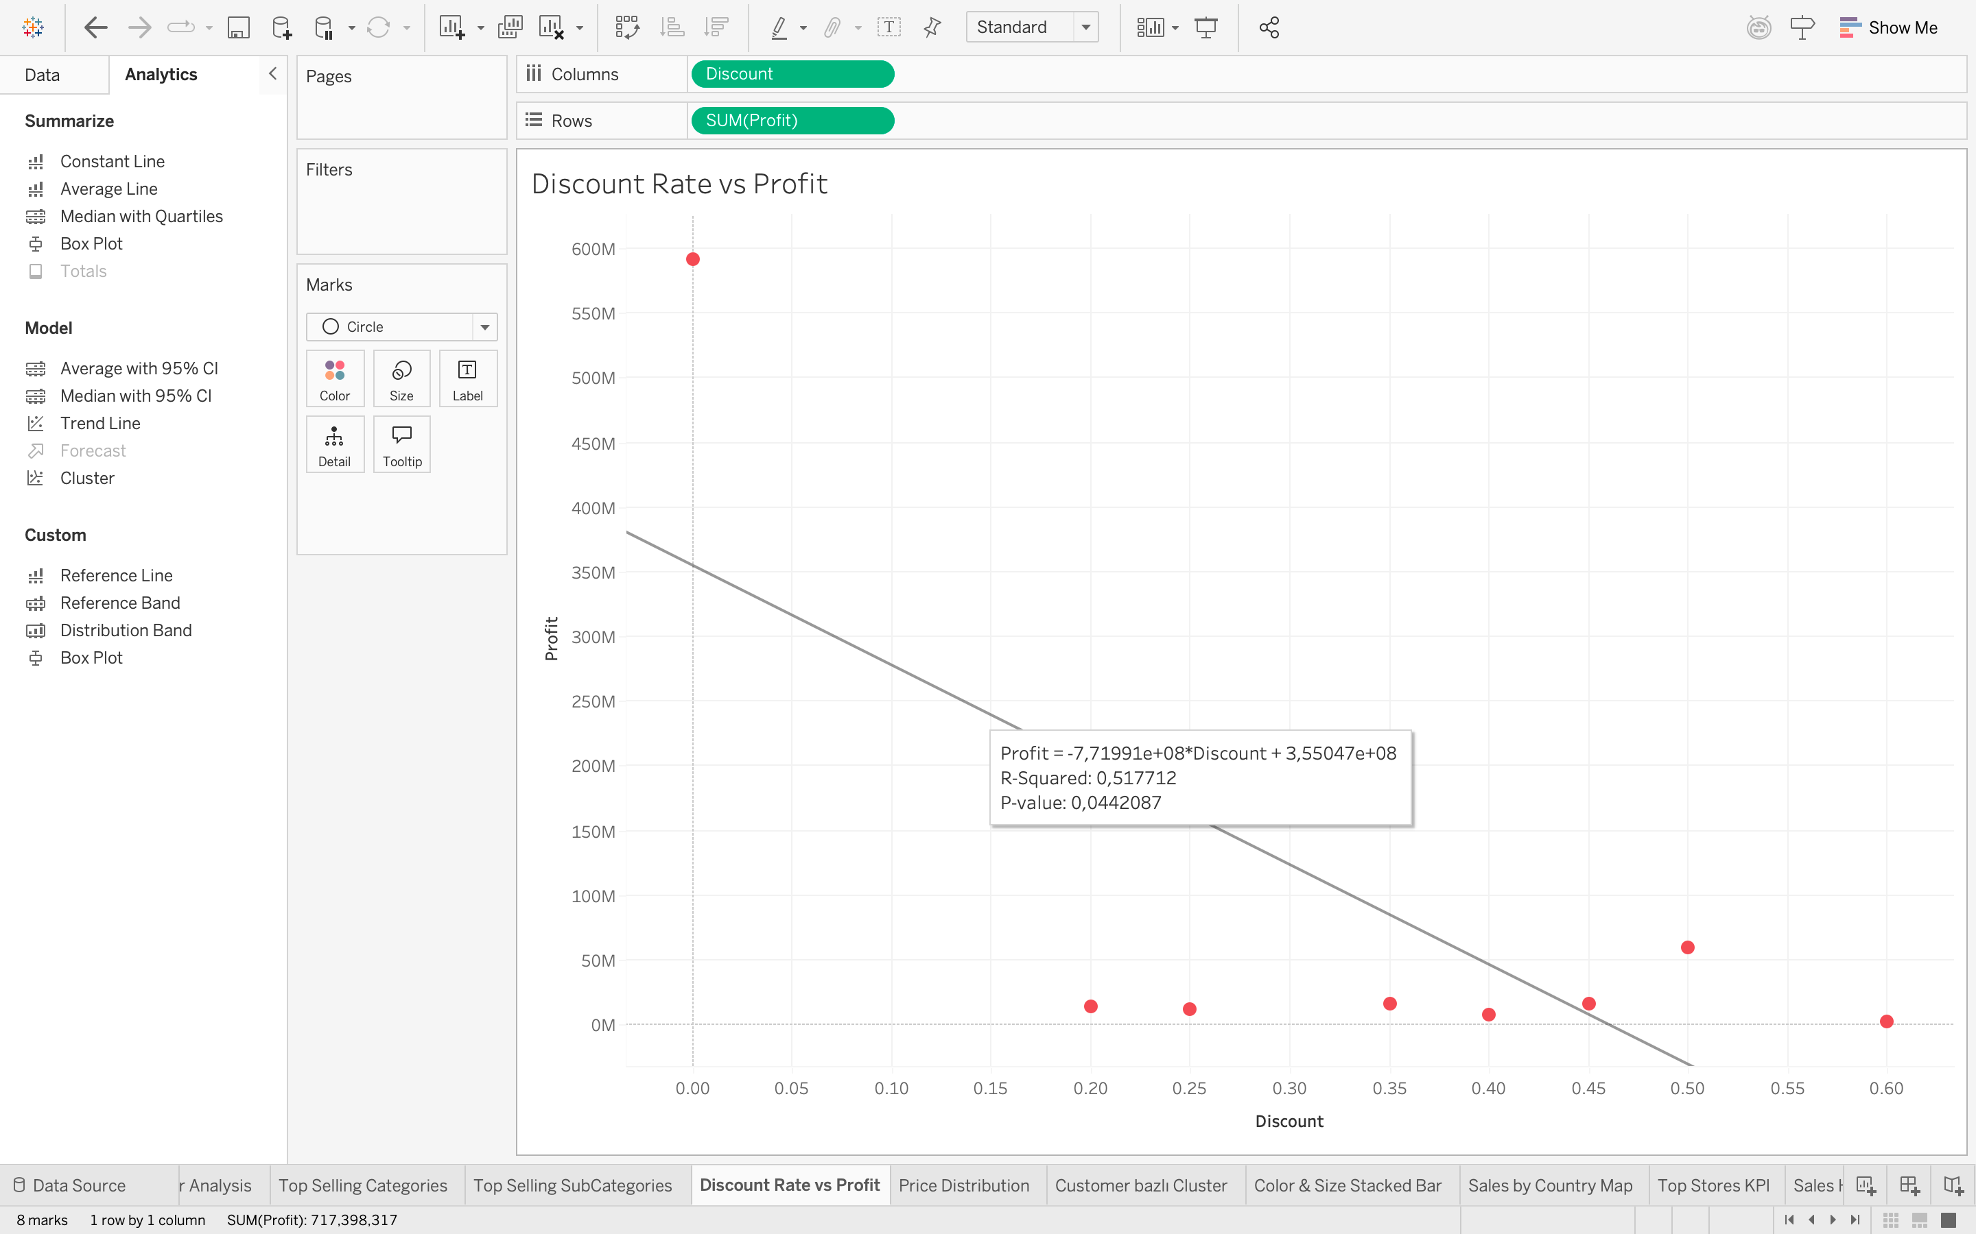
Figure: Discount Rate vs Profit with Linear Regression
As you can see above, polynomial regression is clearly a better fit for the data because line is not well adjusted and has significantly lower R Squared value compared to previous model.

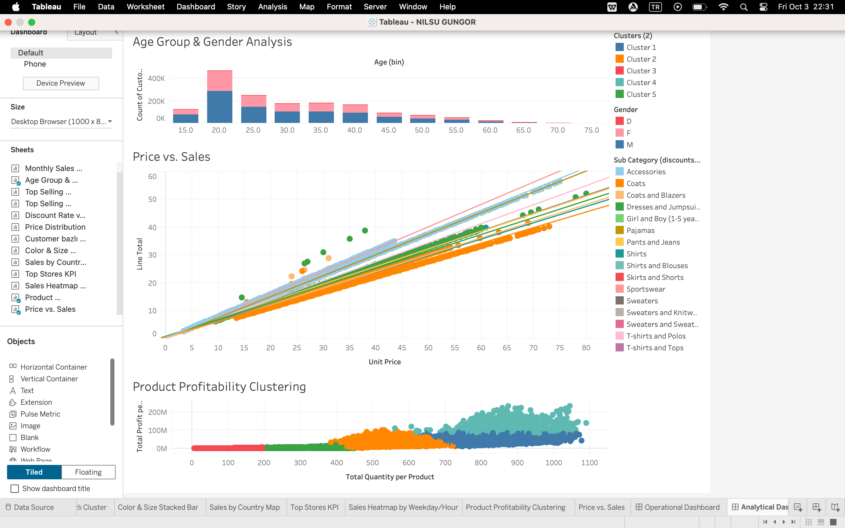
Figure: Analytical Dashboard
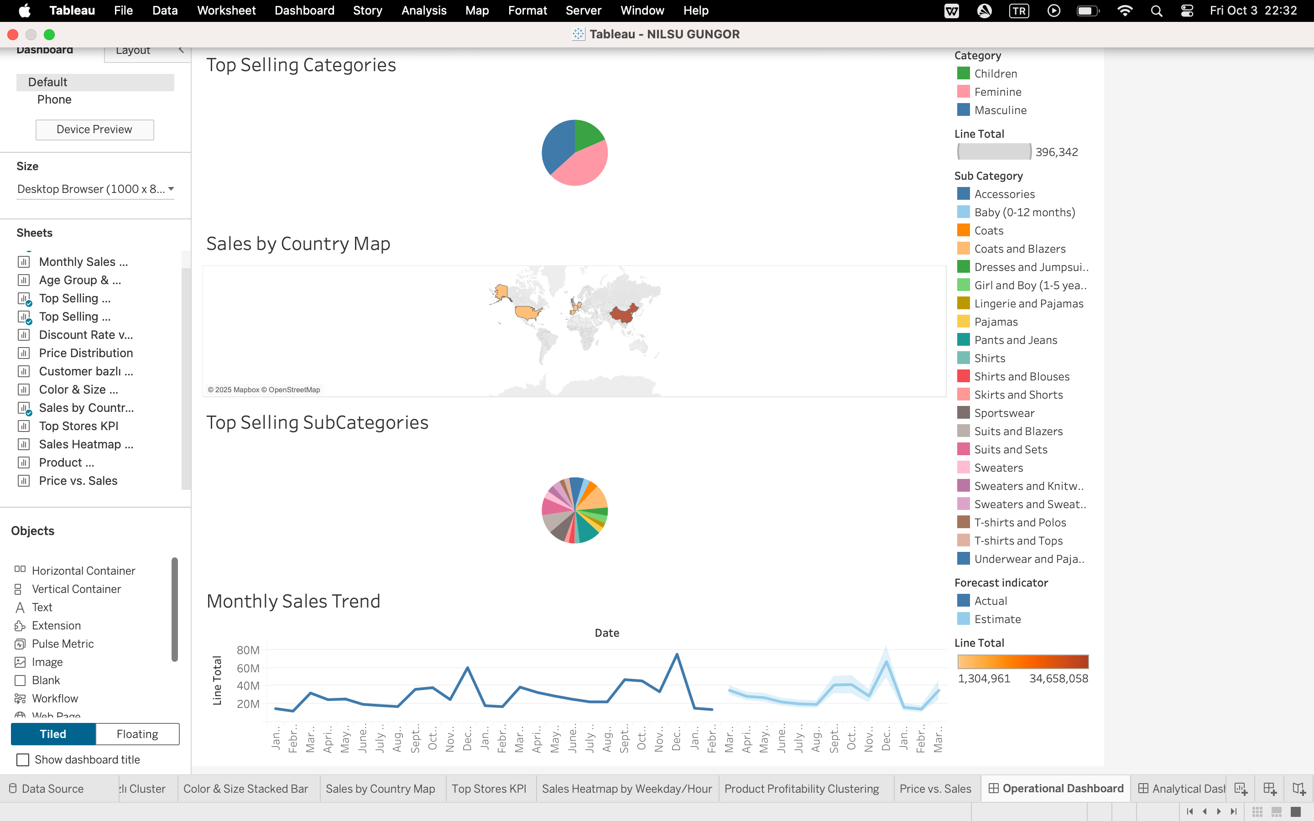
Figure: Operational Dashboard
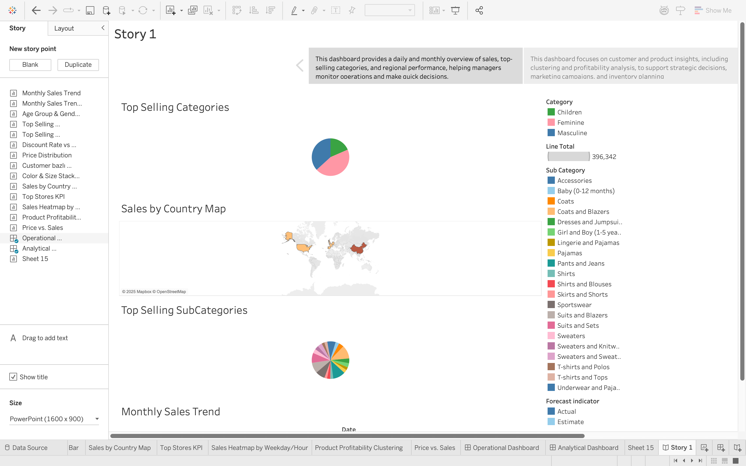
Figure: Story first page, done with operational dashboard
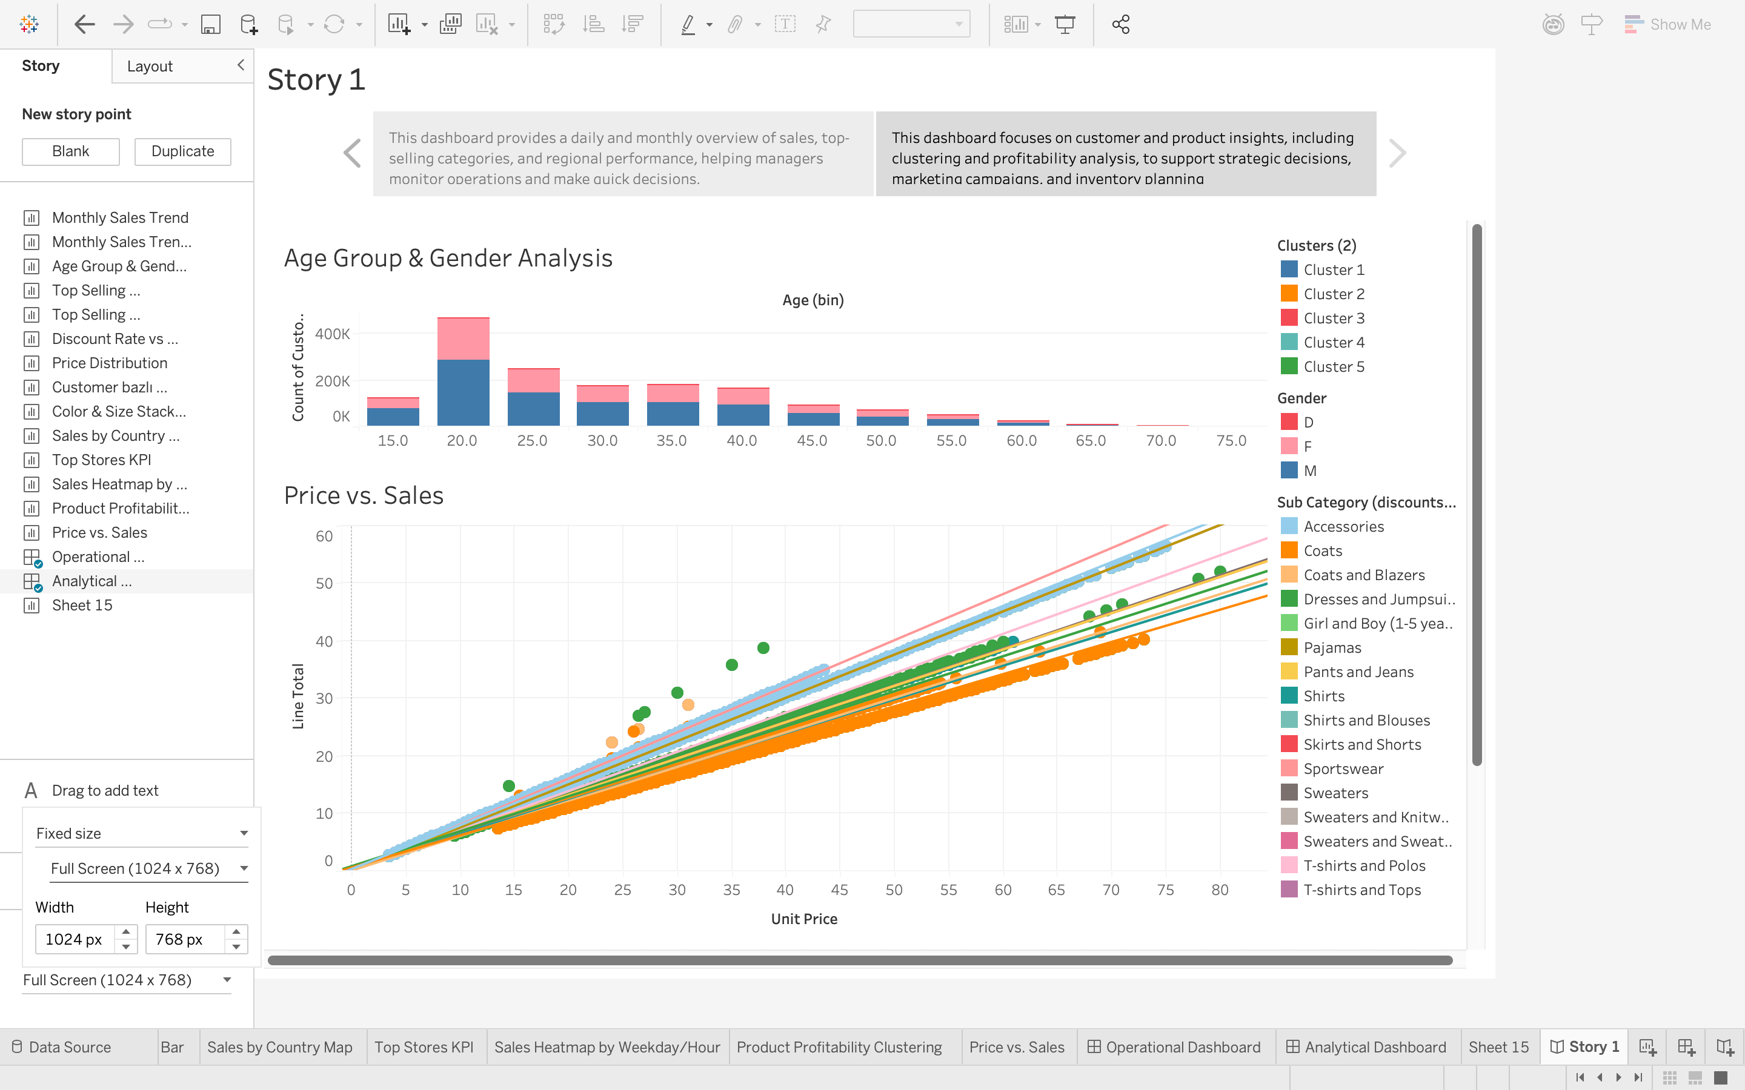
Figure: Story second page, done with the analytical dashboard

DISCUSSION

From the analysis that I did, monthly sales showed clear peaks in December, while Female products and subcategories like Coats & Blazers and Pants & Jeans were the most popular ones. Price analysis showed that customers bought less items If it is more than 240 USD, and black was the most popular color. China had the highest number of customers and stores, and weekday/hour analysis showed that sales were busiest in weekday mornings and weekend evenings. Clustering revealed that most customers spend between 150–200 USD, and product profitability clusters highlighted high-performing “star products” as well as low performers. Forecasting and regression showed seasonal trends and confirmed that higher discounts reduce profit. These analysis shows us that this business could improve performance by focusing promotions on top selling products, adjusting pricing for higher-priced items and lowering the prices, targeting marketing based on customer clusters, and planning stock and staffing according to sales patterns. Since this business is most popular in China, it would be better to open more stores in China as well. It can be given more importance to stores in December because of the increased sales, so it would be wise to increase the number of employees and try to sell more in those timeframes. And since customers usually don’t spend more than 250 usd per trip to store, It would be good to group items that sell most and group them in a way that sums up to 250.

CONCLUDING REMARKS

Working on this assignment gave me a true understanding of how to use Tableau for analyzing complex retail data. While creating visualizations, I faced multiple challenges, such as handling missing values in fields like Color, managing multiple CSV files and their relationships, and making scatter plots and cluster analyses work correctly. At times, trend lines and regression required calculated fields or adjusting data aggregation, which was tricky at first. Despite these difficulties, I was able to create meaningful dashboards, line charts, heatmaps, histograms, and cluster analyses that revealed patterns in sales, customer behavior, and product performance. In general, this project helped me improve my Tableau skills, learn how to troubleshoot common issues, and understand how visualizations can support business decisions.

BIBLIOGRAPHY

Dataset source:
https://www.kaggle.com/datasets/ricgomes/global-fashion-retail-stores-dataset/data?select=transactions.csv

