Task 1
The paper I chose is: “MissForest – nonparametric missing value imputation for mixed-type data” by Daniel Stekhoven and Peter Bühlmann (Stekhoven & Bühlmannn, 2011).
The main problem addressed in this paper
This paper addresses the problem of missing data. It specifically focusses on genetic datasets. Many methods of analysis require data without any unobserved data which requires imputation. The paper states that current prevalent imputation methods are restricted to one type of variable and make problematic assumptions about the distribution of the data. The paper aims to introduce a method of imputation which can take any type of variable and makes as little as possible assumptions as is possible about the structure and distribution of the data.
The proposed solution
The paper provides an alternative imputation method that trains a random forest model on the non-missing values, after which the missing values are predicted using the trained model. The method is called missForest. Normally a random forest algorithm weighs the frequency of observed variables after being trained on a complete response variable. The algorithm this paper provides alternatively allows training on only the observed parts of a dataset that contains missing values.
Any optimization techniques or special cases discussed in the paper
The paper considers the computational efficiency of the algorithm and compares the runtimes to the other imputation methods. It notes that only KNNimpute is faster compared to missForest.
Two ways to reduce the runtime are given. One way is to reduce the number of trees used in the forest. In the comparison this is set to 100. The paper shows that reducing the number of trees has a stagnating influence on imputation error, while it has a strong influence on computation time. Another way is to lower the number of variables used at a node. Increasing the number of variables selected at each node has a minimal effect on the imputation error, but strongly increases run time.
The strengths and limitations in the paper
The strength of this paper lies in the fact that it provides an easy to reproduce imputation method that can be applied to almost any kind of data. The algorithm created comes with an R package, which makes the method extremely easy to reproduce. The paper shows the readers that it is valuable by robustly comparing its methodology to other established imputation methods.
From an open science perspective one of the weaknesses of the paper is that it does not provide an easy to access reproduction package to reproduce the results discussed in the package. The missForest R package allows users to easily perform the methodology, but ideally the scripts for performing the comparisons and creating the figures with the 10 publicly available datasets, would also be available.
- The evaluation methodology
The paper evaluates the success of the algorithm by comparing missForest with four different methods and applying all methods on 10 different data sets. For each data set and method 50 independent simulations are performed. One alternative method that is mentioned is the KNNimpute algorithm by Troyanskaya et al. (2001). To allow proper comparison with this k-nearest neighbour method, the paper implements a cross-validation method to obtain a suitable k.
Task 2
- Select and reproduce the main experiment reported in the paper.
The paper includes an R package and clear replication material that I can follow: http://stat.ethz.ch/CRAN/. In our reproduction we will focus on one of the 10 datasets discussed in the paper. Due to ease and availability I chose the voice measure in Parkinson’s patients data set described by Little et al. (2008). Just like the paper we compute the true Normalized Root Mean Square Error (NRMSE) for the dataset with three different amounts of missing values (10%, 20%, 30%). Next this we compute the OOB NRMSE error which measures how well the forest predicts observed cells.
- Compare your results with the results reported in the original paper
Figure 1 of the paper shows the NRMSE for the Parkinson’s data is around 0.3 for all three levels of missing values. It also shows a small increase when the percentage of missing values increases. Figure 4 of the paper shows that the difference between the true error and the OOB error is close to zero for all three different amounts of missing values. For a proportion of missing values of 10 percent, the paper shows a slightly higher OOB value. My results, as can be seen in underneath figure, appear to be very similar.
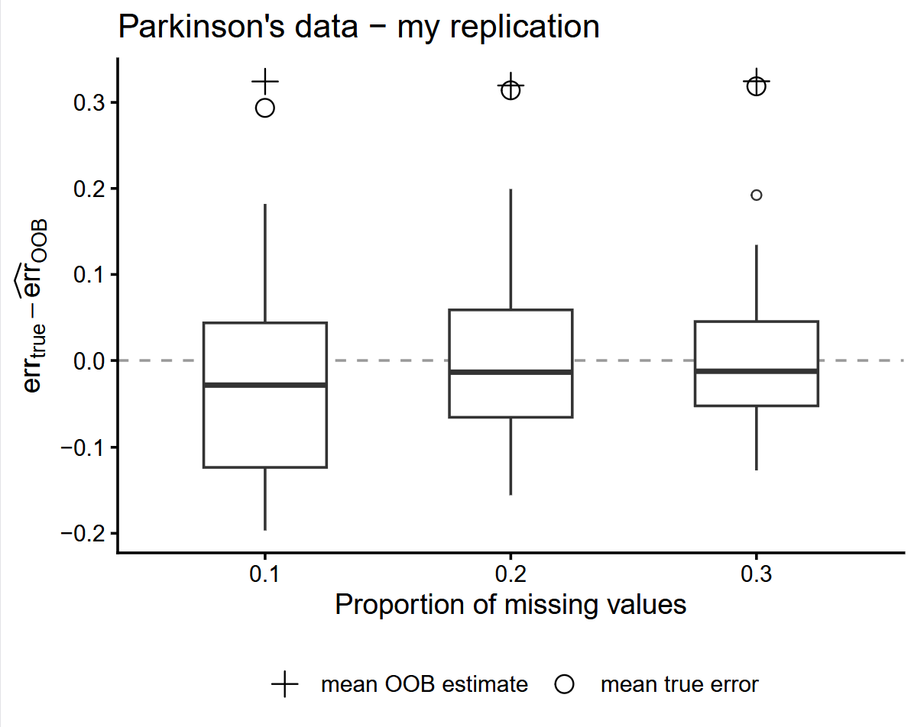
Figure 1: Difference between the true imputation error and the OOB imputation error for three different proportions of missing values in the Parkinson’s data set.
- List all parameters required to run the code and specify the values used
Necessary to run the code is the dataset available on the UC Irvine website and the R script: replicationscript.R.
Section 0 of the script installs the necessary missForest package.
Section 1 of the script performs the missForest imputation.
- rates sets the different proportions of missing values. Set to (0.10, 0.20, 0.30)
- n_sims sets the amount of simulations that should be run. Set to 50 simulations which takes me about 15 minutes.
- Set.seed makes the run reproducable.Set to 2026
Section 2 and 3 of the script create the table with the main results and exact values and the above figure which is based on the values in the table.
- If there are substantial differences between your results and those reported in the original paper, explain the possible reasons for those differences.
There are no substantial differences between the results and those reported in the original paper.
Reference list

Little, M., McSharry, P., Hunter, E., Spielman, J., and Ramig, L. (2008). Suitability of dysphonia measurements for telemonitoring of Parkinsons disease. Available from Nature Precedings.
Stekhoven, D. J. & Bühlmann, P. (2012). MissForest—nonparametric missing value imputation for mixed-type data. Bioinformatics, 28(1), 112–118. https://doi.org/10.1093/bioinformatics/btr597
Troyanskaya, O., Cantor, M., Sherlock, G., Brown, P., Hastie, T., Tibshirani, R., Botstein, D., and Altman, R. (2001). Missing value estimation methods for DNA microarrays. Bioinformatics, 17(6), 520–525.

