Java Classes and Its Implementation Details

1. OrderManagementClass.java this Class is the Starting point of the application
2. It reads xml file from system and publishes message on Kafka TOPIC create.order
3. While running please make sure file path is correctly configure “order.xml”

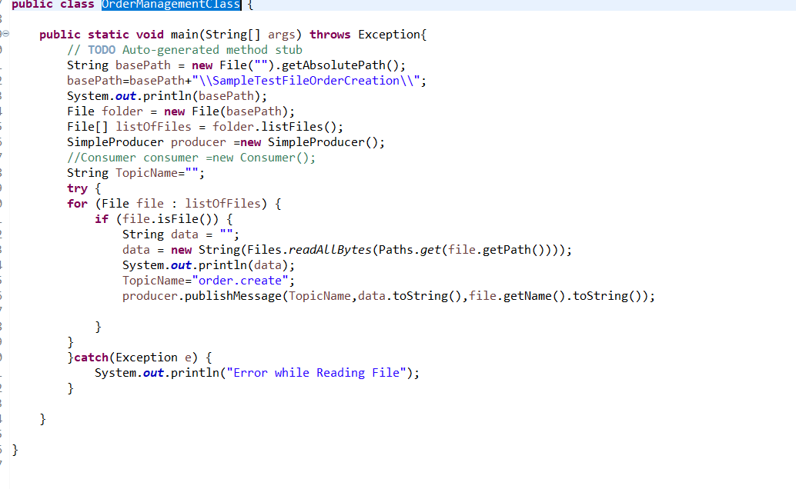

1. Consumer.java this class subscribe to Kafka TOPIC create.order and calls OrderFulfilmentApplication.java to process the order

Before running please make sure KafkaProperties.properties path configure correctly

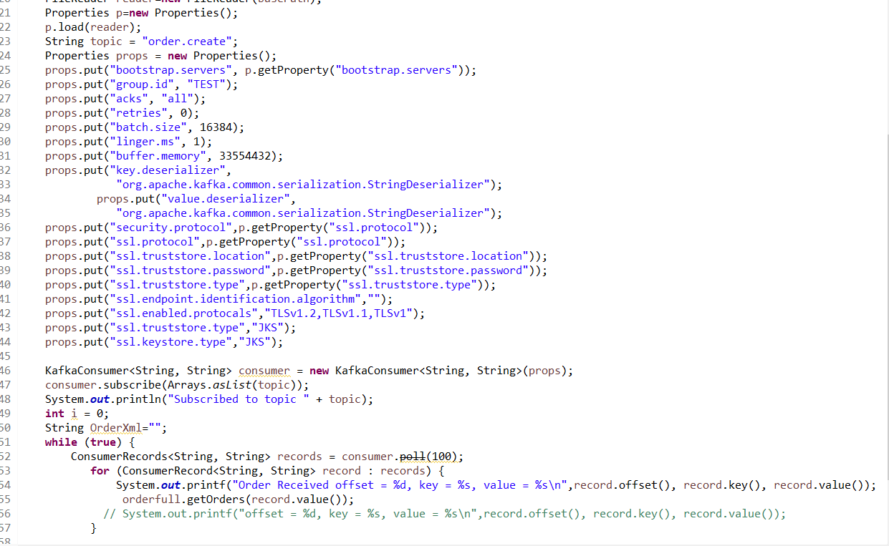

1. OrderFulfilmentApplication.java this class get the message payload and depending category its routes message to ProcessBookOrders.java or ProcessComputerOrders.java

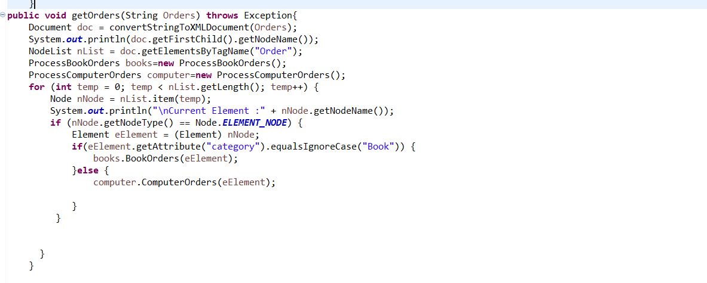

1. ProcessBookOrders.java its gets book order details and routes to different subprocess to process the order and change its status to NEW,SHIPPED and DELIVERED

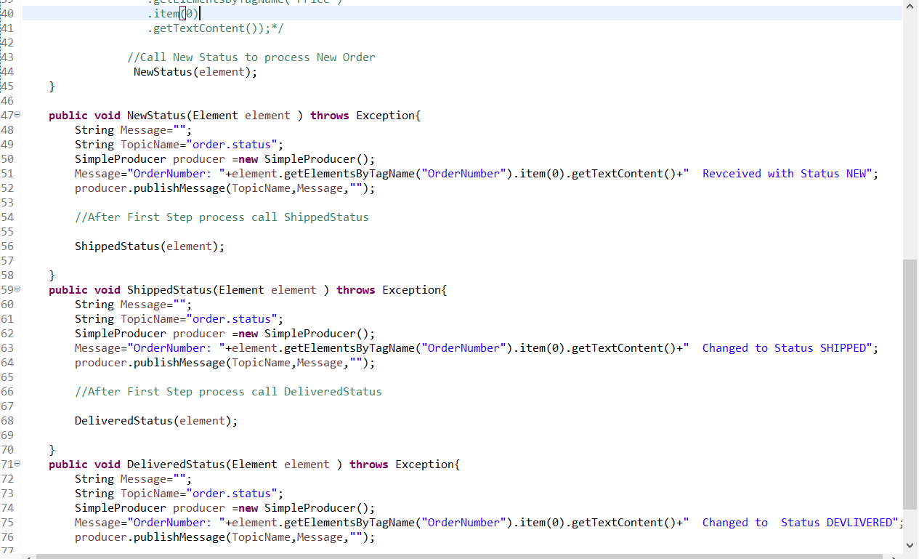

1. ProcessBookOrders.java its gets book order details and routes to different subprocess to process the order and change its status to NEW,SHIPPED and DELIVERED

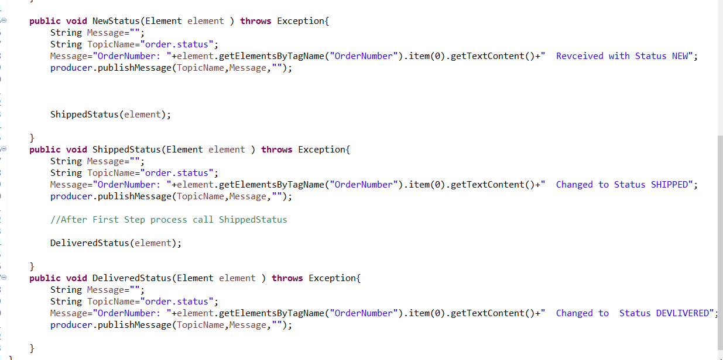

1. SimpleProducer.java this is generic producer which takes TOPIC Name and String payload which need to publish on kafka topics.

