End to End Test Case with Publish Subscribe scenarios

Note : Wherever this code downloaded jar path and other below files need to be configure to run this application, currently file path are of my systems which I used to run the application.

1. TO This this code please make sure system configure properly.
2. server.truststore.jks
3. server.keystore.jks
4. client.truststore.jks
5. order.xml

Above files should be downloaded and have entries in KafkaProperty.properties file

1. kafka-clients-2.2.0.jar
2. slf4j-api-1.7.28.jar
3. slf4j-log4j12-1.7.28.jar
4. snappy-java-1.1.7.3.jar
5. zstd-jni-1.4.3-1

Above jar files needs to integrate with Kafka Server

1. First go the C:\ AOT\JavaKafakTest\bin\Test folder using command line
2. First Run Consumer.java

java -cp "C:\Nilesh\JavaWorkPlace\JavaKafakTest\bin;C:\Nilesh\kafka2_2\kafka-clients-2.2.0.jar;C:\Nilesh\kafka2_2\slf4j-api-1.7.28.jar;C:\Nilesh\kafka2_2\slf4j-log4j12-1.7.28.jar;C:\Nilesh\kafka2_2\snappy-java-1.1.7.3.jar;C:\Nilesh\kafka2_2\zstd-jni-1.4.3-1.jar;C:\Nilesh\kafka\libs\log4j-1.2.17.jar" Test.Consumer

1. Then Run ConsumerStatus.java in new command line

java -cp "C:\Nilesh\JavaWorkPlace\JavaKafakTest\bin;C:\Nilesh\kafka2_2\kafka-clients-2.2.0.jar;C:\Nilesh\kafka2_2\slf4j-api-1.7.28.jar;C:\Nilesh\kafka2_2\slf4j-log4j12-1.7.28.jar;C:\Nilesh\kafka2_2\snappy-java-1.1.7.3.jar;C:\Nilesh\kafka2_2\zstd-jni-1.4.3-1.jar;C:\Nilesh\kafka\libs\log4j-1.2.17.jar" Test.ConsumerStatus

1. Then Run in new command line OrderManagementClass.java which reads order.xml file and publish message to kafka create.order topic

java -cp "C:\Nilesh\JavaWorkPlace\JavaKafakTest\bin;C:\Nilesh\kafka2_2\kafka-clients-2.2.0.jar;C:\Nilesh\kafka2_2\slf4j-api-1.7.28.jar;C:\Nilesh\kafka2_2\slf4j-log4j12-1.7.28.jar;C:\Nilesh\kafka2_2\snappy-java-1.1.7.3.jar;C:\Nilesh\kafka2_2\zstd-jni-1.4.3-1.jar;C:\Nilesh\kafka\libs\log4j-1.2.17.jar" Test.OrderManagementClass

SameMessage Structure :order.xml which has multiple orders.

<?xml version = "1.0"?>

<Orders>

<Order category = "book">

<OrderNumber>123456</OrderNumber>

<BookName>The Tiger</BookName>

<BookAuthor>Nilesh</BookAuthor>

<Price>85</Price>

</Order>

<Order category = "book">

<OrderNumber>123457</OrderNumber>

<BookName>The Lion</BookName>

<BookAuthor>Nilesh</BookAuthor>

<Price>85</Price>

</Order>

<Order category = "computer">

<OrderNumber>123458</OrderNumber>

<ComputerModel>T400</ComputerModel>

<ComputerMake>Lenovo</ComputerMake>

<Price>85000</Price>

</Order>

</Orders>

1. After running OrderManagementClass.java you should see xml files is read and message publish to create.order topic

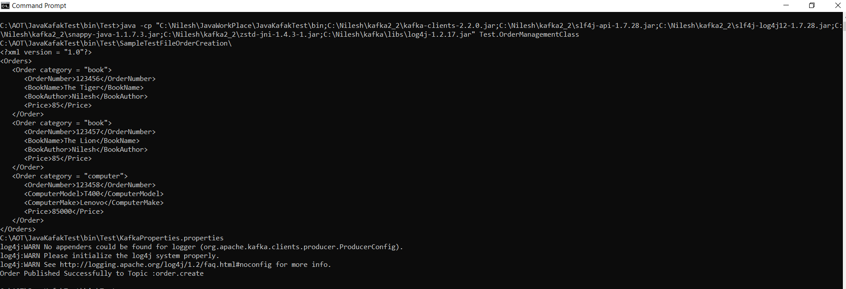

1. One command line where Consumer.java is running and you should see message received processed and sent to other topic create.status

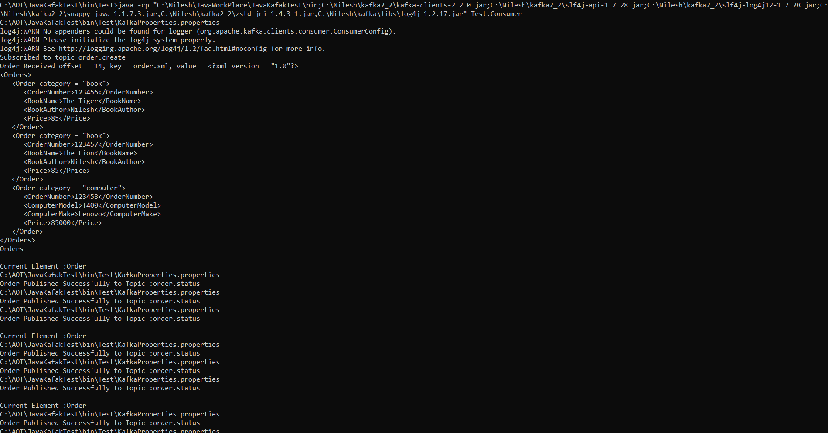

1. One command line where ConsumerStatus.java is running and you should see message received for status changed

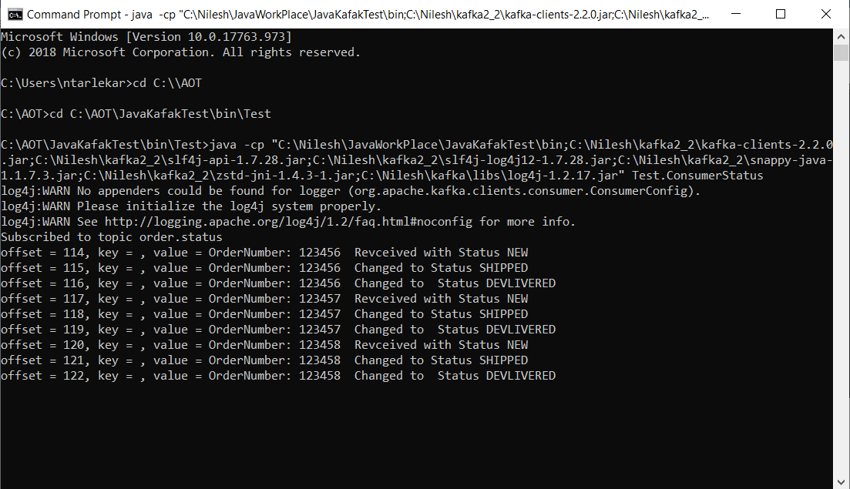

1. Negative Scenario test. Change client.truststore.jks passed in KafkaPropert.properties

Message should not publish and should get error

