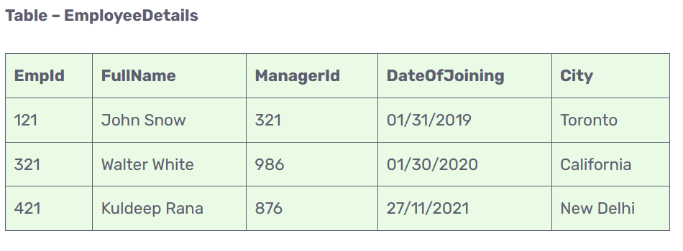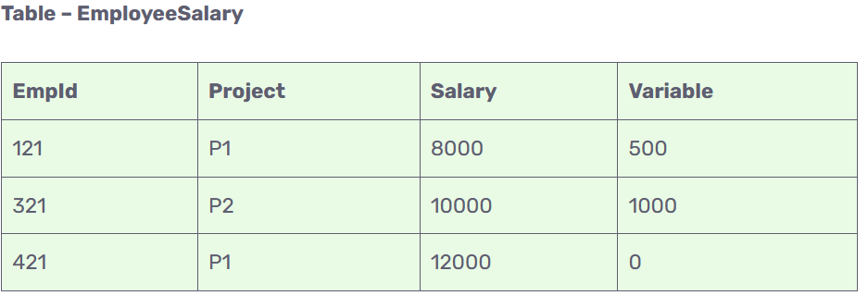

**1.Write a SQL query for creating EmployeeDetails table**.

Ans. CREATE TABLE EmployeeDetails( EmpId int,FullName varchar(32),ManagerId int, DateOfJoining date, city varchar(32));

**2.Insert data into table EmployeeDetails.**

Ans. INSERT INTO employeedetails (EmpId, FullName, ManagerId, DateOfJoining, city) VALUES (321, 'John Snow', 521, 2019-12-04, 'Dilli');

3. **Write an SQL query to fetch the EmpId and FullName of all the employees working under the Manager with id – ‘986’.**

**Ans.** SELECT EmpId, FullName

FROM EmployeeDetails

WHERE ManagerId = 986;

**4. Write an SQL query to fetch the different projects available from the EmployeeSalary table.**

Ans. SELECT DISTINCT(Project)

FROM EmployeeSalary;

**5. Write an SQL query to fetch the count of employees working in project ‘P1’.**

Ans. SELECT COUNT(*)

FROM EmployeeSalary

WHERE Project = 'P1';

**6. Write an SQL query to find the maximum, minimum, and average salary of the employees.**

Ans. SELECT Max(Salary),

Min(Salary),

AVG(Salary)

FROM EmployeeSalary;

7. **Write an SQL query to find the employee id whose salary lies in the range of 9000 and 15000.**

**Ans.** SELECT EmpId, Salary

FROM EmployeeSalary

WHERE Salary BETWEEN 9000 AND 15000;

**8.Write an SQL query to fetch those employees who live in Toronto and work under the manager with ManagerId – 321.**

**Ans.** SELECT EmpId, City, ManagerId

FROM EmployeeDetails

WHERE City='Toronto' AND ManagerId='321';

**9. Write an SQL query to** f**etch all the employees who either live in California or work under a manager with ManagerId – 321.**

**Ans.** SELECT EmpId, City, ManagerId

FROM EmployeeDetails

WHERE City='California' OR ManagerId='321';

**10. Write an SQL query delete any row from EmployeeDetails.**

**Ans.** Delete from EmployeeDetails where EmpId=121;