1. Evidence of the design

a. Requirement Specification for ABC tax record reading system.

A user enters a person ID and press the "get tax report" button. Then the application displays user details and his tax records for the past years.

The person details comprise of name, address and contact details. Personal tax records consist of a summary of annual tax records. A tax record consists of year, annual income, tax rate, taxed amount and paid amount. The person details will be shown be shown next to the person ID in the layout.

Annual tax report information will be presented in a table format.

The application does not allow user to alter information. The data displayed will be read only.

The application needs to implement to support a distributed environment where each component needs to operate independently. Each layer of the distributed environment (GUI, Service layer, Business rules and database) to have clearly defined API.

b. Class diagram

\* Class diagram was drawn on Axure and a copy of the file is included in the folder.

\* A diagram of a layer structure of the application is included in the folder.

c. Test results

Each layer was tested using a main method to ensure the class implementation is valid. It ensured the expected result were met.

1.Testing the StaffDetailsWrapper class

Results: positive results

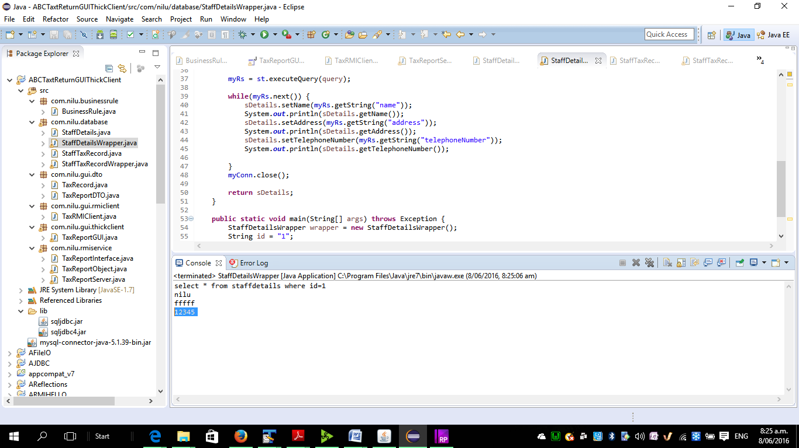

2.Testing the TaxRecordWrapper class

Result: positive result

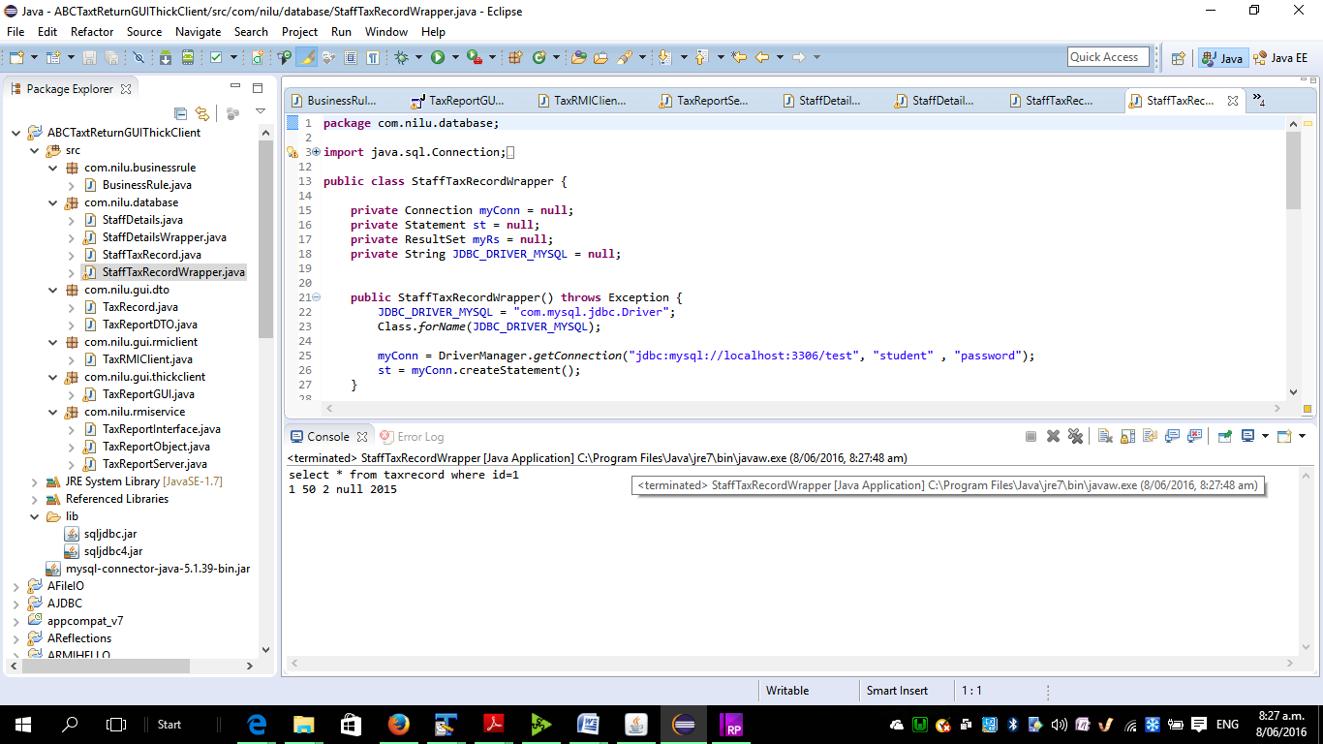

3.Testing BusinessRule

Test result: Positive

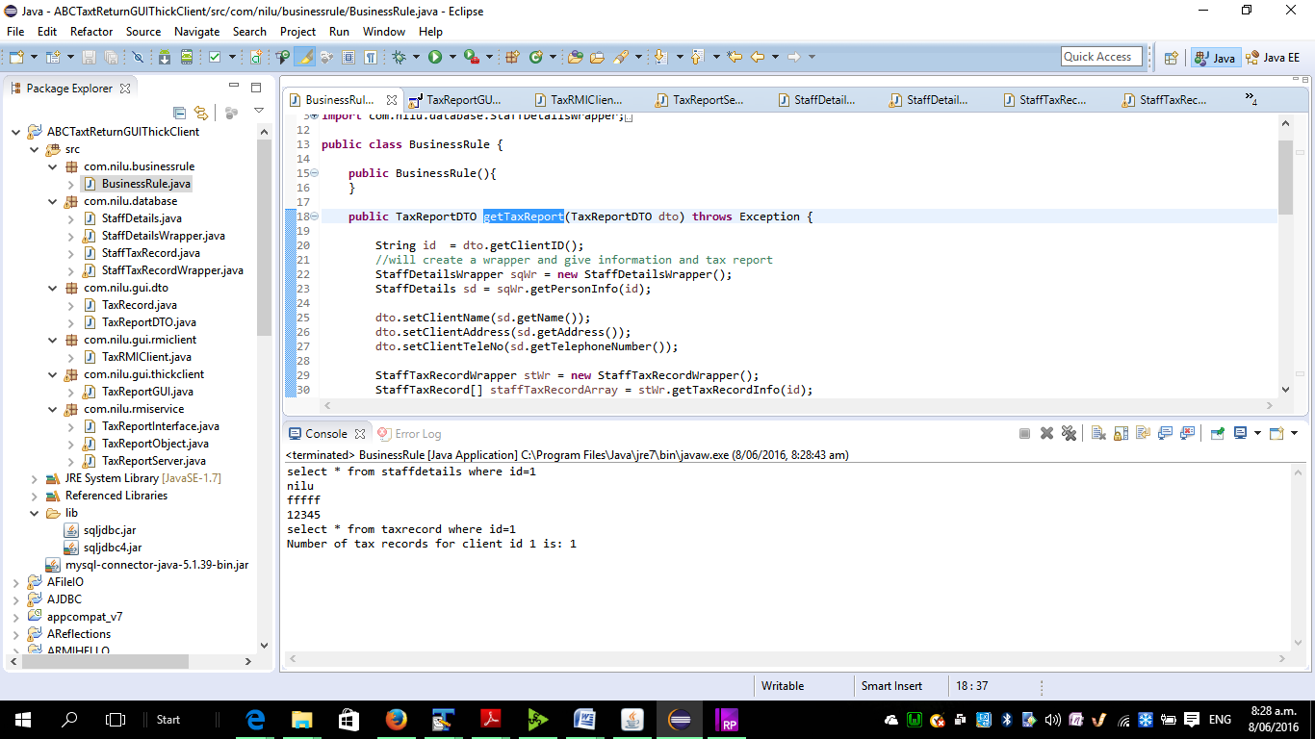

4. Incremental Development

tested the GUI first as a single application

Results: positive details were shown on the GUI.

added the Service layer and then tested service layer

Results: positive details were shown on the GUI

Results shown a as a print screen below:

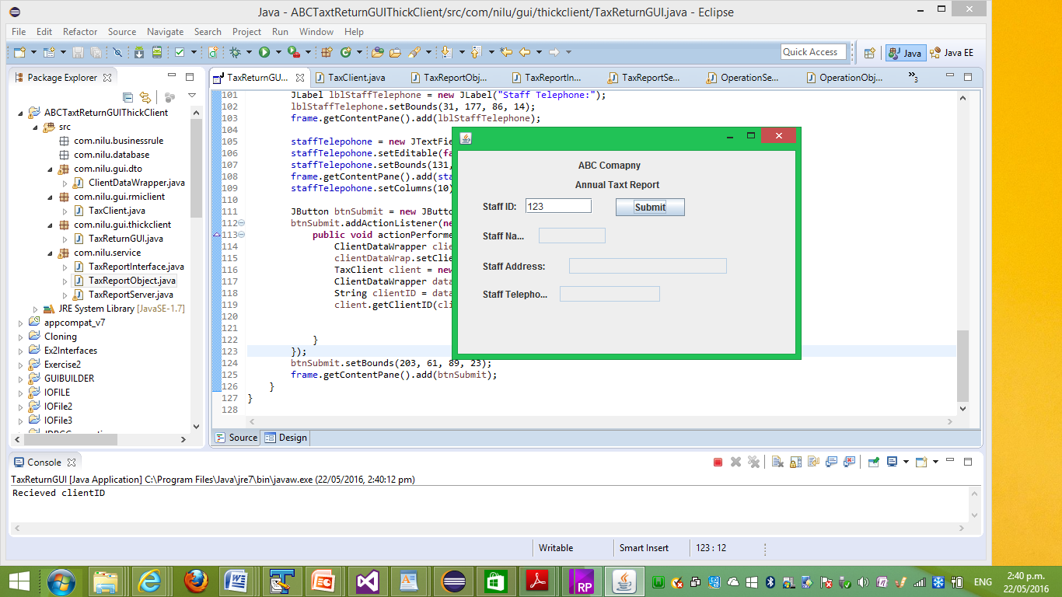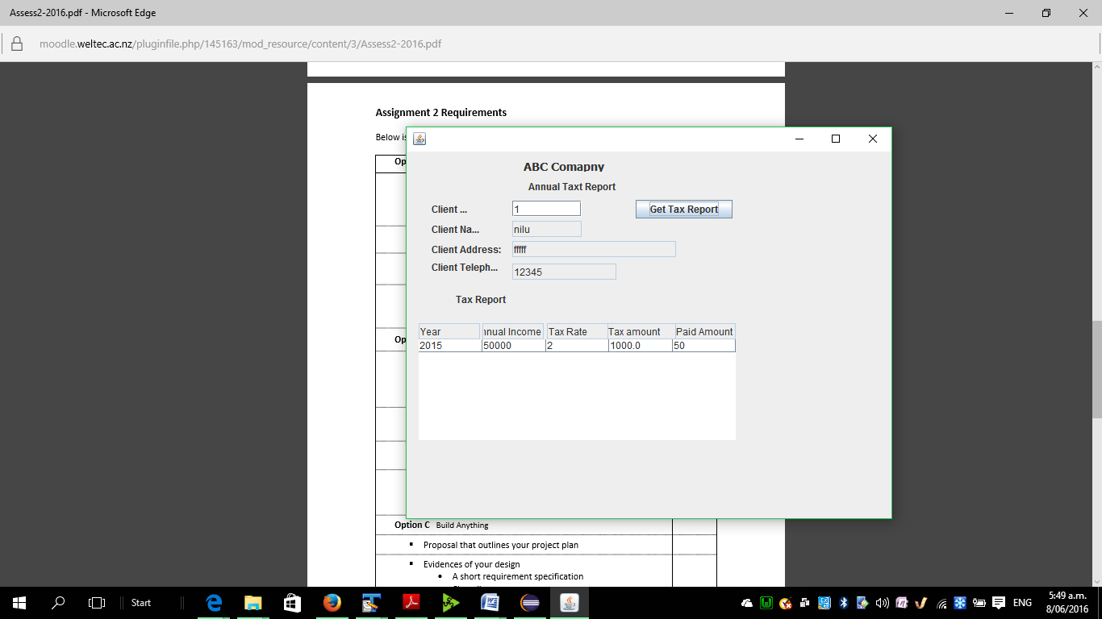

d. Screen shot of application

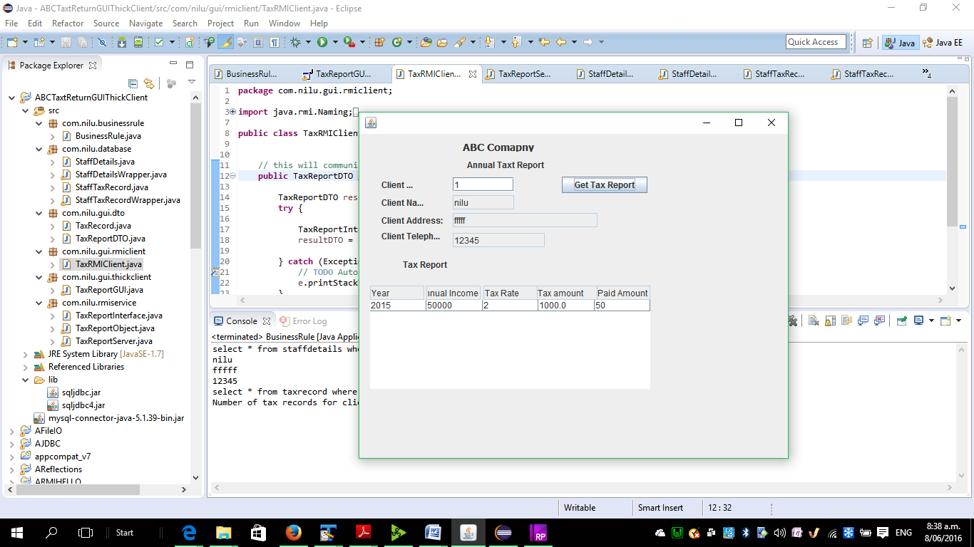

Application showing multiple records

