Initiate a plan with AI following a systematic approach
- Used a well formulated prompt with a persona, clear task, expected output and context that directs the AI to come up with a more robust and accurate plan
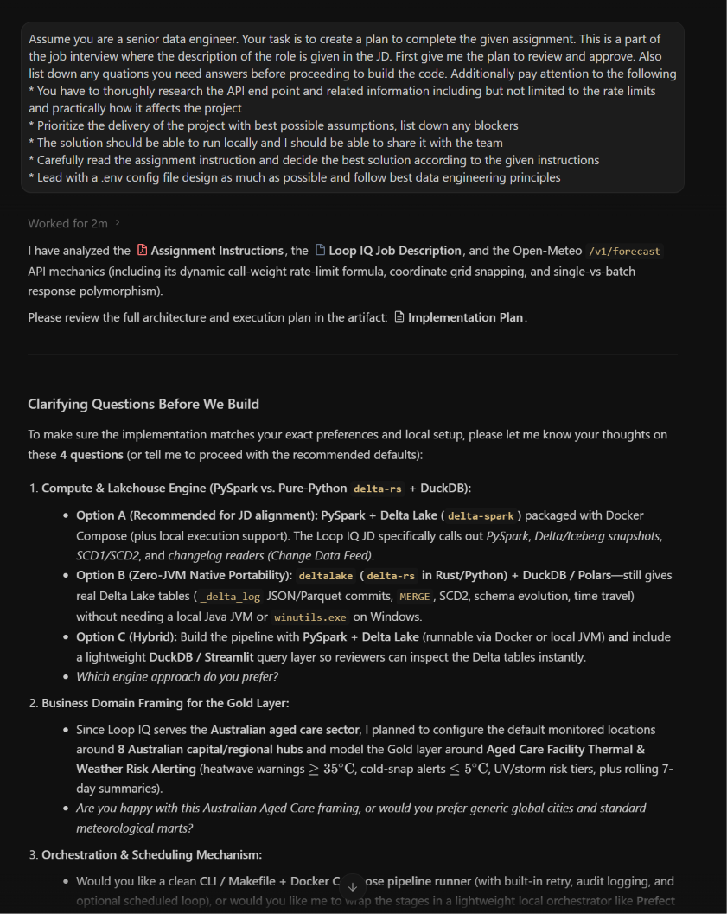

Enhanced AI responses
- Added more valuable features to the initial plan given by the AI. These features are adding a data dictionary, track API rate limit and a plan to archive data files
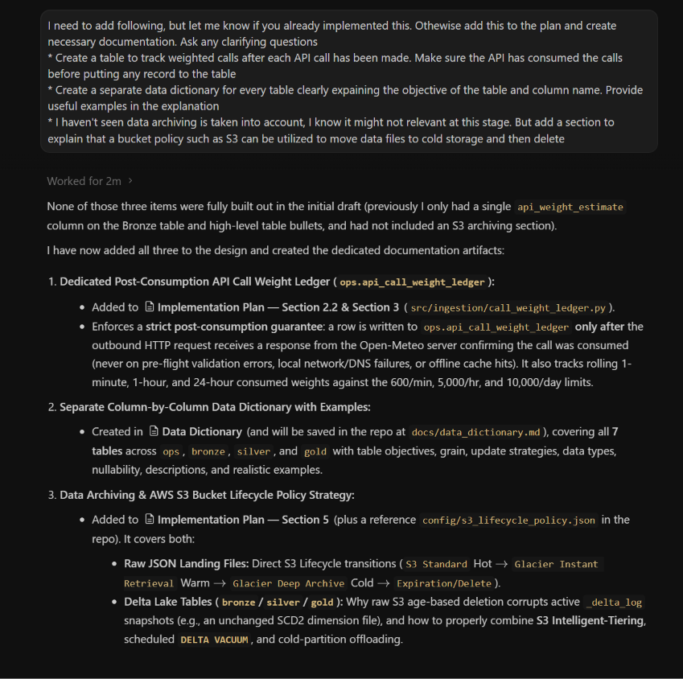
- Refine the plan and tighten or correct few initial suggestions given by the AI.
- Design 3 bronze tables for 15_minute, hourly and daily weather events instead of just dumping raw data to a single bronze table: this is useful in case it needs to fix or edit one feature
- Create and document data quality rules: Essential for regulated environments
- Clearly explain field origins in the data dictionary: Help understand every field used in the model
- Add a logging mechanism: Required feature to trace errors in case of a failure and to run the remaining components without running the whole pipeline again
- Remove is_forecast flag from silver layer: Forecast flag should be dynamically decided based on the time of the reporting. Silver layer does not intend to for reporting. Therefore this flag should be defined in the gold layer
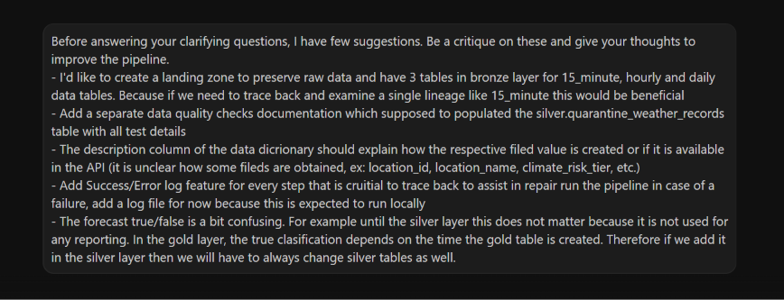
AI responses (shortened)
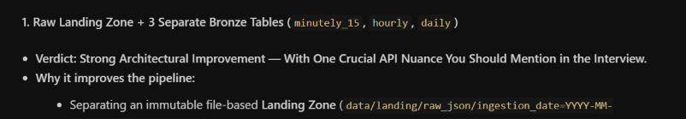
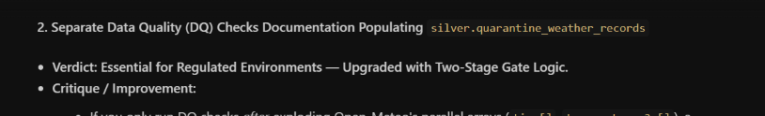
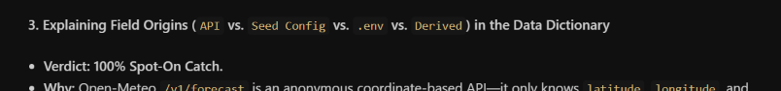
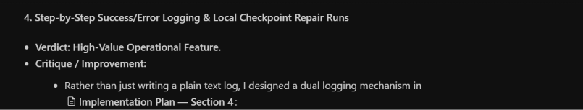
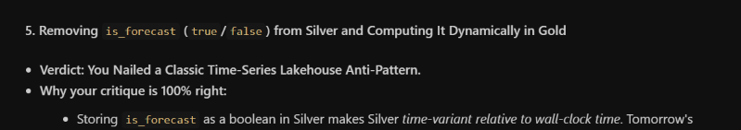

Cross validate one AI plan with another AI
- For greater accuracy it is good practice to validate the plan given by Gemini with another AI such as Claude. This will give us an unbiased assessment of the MVP and get the project moving with the best plan. However measures has to be taken to prevent Claude being too critique about the current plan and making substantial changes which will go through unnecessary back and forth cycle of reviews delaying the first version of the product (img: validate1).
- Used Claude to refine the repo after testing the workflow locally in the development PC as well as in another PC, which verified the end to end run with repair run and failure logs. Clause was able to close some minor gaps and make the pipeline more robust (img: validate2)

Validate 1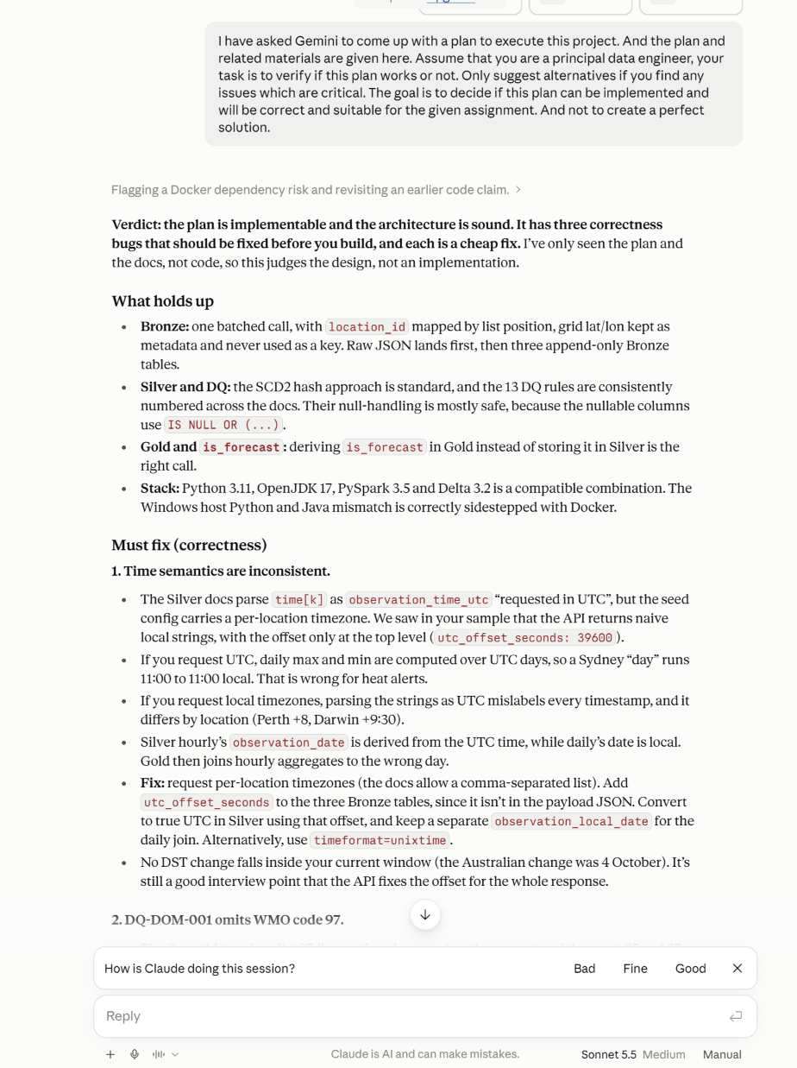
Validate 2
