METHOD

- Search Tree
The search tree is generated as an n-ary tree represented by an adjacency list (vector<vector<int>>). The function takes two parameters. The total number of nodes and the maximum number of branches per node. It iterates through each node i and calculates its children using the formula child = branches * i + j , where j is the current branch number. The graph populates level by level, and an ‘if’ condition ensures no child nodes are added once the total_nodes limit is reached.
- Implementation of BFS
The BFS function takes a constant reference to the graph's adjacency list, a start node, a goal node, and a measurements structure to track performance metrics. It uses a visited array to avoid processing cycles, a parent array to reconstruct the final path, and a FIFO queue to manage the exploration. The search begins by pushing the start node into the queue and marking it visited. While the queue is not empty, the algorithm pops the front node (current). If it is the goal, the search terminates early. Otherwise, it iterates through all unvisited neighbors of current, marks them as visited, sets current as their parent, and pushes them into the queue. Throughout this process, it updates the maximum queue size, node expansion count, and execution time. Then it uses the parent array to track from the goal to the start, printing the path found.
- Implementation of DFS
The DFS function takes a constant reference to the graph's adjacency list, a start node, a goal node, and a measurements structure to track performance. It uses a visited array to prevent cycles, a parent array to reconstruct the path, and a LIFO stack to manage exploration. The search begins by pushing the start node onto the stack. While the stack is not empty, the algorithm pops the top node (current). It checks if the node has already been visited. If not, it marks it visited and increments the expansion count. If it is the goal, the search terminates early. Otherwise, it iterates through all unvisited neighbors in reverse order, pushing rightmost children first so that the leftmost child sits at the top of the stack to be processed next. It logs their parent and pushes them onto the stack. Then it uses the parent array to track from the goal to the start, printing the path found.

- Implementation of DLS
The DLS function is a recursive variation of DFS that takes the graph's adjacency list, the current node, the goal, a depthLimit, tracking arrays (visited and path), a measurements structure, and the currentDepth. At each call, it updates the maximum recursion depth and increments the expanded nodes count. If the current node is the goal, it pushes the node to the path array and returns true. If the node is not the goal and depthLimit == 0, it returns false, stopping deeper exploration. Otherwise, it marks the node as visited and recursively calls DLS on all unvisited neighbors, passing depthLimit - 1 and currentDepth + 1. If any recursive call returns true, the current node adds itself to the path and returns true, building the path in reverse as the recursion unwinds. If no neighbors lead to the goal, it backtracks by marking the current node unvisited (visited[current] = false) and returns false.

- Implementation of IDS
The IDS function is an iterative function that repeatedly calls the DLS function. It takes the graph's adjacency list, the start node, the goal, a maximum depth limit, and a measurements structure. Instead of being recursive itself, IDS uses a ‘for’ loop to increase the depth limit from 0 up to maximum depth. At the start of each iteration, it resets the visited array, the path, and temporary metrics, starting a fresh Depth-Limited Search. After each DLS call, it adds the nodes expanded during that iteration to the running total and updates the maximum stack size. If DLS successfully finds the goal, IDS sets the success flag to true, prints the reversed path, and immediately breaks out of the loop to prevent searching deeper. If the loop reaches maximum depth without success, it reports that the goal was not found. Finally it records the total execution time across all iterations.

- Execution time and space usage
The execution time and space usage were tracked using a measurements structure passed by reference into each algorithm. To measure execution time, the C++ std::chrono::high_resolution_clock was used to capture timestamps immediately before the search began and immediately after it is over, storing the duration in milliseconds in the structure's executionTime field. Measuring the space usage, for BFS and DFS, the code checks the size of the queue or stack during every iteration and updates the stackSize variable if the current size exceeds the previous maximum. For DLS and IDS, which are recursive, space was measured by tracking the maximum recursion depth reached (currentDepth + 1). Additionally, the structure tracks the total number of nodesExpanded to measure the overall computational effort of each search.

RESULTS
Execution Time (ms)
 |  | BFS | DFS | DLS | IDS
Tree Size(no. of nodes) | 1000 | 4.2384 | 3.2099 | 3.1726 | 7.1895
(branches=2) | 10000 | 44.854 | 39.5937 | 12.8641 | 81.5842
 | 100000 | 816.909 | 395.82 | 626.165 | 1736.37
 | 1000000 | 5123.2 | 3823.79 | 6527.93 | 18891.9
 | 5000000 | 16927.2 | 34778.1 | 22337.9 | 109189
 | 10000000 | 34620.5 | 35266.6 | 14206.5 | 79587.3
Branching Factor | 2 | 24.5999 | 12.1497 | 9.9838 | 47.1841
(nodes=1000) | 3 | 13.4044 | 10.9406 | 6.6003 | 13.4868
(goal=999) | 4 | 12.073 | 8.5024 | 6.7661 | 8.6193
 | 5 | 7.0201 | 1.2776 | 0.9906 | 4.0306
Goal Position | Near the root(6) | 0.1012 | 2.76 | 0.0417 | 0.0727
(nodes-1000) | Middle depth(500) | 2.0412 | 4.8969 | 3.8369 | 3.8071
 | Deep level(990) | 5.0021 | 3.5585 | 2.9609 | 8.1632
 | Does not exist | N/A | N/A | N/A | N/A
Tree Structure | Relatively balanced | 11.2502 | 6.5374 | 9.5564 | 14.5267
(goal=900) | Highly imbalanced | 11.8322 | 6.4004 | 0.0999 | 0.9913
Depth Limit | 2 | 4.3287 | 4.105 | 0.034 | 6.0724
(goal=900) | 4 | 4.6157 | 2.4577 | 0.0976 | 5.7508
 | 6 | 4.8688 | 2.4989 | 0.4072 | 5.6774
 | 8 | 3.4293 | 2.4189 | 2.3015 | 8.6279
 | 10 | 3.5853 | 2.4426 | 4.2753 | 6.1341
Table 1: Execution Time (milliseconds)
Nodes Expanded
 |  | BFS | DFS | DLS | IDS
Tree Size(no. of nodes) | 1000 | 1000 | 981 | 981 | 1994
(branches=2) | 10000 | 10000 | 9622 | 3626 | 19995
 | 100000 | 100000 | 28938 | 68940 | 199994
 | 1000000 | 1000000 | 551436 | 951438 | 1999993
 | 5000000 | 5000000 | 4611406 | 1611408 | 9999992
 | 10000000 | 1000000 | 9222799 | 3222801 | 19999992
Branching Factor | 2 | 1000 | 981 | 981 | 1994
(nodes=1000) | 3 | 1000 | 955 | 955 | 1498
(goal=999) | 4 | 1000 | 881 | 881 | 1334
 | 5 | 1000 | 276 | 276 | 1251
Goal Position | Near the root(6) | 7 | 769 | 13 | 11
(nodes-1000) | Middle depth(500) | 501 | 982 | 982 | 995
 | Deep level(990) | 991 | 960 | 960 | 1973
 | Does not exist | N/A | N/A | N/A | N/A
Tree Structure | Relatively balanced | 901 | 784 | 784 | 1797
(goal=900) | Highly imbalanced | 901 | 901 | 11 | 66
Depth Limit | 2 | 901 | 784 | 7 | 1797
(goal=900) | 4 | 901 | 784 | 31 | 1797
 | 6 | 901 | 784 | 127 | 1797
 | 8 | 901 | 784 | 511 | 1797
 | 10 | 901 | 784 | 784 | 1797
Table 2: Nodes Expanded
Maximum queue/stack size
 |  | BFS | DFS | DLS | IDS
Tree Size(no. of nodes) | 1000 | 500 | 10 | 10 | 10
(branches=2) | 10000 | 5000 | 14 | 14 | 14
 | 100000 | 50000 | 17 | 17 | 17
 | 1000000 | 500000 | 20 | 20 | 20
 | 5000000 | 2500000 | 23 | 23 | 23
 | 10000000 | 5000000 | 24 | 24 | 24
Branching Factor | 2 | 500 | 10 | 10 | 10
(nodes=1000) | 3 | 667 | 13 | 7 | 7
(goal=999) | 4 | 750 | 16 | 6 | 6
 | 5 | 800 | 21 | 6 | 6
Goal Position | Near the root(6) | 7 | 10 | 4 | 3
(nodes-1000) | Middle depth(500) | 500 | 10 | 10 | 9
 | Deep level(990) | 500 | 10 | 10 | 10
 | Does not exist | N/A | N/A | N/A | N/A
Tree Structure | Relatively balanced | 500 | 10 | 10 | 10
 | Highly imbalanced | 1 | 1 | 11 | 11
Depth Limit | 2 | 500 | 10 | 3 | 10
(goal=900) | 4 | 500 | 10 | 5 | 10
 | 6 | 500 | 10 | 7 | 10
 | 8 | 500 | 10 | 9 | 10
 | 10 | 500 | 10 | 10 | 10
Table 3: Maximum queue/stack size
Goal found/not found
 |  | BFS | DFS | DLS | IDS
Tree Size(no. of nodes) | 1000 | Yes | Yes | Yes | Yes
(branches=2) | 10000 | Yes | Yes | Yes | Yes
 | 100000 | Yes | Yes | Yes | Yes
 | 1000000 | Yes | Yes | Yes | Yes
 | 5000000 | Yes | Yes | Yes | Yes
 | 10000000 | Yes | Yes | Yes | Yes
Branching Factor | 2 | Yes | Yes | Yes | Yes
(nodes=1000) | 3 | Yes | Yes | Yes | Yes
(goal=999) | 4 | Yes | Yes | Yes | Yes
 | 5 | Yes | Yes | Yes | Yes
Goal Position | Near the root(6) | Yes | Yes | Yes | Yes
(nodes-1000) | Middle depth(500) | Yes | Yes | Yes | Yes
 | Deep level(990) | Yes | Yes | Yes | Yes
 | Does not exist | No | No | No | No
Tree Structure | Relatively balanced | Yes | Yes | Yes | Yes
(goal=900) | Highly imbalanced | Yes | Yes | No | No
Depth Limit | 2 | Yes | Yes | No | Yes
(goal=900) | 4 | Yes | Yes | No | Yes
 | 6 | Yes | Yes | No | Yes
 | 8 | Yes | Yes | No | Yes
 | 10 | Yes | Yes | Yes | Yes
Table 4: Goal found/not found

Goal Depth
 |  | BFS | DFS | DLS | IDS
Tree Size(no. of nodes) | 1000 | 9 | 9 | 9 | 9
(branches=2) | 10000 | 13 | 13 | 13 | 13
 | 100000 | 16 | 16 | 16 | 16
 | 1000000 | 19 | 19 | 19 | 19
 | 5000000 | 22 | 22 | 22 | 22
 | 10000000 | 23 | 23 | 23 | 23
Branching Factor | 2 | 9 | 9 | 9 | 9
(nodes=1000) | 3 | 6 | 6 | 6 | 6
(goal=999) | 4 | 5 | 5 | 5 | 5
 | 5 | 5 | 5 | 5 | 5
Goal Position | Near the root(6) | 2 | 2 | 2 | 2
(nodes-1000) | Middle depth(500) | 8 | 8 | 8 | 8
 | Deep level(990) | 9 | 9 | 9 | 9
 | Does not exist | N/A | N/A | N/A | N/A
Tree Structure | Relatively balanced | 9 | 9 | 9 | 9
(goal=900) | Highly imbalanced | 900 | 900 | N/A | N/A
Depth Limit | 2 | 9 | 9 | N/A | 9
(goal=900) | 4 | 9 | 9 | N/A | 9
 | 6 | 9 | 9 | N/A | 9
 | 8 | 9 | 9 | N/A | 9
 | 10 | 9 | 9 | 9 | 9
Table 5: Goal Depth
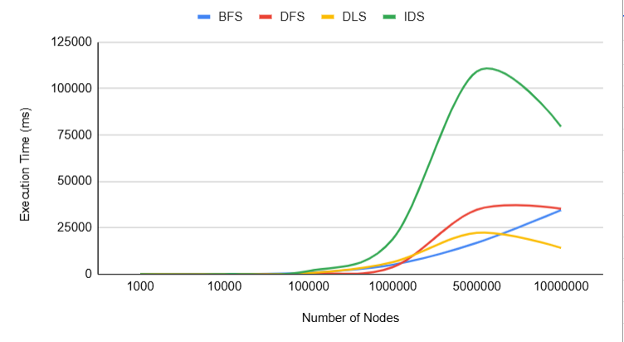
Graph 1: Execution Time
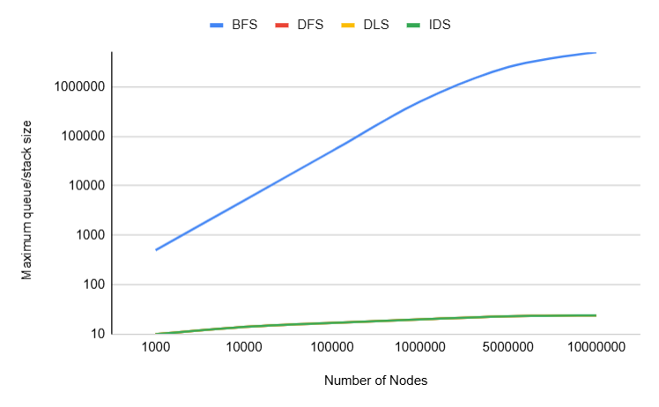
Graph 2: Space Usage
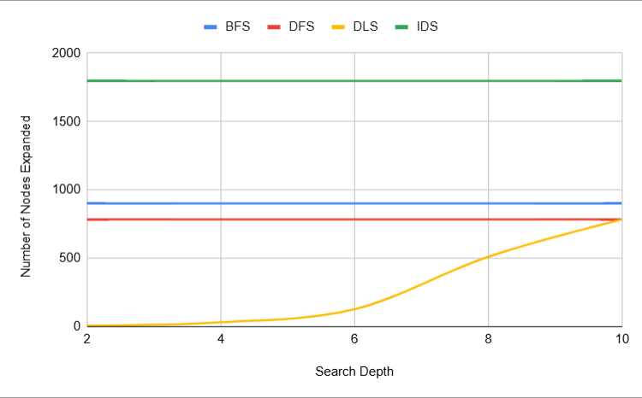
Graph 3: Effect of Depth

DLS is the fastest one and IDS is the slowest one. Both BFS and DFS suitable for max scale but DFS is highly efficient in mid-scales (Graph 1).
BFS experiences severe exponential memory growth at the large scale because it must keep an entire level of the tree in memory simultaneously. DFS, DLS and IDS shows highly optimized, logarithmic space complexity, keeping their maximum stack sizes remarkably flat at just 24 entries even when tracking 10,000,000 nodes (Graph 2).
BFS, DFS, and IDS expand a completely fixed number of nodes (901, 784, and 1,797 respectively) regardless of the search depth. Meanwhile DLS shows an exponential growth as search depth increases, expanding just 7 nodes at depth 2 up to 784 nodes at depth 10 (Graph 3).
DISCUSSION
- BFS used by far the most memory. BFS required a maximum queue size of 5,000,000 entries at the 10 million node scale. This happens because BFS explores level by level, forcing it to hold the current depth's nodes in RAM simultaneously.
- DLS was the fastest when the target was outside its limit or at the very bottom. It hits a hard depth limit, triggers a cut-off failure, and stops exploring early.
DFS was the fastest in mid-scale successful searches. It dives straight down a single branch and can hit the goal quickly without expanding side nodes.
BFS becomes highly competitive at larger scales. When a tree is fully saturated, the queue operations in BFS can outpace deep recursive backtracking stack frames.
- When the branching factor increased, the number of nodes grew exponentially.
BFS memory to explode immediately, as a wider tree means exponentially more sibling nodes must be tracked in the queue at once.
IDS and DLS runtimes to slow down significantly due to the sheer volume of new generation paths generated at the deeper thresholds.
- If the goal was near the root, BFS found it instantly. The slowest was DFS.
If the goal was in middle depth, DFS found it rapidly. The slowest was IDS.
If the goal was in deep level, DFS was the faster and both BFS and IDS were slower.
- When the DLS depth limit was smaller than the goal depth, DLS failed and reported Goal not found.
- IDS repeats previous searches because it does not keep a history of expanded nodes between iterations. This type of designs focus on saving memory.
- The experimental results mostly agreed with theoretical complexities, with minor deviations caused by the device used for the experiment. In some instances some algorithms struggled with relatively higher runtimes even in their ideal search scenarios. This occurred because the machine was forced to deal with cache pollution.

COMPUTER SPECIFICATIONS
Processor - Intel(R) Core(TM) i7-7600U CPU @ 2.80GHz 2.90 GHz
Installed RAM - 8.00 GB (7.89 GB usable)
Graphics Card - Intel(R) HD Graphics 620 (128 MB)
Storage - 238 GB SSD THNSF5256GPUK TOSHIBA
System Type - 64-bit operating system, x64-based processor

