**Title**: Physical Fitness is Related to Body Fat and Heart Rate Variability during Exercise in Community-Dwelling Older People: a cross-sectional study.

**Authors**: Autor,1 Autor,2 Autor,3 Autor,4 Autor,5 Autor.6 *

1 Affiliation, location.

2 Affiliation, location.

3 Affiliation, location.

4 Affiliation, location.

5 Affiliation, location.

6 Affiliation, location.

### *Corresponding author

Autor, Affiliation, location. e-mail: autor@mail.com. Address: XXXX. Phone: XXXX.

## Abstract

**Background**: Physical fitness, body composition, and the autonomic response to exercise are important predictors of health-related outcomes in older adults, but their interplay is not fully understood, therefore, this study aims to assess the associations between these variables and possible mediating effects. **Methods**: an observational cross-sectional study was conducted in 81 community-dwelling older people, recruited by non-probabilistic sampling. To obtain body composition parameters, a bio-impedance analysis was made, then, the Short Physical Performance Battery (SPPB) was used to assess physical fitness, and the Heart Rate Variability (HRV) was recorded before, during and after the Two-Minute Step Test (TMST), to assess cardiac autonomic response to physical exercise. Geriatric depression and anxiety symptoms were assessed as secondary measures. Correlation and mediating effects analyses were carried out. **Results**: SPPB score was negatively related to body fat percentage (r = -0.273, p = 0.015), but positively related to SNS index during exercise (r = 0.313, p = 0.006). Also, a negative link existed between body fat and sympathetic activity: SNS index (r = -0.252, p = 0.030) and Stress index (r = 0.258, p = 0.027) during TMST. But a positive link with parasympathetic activity: RMSSD (r = 0.253, p = 0.029) and SDNN (r = 0.269, p = 0.020) **Conclusion**: Body fat was inversely correlated to both physical fitness and cardiac autonomic activity during exercise, with sympathetic drive associated with physical fitness in older people. Furthermore, physical fitness may mediate the effect of body fat on cardiac autonomic activity during exercise, and total muscle mass may mitigate the negative effect of increased adiposity on physical fitness, highlighting its pivotal role in older people’s health. However, further research is needed to elucidate mediating effects of psychological variables in this field.

**Keywords**: Aged, Physical Functional Performance, Exercise Test, Body Composition, Autonomic Nervous System

# Introduction

The process of aging is accompanied by a multitude of physiological changes that have the potential to significantly impact people’s overall health and well-being (1,2). Body composition and cardiovascular function are particularly relevant, as they are closely associated with the aging process (3–7). In recent times, there has been a growing interest in comprehending the interplay between physical fitness, body composition, and cardiac autonomic response to exercise in older individuals, as these factors play pivotal roles in determining health outcomes within this age group.

Physical fitness has been classically defined as the ability to perform daily tasks with vigor and without undue fatigue, and with ample energy to enjoy leisure-time pursuits and to meet unforeseen emergencies (8). Therefore, it is a crucial component of healthy aging. The term encompasses a multitude of aspects, typically including cardiorespiratory endurance, muscular endurance and strength, body composition, and flexibility (9). Numerous studies have demonstrated the positive impact of physical fitness on overall health and longevity, emphasizing its role in reducing the risk of chronic diseases, and improving quality of life and functional independence in older adults (10–13)

Moreover, the alteration of body composition, specifically the proportion of body fat, is accompanied by significant changes with age, resulting in a tendency towards an increase in adiposity and a decrease in lean muscle mass (14,15). Excessive body fat accumulation, particularly visceral adiposity, has been associated with a higher risk of cardiovascular disease, metabolic disorders, and functional limitations in older individuals (16,17).

Autonomic nervous system (ANS) plays a critical role in regulating cardiovascular function, with sympathetic and parasympathetic branches exerting opposing effects on heart rate and vascular tone. Furthermore, during stressful situations, such as physical exercise, the ANS ensures a sufficient cardiac response to higher metabolic demands (18). The measurement of heart rate variability (HRV), serves as a non-invasive indicator of ANS activity and cardiovascular health (19,20). A reduction in rest HRV has been linked to various adverse outcomes, including cardiovascular events and morbidity, while insufficient HRV reduction during exercise may lead to impaired physical capacity (20–22).

However, HRV is not only influenced by physical and environmental stressors. Psychological factors such as anxiety and depression have also been linked to changes in ANS activity (23,24). Notably, older individuals may be more susceptible to these psychological factors, making it crucial to measure and control for their effects (25,26).

Despite extensive research into physical fitness, body composition, and cardiovascular health in older adults, gaps persist in the understanding of their interrelationships and factors mediating them. One area of interest is the relationship between physical fitness, body fat percentage, and cardiac autonomic response to exercise in older individuals. This study explores their collective influence on physical fitness in the aging population.

The conceptualization of this investigation is based on the recognition of the interplay between physical fitness, body composition, and autonomic cardiovascular regulation in aging. We aim to answer the following research question: How does physical fitness relate to body fat percentage and cardiac autonomic response to exercise in older people? By elucidating these correlations, we hope to gain valuable insights into the relationships that underlie age-related modifications in physical fitness and identify potential interventions to enhance health outcomes in older adults. Even more, we seek to understand the mediating effect of the variables, including frequent psychological traits, such as geriatric depression and anxiety.

We hypothesize that physical fitness will be inversely related to body fat percentage and associated with cardiac autonomic response during exercise in older individuals. In our opinion, it will be essential for this population to have an optimal cardiac autonomic response, characterized by a shift towards sympathetic activity predominance, in order to achieve a grater performance during physical fitness testing.

The primary objective of this study is to investigate the relationship between physical fitness, body fat percentage, and cardiac autonomic response to exercise in older people. Even more, We aimed to assess the mediating effect of psychological variables on these relationships, with implications for cardiovascular health and functional capacity in aging.

# Methods

## Aims and Study design

A prospective observational, cross-sectional study was conducted in one data collection session, to determine the associations between physical fitness, body composition and cardiac autonomic response to moderate-intensity exercise.

## Setting

This study was conducted at the Centro Asistencial Docente e Investigación (Assistance, Teaching, and Research Center), belonging to the University of Magallanes (CADI-UMAG), in the city of Punta Arenas, Chile. All the assessments were made between 09:00 and 11:00 hours of the morning. The privacy and comfort of the subjects was ensured, the room temperature was set at 20°C and a white artificial lighting was used.

## Participants

81 community-dwelling older adults were recruited and selected by non-probabilistic sampling, from the Region of Magallanes and Chilean Antartica, Chile. They were included if: 65 years age or older; residents of the Region of Magallanes and Chilean Antarctica, Chile; and being able to understand the study aims and instructions. But they were excluded in case of: diagnosis of congenital heart disease; consumption of beta-blocker drugs, taking stimulant substances within 24 h before assessments session; motor or cognitive disability; inability to understand instructions or written content; or presence of pain during cardiac or physical assessments.

All participating subjects gave their permission and provided informed consent before participation. The Ethics Committee of the University of Magallanes (N°XXX/YY/YEAR) approved this study following the regulations established by the Declaration of Helsinki on ethical principles in human beings.

## Procedures

During recruitment, the participants were instructed to avoid the use of psychoactive substances for the 24 hours prior to the assessment, and to sleep for at least 7 hours during the previous night. Upon arrival, participants were informed about the study aims and risks associated with their participation, and the socio-demographic and medical information was collected during the initial interview. Then, Body composition parameters were measured using bioimpedance analysis, and psychological questionnaires for anxiety and depression screening were applied by a supervised psychology undergraduate student.

Cardiac autonomic response to physical exercise was measured as previously validated for this age group (27). The protocol is briefly described below:

HRV was recorded through a non-invasive chest band, immediately before, during, and immediately after the execution of the two-minutes step test (TMST). Vital signs, including blood pressure, were monitored throughout the test, and participants’ well-being was visually checked to ensure they were comfortable and prepared. For resting HRV measurements (before and after the application of the TMST), the volunteers remained seated in a chair, with feet and back supported, ensuring avoiding to talk during the recordings. R-R intervals were recorded continuously during the last 10 min of rest, and were subsequently analyzed for 5 min in each occasion. The breathing rate was spontaneous. As part of the protocol, it was ensured that the participant needed to have a blood pressure less than 140/90 mmHg to start the HRV measurements.

Finally, after 15 minutes of resting from the TMST, the Short Physical Performance Battery (SPPB) was applied to the participants. Blood pressure, heart rate and general aspect of the subjects was verified before ending the session.

Physical and physiological assessments, as well as the initial interview, were made by professional physiotherapists.

## Instruments

### Short physical performance battery

SPPB consists of a physical test used to measure three components of physical fitness, described below (28):

Balance: to achieve the maximal score (4 points), the subject should be able to stay balanced for at least 10 seconds in side-by-side stand (feet together), semi-tandem stand and tandem stand.

Usual gait speed: the subjects are asked to walk normally a 4 meters distance. Two chances are given and the best of both is registered. To achieve the maximal score (4 points), they should obtain 4.82 sec. or less.

Lower body fitness: The subjects are asked to perform 5 chair stands without using their arms and time upon complete is registered. A time lower or equal 11.19 sec. gives the maximal score (4 points).

To obtain the final score, the summing of the three components is calculated, with a maximal total score of 12 points.

### Body composition

Body mass (kg) and total body fat (%) were assessed by bioimpedance using the Tanita BC-558 Ironman Segmental Body Composition Monitor (Tanita Ironman, Arlington Heights, IL 60005, USA), with a concordance of 89.3% compared to the Dual X-ray Absorption test using standard measurement protocols (29).

### Cardiac autonomic activity

Cardiac autonomic activity was assessed using R-R interval recordings (HRV) obtained through the Polar Team2 system (Polar®) application. Artifacts and ectopic heartbeats, which did not exceed 3% of the recorded data, were excluded (30). Time-domain parameters considered for analysis included the square root of the mean squared differences of successive R-R intervals (RMSSD, expressed in ms) as an index of parasympathetic activity (31), and the standard deviation of RR intervals (SDNN), reflecting total variability encompassing both sympathetic and parasympathetic contributions to cardiac autonomic function (32,33). Additionally, the Stress Index (SI) and Parasympathetic and Sympathetic Nervous System Index (PNS and SNS, respectively) were computed. The PNS Index, indicative of total vagal stimulation, was derived from mean R-R intervals, RMSSD, and Poincaré Plot Index SD1 in normalized units (linked to RMSSD), representing deviations from normal population averages (32,34). The SNS Index, reflecting total sympathetic stimulation, was derived from mean R-R intervals, Baevsky’s Stress Index (positively related to cardiovascular system stress and cardiac sympathetic activity), and the Poincaré Plot Index SD2 in normalized units (related to SDNN) with interpretation similar to the PNS Index (32,34). The SI serves as an indicator representing the ANS control system’s workload (35), normalized by the square root of Baevsky’s SI (36). All analyses conducted to compute HRV related indices were performed using Kubios HRV® software (Kuopio, Finland).

### Two-Minutes Step Test

The TMST is a sub-test from the Senior Fitness Test, demanding a low to moderate intensity (27,37). The test consists of a two-minute assessment designed to evaluate cardiorespiratory fitness. Participants are instructed to raise their right knee to a marked point on a wall as many times as possible within the given time frame, ensuring that each raise reaches at least a 70° angle at the thigh-femoral joint. The number of valid steps were recorded for each subject.

### Geriatric Depression Scale

The 30-questions Geriatric Depression Scale (GDS-30) was employed to assess subject’s depressive symptoms (38). It consists of a 30 dichotomous questionnaire, where participants are asked about their past-week feelings in reference to depressive symptoms (for instance, “Do you feel that your life is empty?”), with higher scores (i. e., “yes” responses) representing more depressive symptoms. It was first developed by Yesavage and colleagues (39) and is currently widely used (40). The spanish version, employed in this study, has been previously validated, with a Cronbach alpha coefficient of 0.82 (41).

### Beck Anxiety Inventory

The Beck anxiety Inventory was employed to assess anxiety symptoms. It consists of a 21-items questionnaire based on usual anxiety symptoms and a 4-options Likert scale from 0 (“Not at all”) to 3 (“Severely”), meaning the severity reported by the subject in each one. It was originally developed by Beck and colleagues (42). In this study, the spanish version is used, which has demonstrated a high internal consistency in older people (α = 0.94) (43).

## Statistical analysis

We used mean and standard deviation (SD) to describe continuous variables, absolute and relative frequencies to describe discrete variables. In order to assess the relationship between variables, we used Pearson’s product-moment correlation (r), and to assess differences between groups we used standardized mean difference (SMD) and 95% confidence intervals (CI95%).

As a way of controlling for the influence of psycho-physiological variables on the cardiac autonomic response of the subjects to exercise, we assess the average causal mediation effect (ACME), the average direct effect (ADE) of the main effects after taking into account the effect of moderator variables into the observed relationships and the proportion of the effect that its mediated by these variables (44). To assess the significance of moderating variables, we used non overlapping CI95%, estimated based on non parametric bootstrapping by using Monte Carlo resampling, and bias-corrected and accelerated CI95%, using the *mediation* R package to this end (45).

We defined a type I error rate at 5% ( $α$ = 0.05) as our threshold for null hypothesis significance testing, and non-overlapping CI95% over the null effect for sex differences and mediation analyses. All analyses were computed using the *R* programming language for statistical computing, (46).

# Results

## Sample characteristics

The sample assessed consisted on 81 adults (age: 71.1 ± 6.2 years old, BMI: 31 ± 6.2 kg/m2), of whom 67 (82.7%) were females. Sociodemographic and anthropometric characteristics of the sample can be seen in table 1.

|  | | **Sex** | |  | |
| --- | --- | --- | --- | --- | --- |
| **Characteristic** | **Overall**, N = 811 | **Female**, N = 671 | **Male**, N = 141 | **Difference**2 | **95% CI**23 |
| Age (years) | 71.1 ± 6.2 | 71.0 ± 6.4 | 71.9 ± 5.5 | -0.15 | -0.73, 0.43 |
| Hypertension | 33 (41%) | 26 (39%) | 7 (50%) |  |  |
| Diabetes | 12 (15%) | 9 (13%) | 3 (21%) |  |  |
| Body weight (kg) | 74.6 ± 13.2 | 72.8 ± 12.6 | 85.0 ± 12.7 | -0.98 | -1.6, -0.33 |
| Height (cm) | 155.8 ± 9.2 | 153.3 ± 7.6 | 167.8 ± 6.3 | -2.1 | -2.8, -1.4 |
| BMI (kg/m2) | 31.0 ± 6.2 | 31.2 ± 6.5 | 29.7 ± 3.2 | 0.28 | -0.36, 0.92 |
| BMI category |  |  |  |  |  |
| Normal | 7 (9%) | 6 (9%) | 1 (9%) |  |  |
| Overweight | 35 (45%) | 29 (43%) | 6 (55%) |  |  |
| Obese | 36 (46%) | 32 (48%) | 4 (36%) |  |  |
| Muscle mass (kg) | 43.9 ± 8.2 | 41.0 ± 4.3 | 59.9 ± 6.5 | -3.5 | -4.4, -2.7 |
| Fat mass (%) | 37.5 ± 9.3 | 39.5 ± 8.3 | 26.2 ± 6.4 | 1.8 | 1.2, 2.5 |
| Bone mass (%) | 2.3 ± 0.4 | 2.2 ± 0.2 | 3.1 ± 0.3 | -3.6 | -4.5, -2.8 |
| Water (%) | 47.0 ± 6.7 | 45.4 ± 5.6 | 55.8 ± 5.0 | -2.0 | -2.7, -1.3 |

**Table 1**. Main sample characteristics. Body composition and sociodemograpic variables are displayed for the overall sample and aggregated by sex. Differences between males and females are displayed as SMD and CI95% for continuous variables.

## Body composition and autonomic response

We observed that body fat percentage was linked to a lower SNS (r = -0.252, p = 0.030) and Stress index (r = -0.258, p = 0.027) response during the TSMT. In addition, body fat percentage was positively correlated with time domain HRV during exercise, more specifically RMSSD (r = 0.253, p = 0.029) and SDNN (r = 0.269, p = 0.020). No other body composition variables were found to influence the cardiac autonomic response to exercise.

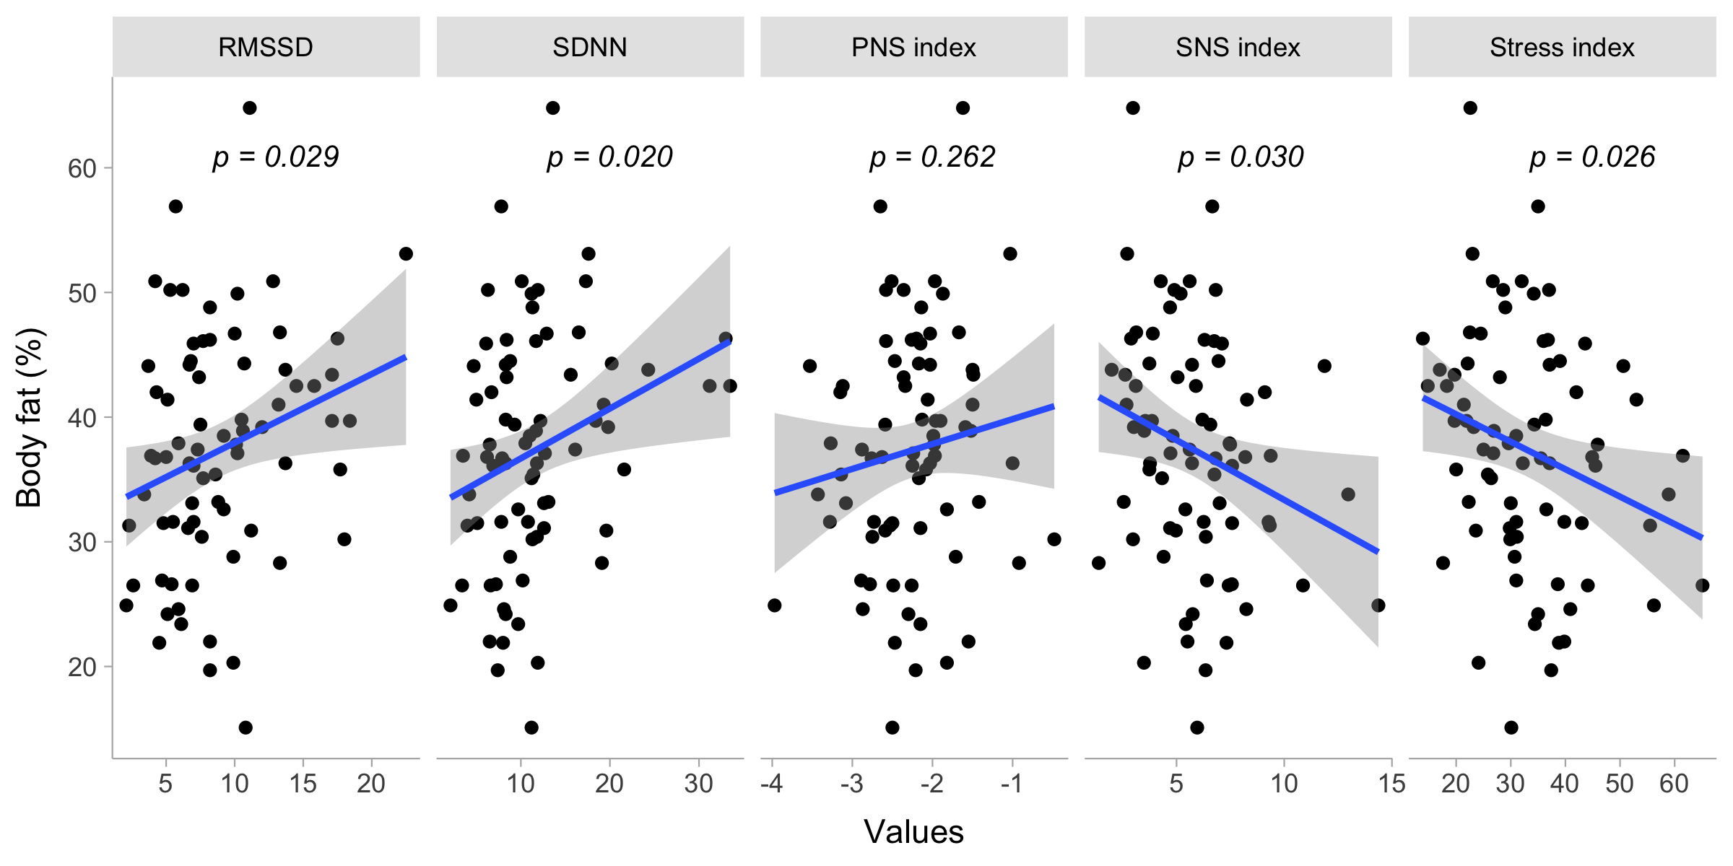

**Figure 1**. Bivariate dispersion plots between body fat and HRV related measures. Significance values for the Pearson’s product-moment correlation test is shown.

## Body composition and physical fitness

In addition, greater SPPB score was observed in leaner (r = -0.273, p = 0.015) and individuals with lower BMI values (r = -0.225, p = 0.047). Similar findings were observed between total steps from the TMST and body fat percentage (r = -0.279, p = 0.013) and bodyweight (r = -0.232, p = 0.041). Not enough evidence was observed to suggest a correlation between total muscle mass with either total SPPB score (r = -0.063, p = 0.584) or total number of steps in TMST (r = -0.070, p = 0.541).

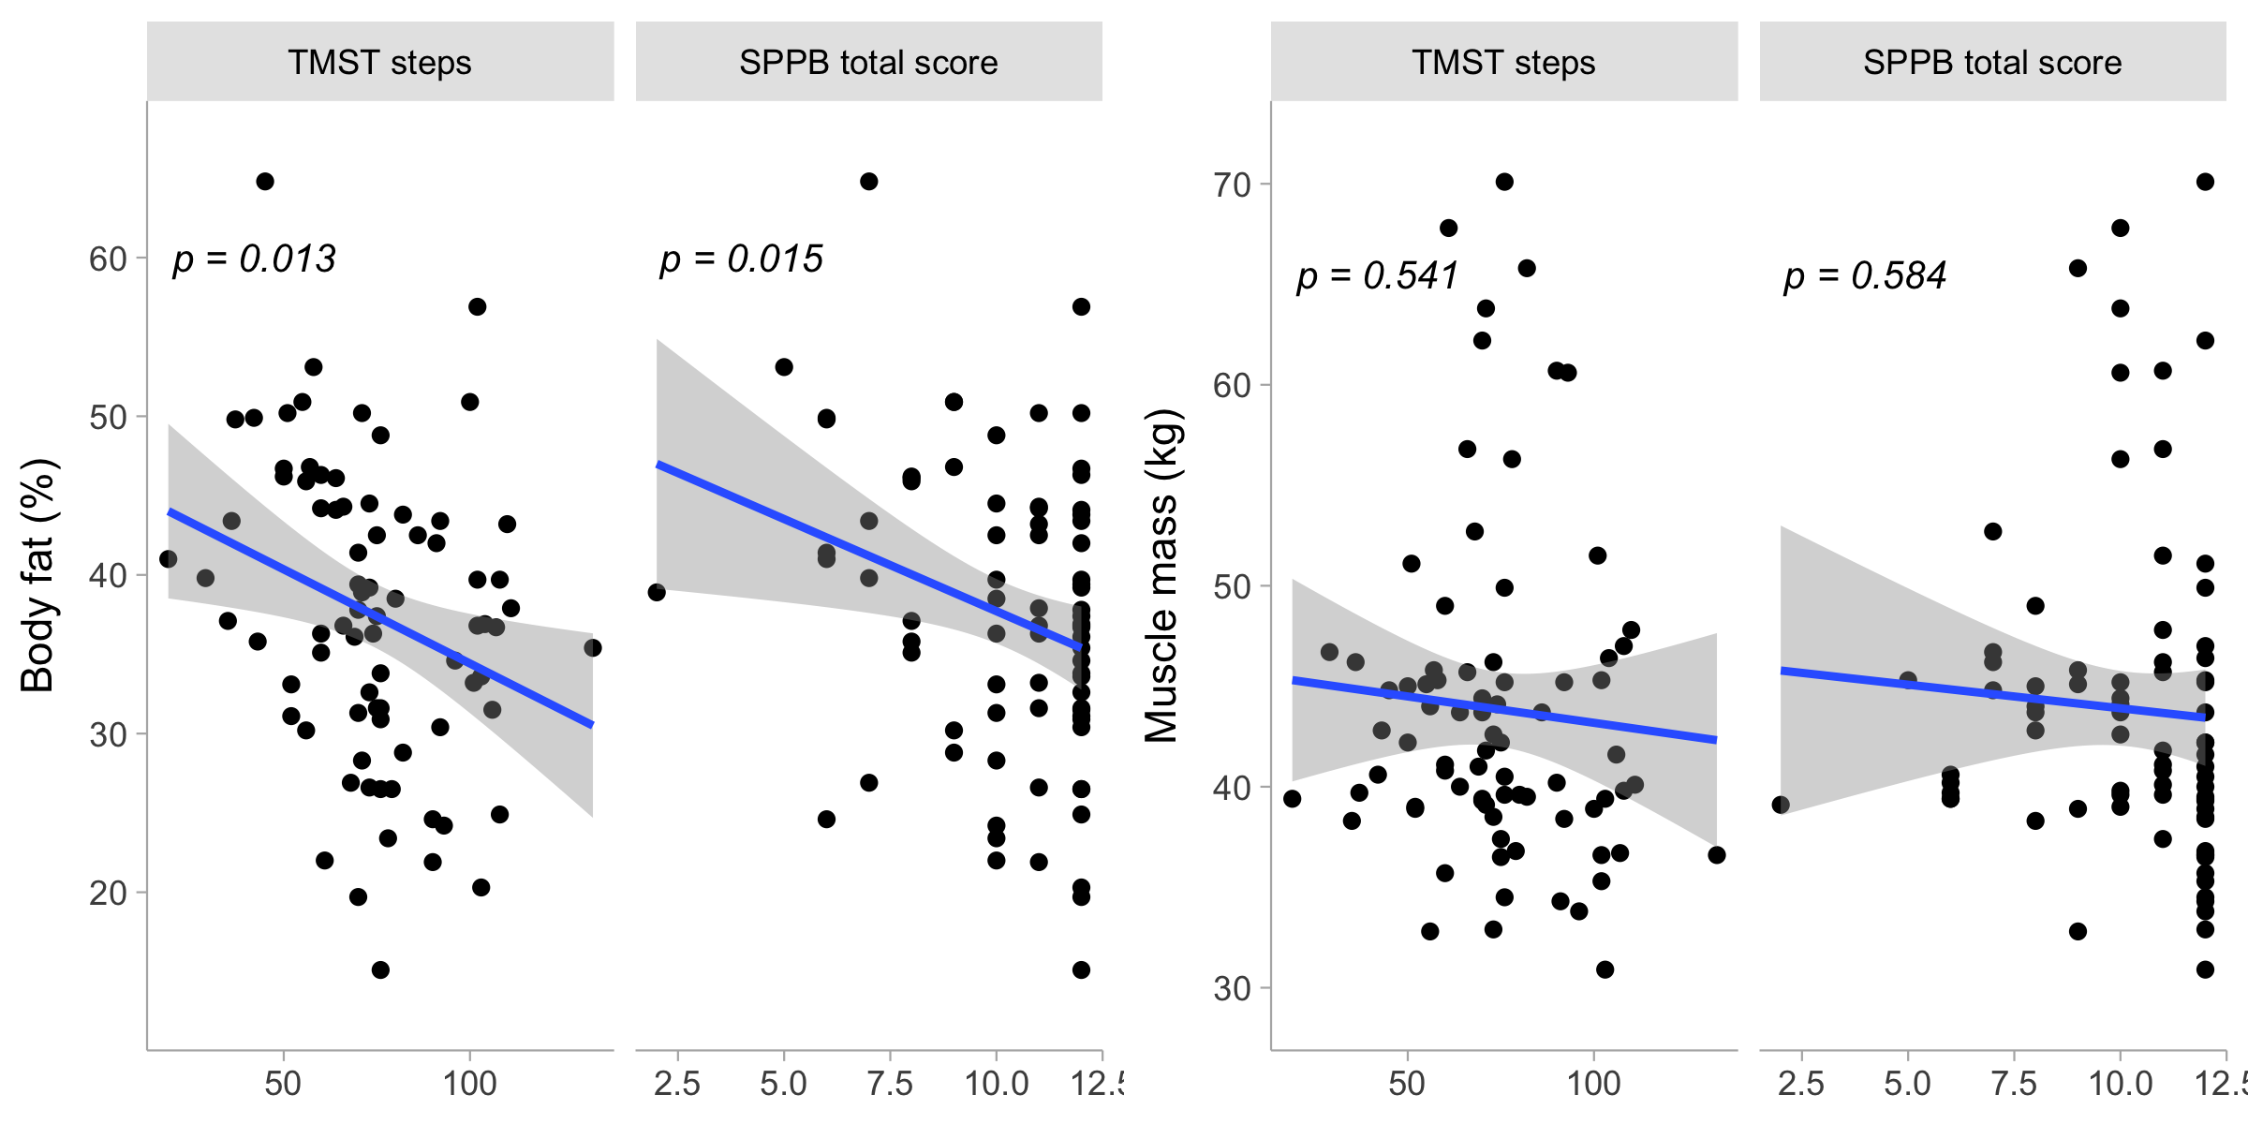

**Figure 2**. Bivariate dispersion plots between physical fitness and body composition related measures. Significance values for the Pearson’s product-moment correlation test is shown.

## Physical fitness and cardiac autonomic response to exercise

Physical fitness, reflected through SPPB total score and total steps in TMST, was positively correlated with a greater sympathetic activity during exercise, which was reflected by SNS index (SPPB score, r = 0.313, p = 0.006; TMST steps, r = 0.265, p = 0.022), mean HR (SPPB score, r = 0.355, p = 0.002; TMST steps, r = 0.338, p = 0.003) and its inverse counterpart mean R-R (SPPB score, r = -0.35, p = 0.002; TMST steps, r = -0.311, p = 0.007). Total number of steps from TMST was also inversely correlated with parasympathetic indices during exercise like RMSSD (r = -0.285, p = 0.014) and PNS index (r = -0.344, p = 0.003).

However, this appears to be accompanied by an proportional decrease in parasympathetic drive during exercise with increasing levels of physical fitness displayed in the SPPB, which was denoted by the inverse correlation of the later with PNS index during (r = -0.375, p = 0.001) and after exercise (r = -0.229, p = 0.049), in addition to RMSSD during exercise (r = -0.294, p = 0.010)

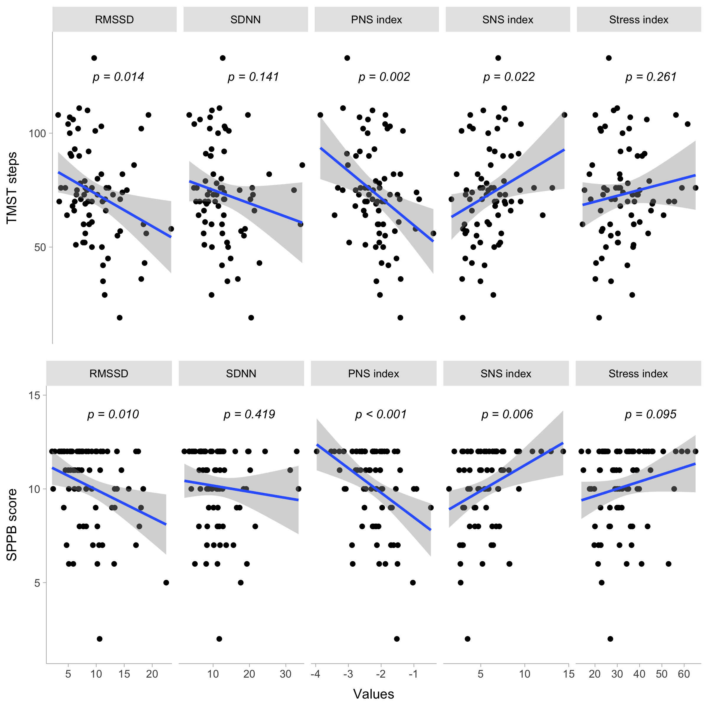

**Figure 3**. Bivariate dispersion plots between physical fitness and HRV related measures. Significance values for the Pearson’s product-moment correlation test is shown.

## Mediation analysis

Mediation analyses suggest many potential influential effects for the relationships for body composition and parasympathetic indices. In this context, the average direct effect (ADE) of body fat percentage on RMSSD during exercise (ADE = 0.088, CI95%[-0.005, 0.200], p = 0.077) was accentuated when considering the influence of SPPB score (ACME = 0.0289, CI95%[0.003, 0.110], p = 0.057; Total effect = 0.117, CI95%[0.028, 0.240], p = 0.012). Similar findings were observed when considering the mediation effect of TMST steps into account (ACME = 0.0283, CI95%[0, 0.07], p = 0.079; Total effect = 0.117, CI95%[0.028, 0.240], p = 0.012). No other parasympathetic indicators were influenced or mediated by fitness or psychological related measures.

Additionally, and in the case on sympathetic indicators, the effect of body fat on SNS index during exercise (ADE = -0.050, CI95%[-0.107, 0.01], p = 0.077) was influenced by SPPB score in similar way as with RMSSD, enhancing the original main observed effect (ACME = -0.016, CI95%[-0.049, 0], p = 0.041; Total effect = -0.066, CI95%[-0.125, -0.010], p = 0.016). Similar effects were observed with TMST steps in this regard (ACME = -0.015, CI95%[-0.042, 0], p = 0.050; Total effect = -0.066, CI95%[-0.125, -0.010], p = 0.016). No other sympathetic indices were notoriously modified in the presence of either SPPB score, TMST steps or psychological variables.

When assessing potential mediators for the effect of body composition on fitness related measures, we found that the effect of body fat percentage on SPPB score (ADE = -0.075, CI95%[-0.123, -0.020], p = 0.007) is partially diminished when considering the influence of total muscle mass (ACME = 0.011, CI95%[0, 0.040], p = 0.107; Total effect = -0.064, CI95%[-0.111, -0.010], p = 0.014). Similar mediation effects of total muscle mass were observed (ACME = 0.118, CI95%[0.005, 0.350], p = 0.075) when assessing the effect of body fat percentage on TMST steps (ADE = -0.773, CI95%[-1.193, -0.300], p = 0.001; Total effect = -0.655, CI95%[-1.084, -0.210], p = 0.004). No other mediating effects were observed for any of the psychological measures for any of the relationships between body composition and physical fitness measures.

Main results are represented in the Figure X.

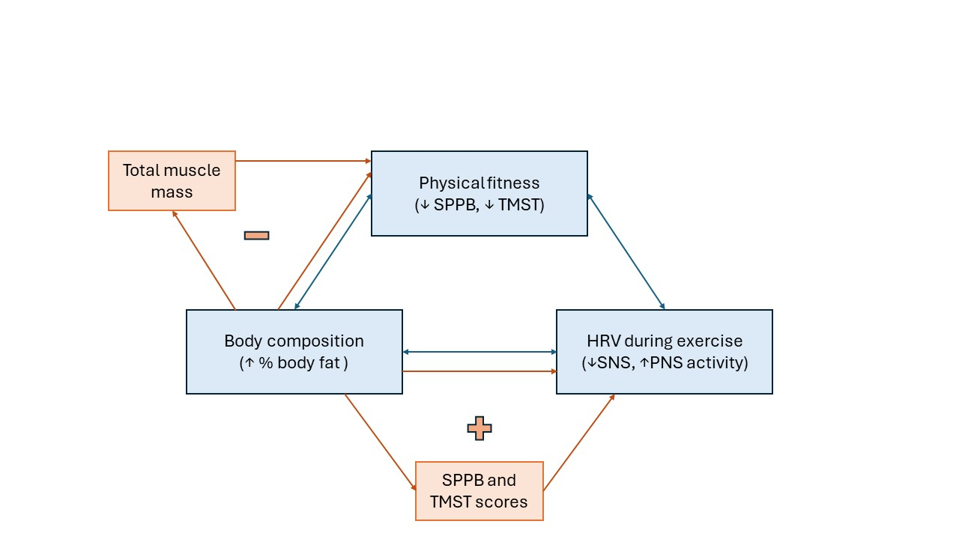 **Figure 4**. Diagram of main results observed form the data. Blue arrows and boxes represent the correlation between variables, while orange arrows and boxes represent the factors mediating the above correlations. “+” means that the mediating factor enhances the main observed effect, contrary to “-”, reflecting a diminished main effect when considering the mediating factor.

# Discussion

This study aimed to investigate the relationship between physical fitness, body fat percentage, and cardiac autonomic response to exercise in older people. Through correlational and mediating analyses, we aimed to elucidate the interplay between these factors and their implications for cardiac autonomic function during physical efforts.

It was hypothesized that a higher body fat percentage would be inversely correlated to physical fitness. Our results aligns with this hypothesis and with those of previous research regarding body composition and physical performance, with a proportional decrease in aging individuals (47,48).

However, the mediating analysis showed that total muscle mass diminished the main observed effect of body fat on physical fitness, with more muscled individuals displaying a better physical performance despite the body fat percentage. This finding suggests that older adults could be benefited of activities that promotes their muscle mass conservation, even when they have high body fat percentages [cita requerida]. Nevertheless, caution is advised in the interpretation of this result, as the close physiological association among increasing body fat and decreasing muscle mass during aging have been well-studied [cita requerida: sarcopenic obesity]

Regarding the link between physical fitness and cardiac autonomic response to exercise, our results evidenced that individuals with a high sympathetic drive while exercising, had greater physical fitness. Previous research had demonstrated the utility of HRV and exercise-induced responses in those metrics as a potential marker of cardiorespiratory fitness in these individuals (22), supporting the current hypothesis that a greater sympathetic drive facilitates physical performance during moderate intensity activities. Even more, it has been previously demonstrated that physically active individuals have an enhanced autonomic response to exercise, playing a pivotal role and strengthening this hypothesis (49,50).

Furthermore, the increase in body fat percentage was related to a reduced sympathetic activity and a higher parasympathetic activity during TMST, as hypothesized (i.e., SNS index, SI, SDNN and RMSSD). Throughout the course of physical efforts, ANS is expected to shift into a sympathetic predominance, ensuring a sufficient response to higher metabolic demands (51). However, aged individuals may present an impaired ANS response to physical exercise (27). In that sense, our results support that body composition plays a role in autonomic response. Moreover, they suggest that the negative effects of body fat on physical fitness in older adults, may be partially attributable to less efficient autonomic inputs to the cardiovascular system [cita requerida].

Surprisingly, mediating analyses found that higher physical fitness (SPPB and TMST scores) intensifies the negative impact of body fat on autonomic control. This unexpected finding hints at a complex interplay between physical fitness, adiposity, and cardiac autonomic regulation. Our results indicate that in individuals with greater functional capacity, the influence of body fat on HRV is amplified rather than mitigated. This observation challenges traditional conceptions about the relationship between physical fitness and cardiac autonomic regulation, and raises questions about the underlying mechanisms involved.

As far as we know, there are not preceding studies addressing these findings. We posit that there exists further factors influencing the mediation effect. For instance, body distribution of the adipose tissue was not explored, specially when it is known that visceral fat has an important impact on cardiovascular health and its autonomic regulation [cita requerida]. Participants with higher fitness may have a different fat distribution compared with lower performance individuals, which may induce different effects on autonomic drive to the heart [cita requerida]. Furthermore, other physical physiological, demographic or psychological variables may be playing an unexplored role. However, these hypothesis must be examined under scientific standards. Therefore, exhaustive research is needed to address this intriguing interplay.

Our results provide evidence to support the interplay between physical fitness, body fat, and cardiac autonomic response to exercise in older individuals. Physical fitness is negatively affected by higher body fat percentage, while also being associated with impaired cardiac autonomic response to exercise, characterized by decreased sympathetic drive and increased parasympathetic tone. Additionally, this altered autonomic response is related to lower physical performance in older individuals, both variables being important predictors of health outcomes in this population (52,53). Overall, our findings underscore the triangular and bidirectional relationship among these variables.

However, our results did not evidence a mediating effect of either GDS-30 or BAI scores, challenging our initial hypothesis. These finding suggests a nuanced interplay between psychological variables and physical/physiological measures in older people, underscoring the need for further research to elucidate underlying mechanisms and variables beyond depression and anxiety. While the lack of evidence suggesting any mediating effects does not diminish the significance of psychological factors in aging, it highlights the complexity of their influence.

This study was strengthened by the fact that both SPPB and TMST measures consistently aligned in their interaction with other variables, which supports a global understanding of physical fitness in older people, rather than specific aspects, and by the exploration of mediating factors in the primary results. Nonetheless, this cross-sectional study, it is not without limitations. First, our study design prevents us from making causal inferences about the direction of the relationships, highlighting the relevance of experimental and longitudinal research exploring causal relations between our variables and potential underlying mechanisms. Second, a relatively small sample was included, limiting generalizability and statistical power of the analysis. Furthermore, the sample consisted mainly of women (82.7%), limiting our ability to make sex comparisons and decreasing the representativeness of the sample. Further research could investigate the impact of cardiac autonomic response on performance during the same task, in this age group.

# Conclusion

The results highlighted a structural bidirectional relationship among variables. Body fat percentage was inversely correlated to both physical fitness and cardiac autonomic activity during exercise, with sympathetic drive associated with physical fitness in older people. Furthermore, physical fitness may mediate the effect of body fat on cardiac autonomic activity during exercise, and total muscle mass may mitigate the negative effect of increased adiposity on physical fitness, highlighting its pivotal role in older people’s health. However, further research is needed to elucidate mediating effects of psychological variables in this field.

# Author Contributions

All authors listed have made a substantial, direct and intellectual contribution to the work and approved it for publication.

# Funding

[…].

# Institutional Review Board Statement

[…].

# Informed Consent Statement

[…]

# Data availability statement

The raw data supporting the conclusions of this article will be made available by the authors without undue reservation.

# Conflicts of interests

The authors declare that the research was conducted without any commercial or financial relationships construed as a potential conflict of interest.

# Referencias

1. Partridge L, Deelen J, Slagboom PE. [Facing up to the global challenges of ageing](https://doi.org/10.1038/s41586-018-0457-8). Nature. 2018 Sep;561(7721):45–56.

2. Feng Z. [Global convergence: Aging and long-term care policy challenges in the developing world](https://doi.org/10.1080/08959420.2019.1626205). Journal of aging & social policy. 2019;31(4):291–7.

3. Malandrino N, Bhat SZ, Alfaraidhy M, Grewal RS, Kalyani RR. [Obesity and aging](https://doi.org/10.1016/j.ecl.2022.10.001). Endocrinology and metabolism clinics of North America. 2023 Jun;52(2):317–39.

4. Liu C, Wong PY, Chung YL, Chow SK-H, Cheung WH, Law SW, et al. [Deciphering the "obesity paradox" in the elderly: A systematic review and meta-analysis of sarcopenic obesity](https://doi.org/10.1111/obr.13534). Obesity reviews : an official journal of the International Association for the Study of Obesity. 2023 Feb;24(2):e13534.

5. Ferrucci L, Fabbri E. [Inflammageing: Chronic inflammation in ageing, cardiovascular disease, and frailty](https://doi.org/10.1038/s41569-018-0064-2). Nature reviews Cardiology. 2018 Sep;15(9):505–22.

6. Xie S, Xu S-C, Deng W, Tang Q. [Metabolic landscape in cardiac aging: Insights into molecular biology and therapeutic implications](https://doi.org/10.1038/s41392-023-01378-8). Signal transduction and targeted therapy. 2023 Mar 14;8(1):114.

7. Gielen E, Beckwée D, Delaere A, De Breucker S, Vandewoude M, Bautmans I, et al. [Nutritional interventions to improve muscle mass, muscle strength, and physical performance in older people: An umbrella review of systematic reviews and meta-analyses](https://doi.org/10.1093/nutrit/nuaa011). Nutrition reviews. 2021 Jan 9;79(2):121–47.

8. Siscovick DS, LaPorte RE, Newman JM. [The disease-specific benefits and risks of physical activity and exercise](https://www.ncbi.nlm.nih.gov/pmc/articles/PMC1424738). Public health reports (Washington, DC : 1974). 1985;100(2):180–8.

9. Caspersen CJ, Powell KE, Christenson GM. [Physical activity, exercise, and physical fitness: Definitions and distinctions for health-related research](https://www.ncbi.nlm.nih.gov/pmc/articles/PMC1424733). Public health reports (Washington, DC : 1974). 1985;100(2):126–31.

10. Lee IM, Paffenbarger RS Jr, Hennekens CH. [Physical activity, physical fitness and longevity](https://doi.org/10.1007/BF03340123). Aging (Milan, Italy). 1997;9(1-2):2–11.

11. Strasser B, Burtscher M. [Survival of the fittest: VO2max, a key predictor of longevity?](https://doi.org/10.2741/4657) Frontiers in bioscience (Landmark edition). 2018 Mar 1;23(8):1505–16.

12. Yang J, Christophi CA, Farioli A, Baur DM, Moffatt S, Zollinger TW, et al. [Association between push-up exercise capacity and future cardiovascular events among active adult men](https://doi.org/10.1001/jamanetworkopen.2018.8341). JAMA network open. 2019 Feb 1;2(2):e188341.

13. López-Bueno R, Andersen LL, Koyanagi A, Núñez-Cortés R, Calatayud J, Casaña J, et al. [Thresholds of handgrip strength for all-cause, cancer, and cardiovascular mortality: A systematic review with dose-response meta-analysis](https://doi.org/10.1016/j.arr.2022.101778). Ageing research reviews. 2022 Dec;82:101778.

14. Palmer AK, Jensen MD. [Metabolic changes in aging humans: Current evidence and therapeutic strategies](https://doi.org/10.1172/JCI158451). The Journal of clinical investigation. 2022 Aug 15;132(16):e158451.

15. Pataky MW, Young WF, Nair KS. [Hormonal and metabolic changes of aging and the influence of lifestyle modifications](https://doi.org/10.1016/j.mayocp.2020.07.033). Mayo Clinic proceedings. 2021 Mar;96(3):788–814.

16. Neeland IJ, Ross R, Després J-P, Matsuzawa Y, Yamashita S, Shai I, et al. [Visceral and ectopic fat, atherosclerosis, and cardiometabolic disease: A position statement](https://doi.org/10.1016/S2213-8587(19)30084-1). The lancet Diabetes & endocrinology. 2019 Sep;7(9):715–25.

17. Powell-Wiley TM, Poirier P, Burke LE, Després J-P, Gordon-Larsen P, Lavie CJ, et al. [Obesity and cardiovascular disease: A scientific statement from the american heart association](https://doi.org/10.1161/CIR.0000000000000973). Circulation. 2021 May 25;143(21):e984–1010.

18. Freeman JV, Dewey FE, Hadley DM, Myers J, Froelicher VF. [Autonomic nervous system interaction with the cardiovascular system during exercise](https://doi.org/10.1016/j.pcad.2005.11.003). Progress in cardiovascular diseases. 2006;48(5):342–62.

19. Zhao Y, Yu H, Gong A, Zhang S, Xiao B. [Heart rate variability and cardiovascular diseases: A mendelian randomization study](https://doi.org/10.1111/eci.14085). European journal of clinical investigation. 2024 Jan;54(1):e14085.

20. Kubota Y, Chen LY, Whitsel EA, Folsom AR. [Heart rate variability and lifetime risk of cardiovascular disease: The atherosclerosis risk in communities study](https://doi.org/10.1016/j.annepidem.2017.08.024). Annals of epidemiology. 2017 Oct;27(10):619–625.e2.

21. Tiwari R, Kumar R, Malik S, Raj T, Kumar P. [Analysis of heart rate variability and implication of different factors on heart rate variability](https://doi.org/10.2174/1573403X16999201231203854). Current cardiology reviews. 2021;17(5):e160721189770.

22. Mongin D, Chabert C, Extremera MG, Hue O, Courvoisier DS, Carpena P, et al. [Decrease of heart rate variability during exercise: An index of cardiorespiratory fitness](https://doi.org/10.1371/journal.pone.0273981). PloS one. 2022 Sep 2;17(9):e0273981.

23. Brown L, Karmakar C, Gray R, Jindal R, Lim T, Bryant C. [Heart rate variability alterations in late life depression: A meta-analysis](https://doi.org/10.1016/j.jad.2018.04.071). Journal of Affective Disorders. 2018 Aug;235:456–66.

24. Cheng Y-C, Su M-I, Liu C-W, Huang Y-C, Huang W-L. [Heart rate variability in patients with anxiety disorders: A systematic review and meta-analysis](https://doi.org/10.1111/pcn.13356). Psychiatry and clinical neurosciences. 2022 Jul;76(7):292–302.

25. Schlechter P, Ford TJ, Neufeld SAS. [The development of depressive symptoms in older adults from a network perspective in the english longitudinal study of ageing](https://doi.org/10.1038/s41398-023-02659-0). Translational psychiatry. 2023 Nov 25;13(1):363.

26. Andreescu C, Varon D. [New research on anxiety disorders in the elderly and an update on evidence-based treatments](https://doi.org/10.1007/s11920-015-0595-8). Current psychiatry reports. 2015 Jul;17(7):53.

27. Castillo-Aguilar M, Mabe Castro M, Mabe Castro D, Valdés-Badilla P, Herrera-Valenzuela T, Guzmán-Muñoz E, et al. Validity and reliability of short-term heart rate variability parameters in older people in response to physical exercise. International Journal of Environmental Research and Public Health [Internet]. 2023;20(5). Available from: <https://www.mdpi.com/1660-4601/20/5/4456>

28. Guralnik JM, Simonsick EM, Ferrucci L, Glynn RJ, Berkman LF, Blazer DG, et al. [A short physical performance battery assessing lower extremity function: Association with self-reported disability and prediction of mortality and nursing home admission](https://doi.org/10.1093/geronj/49.2.M85). Journal of Gerontology. 1994 Mar;49:M85–94.

29. Mialich MS, Martinez EZ, Júnior AAJ. Comparative study of instruments for the analysis of body composition in a sample of the brazilian population. In 2011. Available from: <https://api.semanticscholar.org/CorpusID:220870368>

30. Malik M. Heart rate variability: Standards of measurement, physiological interpretation, and clinical use: Task force of the european society of cardiology and the north american society for pacing and electrophysiology. Annals of Noninvasive Electrocardiology. 1996;1(2):151–81.

31. Buchheit M, Chivot A, Parouty J, Mercier D, Al Haddad H, Laursen PB, et al. [Monitoring endurance running performance using cardiac parasympathetic function](https://doi.org/10.1007/s00421-009-1317-x). European journal of applied physiology. 2010 Apr;108(6):1153–67.

32. Berntson GG, Bigger JT Jr, Eckberg DL, Grossman P, Kaufmann PG, Malik M, et al. [Heart rate variability: Origins, methods, and interpretive caveats](https://doi.org/10.1111/j.1469-8986.1997.tb02140.x). Psychophysiology. 1997 Nov;34(6):623–48.

33. Buchheit M, Gindre C. Cardiac parasympathetic regulation: Respective associations with cardiorespiratory fitness and training load. American Journal of Physiology-Heart and Circulatory Physiology. 2006;291(1):H451–8.

34. Rajendra Acharya U, Paul Joseph K, Kannathal N, Lim CM, Suri JS. Heart rate variability: A review. Medical and biological engineering and computing. 2006;44:1031–51.

35. Yoo HH, Yune SJ, Im SJ, Kam BS, Lee SY. [Heart rate variability-measured stress and academic achievement in medical students](https://doi.org/10.1159/000513781). Medical Principles and Practice. 2020 Dec 16;30(2):193–200.

36. Methodical recommendations USE KARDiVAR SYSTEM FOR DETERMINATION OF THE STRESS LEVEL AND ESTIMATION OF THE BODY ADAPTABILITY standards of measurements and physiological interpretation. In 2009. Available from: <https://api.semanticscholar.org/CorpusID:29215863>

37. Rikli RE, Jones CJ. Functional fitness normative scores for community-residing older adults, ages 60-94. Journal of Aging and Physical Activity [Internet]. 1999;7:162–81. Available from: <https://journals.humankinetics.com/view/journals/japa/7/2/article-p162.xml>

38. Gana K, Bailly N, Broc G, Cazauvieilh C, Boudouda NE. [The geriatric depression scale: Does it measure depressive mood, depressive affect, or both?](https://doi.org/10.1002/gps.4582) International journal of geriatric psychiatry. 2017 Oct;32(10):1150–7.

39. Yesavage JA, Brink TL, Rose TL, Lum O, Huang V, Adey M, et al. [Development and validation of a geriatric depression screening scale: A preliminary report](https://doi.org/10.1016/0022-3956(82)90033-4). Journal of psychiatric research. 1982;17(1):37–49.

40. Zenebe Y, Akele B, W/Selassie M, Necho M. [Prevalence and determinants of depression among old age: A systematic review and meta-analysis](https://doi.org/10.1186/s12991-021-00375-x). Annals of general psychiatry. 2021 Dec 18;20(1):55.

41. Fernández-San Martín MI, Andrade-Rosa C, Molina JD, Muñoz PE, Carretero B, Rodríguez M, et al. [Validation of the spanish version of the geriatric depression scale (GDS) in primary care](https://doi.org/10.1002/gps.588). International journal of geriatric psychiatry. 2002 Mar;17(3):279–87.

42. Beck AT, Epstein N, Brown G, Steer RA. [An inventory for measuring clinical anxiety: Psychometric properties](https://doi.org/10.1037//0022-006x.56.6.893). Journal of consulting and clinical psychology. 1988 Dec;56(6):893–7.

43. Rodríguez Reynaldo M, Martínez Lugo M, Rodríguez Gómez J. Estudio de las características psicométricas del inventario de ansiedad beck (en castellano) en una muestra de envejecidos puertorriqueños. Revista Española de Geriatría y Gerontología [Internet]. 2001;36(6):353–60. Available from: <https://www.sciencedirect.com/science/article/pii/S0211139X01747555>

44. Imai K, Keele L, Yamamoto T. Identification, inference, and sensitivity analysis for causal mediation effects. Statistical Science [Internet]. 2010;25(1):51–71. Available from: <http://imai.princeton.edu/research/mediation.html>

45. Tingley D, Yamamoto T, Hirose K, Keele L, Imai K. mediation: R package for causal mediation analysis. Journal of Statistical Software [Internet]. 2014;59(5):1–38. Available from: <http://www.jstatsoft.org/v59/i05/>

46. R Core Team. R: A language and environment for statistical computing [Internet]. Vienna, Austria: R Foundation for Statistical Computing; 2021. Available from: <https://www.R-project.org/>

47. Paranhos Amorim DN, Nascimento D da C, Stone W, Alves VP, Coelho Vilaça E Silva KH. [Body composition and functional performance of older adults](https://doi.org/10.1016/j.afos.2022.04.002). Osteoporosis and sarcopenia. 2022 Jun;8(2):86–91.

48. Fatyga-Kotula P, Wizner B, Fedyk-Łukasik M, Grodzicki T, Skalska A. [New insights on the link between body composition, nutritional status and physical performance in elderly outpatients](https://doi.org/10.24425/fmc.2022.141698). Folia medica Cracoviensia. 2022;62(2):37–48.

49. Sarmento A de O, Santos A da C, Trombetta IC, Dantas MM, Oliveira Marques AC, Nascimento LS do, et al. [Regular physical exercise improves cardiac autonomic and muscle vasodilatory responses to isometric exercise in healthy elderly](https://doi.org/10.2147/CIA.S120876). Clinical interventions in aging. 2017 Jun 28;12:1021–8.

50. Soares-Miranda L, Sattelmair J, Chaves P, Duncan GE, Siscovick DS, Stein PK, et al. [Physical activity and heart rate variability in older adults: The cardiovascular health study](https://doi.org/10.1161/CIRCULATIONAHA.113.005361). Circulation. 2014 May 27;129(21):2100–10.

51. Marasingha-Arachchige SU, Rubio-Arias JÁ, Alcaraz PE, Chung LH. [Factors that affect heart rate variability following acute resistance exercise: A systematic review and meta-analysis](https://doi.org/10.1016/j.jshs.2020.11.008). Journal of sport and health science. 2022 May;11(3):376–92.

52. Langhammer B, Bergland A, Rydwik E. [The importance of physical activity exercise among older people](https://doi.org/10.1155/2018/7856823). BioMed research international. 2018 Dec 5;2018:7856823.

53. Tan JPH, Beilharz JE, Vollmer-Conna U, Cvejic E. [Heart rate variability as a marker of healthy ageing](https://doi.org/10.1016/j.ijcard.2018.08.005). International journal of cardiology. 2019 Jan 15;275:101–3.