**Title**: Modeling Nonlinear R-R Interval Dynamics during Exercise: A Novel Logistic Approach to Cardiovascular Recovery.

**Authors**: Matías Castillo-Aguilar1,2, […], Cristian Núñez-Espinoza1,3*.

1 Centro Asistencial Docente e Investigación (CADI-UMAG), University of Magallanes, Punta Arenas, Chile.

2 Kinesiology Department, University of Magallanes, Punta Arenas, Chile.

3 School of Medicine, University of Magallanes, Punta Arenas, Chile.

### *Correspondence:

Cristian Núñez-Espinosa, School of Medicine, University of Magallanes, Punta Arenas, Chile. Centro Asistencial de Docencia e Investigación CADI-UMAG, Chile. e-mail: [cristian.nunez@umag.cl](mailto:cristian.nunez@umag.cl). Address: Avenida Bulnes 01855, Box 113-D. Phone: +56 61 2201411.

## Abstract

**Objective**: […]. **Methods**: […]. **Results**: […]. **Conclusion**: […].

**Keywords**: […].

# Introduction

Current research has extensively examined the mechanisms underlying cardiac autonomic dynamics in response to exercise and their links to health-related quality of life and cardiovascular disease risk. Understanding these autonomic processes offers valuable insights into optimizing exercise-induced adaptations, with implications for both younger and older individuals.

In this context, the study of R-R intervals (RRi) in response to exercise has emerged as an important research area, given its relevance to cardiovascular health, athletic performance, and physiological adaptation (Kristal-Boneh et al., 1995; Thayer et al., 2010; Dong, 2016; Lundstrom et al., 2023). Unlike heart rate variability (HRV), which aggregates autonomic responses over time, RRi analysis provides a more granular, direct view of cardiac electrical activity during or immediately following exercise, particularly in older adults (Mongin et al., 2022; Castillo-Aguilar et al., 2023; Mabe-Castro et al., 2024). Analyzing the temporal dynamics of RRi (i.e., the time between successive heartbeats) provides invaluable insights into how the cardiovascular system behaves to and recovers from physical stressors such as exercise-induced fatigue and competition-related strain (Castillo-Aguilar et al., 2021; Eser et al., 2022).

Understanding these fluctuations is particularly relevant during dynamic exercise periods, where the autonomic nervous system (ANS) shifts between parasympathetic withdrawal and sympathetic activation (Boettger et al., 2010). Modeling RRi dynamics, rather than relying on broader HRV metrics, allows for a direct assessment of physiological markers of autonomic adaptation to stress (Hautala et al., 2003). This approach is valuable for identifying recovery patterns and understanding cardiovascular reactivity across individuals with various fitness levels (Mongin et al., 2022).

Despite its importance, modeling RRi behavior during and after exercise in a continuous measurement poses significant challenges. Traditional approaches, such as linear regression and time-series analysis, often fail to capture the intricate transitions in RRi, especially under intense exertion and recovery phases. This difficulty arises due to the inherently non-linear and non-stationary nature of HRV (Gronwald et al., 2019a). While linear models oversimplify these dynamics, advanced non-linear approaches have been developed to address the limitations of linear analysis. However, many focus on HRV summaries rather than direct RRi modeling (Gronwald et al., 2019b).

Recent studies have begun exploring non-linear models for RRi dynamics, recognizing their potential to capture the complexity of cardiovascular response to exercise. Exponential decay models, for example, have been proposed to describe RRi recovery, while logistic functions have been used to model the gradual return to baseline after high-intensity exercise (Gronwald et al., 2019b; Molkkari et al., 2020). These models offer advantages over traditional HRV metrics by providing a more detailed understanding of the cardiovascular system’s response to exercise (Wu and Poon, 2003). However, despite these advancements, few models are specifically designed to capture real-time RRi fluctuations, and even fewer consider individual variability factors such as fitness level, autonomic balance, and exercise intensity (Kanniainen et al., 2023).

Given the unique characteristics of RRi, their direct relationship with cardiac electrical activity, and responsiveness to autonomic changes, there is a compelling need for a model that accurately represents RRi’s non-linear fluctuations during exercise and recovery. Such a model would offer a more physiologically relevant representation of the heart’s behavior compared to the broader HRV indices commonly used in research (Bacopoulou et al., 2021).

Hence, the primary objective of this paper is to present a novel non-linear model that characterizes RRi fluctuations during exercise and recovery. This model is designed to capture the complex, real-time changes in RRi, providing meaningful parameters that can enhance our understanding of the physiological processes underlying cardiovascular adaptation to exercise. By focusing exclusively on RRi, the model can deliver insights directly applicable to athletic training regimens, recovery protocols, and clinical practices aimed at improving cardiovascular health. The proposed model seeks to bridge the gap between existing modeling frameworks and the physiological reality of RRi dynamics during exercise.

# Methods

## Model Specification

The mathematical model proposed to characterize the RRi response to exercise and recovery is defined by Equation 1.

$$\begin{matrix}\text{RRi}\left(t\right)=α+\frac{β}{1+e^{λ\left(t−τ\right)}}+\frac{−β⋅c}{1+e^{ϕ\left(t−τ−δ\right)}}\end{matrix} \left(1\right)$$

This model includes two logistic functions representing the RRi dynamics across exercise and recovery phases. The first logistic term models the decrease in RRi during exercise, where the parameter $β$ denotes the magnitude of this decline. The rate of decline is governed by $λ$, while $τ$ represents the onset of the RRi decrease or the time at which the physiological shift begins.

The second logistic term accounts for RRi recovery post-exercise. Here, $c$ scales the magnitude of recovery relative to the initial decline represented by $β$, effectively capturing the proportion of the decline regained during recovery. The rate at which RRi returns to baseline is controlled by $ϕ$, and $δ$ indicates the lag following the cessation of exercise, marking the beginning of recovery.

This logistic structure is well-suited to modeling the RRi dynamics, providing a smooth, continuous transition for the decline and recovery phases. Logistic growth functions are particularly effective in physiological modeling contexts, where transitions (e.g., rest to exercise or exercise to recovery) occur gradually and non-linearly. Compared to conditional models, which may introduce abrupt transitions, this model is designed to minimize discontinuities, thus offering a realistic representation of RRi responses without artifacts.

## Sensitivity to model parameters

To assess the sensitivity of model parameters in influencing RRi over time, we implemented a Sobol sensitivity analysis using Monte Carlo simulations. Sobol analysis was selected for its robustness in handling non-linear and non-monotonic relationships, which are intrinsic to RRi dynamics in response to exercise. To compute Sobol indices, a total of 1000 Monte Carlo simulations were conducted, with each simulation involving 1000 randomly sampled parameter sets (1,000,000 model runs in total). For each set of parameters, RRi were calculated at each time point $t$ across a range from 0 to 20 minutes at intervals of 0.1 minutes (i.e., 6 seconds). The resulting Sobol indices provided a measure of the contribution of each parameter to the variance in RRi at each time point.

The first-order Sobol index for each parameter was computed by isolating the variance attributable to each parameter while averaging over the others. To achieve this, we perturbed each parameter individually while holding all other parameters at their average values across the samples. The proportion of variance explained by each parameter at each time point was calculated by dividing the variance of the estimated RRi of the perturbed parameter by the total variance, which accounts for the variation in all model parameters simultaneously, yielding time-dependent Sobol indices. The selected parameter ranges, provided in Table 1, reflect a 50% variation in both directions from a reference value for each parameter.

|  |  |  |  |  |  |  |  |
| --- | --- | --- | --- | --- | --- | --- | --- |
| x 0.5 | 400 | -200 | 0.5 | -1.151 | -0.602 | 2.5 | 1 |
| Reference | 800 | -400 | 1.0 | -2.303 | -1.203 | 5 | 2 |
| x 1.5 | 1200 | -600 | 1.5 | -3.454 | -1.806 | 7.5 | 3 |

**Table 1**. Parameter ranges for sensitivity analysis to be used as the limits to sample from uniform distribution and designed to evaluate model response to variability. Each parameter’s range reflects a ±50% variation from its reference value. It is worth noting that reference values for $λ$ and $ϕ$ parameters were set considering a reference rate of 90% and 70% change per minute in the original scale of these parameters.

## Usage of real-world RRi data

To further assess the performance and applicability of the proposed model, real-world RRi data were analyzed in addition to the synthetic data generated through simulation. This dataset was derived from a cohort participating in the FONDECYT Project No. 11220116, funded by the Chilean National Association of Research and Development (ANID). Ethical approval was granted by the Ethics Committee of the University of Chile (ACTA No. 029-18/05/2022) and the Ethics Committee of the University of Magallanes (No. 008/SH/2022).

The dataset consisted of 272 participants who underwent a validated exercise protocol encompassing rest, exercise, and recovery phases within a single, continuous measurement session (Castillo-Aguilar et al., 2023). Continuous heart rate data, including RRi, were collected using the Polar Team2 system (Polar®) application, which is capable of capturing dynamic fluctuations associated with varying exercise intensities and recovery.

Preprocessing steps were conducted to remove artifacts and ectopic heartbeats, with less than 3% of data excluded following established guidelines (Malik, 1996). The preprocessed RRi data were then aggregated into time intervals to facilitate analysis, allowing the examination of acute exercise responses as well as post-exercise recovery patterns.

This real-world dataset provided a critical context for validating the model’s predictive capability against observed physiological responses, offering a robust foundation for understanding RRi dynamics under conditions of physical activity.

## Parameter Estimation

Parameter estimation was performed using Hamiltonian Monte Carlo (HMC) with the No-U-Turn Sampler (NUTS) to explore the parameter space. This method is suitable for high-dimensional spaces and utilizes gradient information for efficient sampling. The parameters $α$, $β$, $c$, $λ$, $ϕ$, $τ$, and $δ$ were estimated by sampling from the posterior distribution, which was constructed from observed RRi data and model predictions. The Bayesian framework allows the incorporation of prior distributions for parameters, enhancing the reliability of the estimates.

The gradient of the log-likelihood function for each parameter was computed during estimation using the brms R package, which employs the Stan probabilistic programming language. Convergence of the HMC chains was evaluated using the Gelman-Rubin diagnostic and trace plots to ensure reliable parameter estimates. This quantification of uncertainty is essential for assessing the stability of parameter estimates, particularly in the presence of noisy RRi data.

The fitting process utilized five Markov Chain Monte Carlo (MCMC) chains, each consisting of 10,000 iterations with a burn-in period of 5,000 iterations, resulting in a total of 25,000 post-warmup samples.

To enhance the exploration of parameter space we performed a two-stage analysis: individual-level and group-level estimates.

### Individual-level analysis

Firstly, each subject’s RRi data was standardize against his own mean and standard deviation to improve convergence and exploration of the posterior distribution. The standardized RRi data for each time point was computed as:

This standardization allowed the model to focus on relative changes in RRi dynamics, independent of individual baseline differences.

The model for each subject was then specified in terms of standardized RRi data :

where , , , , , , are the individual-specific model parameters and is the residual error term at each time point .

Afterwards, we transformed the estimated and parameters back to the original RRi scale, ensuring a physiologically meaningful interpretation. The transformation for each subject is given by:

Priors were chosen based on physiological constraints and graphical visualization of standardized RRi data, ensuring identifiability of model parameters by constraining the parameter space to plausible values, which improves model convergence. The prior distributions are defined as follows:

Simulated standardized RRi dynamics based on prior parameter distributions are shown in Figure 1.

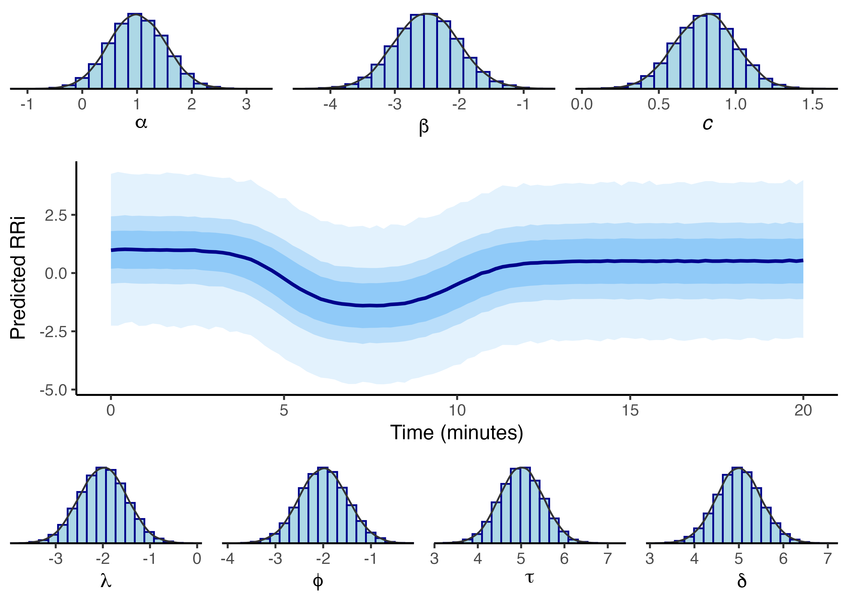

**Figure 1**. Prior predicted RRi response to exercise, illustrating uncertainty in model parameters from the prior distribution. Shaded areas represent 95%, 80%, and 60% quantile CI.

### Group-level analysis

After obtaining the posterior distribution for each subject’s parameters, the mean and standard deviation for each parameter were calculated. These estimates were then used as input data to create a multivariate hierarchical model, capturing variability at both the subject and group levels. The model is described as follows:

For each subject , the parameter vector is modeled as:

where is the group-level mean for parameter , represents the subject-level random effect for subject on parameter , and is the residual variance for parameter .

The subject-level effects are assumed to follow a multivariate normal distribution:

where is the covariance matrix that captures correlations between the random effects for different parameters across subjects.

This hierarchical structure enables us to capture individual variability through subject-level random effects while also estimating group-level effects across all parameters, thus providing estimates into both subject-level and population-level model parameters.

## Model Evaluation

The model’s predictive performance was assessed using approximate leave-one-out (LOO) cross-validation for Bayesian models, utilizing Pareto-smoothed importance sampling. The primary evaluation metrics included root mean square error (RMSE) and mean absolute percentage error (MAPE). These metrics were selected for their capacity to quantify both absolute and relative errors, thereby providing a comprehensive assessment across the varying scales of RRi dynamics, including resting baseline, peak decline, and recovery.

Also, residual analysis was conducted to evaluate the model’s accuracy in capturing RRi dynamics. Residuals were defined as the difference between observed and predicted RRi values. These residuals were analyzed for temporal structure and autocorrelation to ensure that no systematic patterns remained in the errors. This indicates that the model has sufficiently captured the underlying dynamics of the RRi response to exercise.

# Results

## Non-linear model and deterministic behaviour

### RRi as a linear combination of logistic functions

According to the proposed model in Equation 1, the dynamics of RRi in response to physical exertion can be represented as a linear combination of a baseline RRi $α$ and two logistic functions, denoted as $f_{1}\left(t\right)$ and $f_{2}\left(t\right)$. The function $f_{1}\left(t\right)$ models the initial decay in RRi following the initiation of exercise while $f_{2}\left(t\right)$ characterizes the recovery phase after exercise cessation.

The fundamental structure of both logistic functions can be expressed as:

$$\begin{matrix}f\left(t\right)=\frac{a_{1}}{1+e^{a_{2}\left(t−a_{3}\right)}}\end{matrix} \left(3\right)$$

In this equation, $a_{1}$ represents the asymptotic value approached by the logistic function, which can be either positive (indicating an increase) or negative (indicating a decrease). For $f_{1}\left(t\right)$, this parameter is specified as $β$, indicating the absolute change in RRi at the onset of exercise. In contrast, for $f_{2}\left(t\right)$, $a_{1}$ is reparameterized as $−β⋅c$, where $c$ denotes the proportion of change relative to the initial drop indicated by $β$. This reparameterization ensures that, after the initial decline, the second logistic function facilitates the return of RRi toward the baseline value $α$.

The parameter $a_{2}$ defines the rate at which the specified increase or decrease occurs. This rate parameter is expressed on a logarithmic scale; to convert it to a percentage change per unit of time, it can be scaled as $1−exp\left(a_{2}\right)$. For instance, a 90% decrease per unit time corresponds to $a_{2}=log\left(1−0.9\right)$, resulting in an approximate value of -2.302585.

The parameter $a_{3}$ serves as an activation threshold, causing the value within the exponential function, and consequently, the value in the denominator, to increase significantly until reaching $a_{3}$. Beyond this point, the denominator approaches 1, allowing the logistic function to attain the asymptotic level determined by the numerator. The behavior of the model constituents is illustrated in Figure 2.

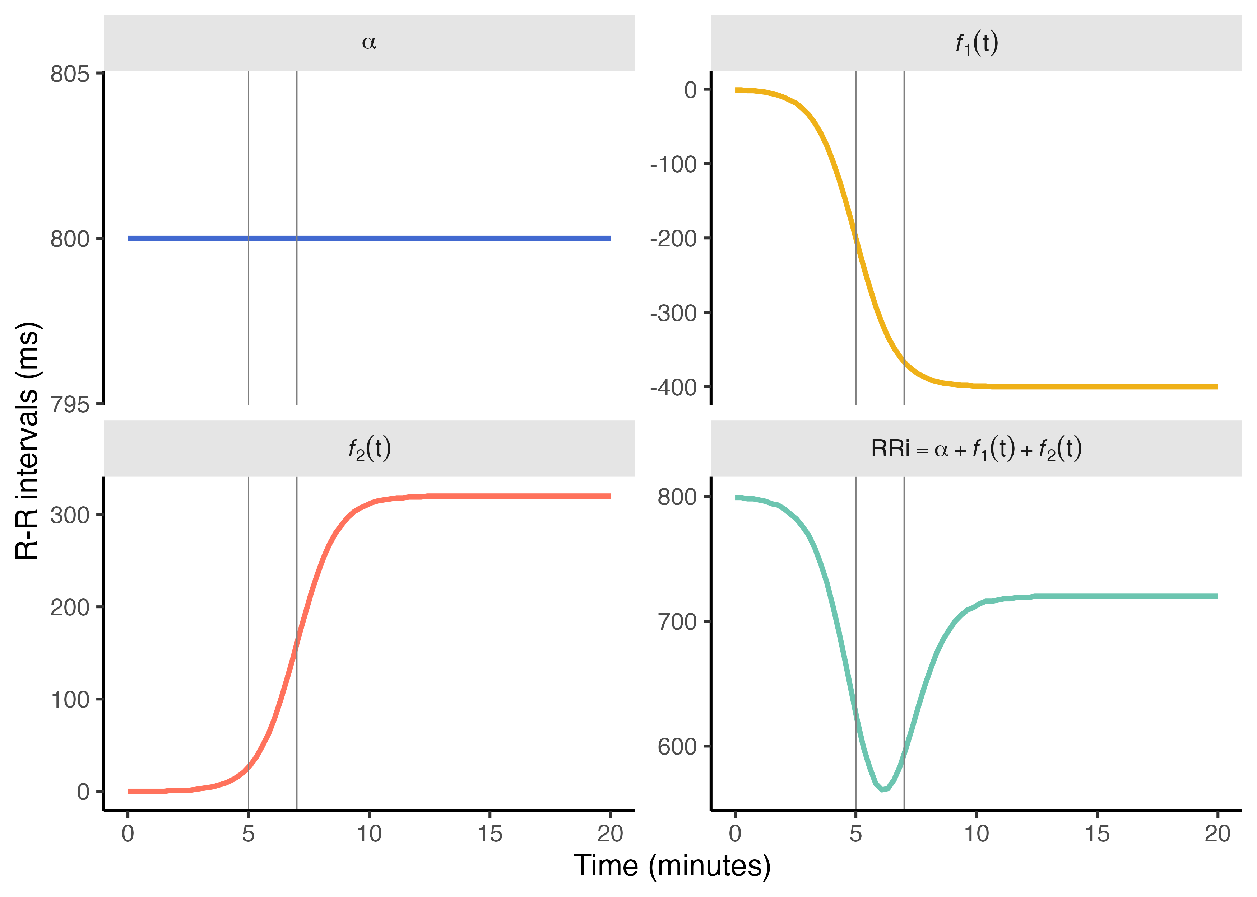

**Figure 2**. The RRi dynamics in response to exercise are expressed as a linear combination of model constituents based on the baseline RRi $α$ and two logistic functions, denoted $f_{1}\left(t\right)$ and $f_{2}\left(t\right)$, respectively.

### Sensitivity to parameter variability

Sobol sensitivity analysis reveals that the parameter $α$ exerts the most substantial influence on the model’s output, followed by parameters $c$ and $δ$. In contrast, parameters $β$, $λ$, and $ϕ$ demonstrate relatively minor effects, with some values crossing zero, indicating negligible influence within the tested parameter ranges.

Individual perturbation of each parameter highlighted that RRi dynamics are sensitive to the baseline RRi parameter, $α$. Conversely, the rate parameters for the initial decay during exercise, $λ$, and the recovery post-exercise, $ϕ$, show lower sensitivity, suggesting that they are not primary sources of variation in predicted RRi trajectories when assessed in isolation. The results of the sensitivity analysis are illustrated in Figure 3.

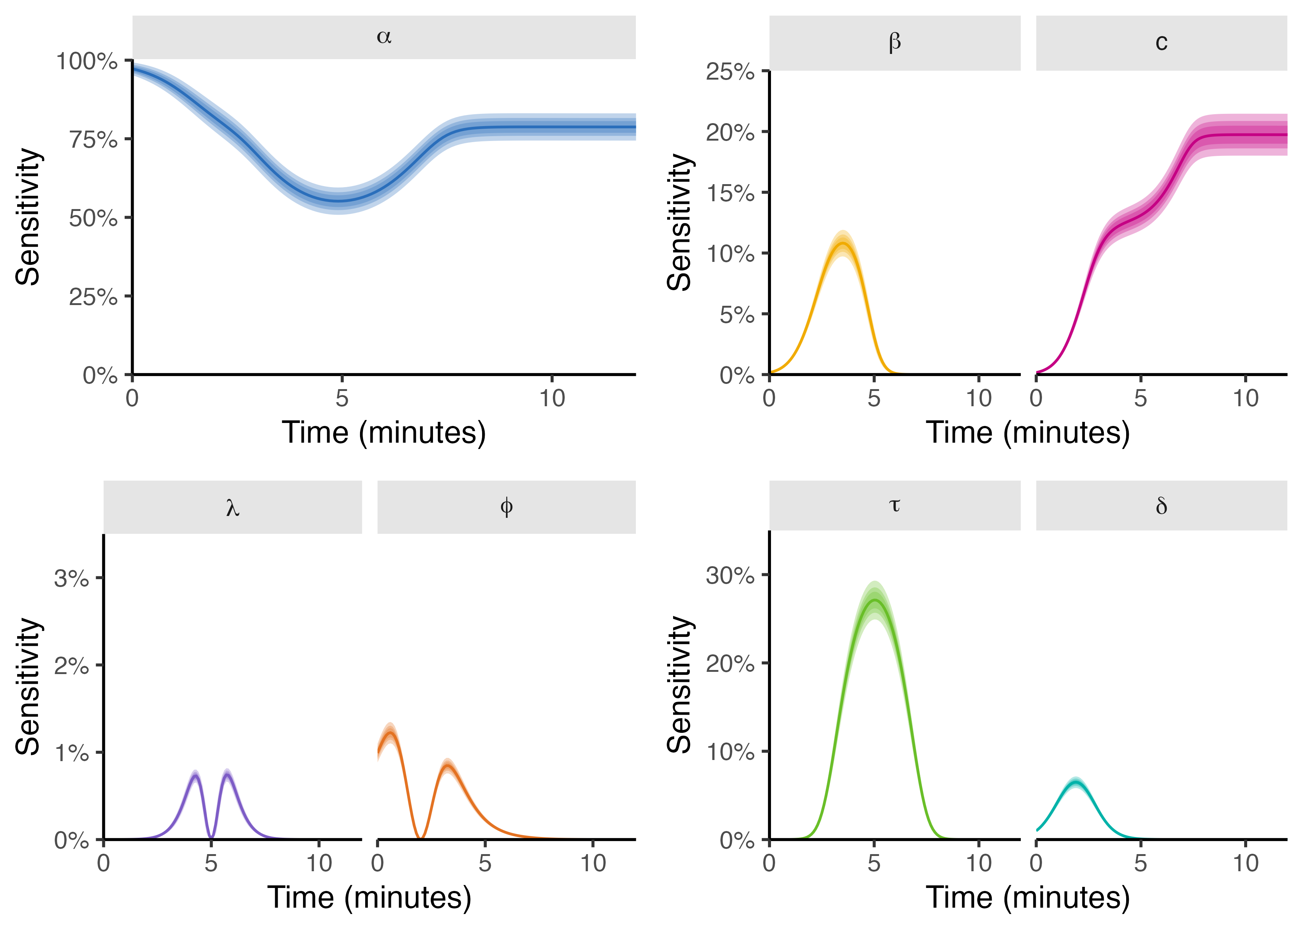

**Figure 3**. Sensitivity analysis results illustrating the impact of parameter variability on model predictions and the percentage of explained variance accounted for each model parameter. Shaded areas represent 95%, 80%, and 60% CI estimated from Monte Carlo samples. Time in x-axis is truncated at 12 minutes, given that around this time, the proportion of the total variance explained by the respective model parameter stabilizes respective of time.

Despite the limited sensitivity of $λ$ and $ϕ$ to mean RRi, these parameters play a pivotal role in determining the rate of change in RRi in response to physical exertion. Therefore, they can significantly affect RRi dynamics over time. The influence of these rate parameters on RRi fluctuations over time is depicted in Figure 4.

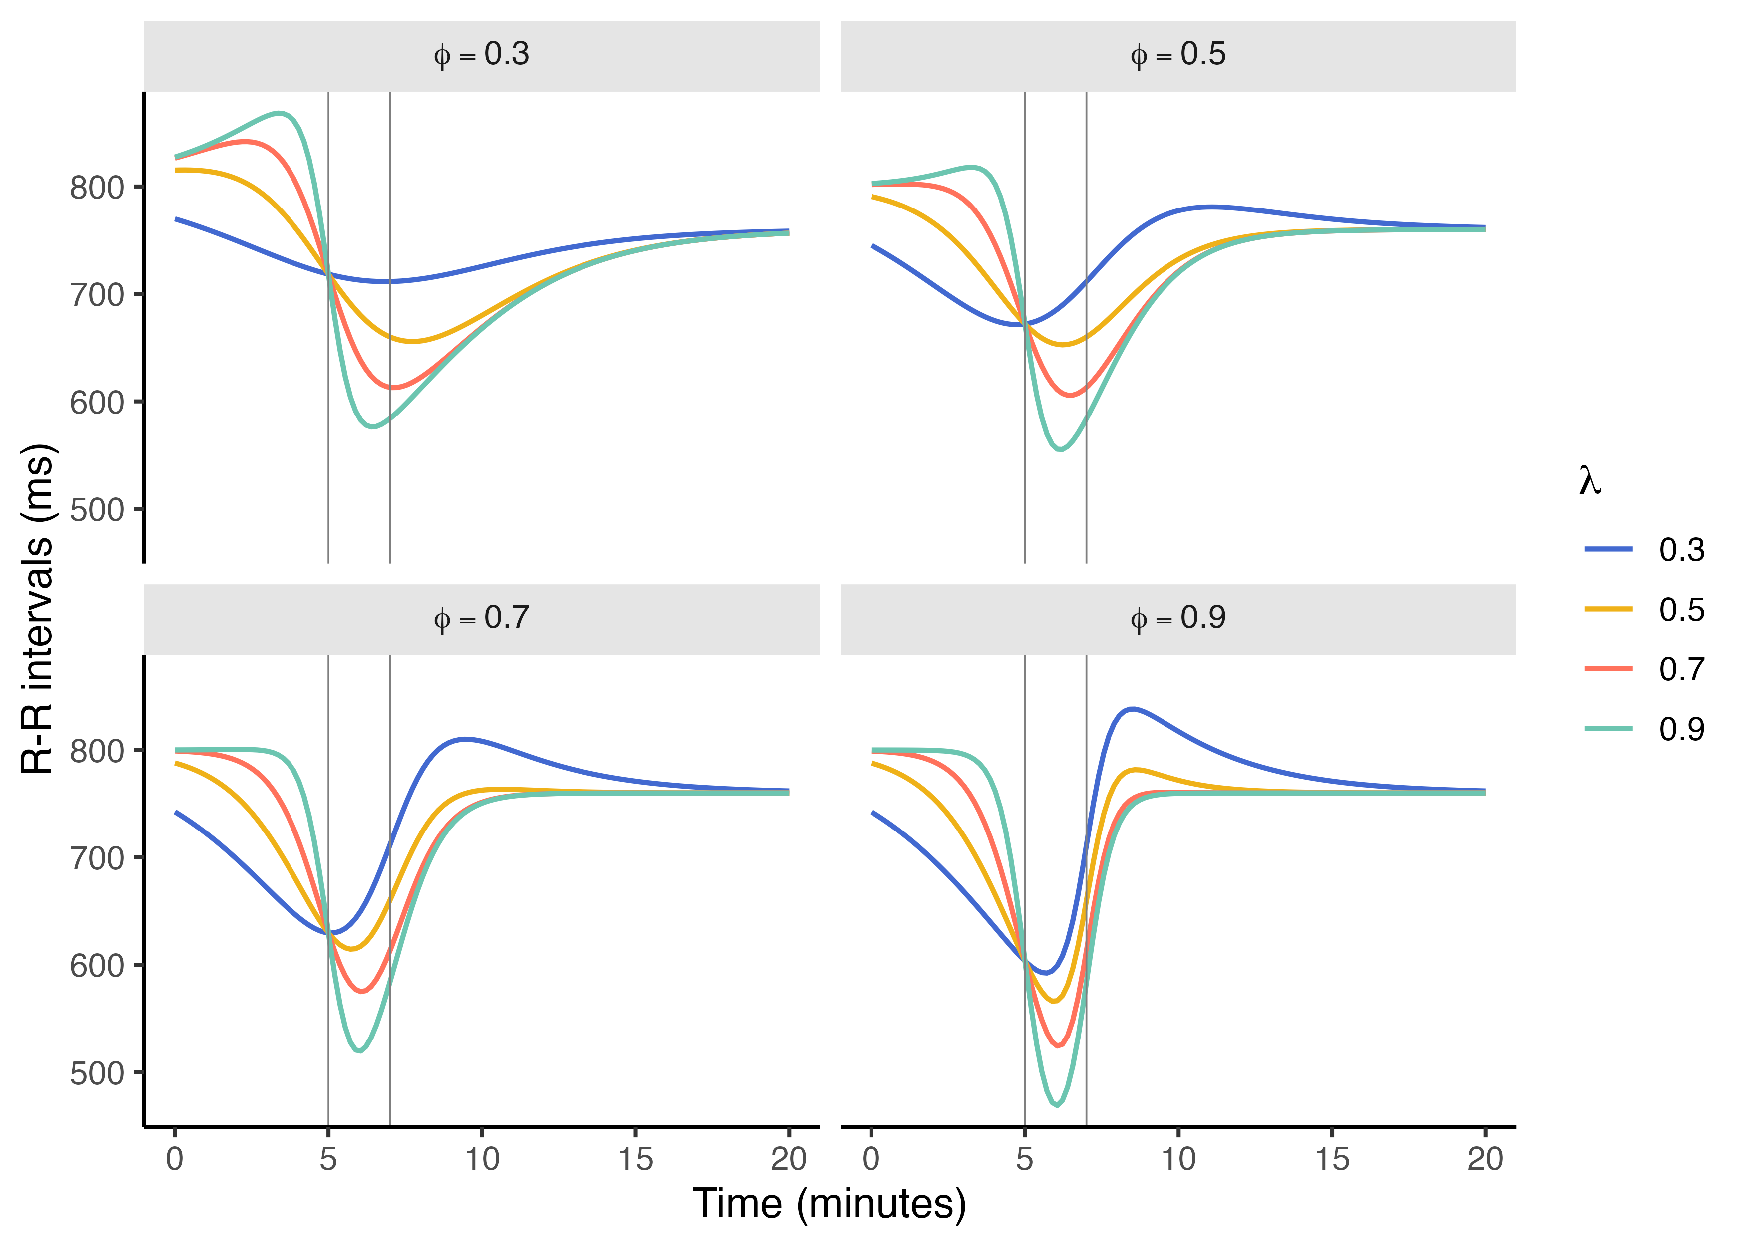

**Figure 4**. Simulated RRi dynamics during exercise with varying $λ$ and $ϕ$ rate parameters expressed as percent change per unit of time. In this simulation, the exercise-induced RRi drop occurs at 5 minutes ($τ$), and cardiovascular recovery begins 2 minutes after exercise initiation ($δ$). The model assumes a 90% recovery ( $c$ = 0.90) of RRi values following a 400 ms drop ($β$) from a baseline of 800 ms ($α$).

## Model behavior to real RRi data

### Sample characteristics

The sample used to assess RRi dynamics consists of a group of 272 subjects selected from a local community of elderly individuals. The sample characteristics can be seen in Table 2

| Characteristic | Overall | Female | Male |
| --- | --- | --- | --- |
| Sex | — | 217 (79.8%) | 55 (20.2%) |
| Age | 71.14 ± 6.03 | 70.73 ± 6.27 | 72.73 ± 4.7 |
| SBP (mm hg) | 130.23 ± 17.07 | 129.58 ± 17.37 | 132.8 ± 15.69 |
| DBP (mm hg) | 77.1 ± 9.58 | 76.68 ± 9.83 | 78.75 ± 8.4 |
| MAP (mm hg) | 94.81 ± 10.69 | 94.31 ± 10.95 | 96.76 ± 9.45 |
| PP (mm hg) | 53.14 ± 14.07 | 52.9 ± 14.26 | 54.05 ± 13.38 |
| BMI | 30.66 ± 5.43 | 30.7 ± 5.64 | 30.53 ± 4.53 |
| Weight (kg) | 75.06 ± 14.23 | 73.88 ± 14.09 | 79.69 ± 13.95 |
| Height (cm) | 156.56 ± 9.18 | 155.29 ± 8.46 | 161.55 ± 10.24 |

**Table 2**. Sample characteristics from which, continuous RRi monitoring data was collected during a rest-exercise-rest protocol. Data is presented as Mean ± SD.

Initial exploration of RRi dynamics using two-dimensional density kernel estimation (see Figure 5) indicates a clear drop in RRi around the 5-7 minutes mark, associated with the exercise-induced cardiovascular stress. However, greater variability across individuals in post-exercise recovery can be observed.

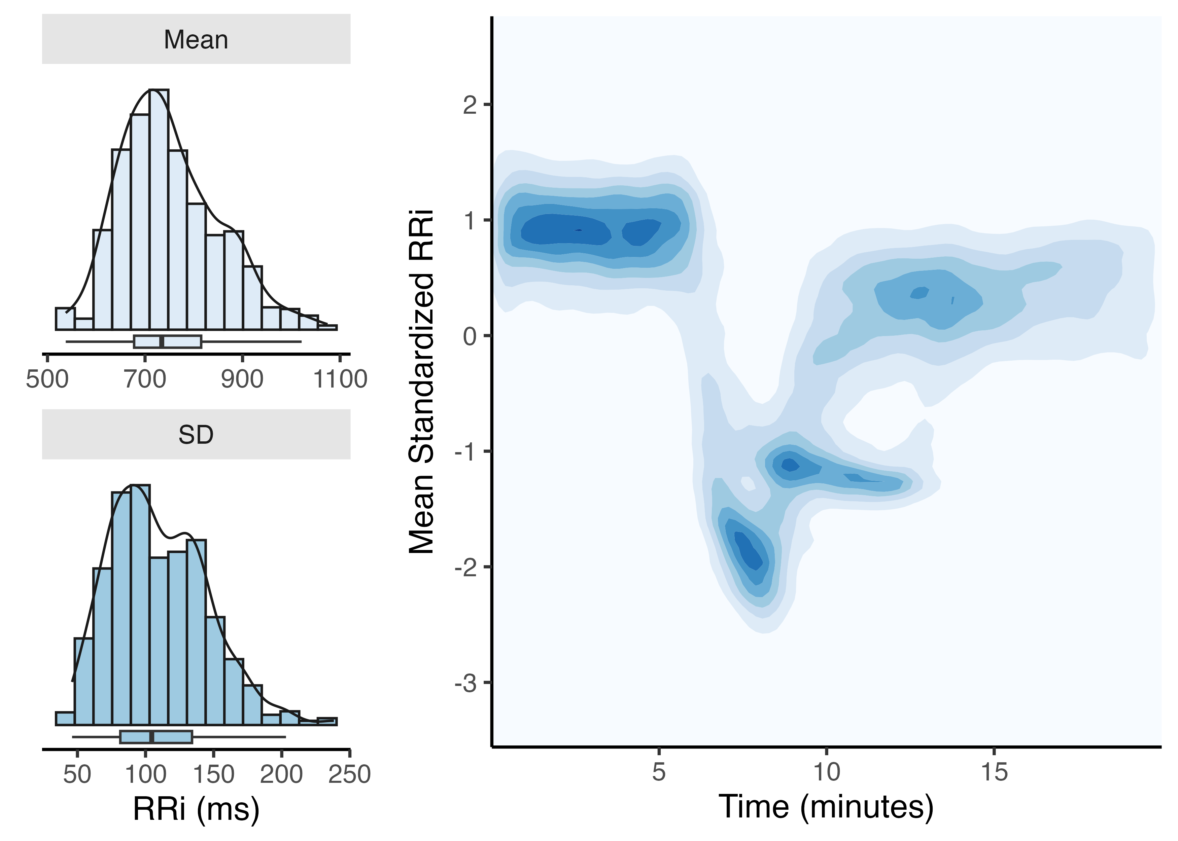

**Figure 5**. Upper panel shows the mean and standard deviation (SD) from each of the subject’s RRi recordings, used for the standardization process. Lower panel indicate the 2D kernel density of standardized RRi dynamics over time from a sample of individuals subjected to a rest-exercise-rest protocol. Darker colors indicate greater probability density. The contrary can be said about lighter colors.

# Discussion

In this study, we present a non-linear model designed to RRi fluctuations during exercise and recovery, providing an in-depth view of cardiac autonomic dynamics. By focusing on RRi rather than aggregate HRV metrics, our approach enables real-time tracking of cardiovascular responses to physical stress, which has implications for both clinical and athletic applications. This model marks a step forward in computational physiology, bridging the gap between theoretical frameworks and practical monitoring applications.

The Sobol sensitivity analysis revealed baseline RRi () and recovery proportion () as key drivers of model output variance, consistent with physiological expectations. Baseline RRi reflects intrinsic cardiac properties, while recovery proportion captures autonomic re-engagement post-exercise, both central to cardiovascular adaptation. The relatively low sensitivity of decay and recovery rate parameters ( and ) suggests the model is robust to moderate fluctuations in these rates, which enhances its reliability for both individualized and group-based applications.

Sobol analysis was selected for its capacity to handle non-linear, time-varying relationships, but it assumes parameter independence and demands substantial computational resources. This assumption may overlook interdependencies typical in biological systems, where parameters such as decay rates and recovery kinetics often interact. For future work, alternative sensitivity methods, such as Bayesian sensitivity analysis, could address interdependencies and potentially improve interpretive accuracy in complex biological contexts. Additionally, real-time applications in resource-limited environments may benefit from computational optimizations, such as surrogate modeling or sparse-grid approximations, to reduce processing time while maintaining analytical depth.

The practical application of this model extends to clinical monitoring and athletic training, but further validation is essential to confirm its robustness in real-world conditions. To support clinical decision-making, future studies should validate the model against established physiological benchmarks, such as VO₂ max and lactate thresholds, which would facilitate its integration into routine health assessments. For instance, this model could be valuable in cardiovascular rehabilitation programs, where tracking real-time autonomic responses can help personalize exercise regimens, ensuring adequate recovery without overstressing the cardiovascular system. Furthermore, for at-risk populations, the model could assist in detecting autonomic irregularities indicative of early cardiovascular dysfunction.

For athletic applications, the model has potential in guiding interval training, where it could help identify optimal recovery points between intense exercise bouts. In this setting, real-time tracking of RRi dynamics may help prevent overtraining and optimize performance by aligning training load with individual recovery capacity. However, extending this model beyond controlled, single-bout settings requires further validation, particularly in dynamic environments where external factors like temperature, altitude, and psychological stress can influence RRi. Integrating the model with wearable devices would be essential for field applications, but these devices must capture RRi with sufficient accuracy to maintain model precision. Future studies should focus on adapting the model for wearable technology and testing it in diverse settings to evaluate its reliability across environmental and situational variations.

Traditional models of RRi often rely on linear assumptions or simple exponential functions, which fail to capture the transient, non-stationary nature of RRi during exercise and recovery. By using logistic functions to model both the decay and recovery phases, our non-linear approach accommodates gradual autonomic shifts more effectively than exponential functions, offering a physiologically relevant representation of RRi dynamics. This model also enhances interpretability by isolating time-dependent contributions of each parameter, as demonstrated in the Sobol analysis, thereby enabling applications across varied fitness levels and exercise intensities.

While recent studies have developed non-linear models, many focus on HRV aggregates that summarize rather than directly model RRi changes. By focusing on RRi, our model provides a high-resolution view of cardiac adaptation, which is particularly valuable for both clinical and athletic settings. Furthermore, the ability to adapt the model parameters to real-time changes in RRi has the potential to enhance sensitivity in detecting subtle shifts in autonomic state, which aggregated HRV indices may obscure.

This model has limitations that warrant careful consideration. First, the uniform parameter sampling used in sensitivity analysis, though practical, may not fully capture individual variability in populations with extreme autonomic profiles or chronic health conditions. Moving forward, incorporating empirical distributions or Bayesian priors based on population data could refine parameter estimates, enhancing individualization for diverse clinical populations, such as older adults or individuals with cardiovascular disease.

Another area for future research is multi-session modeling to account for cumulative adaptations over repeated exercise sessions. Real-world training and rehabilitation often involve multiple bouts of exercise that can introduce cumulative autonomic fatigue or adaptation. Extending the model to track such longitudinal effects could help identify early signs of overtraining or autonomic exhaustion, thereby providing a preventive tool for both clinical and athletic populations. Additionally, considering environmental and psychological factors—such as temperature, stress, or sleep quality—would add robustness, ensuring that model predictions remain accurate across varied real-world contexts.

# Conclusion

In summary, this study introduces a non-linear model of RRi dynamics that captures complex, real-time fluctuations reflecting the autonomic nervous system’s response to exercise and recovery. By focusing on RRi, the model offers enhanced sensitivity to physiological changes, making it well-suited for personalized applications in clinical and athletic settings. The use of Sobol sensitivity analysis enabled a time-dependent interpretation of parameter effects, underscoring the model’s adaptability to diverse physiological states and exercise intensities. Nevertheless, further validation, particularly with multi-session and wearable-based applications, is essential to establish the model’s robustness and applicability in dynamic, real-world environments. By advancing precision in cardiovascular monitoring, this model holds promise for supporting individualized health and performance interventions, contributing meaningfully to the fields of computational physiology and applied health sciences.

# Authors’ Contributions

Conceptualization, MC-A; Data curation, MC-A; Investigation, MC-A; Methodology, MC-A, NMD; Supervision, CN-E; Formal analysis, MC-A; Visualization, MC-A; Writing–original draft, MC-A, CN-E, […]; Writing–review & editing, MC-A, CN-E, […]. All authors have read and agreed to the published version of the manuscript.

# Funding

This research did not receive any funding.

# Data Availability Statement

The data supporting the conclusions of this article will be available from the authors without reservation.

# Conflict of Interest

The authors declare that this research was conducted without any commercial or financial relationships that could be construed as potential conflicts of interest.

# References

Bacopoulou, F., Chryssanthopoulos, S., Koutelekos, J., Lambrou, G. I., and Cokkinos, D. (2021). Entropy in cardiac autonomic nervous system of adolescents with general learning disabilities or dyslexia., in *GeNeDis 2020: Genetics and neurodegenerative diseases*, (Springer), 121–129.

Boettger, S., Puta, C., Yeragani, V. K., Donath, L., Mueller, H.-J., Gabriel, H. H., et al. (2010). Heart rate variability, QT variability, and electrodermal activity during exercise. *Med sci sports exerc* 42, 443–8.

Castillo-Aguilar, M., Mabe Castro, M., Mabe Castro, D., Valdés-Badilla, P., Herrera-Valenzuela, T., Guzmán-Muñoz, E., et al. (2023). Validity and reliability of short-term heart rate variability parameters in older people in response to physical exercise. *International Journal of Environmental Research and Public Health* 20, 4456.

Castillo-Aguilar, M., Valdés-Badilla, P., Herrera-Valenzuela, T., Guzmán-Muñoz, E., Delgado-Floody, P., Andrade, D. C., et al. (2021). Cardiac autonomic modulation in response to muscle fatigue and sex differences during consecutive competition periods in young swimmers: A longitudinal study. *Frontiers in Physiology* 12, 769085.

Dong, J.-G. (2016). The role of heart rate variability in sports physiology. *Experimental and therapeutic medicine* 11, 1531–1536.

Eser, P., Jaeger, E., Marcin, T., Herzig, D., Trachsel, L. D., and Wilhelm, M. (2022). Acute and chronic effects of high-intensity interval and moderate-intensity continuous exercise on heart rate and its variability after recent myocardial infarction: A randomized controlled trial. *Annals of Physical and Rehabilitation Medicine* 65, 101444.

Gronwald, T., Hoos, O., and Hottenrott, K. (2019a). Effects of a short-term cycling interval session and active recovery on non-linear dynamics of cardiac autonomic activity in endurance trained cyclists. *Journal of clinical medicine* 8, 194.

Gronwald, T., Hoos, O., Ludyga, S., and Hottenrott, K. (2019b). Non-linear dynamics of heart rate variability during incremental cycling exercise. *Research in Sports Medicine* 27, 88–98.

Hautala, A. J., Mäkikallio, T. H., Seppänen, T., Huikuri, H. V., and Tulppo, M. P. (2003). Short-term correlation properties of r–r interval dynamics at different exercise intensity levels. *Clinical physiology and functional imaging* 23, 215–223.

Kanniainen, M., Pukkila, T., Kuisma, J., Molkkari, M., Lajunen, K., and Räsänen, E. (2023). Estimation of physiological exercise thresholds based on dynamical correlation properties of heart rate variability. *Frontiers in physiology* 14, 1299104.

Kristal-Boneh, E., Raifel, M., Froom, P., and Ribak, J. (1995). Heart rate variability in health and disease. *Scandinavian journal of work, environment & health*, 85–95.

Lundstrom, C. J., Foreman, N. A., and Biltz, G. (2023). Practices and applications of heart rate variability monitoring in endurance athletes. *International journal of sports medicine* 44, 9–19.

Mabe-Castro, D., Castillo-Aguilar, M., Mabe-Castro, M., Muñoz, R. M., Basualto-Alarcón, C., and Nuñez-Espinosa, C. A. (2024). Associations between physical fitness, body composition, and heart rate variability during exercise in older people: Exploring mediating factors. *PeerJ* 12, e18061.

Malik, M. (1996). Heart rate variability: Standards of measurement, physiological interpretation, and clinical use: Task force of the european society of cardiology and the north american society for pacing and electrophysiology. *Annals of Noninvasive Electrocardiology* 1, 151–181.

Molkkari, M., Solanpää, J., and Räsänen, E. (2020). Online tool for dynamical heart rate variability analysis., in *2020 computing in cardiology*, (IEEE), 1–4.

Mongin, D., Chabert, C., Extremera, M. G., Hue, O., Courvoisier, D. S., Carpena, P., et al. (2022). Decrease of heart rate variability during exercise: An index of cardiorespiratory fitness. *PLoS ONE* 17, e0273981.

Thayer, J. F., Yamamoto, S. S., and Brosschot, J. F. (2010). The relationship of autonomic imbalance, heart rate variability and cardiovascular disease risk factors. *International journal of cardiology* 141, 122–131.

Wu, G., and Poon, C.-S. (2003). Nonlinear neurodynamics model of heart rate variability, multifractality and chaos., in *Proceedings of the 25th annual international conference of the IEEE engineering in medicine and biology society (IEEE cat. No. 03CH37439)*, (IEEE), 3822–3825.