Battery Degradation Analysis Report
Generated: 2026-01-08
Data period: 2023-03 to 2025-12
1. Background
This analysis investigates whether a deep-discharge event affected the round-trip efficiency of the home battery storage system.
1.1 System Overview
The system consists of a solar PV installation with battery storage for self-consumption optimization. Battery efficiency is measured as the ratio of energy discharged to energy charged (round-trip efficiency), accounting for conversion losses in both directions.
1.2 The Deep-Discharge Event
Event Period: February - March 2025
Cause: Faulty inverter prevented battery charging
Duration: Approximately 8 weeks
Consequence: Battery remained in a deeply discharged state for an extended period
Deep discharge events are known to potentially cause irreversible capacity loss and efficiency degradation in lithium-ion batteries, particularly when the battery remains at low state-of-charge for extended periods.
1.3 Research Question
Did the deep-discharge event in February-March 2025 significantly affect the battery's round-trip efficiency?
2. Methods
2.1 Data
• Monthly battery charging and discharging totals from 2023-03 to 2025-12
• Pre-event observations: 23 months
• Post-event observations: 9 months
• Event period (excluded from analysis): February-March 2025
2.2 Efficiency Metric
Monthly round-trip efficiency was calculated as:
Efficiency = Discharge (kWh) / Charge (kWh) x 100%
Months with less than 10 kWh of charging were excluded to avoid division by small numbers and unreliable efficiency estimates.
2.3 Statistical Models
Model 1 (Basic):
Efficiency = β0 + β1(Time) + β2(PostEvent) + ε
Model 2 (With Seasonal Controls):
Efficiency = β0 + β1(Time) + β2(PostEvent) + β3(Winter) + β4(Spring) + β5(Autumn) + ε
Where:
• Time: Months since start of observation (captures natural degradation trend)
• PostEvent: Binary indicator (1 if after March 2025, 0 otherwise)
• Seasonal dummies: Winter, Spring, Autumn (Summer as reference category)
• β2: The coefficient of interest - represents the change in efficiency attributable to the event
Both models use heteroskedasticity-robust standard errors (HC3).
2.4 Additional Tests
• Welch's t-test: Compares mean efficiency between pre- and post-event periods (unequal variances)
• Matched-month paired t-test: Compares the same calendar months before and after the event to control for seasonal effects (e.g., comparing Nov 2024 with Nov 2025)
3. Results
3.1 Descriptive Statistics
Pre-event efficiency:
• Mean: 84.4%
• Standard deviation: 4.9%
• Sample size: 23 months
Post-event efficiency:
• Mean: 79.0%
• Standard deviation: 4.7%
• Sample size: 9 months
Raw difference: -5.4 percentage points
3.2 Model 1: Basic Regression
R-squared: 0.316
Variable Coefficient Std.Err p-value
----------------------------------------------------------------
Intercept 81.04 1.95 0.0000 ***
Time (months) 0.302 0.130 0.0198 *
Post-event -10.81 2.70 0.0001 ***
Significance: *** p<0.001, ** p<0.01, * p<0.05, . p<0.1
Event effect: -10.81 percentage points (95% CI: [-16.10, -5.52], p=0.0001)
3.3 Model 2: With Seasonal Controls
R-squared: 0.633
Variable Coefficient Std.Err p-value
----------------------------------------------------------------
Intercept 77.48 1.87 0.0000 ***
Time (months) 0.183 0.156 0.2431
Post-event -8.18 2.69 0.0024 **
Winter 7.44 1.88 0.0001 ***
Spring 5.31 1.27 0.0000 ***
Autumn 7.18 2.27 0.0015 **
Reference category: Summer
Event effect (controlling for seasonality): -8.18 percentage points (95% CI: [-13.45, -2.90], p=0.0024)
3.4 Matched-Month Paired Comparison
This analysis compares efficiency in the same calendar months before and after the event, controlling for seasonal effects by design.
• Matched months: Apr, May, Jun, Jul, Aug, Sep, Oct, Nov, Dec (n=9)
• Pre-event mean: 83.6%
• Post-event mean: 79.0%
• Mean difference: -4.62 percentage points
Paired t-test: t = 7.587, p = 0.0001
3.5 Robustness Check: Welch's t-test
t-statistic: 2.847
p-value: 0.0121
3.6 Summary of Event Effects Across All Tests
Test Effect (pp) p-value
------------------------------------------------
Model 1 (Basic) -10.81 0.0001 ***
Model 2 (Seasonal) -8.18 0.0024 **
Matched-Month -4.62 0.0001 ***
Welch's t-test -5.37 0.0121 *
pp = percentage points; Significance: *** p<0.001, ** p<0.01, * p<0.05
4. Conclusion
The analysis provides strong and consistent statistical evidence that the deep-discharge event in February-March 2025 significantly degraded battery efficiency.Key findings:

- Basic model: 10.8 pp reduction (p=0.0001)
- Seasonal-adjusted model: 8.2 pp reduction (p=0.0024)
- Matched-month comparison: 4.6 pp reduction (p=0.0001)

The effect is robust across multiple specifications, including models that control for seasonal variation. This rules out the possibility that the observed decline is merely a seasonal artifact.The degradation from approximately 84% to 79% round-trip efficiency will result in increased grid dependency and reduced self-consumption of solar energy.Recommendations:
• Monitor battery capacity and efficiency metrics going forward
• Consider professional battery health assessment
• Implement low-voltage protection to prevent future deep-discharge events
• Factor reduced efficiency into energy management calculations
5. Figure
The figure below shows the battery efficiency analysis:
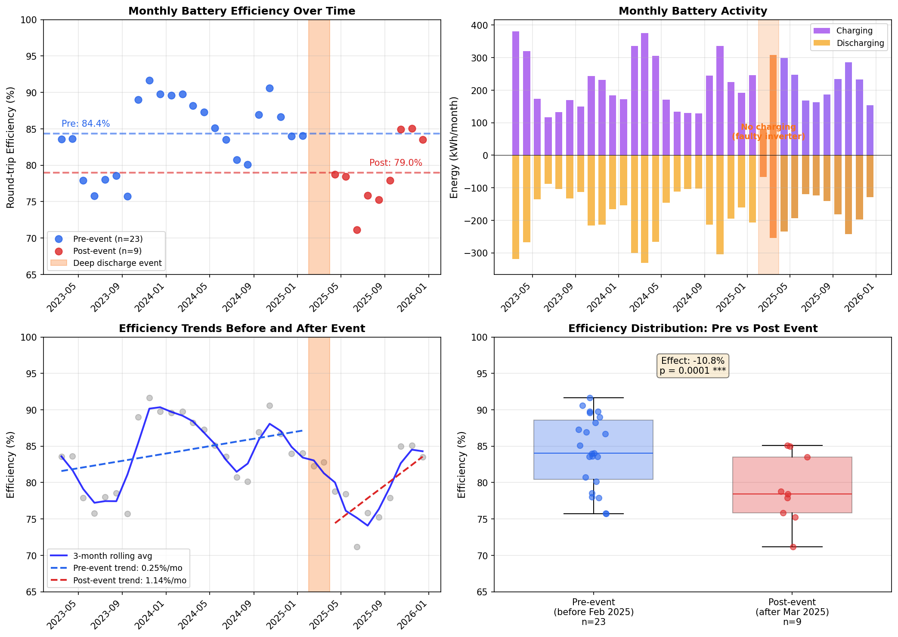
Figure 1: Battery Degradation Analysis
Panel descriptions:
• Top-left: Monthly efficiency time series with event period highlighted in orange
• Top-right: Monthly battery charge/discharge volumes
• Bottom-left: Efficiency trends before and after event with regression lines
• Bottom-right: Box plot comparison of pre/post efficiency distributions

