**Assignment -1**

1. Solve $\frac{d}{dx}\left(x\frac{du}{dx}\right)=\frac{2}{x^{2}}$ $1<x<2$

Boundary Conditions $-x\frac{du}{dx}=\frac{1}{2}$ at $x=2$ and $u=2$ at $x=1$

Solve using a) Point Collocation b) Sub-domain c) Galerkin and d) Least square approaches and compare the results.

**Assignment -2**

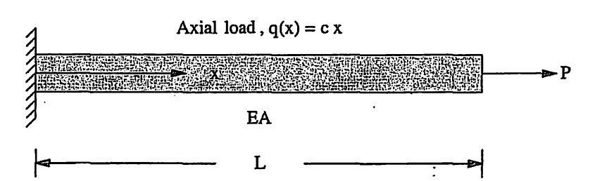

1. The governing equation for the uniform axially loaded bar is given as

$EA\left(\frac{d^{2}u}{dx^{2}}\right)+cx=0$ $0<x<L$

Boundary Conditions $EA\frac{du}{dx}=P$ at $x=L$ and $u=0$ at $x=0$

The potential Energy for the Bar is given as

$π={\int_{0}^{L}{EA\left(\frac{du}{dx}\right)}}^{2}dx-\int_{0}^{L}{cxu}dx-Pu(L)$ $0<x<L$

1. Solve the problem by using the Rayleigh Ritz method assuming a Linear, Quadratic and Cubic trial solution (Hint: The linear solution is of the form $u\left(x\right)=a_{0}+a_{1}x$).
2. Solve the Problem using the Galerkin method both in Strong and Weak formulation and compare the results with those obtained in part a.
3. Write a computer code that will Solve the following using the Galerkin method (Use the weak form) assuming a Linear, Quadratic and Cubic trial solution

$x^{2}\left(\frac{d^{2}U}{dx^{2}}\right)+2x\frac{du}{dx}+x=1$ $1<x<2$

Boundary Conditions $\frac{du}{dx}+2u=5$ at $x=2$ and $u\left(1\right)=2$, Compare the results.

1. Write the weak formulation for the following Differential Equation (You do not have to solve it).

$\left(\frac{d^{4}U}{dx^{4}}\right)+8\frac{d^{2}U}{dx^{2}}+4u=10$ $0<x<5$

Boundary Conditions $u\left(0\right)=0;u^{'}\left(0\right)=1;u\left(5\right)=2;u^{'}\left(5\right)=0$

1. Write a computer code that will solve the PDE in Question 1 of Assignment 1 using the Galerkin weak form approach. Assume a Quadratic, Cubic, Fourth and order solutions and compare the results. Compare the error in both the solution and $τ=-x\frac{du}{dx}$