Set 1 out of 3: Why, How, and Differences (Setting the Ground)
Collection Name: Why Linked Data Infrastructure and Wistor app in the age of EU Data Act?

Intro
Set 1 focuses on the crucial link between the EU Data Act mandate and the necessity of shifting from traditional cloud management (like AWS/Azure/GCP) to a native Linked Data platform like Wistor.

LinkedIn Post Draft (Approx. 350 words)
Hook (Using Template: Contrarian Approach): Stop asking how to store more data on AWS/Azure. Start asking: Is my data legally accessible and semantically structured?
The EU Data Act, fully applicable on September 12, 2025, marks a major shift in Europe's data landscape. It changes the status quo where data was "locked inside the systems of manufacturers or software providers", granting users (individuals, businesses, or public organizations) the right to access and share the data they generate. The mandate is clear: both parties can access all data collected by a machine.
For Data Engineers and Decision Makers, this legal turning point is an accelerator for semantic interoperability. Traditional cloud-centric data architectures, relying on platforms like Amazon Web Services, Azure, and Google Cloud Platform, struggle with the resulting complexity because they are prone to technical and economic issues:

Cloud-Centric (Traditional) Approach | Linked Data & Wistor Alternative
Data Structure: Uses "schema-on-read," creating inaccessible "data swamps". | Data Structure: Data is structured, machine-readable, and reusable using RDF and OWL, providing a formal semantic layer.
Metadata: Describes format, leading to governance gaps. | Metadata: Describes meaning, not just format.
Integration: Requires complex N:M conversions or extensive ETL between systems. | Integration: Promotes 1:N integration using unique URIs and open standards. It also supports N:M conversions including first order logic enabling more interoperability
Data Lock-in: High risk due to dependency on proprietary platform features, especially on data access | Data Lock-in: Wistor is a native linked data platform built on open standards (RDF, OWL, SHACL,SPARQL), ensuring no dependency on proprietary platforms and providing freedom of choice.
Wistor makes compliance lead to collaboration. The platform provides the foundation to build, connect, and scale data ecosystems that align with European data legislation. By shifting to native Linked Data, organizations can move beyond storing raw data and instead focus on connecting data, enriching metadata, and improving the traceability of information.
(Actionable Insight: The first step is to Map your data landscape, Adopt open standards, and Set up governance for your resulting data graph.)

Read my full article here in Wistor blog:

Wistor Blog Post Draft (Introduction Section - Est. 550-650 words of 1,500-2,500 total)
TITLE: Compliance as Catalyst: Why the EU Data Act Forces a Strategic Migration from Cloud Silos (AWS/Azure) to Native Linked Data (Template: The Product Showdown / Myth Debunker)
1. The Legal Imperative: Data Ownership is No Longer Negotiable
The EU Data Act, effective September 12, 2025, is more than a legal update; it is a cultural and technical change that redefines digital trust and data ownership across Europe. For decades, data generated by connected products remained "locked inside the systems of manufacturers or software providers". This law overturns that, granting users—be they individuals, businesses, or public organizations—the right to access and share the data they generate. The core principle established by the European Commission is simple: both parties can access all data collected by a machine.
This mandate creates an immediate, pervasive requirement for semantic interoperability. Data must be ready for instantaneous exchange and reuse, which is a challenge traditional infrastructures often fail to meet.
2. The Cloud Paradox: The Dual Crisis of Hyperscalers (AWS, Azure, and GCP)
The modern data landscape relies heavily on distributed cloud systems, including major platforms like Amazon Web Services (AWS), Microsoft Azure, and Google Cloud Platform (GCP). While offering scale and flexibility, traditional big data management within these architectures faces a dual crisis that undermines Data Act compliance:
- Technical Complexity (Silos and Swamps): Cloud data lakes, using a "schema-on-read" strategy, often become "data swamps" because they lack descriptive metadata and robust governance. Data integration among heterogeneous sources relies on fragile, resource-intensive N:M (many-to-many) conversions or extensive ETL processes.
- Economic Complexity (Opaque Cost and Lock-in): Expenditure on compute, storage, and data transfer is often opaque and difficult to optimize, leading to vendor dependency and the risk of vendor lock-in on proprietary formats and platforms.
These issues mean that while these platforms can store the volume of data generated, they are structurally ill-equipped to handle the legal and semantic requirements for compulsory data sharing and reusability.
3. Linked Data: The Blueprint for Mandated Interoperability
Linked Data (LOD) and Knowledge Graphs provide the structural solution required by the Data Act. The law directly supports principles the Linked Data community has championed for years:
- Data Structure: Data must be structured, machine-readable, and reusable. This moves data beyond raw storage into formats like RDF, which simplifies integration by facilitating 1:N relationships using unique URLs as reference points.
- Metadata: Metadata must describe meaning, not just format. This semantic enrichment is essential for building digital trust and ensuring data context is maintained when data is shared across organizational boundaries.
- Interconnection: Systems must interconnect through open standards rather than isolated APIs. Utilizing standards like RDF, OWL, SHACL, and DCAT-AP makes this vision practical, turning the "Web of Data" into a single, massive data-space.
4. Wistor: The Native Alternative to Cloud Middleware
Wistor is designed specifically to address the failures of applying a semantic layer on top of traditional databases. Wistor is the only native linked data platform built from the ground up on LOD principles:
- Native Standards: Wistor is natively designed around RDF, OWL, and SHACL. Every object, attribute, and relation is stored as linked data from the start, avoiding the compromises of middleware solutions typically needed to integrate semantics into traditional cloud silos.
- Decoupling and Control: The platform strictly decouples the data layer and the application layer. This separation ensures that the data remains independent, fully owned by the organization, and that there is no vendor lock-in because there is no dependency on proprietary formats.
- Enhanced Solutions: Wistor's native approach enables sophisticated governance (using SHACL validation for compliance) and cost-effective reuse, allowing data to be reusable across projects, systems, and partners. We empower data engineers to configure apps using SPARQL directly on the triple store.
By making the data itself the stable core, Wistor transforms the regulatory requirement of the EU Data Act into an architectural advantage, proving that compliance should lead to collaboration.

Suggested Images:
[I believe we have to create our own diagrams with good designs but these are some things to inspire:
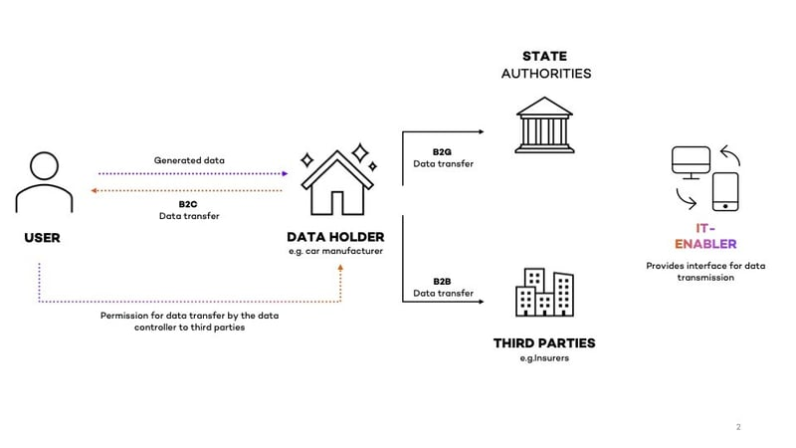Source: https://diconium.com/en/blog/eu-data-act.

And this presentation has a good explanations + diagrams to inspire: https://www.slideshare.net/slideshow/linked-data-for-lean-enterprise-data-management

