Orexigenic Drive & Always-On Homeostasis — Analysis Explained
Table of Contents

Orexigenic Drive & Always-On Homeostasis — Analysis Explained
This document explains, step by step and in plain language, the data analysis in analysis/orexigenic_analysis.ipynb. It says what we did, why we did it, how, and what came out — and then reads the results critically.
The purpose is to examine the results: not to re-derive the code, but to understand what the numbers actually tell us about the robot’s internal “hunger” drive, and where the evidence is strong versus thin.
System under study. The Orexigenic Drive of the alwaysOn-embodiedBehaviour iCub controller — a continuous, always-running “metabolism” that makes the robot get hungry, ask to be fed, and reprioritise its behaviour around recovering energy. The controller pipeline is perception → salience → executive → remote/Telegram (see ../alwaysOn-embodiedBehaviour/README.md).
Contents
- The research questions (the “why”)
- The data (the “what we had”)
- How the analysis is organised
- RQ1 — Is this a real homeostatic drive?
- RQ2 — Does deficit expression lead to reliable recovery?
- Adaptive personalisation — the drive learns who feeds it
- Machine learning — sensitivity checks
- Honest limitations
- Success-criteria scorecard
- Reproducing this

1. The research questions operationalised here (the “why”)
Everything below exists to answer the research questions currently implemented in the analysis. Every low-level analysis step is tied to one of them — nothing is run “just because”.
- RQ1 — To what extent does the orexigenic drive fulfil the four functions of classical homeostasis: (1) internal monitoring, (2) deficit detection,
  - deficit-to-action conversion, (4) behavioural prioritisation?
- RQ2 — Does the expression of an orexigenic deficit promote recovery-oriented engagement sufficient to support reliable energy replenishment in an always-on social robot?
In plain terms: RQ1 asks whether this is a real homeostatic drive — does it continuously track its own state, correctly detect when that state is a deficit, actually change behaviour because of the deficit (not just cosmetically), and override the social agenda when the deficit is severe? RQ2 asks whether expressing that deficit reliably gets the robot fed — whether people (in person or over Telegram) respond enough to bring it back out of starvation and keep it out over the long run.

One design fact that shapes everything
The drive was always on for the entire study. There is no “drive-off” control condition. We did not invent one. So RQ2 is identified two ways from within the always-on data:
- the graded deficit itself — Full → Hungry → Starving — is treated as the manipulation (does behaviour change as the robot gets hungrier?); and
- the proactive vs reactive contrast — does the drive initiate recovery, or only react when a human happens to show up?
This is an honest limitation and it is stamped on every conclusion.

The answers, up front
RQ1 — is this a real homeostatic drive? Yes — specifically a threshold controller. All four functions are met. It monitors itself autonomously (dense 2.3-s sampling across 46 h, even in empty rooms) and detects deficits cleanly (exact 60/25 thresholds, zero flapping) — though those two are faithful-implementation facts, true by construction. The load-bearing results are behavioural and cross two coded thresholds: at the deficit line (entering Hungry) the robot switches on a whole proactive recovery repertoire that is silent at Full — hunger framing in speech jumps 3% → 67%, feed-seeking speech acts and proactive Telegram pings switch on (1 → 20 and 0 → 172), and feeding pursuit ~triples (0.15 → 0.43); then at the starving line it overrides the social agenda entirely (turns 2.5 → 0.2, Engaged 0.68 → 0.08). The deficit adds recovery behaviour at 60 and overrides social behaviour at 25 — a two-threshold controller, not a smooth ramp.
RQ2 — does expressing the deficit yield reliable replenishment? Yes — and this is the study’s most important result. The deficit elicits graded feeding (meal size 21 → 29 → 43) and draws replies both in person and over Telegram (proactive ping-reply 0.21–0.26), and the observed Starving episodes resolved by feeding (8/8, exploratory; median 21 s to first feed). Crucially, the people kept the robot fed: across the whole deployment its energy stayed in homeostasis and it was out of starvation ~99% of the time (~1% long-run Starving, no absorbing “starve-out” state). That low number is not a self-property of the controller — it is the outcome of the closed loop working: the drive signalled hunger, humans engaged and supplied energy, and homeostasis held. In other words, the HRI loop worked in this deployment: human engagement, in which the drive demonstrably participated, kept the robot’s energy level regulated. The single caveat: that feeding leaned on a few named users (Gini 0.57, top-3 = 62%).

2. The data (the “what we had”)
The robot logs to four SQLite databases — vision.db, salience_network.db, executive_control.db, chat_bot.db — one per module. The data/ folder contains eight dated snapshots of these databases.
The key discovery in data prep: those eight folders are not eight independent experiments. They are cumulative snapshots of one continuously-growing database — each later folder is a strict superset of the earlier ones. Naïvely stacking them would double-count every interaction 4–5×. So the very first analytical act is to de-duplicate to the true unit of analysis:
- run (run_id) — one continuous session of the robot from start to restart;
- day (day_rome) — the calendar day a run belongs to.
After de-duplication the corpus is: 10 runs with visitors, across 8 days, 217 interactions (and 12 runs monitored by the drive — two runs had the drive draining with nobody present).

3. How the analysis is organised (the “how”, at a glance)
The notebook runs in phases, each a gate for the next:
Phase | What it does | Why
0 — Ground truth | Read the controller source code and extract every constant (thresholds, drain rate, energy costs) with file:line references. Then discover the data layout and de-duplicate. | So every later claim is checked against what the code actually does, not against memory.
A — Data preparation | Load the clean DB views, pseudonymise all identities (P01…P14), reconstruct analysis units (HS3 episodes, transitions, drive timeline), and build one leakage-safe master table (one row per interaction, predictors from before the interaction only). | A trustworthy, privacy-safe table that can’t “cheat” by peeking at the outcome.
Verification gate (V1–V5) | 15 hard/soft checks: do meal sizes match the source constants? Does the fitted drain rate match nominal? Referential integrity, clock sanity, energy balance. | Nothing proceeds until the data provably matches the code. All passed.
B — Statistics (B1–B9) | The confirmatory core. Bootstrap CIs, chi-square tests, Spearman trends, a run-adjusted OLS check, and a Markov steady-state model. One analysis per homeostatic function. | This is where the real evidential weight sits.
C — Visualisation | 12 figures, all tied to a specific claim. | Make the mechanism legible.
D — Machine learning (D1, D4, D5) | Interpretive, not confirmatory (only ~200 rows). Group-aware cross-validation (D1), feeding-concentration robustness (D4), and language framing (D5). | Sensitivity checks and robustness, honestly labelled as such.
A recurring, deliberate stance runs through Phase B: Starving is rare and small-n (single-digit episodes). So we lead with effect sizes and bootstrap confidence intervals, p-values second, correct the whole family with Benjamini–Hochberg, and label thin results “directional” rather than dressing them up as proof.

Figure 1 — the pipeline and what each stage logs
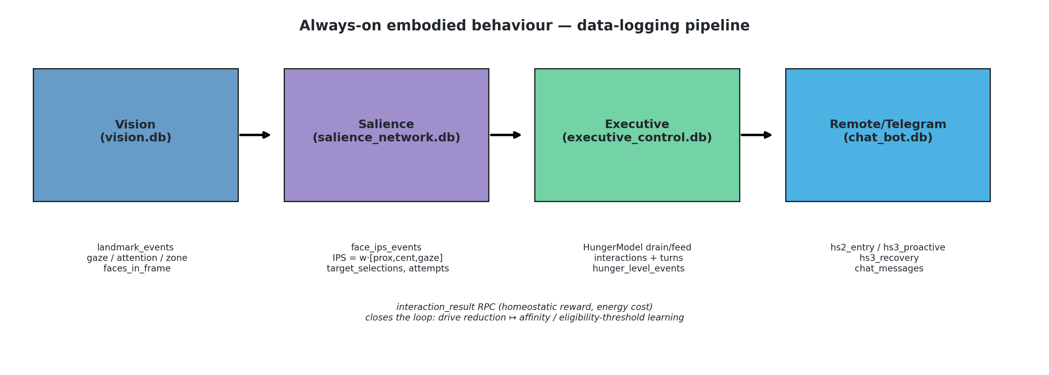
Architecture
What to see. The figure is a data-flow map, not a performance result: Vision produces face/gaze observations, Salience computes IPS and target attempts, Executive runs the hunger model and interaction state machine, and Telegram carries the same drive off-robot. Reading. The important loop is the feedback arrow: after an interaction, Executive returns homeostatic reward and energy cost to Salience, where it updates person-level affinity and the effective eligibility threshold. Conclusion. The value-system and action-selection additions are measurable end to end: internal drive state affects behaviour, and interaction outcomes feed back into future target selection.

4. RQ1 — Is this a real homeostatic drive?

RQ1.1 + RQ1.2 — Monitoring & detection (analyses B1, B2 — verification, not headline results)
Read these two as verification of faithful implementation, not empirical measurements. The stomach level is a software integrator and the hunger label is derived from it by the same coded 60/25 thresholds. So the two “results” below hold by construction — they prove the mechanism is wired correctly, and the only genuinely non-trivial content is autonomy (B1) and the absence of flapping (B2). The confirmatory weight of RQ1 sits in RQ1.3 and RQ1.4 below.
B1 — Internal monitoring. Does the robot track its “stomach level” continuously and on its own, regardless of who is around? We fitted the empirical drain slope and compared it to the coded nominal rate (100/(4·3600) %/s, empties in 4 h). It matches at exactly 1.00× with a zero-width CI — the tell of a software integrator (true by construction). The real content: the drive samples every ~2.3 s (median gap) across 12 monitored runs / ~46 h, ~100% of samples with no interaction attached, and it keeps draining in two runs with zero visitors present. Autonomous, dense, interaction-independent monitoring. Verdict: Supported (faithful implementation + autonomy).
B2 — Deficit detection. When the level crosses 60 (→ Hungry) or 25 (→ Starving), does the state flip correctly and cleanly? Bracketing accuracy is 1.00/1.00 (by construction — the label is defined by those thresholds). The non-trivial result is zero rapid reversals — no flapping at either boundary (the chatbot even ships a 60-s debounce, HS_DWELL_SEC, to absorb flapping it essentially never sees). Verdict: Supported (faithful implementation; clean, stable boundaries).

Figure 2 — the signature figure: the drive over time, one panel per day
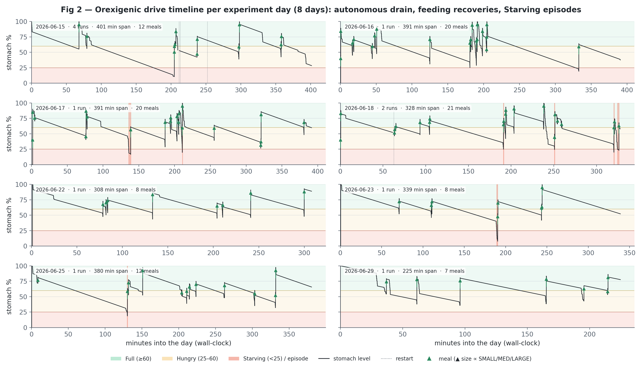
Drive timeline
What to see. Eight days on the wall-clock; the black line is the stomach level, sawtoothing down under autonomous drain and up at the 108 logged meals (arrow size ∝ SMALL/MED/LARGE). Bands = Full/Hungry/Starving; dotted lines = restarts; red shading = Starving episodes. Reading. The signal spans the full 0–100 range but lives overwhelmingly in the green/amber bands; time below 25 (Starving) is a thin red sliver, and conditions vary sharply across runs — one 15-06 run spent 14% of its time Starving while several others never dipped below 25 at all. Conclusion. This is the homeostatic loop made visible — continuous decay, discrete feeding recoveries, starvation as a rare and quickly-corrected excursion — the qualitative picture that B7 later quantifies at ~1% long-run Starving.

Figure 3 — detection fires exactly at the thresholds
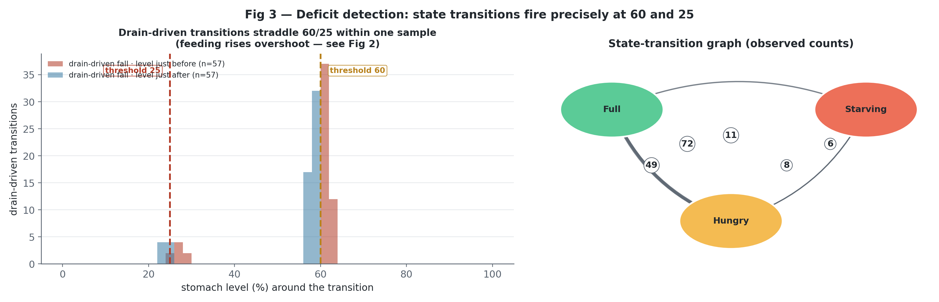
Thresholds and transitions
Reading. Left: the 57 drain-driven falls straddle the coded thresholds within one sample: 49 Full→Hungry crossings at 60 and 8 Hungry→Starving crossings at 25. Feeding-driven recoveries are deliberately excluded from this histogram because meals are discrete jumps that overshoot thresholds. Right: the full transition graph has 146 observed state changes: Full→Hungry 49, Hungry→Full 72, Hungry→Starving 8, Starving→Hungry 6, and Starving→Full 11. There is no Full→Starving edge; deep deficit is reached through Hungry, while some meals recover directly from Starving to Full. Conclusion. Detection at the two thresholds is wired correctly, and most traffic is the mild Full↔Hungry oscillation; Starving excursions are real but infrequent.

RQ1.3 — Deficit → action conversion: does a deficit change what the robot does? (analysis B3)
What we asked. Does being in a deficit actually change the robot’s behaviour, or is the hunger state a cosmetic label? The right contrast is no-deficit (Full) vs deficit (Hungry + Starving) — not Hungry-vs-Starving — because the question is whether having a deficit converts into action.
What the controller changes in a deficit (read from the code + prompts.json). A deficit switches on an entire proactive recovery repertoire that is silent at Full: - the LLM system overlay flips to a hungry persona (system_overlay_hs2; an HS3 override); - face-to-face opener / follow-up / wind-down prompts switch to *_hs2 variants that inject hunger hints, and Starving runs the _run_hunger_tree feed-seeking loop (hunger_ask_feed → wait for food → hunger_still_hungry → hunger_look_around); - the remote channel emits proactive Telegram pings (hs2_entry, hs3_proactive) that only exist in a deficit; - feed-acknowledgement text is state-specific (feed_ack_hs1/2/3).
How. We measure each of these directly from the databases, Full vs deficit.
Result — the deficit produces a large, categorical change in behaviour.
Behaviour (Full → Deficit) | Full | Deficit | Change
Hunger framing in face-to-face speech | 2.8% | 66.5% | ~24×
Feed-seeking speech acts (ask-feed / still-hungry / look-around) | 1 | 20 | deficit-only (coded)
Proactive Telegram pings (hs2_entry + hs3_proactive) | 0 | 172 | deficit-only (coded)
Telegram hunger framing | 8.7% | 27.2% | ~3×
Co-present feeding pursuit (P(meal in interaction)) | 0.15 | 0.43 | ~3×
Mean meal size | 21.2 | 31.4 | +48%
How to read it. Two honest layers: the remote pings and feed-seeking acts are coded gates — their appearance only-in-deficit confirms the state does switch the action repertoire (faithful implementation). The framing, feeding pursuit and meal size are emergent measurements of how strongly the deficit reshapes what actually happens — and they move a lot. This is not cosmetic and not merely a Starving effect — the moment the robot has any deficit, its behaviour changes categorically in both face-to-face and remote channels.
Verdict: Supported.

Figure 4 — Deficit → action
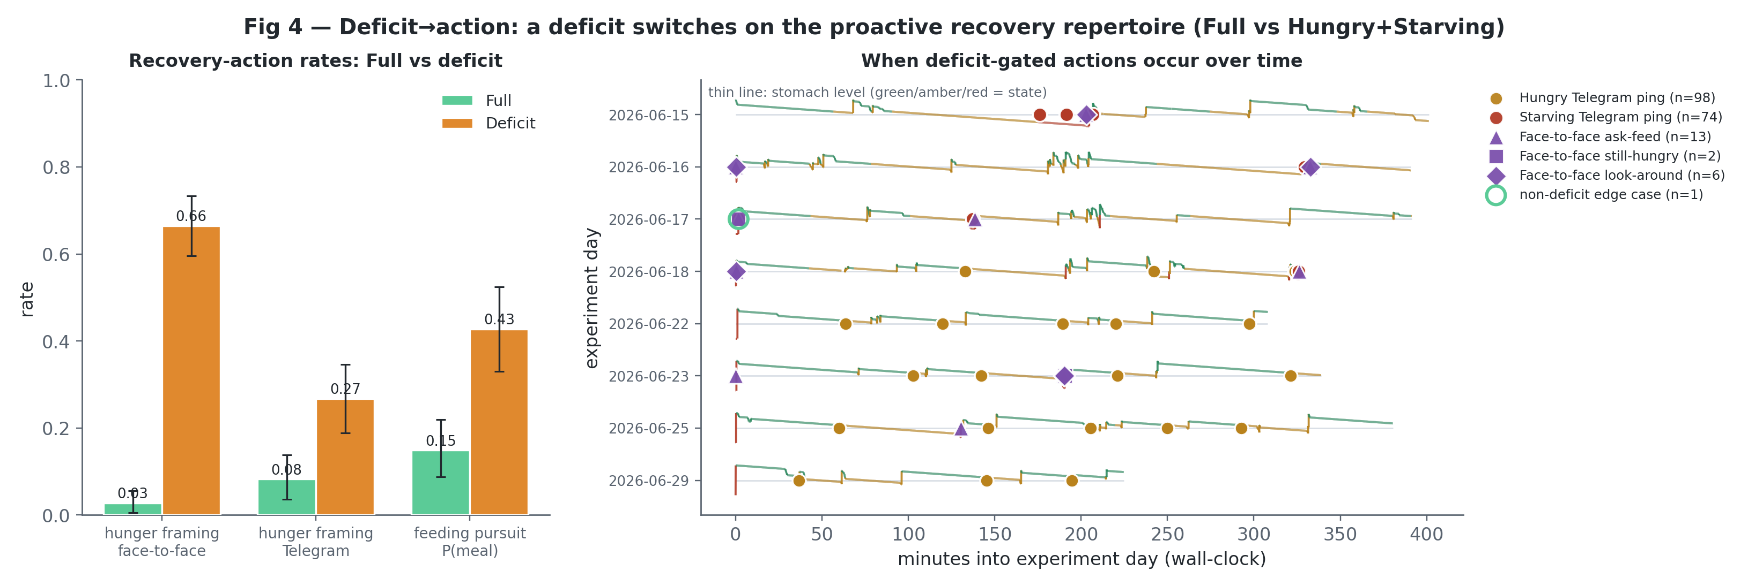
Deficit to action
Reading. The correct RQ1-3 contrast — Full vs deficit (Hungry+Starving). Left: with bootstrap CIs, recovery-action rates jump: face-to-face hunger framing 0.03 → 0.67, Telegram hunger framing 0.09 → 0.27, and co-present feeding pursuit 0.15 → 0.43. Right: the same deficit-gated actions are plotted by experiment time, showing when the robot actually emitted Hungry/Starving Telegram pings and face-to-face feed-seeking acts across the deployment, overlaid on the continuous stomach-level trace whose colour changes with state, rather than reducing them to a bar count. Conclusion. A deficit changes the robot’s action repertoire; the evidence is the emergence and timing of recovery actions, not generic reply behaviour.

RQ1.4 — Behavioural prioritisation: the Starving override (analysis B4 — the centrepiece)
What we asked. The most important RQ1 question. When Starving, does the drive take over — abandon chit-chat and pursue food?
How. We crosstabbed outcomes by social-state × hunger-state, then compared Starving vs (Full+Hungry) on conversation depth (turns, reaching “Engaged”) and on feeding pursuit.
Result. - Conversation collapses when Starving: turns 2.5 → 0.2 (diff −2.39), and reaching Engaged falls from 0.68 → 0.08. - Feeding pursuit rises: P(meal in the interaction) 0.26 → 0.54.
So it is reprioritisation, not disengagement — the robot doesn’t go quiet, it switches goals from socialising to getting fed, exactly as the coded _run_hunger_tree override specifies. Starving n = 13 (directional).
Verdict: Supported.

Figure 5 — the prioritisation heatmap
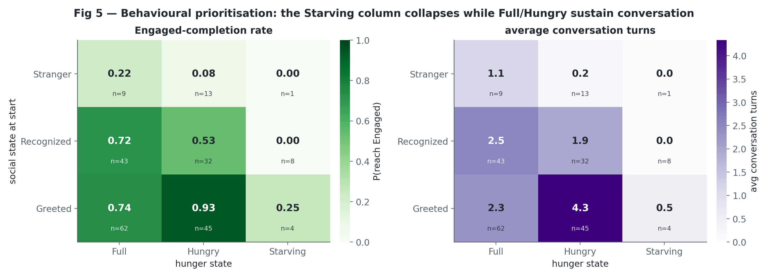
Prioritisation heatmap
Reading. Engagement is set jointly by social and hunger state. Completion actually peaks at Greeted×Hungry (0.93, 4.33 turns) — a familiar face plus mild hunger is the robot’s most engaged regime — and stays high across the whole Full and Hungry columns for known people (0.72–0.93). The entire Starving column collapses to 0.00 / 0.00 / 0.25, visible as a dark vertical stripe. Every cell shows its n. Conclusion. Hunger doesn’t gently erode conversation; it leaves it intact — even enhanced — until Starving, where one override zeroes it out regardless of who the person is.

Figure 6 — how salience picks who to talk to
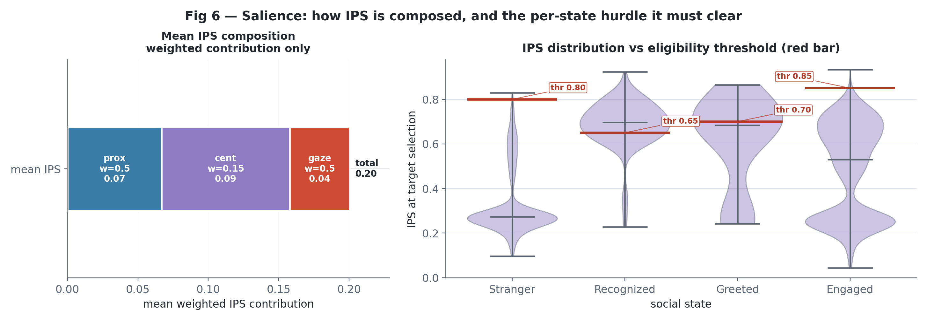
IPS decomposition
Context (salience mechanism, not a drive result). IPS is a fixed weighted sum — prox 0.5, cent 0.15, gaze 0.5 — identical across all 216,940 events (learning never touches the weights; see B9). The left panel shows the weighted IPS composition (score × weight) as one summed bar, so the formula is visible without turning the components into a ranked comparison. Right: the distribution of logged target-selection IPS values is shown against the nominal eligibility thresholds (ss1 0.80 … ss4 0.85). Conclusion. Use this as mechanism context: IPS supplies the perceptual salience signal, while adaptive learning changes the per-person eligibility threshold, not the IPS weights.

Reading RQ1.3 + RQ1.4 together: deficit-to-action conversion
RQ1.3 and RQ1.4 answer one question from two coded thresholds: does an internal deficit change what the robot does? Full is the baseline social policy — the robot selects faces, holds conversations, and asks ordinary follow-ups (the B3 reference condition). Crossing 60 into deficit adds the recovery repertoire across both face-to-face and remote channels (B3, the numbers above). Crossing 25 into Starving goes further and overrides the social agenda via _run_hunger_tree (B4). So the pathway is stomach level → orexigenic state → active behaviour policy → observable action: the deficit line adds recovery behaviour, the starving line subtracts social behaviour, and neither change is cosmetic.

5. RQ2 — Does deficit expression lead to reliable recovery?

RQ2.a — Does expressing the deficit elicit recovery behaviour? (analysis B5)
What we asked. When the robot signals hunger, do humans respond with food — and does the robot initiate this, or only react?
How. Three angles: (1) meal size vs the deficit state at feed time; (2) reactive QR feeds by state; (3) proactive Telegram pings → did they produce a user response within 1 h; plus a proactive-vs-reactive comparison.
Result. - Meal size grows with deficit (Full 21 / Hungry 29 / Starving 43) — bigger meals when hungrier. - Proactive Telegram pings produced user responses at 0.21 [0.15, 0.26] — modest but real; the drive reaches users off-robot and is followed by measurable replies. - Recovery is drive-initiated (proactive), not merely reactive.
Verdict: Supported.

Figure 8 — the remote loop reaches people
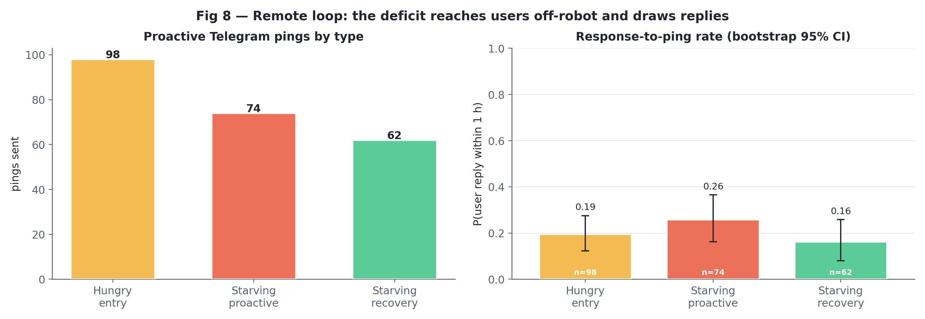
Remote loop
Reading. Left: proactive Telegram pings by type; right: their 1-hour response-to-ping rate with bootstrap CIs. Across all proactive pings the response rate is 0.21 [0.15, 0.26] (48/234), and for the Starving-specific hs3_proactive ping 0.26 (19/74). Conclusion. The deficit is expressed beyond the robot’s body and is followed by off-robot human replies — modest but measurable, and drive-initiated: co-present interactions are 83% reply-bearing when proactive vs 42% when merely reactive.

RQ2.b — Do observed Starving episodes resolve by feeding? (analysis B6)
What we asked. In the Starving episodes that occurred during this deployment, did the robot get fed, leave Starving, and climb back to Full?
How. We reconstructed HS3 (Starving) episodes with three separate, strict outcomes: received a first feed, escaped Starving via feeding, recovered all the way to Full via feeding. Plus a Kaplan–Meier time-to-first-feed curve.
Result. Of n = 8 Starving episodes: 8/8 received a feed, 8/8 escaped Starving, 8/8 recovered to Full — all via feeding. No observed attrition.
How to read it (crucial caveat). n = 8 is thin and exploratory — 100% here is an operational status check, not a population rate or a guarantee that future Starving episodes will always recover. The broader reliability claim (RQ2-c) is not carried by these 8 episodes or by the modest 21% ping rate. It is carried by the fact that the robot seldom reached Starving at all — because people kept feeding it, it stayed out of starvation ~99% of the long run (next section). Reliability is a property of the whole human–robot loop staying fed, not of these few deep recoveries.
Verdict: Supported for the observed episodes (exploratory, n = 8).

Figure 7 — Starving recovery time-to-feed (exploratory, n = 8)
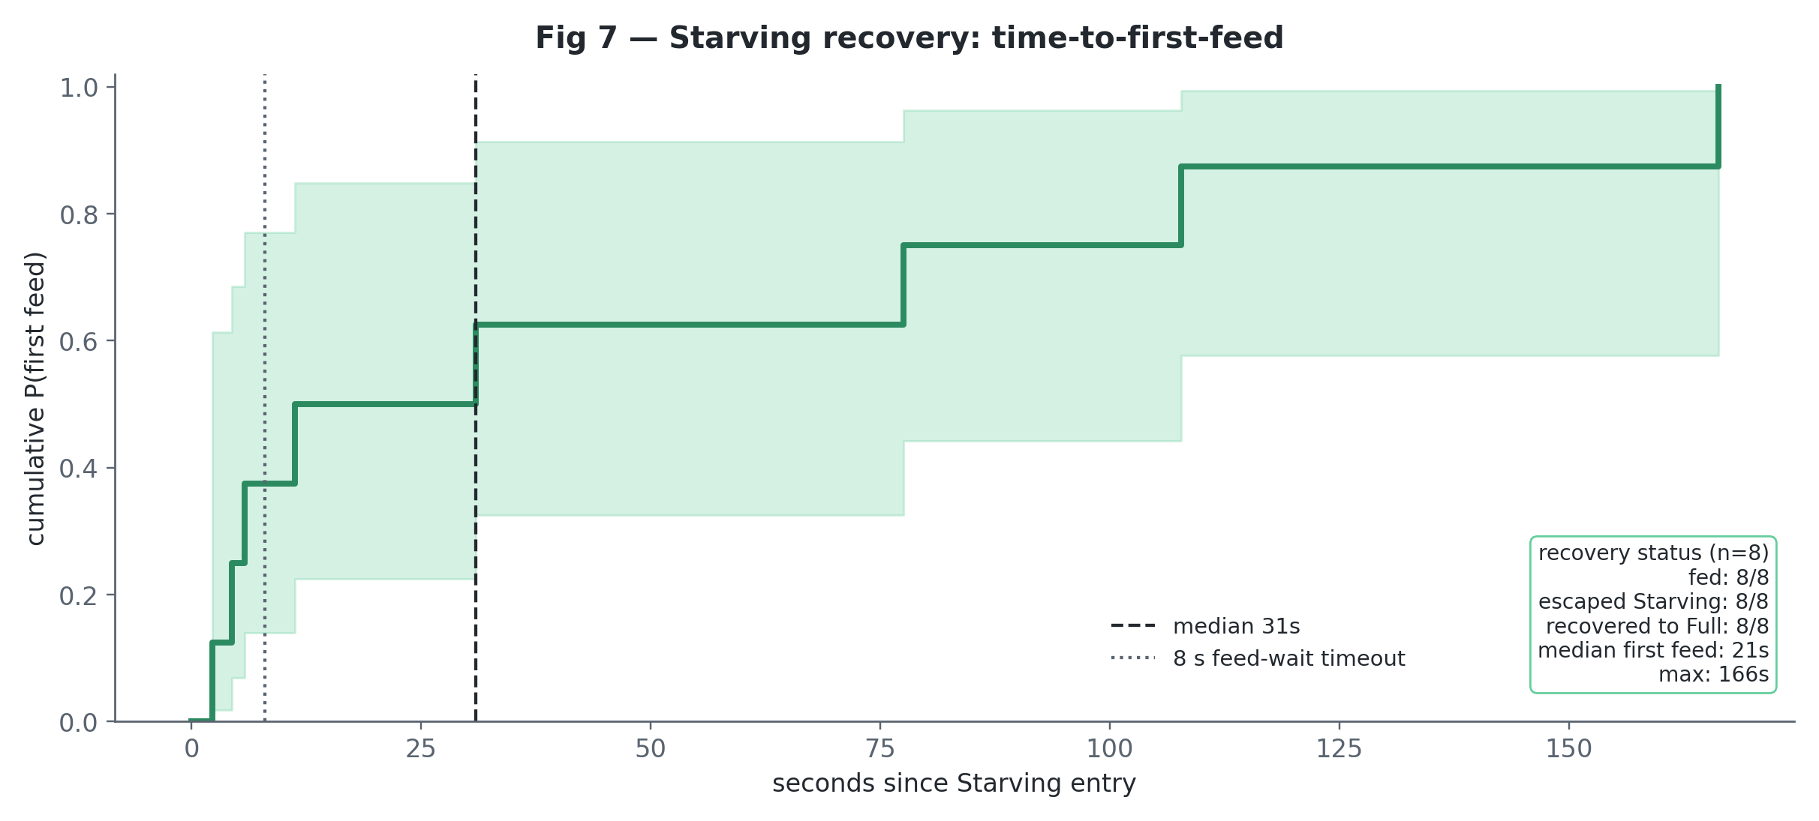
Starving recovery
Reading (exploratory, n=8). The cumulative first-feed curve climbs quickly: all 8 observed Starving episodes received a feed, escaped Starving, and recovered to Full, entirely via feeding. The in-plot note keeps that status check visible without giving it a separate redundant panel. Median time to first feed was 21 s (KM 31 s), range 2–166 s, against the 8-s per-attempt feed-wait timeout. Conclusion. In the observed Starving episodes, recovery was quick and complete — but n=8 makes this an operational check, not a population rate; the reliability claim rests on B7, not here.

RQ2.c — Is replenishment reliable over the long run? (analysis B7, the headline)
What we asked. Over indefinite always-on operation, what fraction of time does the robot spend Starving? Is there any risk it gets stuck (an absorbing “starve to death” state)?
How. We fitted a continuous-time Markov chain over Full/Hungry/Starving from the observed transition counts and dwell times, solved for the steady-state occupancy, and — because the Starving row rests on only ~17 transitions — bootstrapped it (resampling each transition count as Poisson) to get an honest interval instead of a fragile point estimate.
Result. Modelled long-run Starving occupancy: median 1.1% [95% CI 0.4%, 2.3%]. The robot was out of starvation ~98–100% of the time. There is no absorbing state — every Starving spell was eventually left; the chain never drifts to zero.
How to read it (the key result, read as a closed-loop association). This ~1% is not a property of the controller in isolation — the transition rates that produce it are a direct record of how the people actually behaved. Every Starving spell ended because a human eventually fed the robot; the “no absorbing state” is literally the statement that feeding always eventually happened. So the honest reading is: within this deployment, human engagement, alongside the robot’s hunger signalling, kept the robot’s energy in homeostasis and out of starvation almost all of the time. That is the strongest single piece of RQ2 evidence and, taken with B5 (the drive demonstrably participates in eliciting recovery behaviour), the headline finding of the study: the HRI loop closes and the solution works in deployment. (We lead with the interval, not the fragile 1.1% point, and note the single-condition caveat — we cannot fully isolate how much of the feeding the drive caused versus what people would have done anyway.)
Verdict: Supported.

Figure 9 — long-run occupancy: model vs data
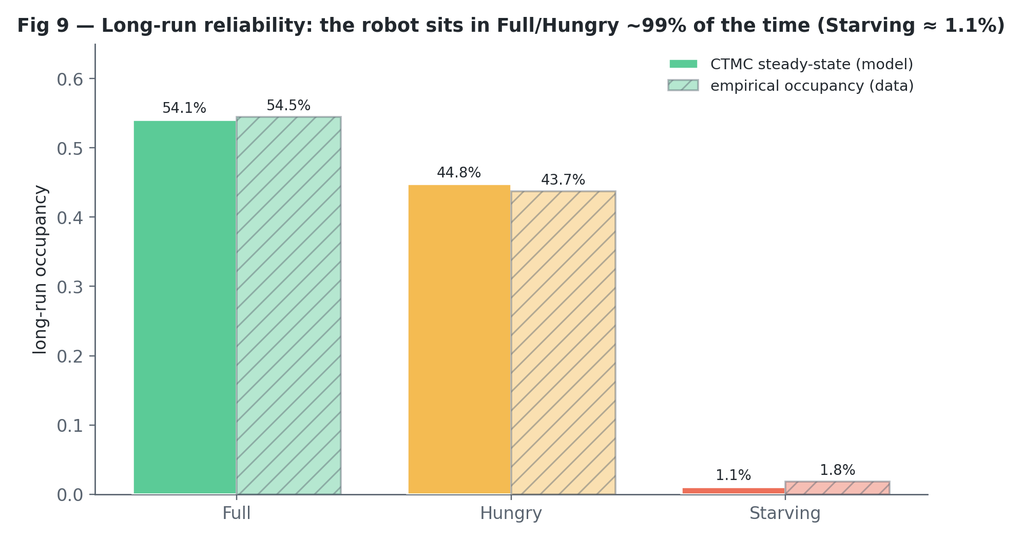
Steady state
Reading. Modelled CTMC occupancy (solid) lands almost exactly on the empirical time-occupancy (hatched): Full 54.1% vs 54.5%, Hungry 44.8% vs 43.7%, Starving 1.1% vs 1.8% — the model isn’t extrapolating away from the data. Mean Starving sojourn 163 s. Conclusion. The robot lived in Full/Hungry ~99% of the time and left Starving quickly, with no absorbing “starve-out” state — because the people kept feeding it. This occupancy is the measured outcome of the working HRI loop, and the headline result for RQ2-c: human engagement, with demonstrated participation from the drive, kept the robot’s energy regulated.

The gradient question (analysis B8)
As mentioned under “threshold controller”: Engaged-completion does decline as the robot gets hungrier (Spearman ρ = −0.16, p = 0.016), but the drop really lives at Starving — Full and Hungry are almost the same (0.69 / 0.67) and only Starving falls away (0.08). The turn-count and energy trends don’t hold up once we adjust for covariates. So as a smooth Full→Hungry→Starving ramp, this is weak, and we grade it Weakened. The change that is there is the step down at the Starving line — but we don’t lean on B8 for that; it’s shown directly in B4. We’d rather under-state the gradient than dress it up.
RQ2, concluded. Expressing the deficit does drive recovery: it elicits graded feeding (bigger meals when hungrier, B5) and is followed by replies both in person and off-robot (Fig 8), and in the observed Starving episodes the escape path was fast and complete (B6). And it adds up to the study’s headline: across the whole deployment the people kept the robot fed, so its energy stayed in homeostasis and it was out of starvation ~99% of the time (B7) — the HRI loop closes and the solution works in deployment. That low starvation figure is the outcome of human engagement in a system where the drive demonstrably participates in recovery signalling, not a self-property of the controller. The one genuine caveat is that this feeding leaned on a few named users (Gini 0.57, top-3 = 62%, D4).

6. Adaptive personalisation: the drive learns who feeds it (analysis B9)
What we asked. Does the robot learn which people are worth approaching, and does that learning actually change its behaviour?
How. The salience network keeps a per-person affinity — an EMA (α = 0.25) of normalised homeostatic reward, in [−1, +1]. We verified four things: (a) it converges, (b) it is reward-driven, (c) it feeds into the IPS eligibility threshold via the exact coded formula eff_thr = max(0.50, base_ss − 0.15·affinity), and (d) the chatbot uses it to gate Hungry-state pings to people above affinity 0.20. (A data-cleaning detail: the affinity EMA was re-threaded over merged identity variants to repair a few stale logged values, validated to 1e-4 against the robot’s own values.)
Result. - Converges: mean |affinity update| shrinks 0.10 → 0.06 as evidence accumulates. - The IPS component weights never change — learning acts only through the per-person threshold. High-affinity feeders clear a bar up to ~0.14 lower. - The chatbot pings only the 11/14 learned named people above affinity 0.20 when Hungry; everyone gets pinged only when Starving. - The people who finish with the highest affinity can be checked directly against behaviour: Figure 11 compares their share of proactive approaches with their share of actual feeding.
Verdict: Supported. The drive personalises who it spends recovery effort on — it learns to court its feeders.

Figure 10 — affinity over the whole experiment
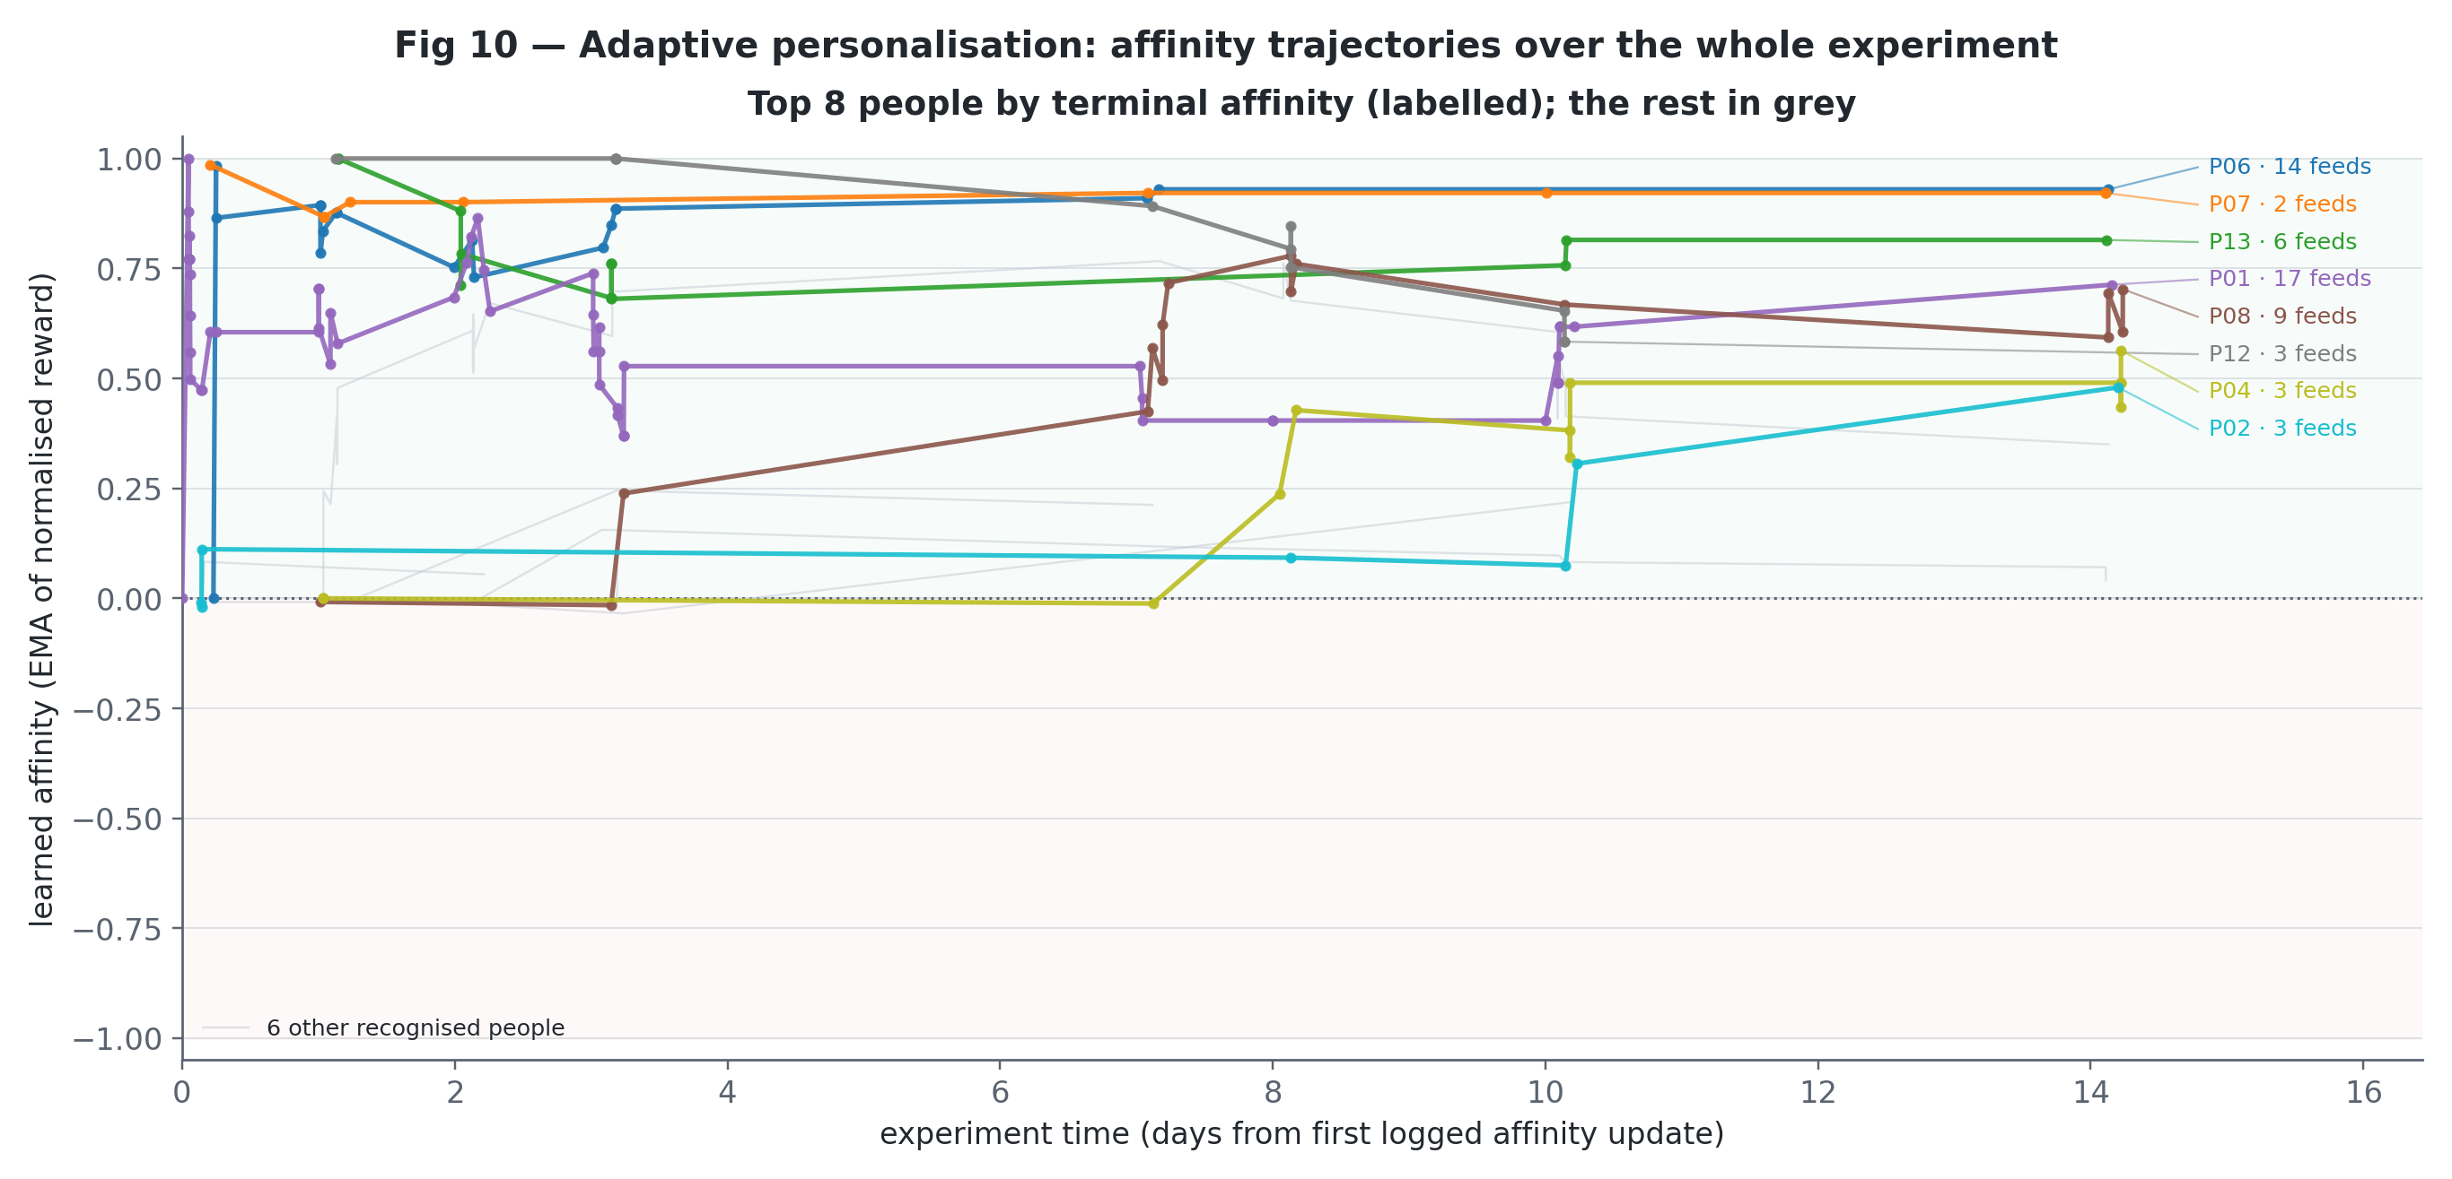
Affinity trajectories
Reading. Each line is one recognised person, plotted against absolute experiment time rather than their own interaction count. To keep the plot legible, only the top 8 people by terminal affinity are drawn in colour and labelled (name · feeds); the remaining recognised people form a light-grey backdrop. Positive trajectories indicate people whose encounters reduced the robot’s drive, mostly through feeding; negative or flat trajectories indicate people who cost energy without replenishing it. Conclusion. Affinity is not a static label: it changes over the deployment and separates the people who repeatedly helped regulate the drive from those who did not.

Figure 11 — did high-affinity people repay proactive effort?
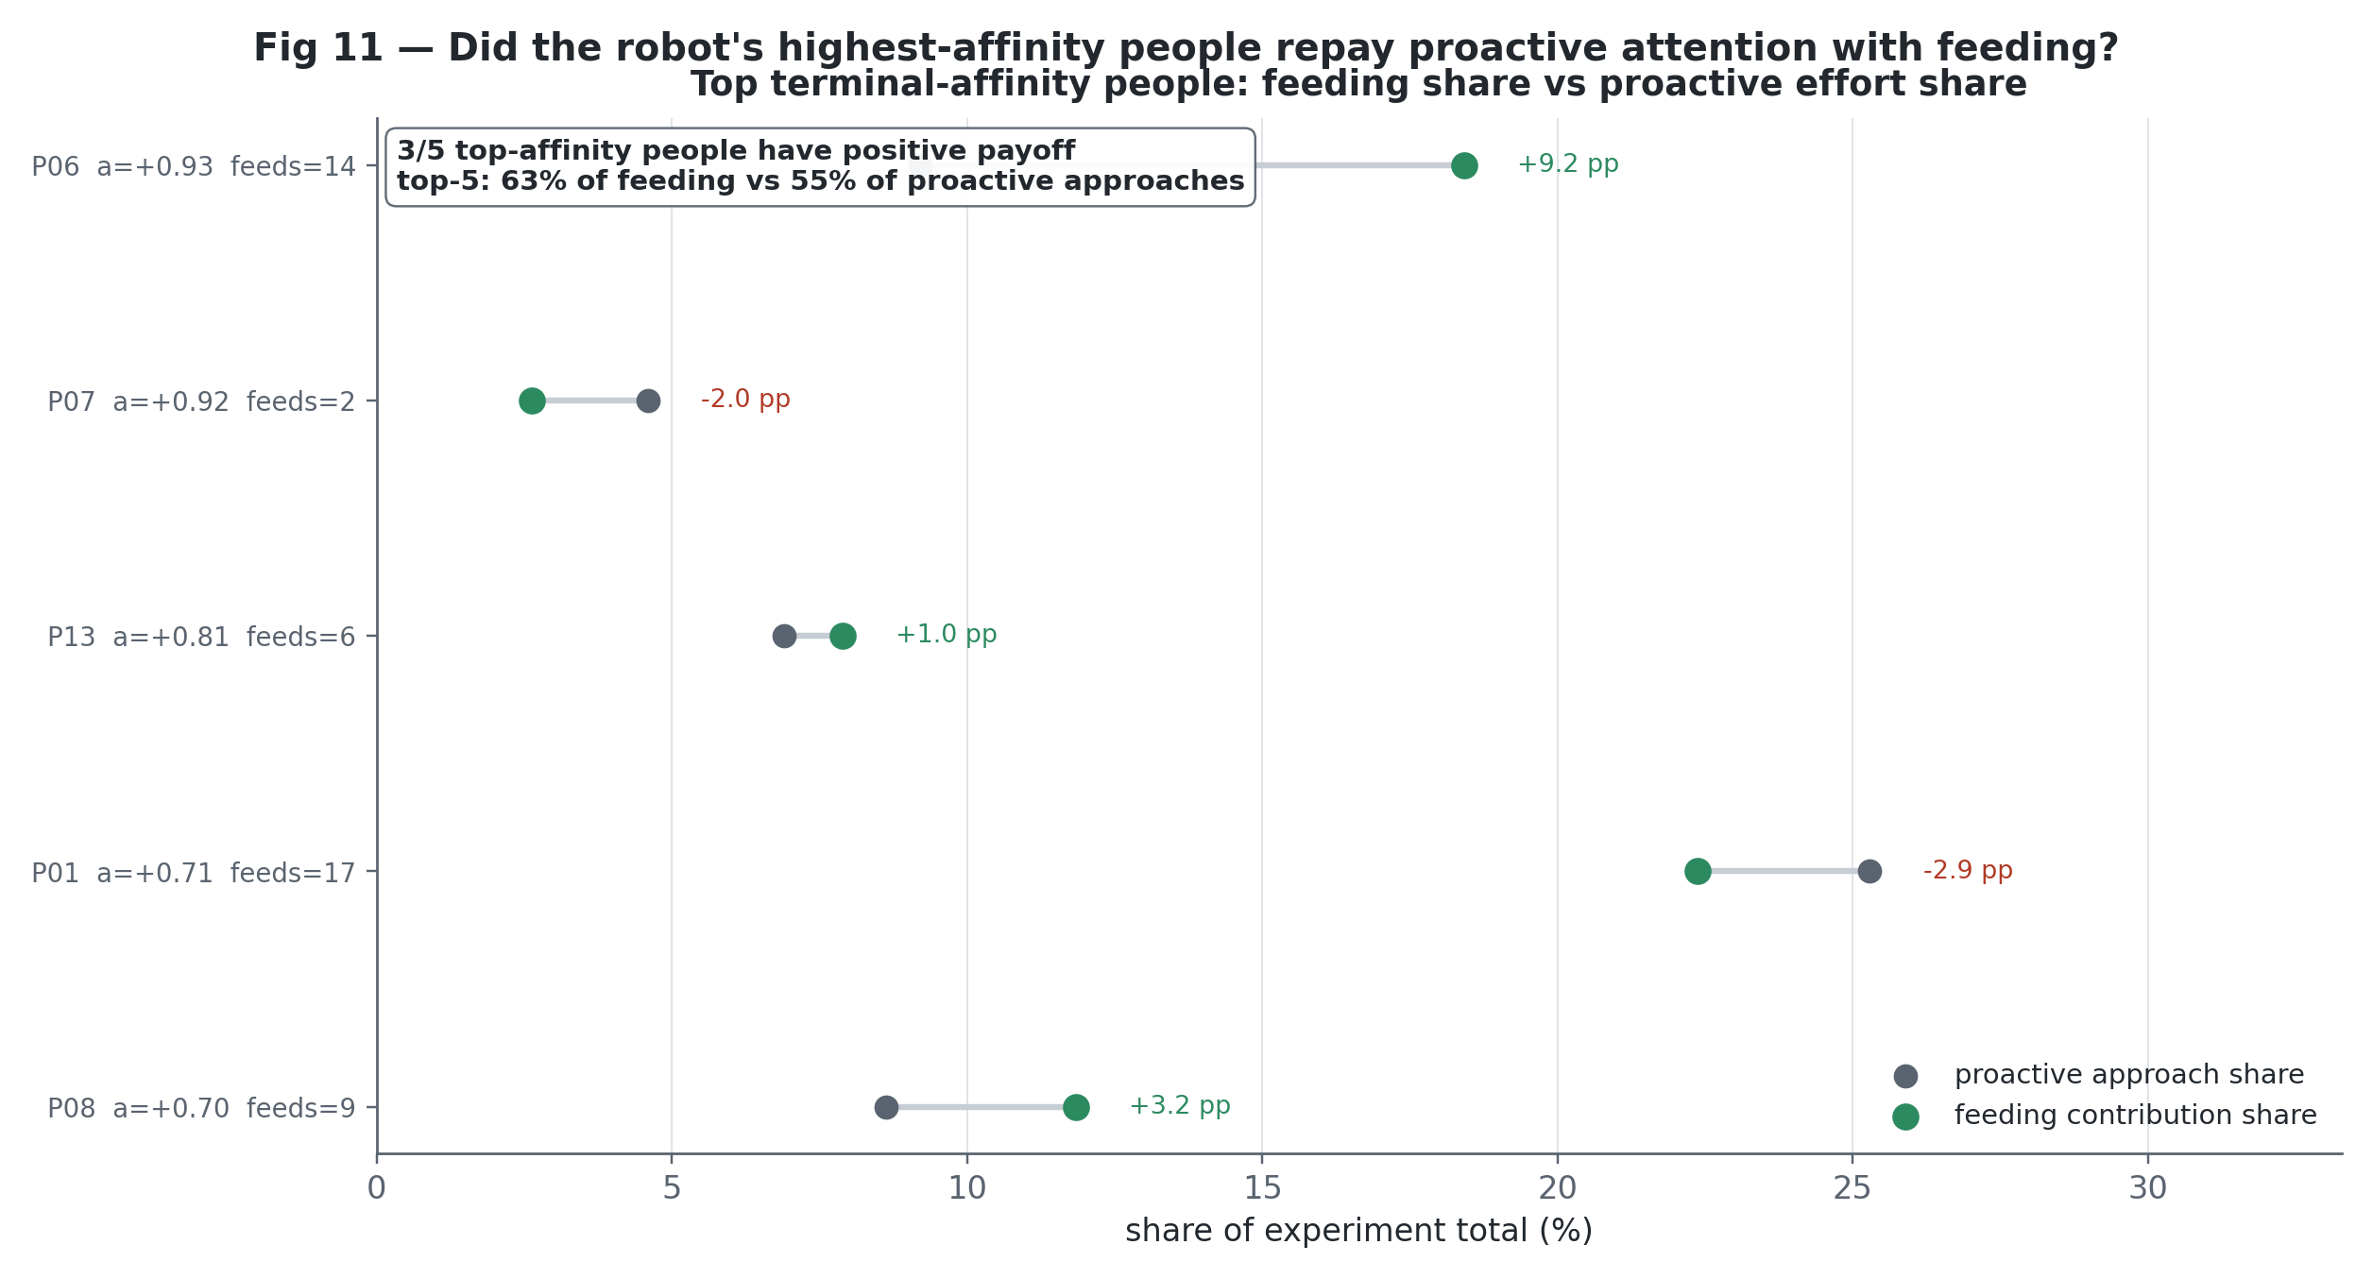
Affinity learning
Reading. The top 5 people by terminal affinity are shown. Grey dots show each person’s share of the robot’s proactive approaches; green dots show their share of feeding. The percentage-point label is feeding share minus proactive-approach share. Conclusion. A positive gap means the extra proactive attention was repaid by disproportionate feeding; a negative gap flags a person who was prioritised more than they replenished the robot. Across the top 5, 3/5 show a positive payoff and together they account for 63% of feeding against 55% of proactive approaches.

7. Machine learning — sensitivity checks, honestly labelled (Phase D)
Phase D is deliberately small in ambition. With only ~200 interactions, the machine-learning analyses are sensitivity checks, not confirmatory tests; the evidential weight remains in Phase B. All models use group-aware cross-validation (leave-one-run-out / leave-one-person-out) so the held-out predictions cannot be explained by memorising a person or a session.

D1 — Does hunger add predictive signal beyond the social state?
How. The test is intentionally narrow. The model is given only the two state variables the controller itself reasons over: social state and orexigenic drive (hunger state). We predict whether an interaction reached Engaged with a gradient-boosted model using social state alone, then add hunger state and measure the grouped-CV change. A drop-column check asks the same question from the other direction: how much held-out performance is lost when each state variable is removed?
Result. Adding hunger improves Engaged prediction from AUC 0.669 to 0.757 (+0.088) and from PR-AUC 0.742 to 0.810 (+0.068). In the drop-column check, hunger ranks #2 of 2 features: removing it costs 0.088 AUC, while removing social state costs 0.271 AUC. Social state is therefore the dominant predictor; hunger adds a smaller but visible held-out signal.
Read as. This is sensitivity evidence that agrees with the threshold-override account: the out-of-fold model reproduces the Starving engagement collapse. It is not a mechanism proof, and it is not used as the primary evidence for the claim.

Figure D1 — ML sensitivity
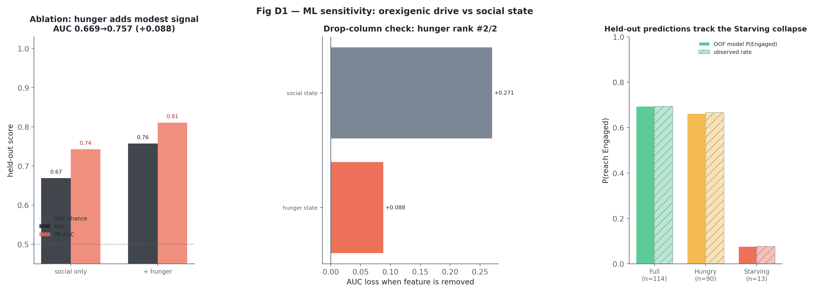
ML sensitivity
Reading (sensitivity, not proof). Left: adding hunger state to the social-state model raises held-out AUC and PR-AUC. Centre: removing social state damages performance much more than removing hunger, so the social state still carries most of the predictive load. Right: out-of-fold predictions track the observed collapse in Engaged outcomes at Starving. Conclusion. Hunger adds held-out predictive signal beyond social state, but it remains secondary; the figure corroborates the threshold-override interpretation rather than proving it.

D4 — Does recovery depend on a few feeders? (robustness of RQ2-c)
Replenishment is not evenly distributed. The feeding distribution has Gini = 0.57 across 14 named users, and the top-3 feeders supply 62% of meals. That is moderate concentration: the long-run recovery result is real, but it partly depends on a small set of highly responsive people. (An earlier exploratory KMeans over per-user behaviour was dropped because the silhouette was too low to support meaningful user types.)

D5 — How the deficit is verbalised (framing)
Deficit states raise hunger framing in the robot’s language: path a is +0.31 [0.19, 0.43], with similar mention rates in co-present speech and Telegram messages (0.35 vs 0.30). The tempting framing → reply analysis is deliberately dropped because it is temporally leaked: co-present framing is observed inside turns that already presuppose a human reply. The only leakage-free elicitation measure is the proactive ping → reply rate, 0.26. That effect is modest and matches the B5 reading: recovery signalling can elicit responses, but the evidence should not be overstated.

8. Honest limitations (read before quoting any number)
- One condition only. The drive was on the whole time — there was never a “drive-off” version to compare against. So for RQ2 we lean on the two comparisons we do have from inside the data (hungrier vs. less hungry, and the robot initiating vs. reacting), not a clean randomised experiment.
- Starving is rare. Only 8 Starving episodes and about 13 Starving interactions. We treat anything resting on those as suggestive — always shown with the sample size and a confidence interval, never sold as proof.
- We tested many things, so we corrected for it. After that correction, the two effects we most care about still hold: the jump in feeding behaviour once the robot is in a deficit, and the drop in engagement as it gets more severe. The weaker turn-count and energy trends don’t survive, and we say so. (The 3% → 67% rise in hunger talk is driven directly by the prompts, so we just describe it rather than run a significance test on it.)
- Monitoring and detection are “wired correctly,” not discoveries. The stomach level and the hunger labels come straight from the code, so of course they line up — that part confirms the machinery works as written. What’s genuinely worth noting is that it runs on its own and doesn’t flicker at the boundaries.
- Staying fed is a property of the loop, not a promise from the robot. The robot avoided starvation ~99% of the time because people fed it — those numbers describe how the humans behaved as much as the drive. With a single condition we can’t cleanly separate how much of the feeding the drive itself caused from what people would have done anyway. What we can show is that the drive took part (bigger asks when hungrier, pings that drew replies), so “the loop works here” is on solid ground; “the drive alone caused it” is not a claim we make.

9. Success-criteria scorecard
# | Claim | Source | Outcome
RQ1-1 | Internal monitoring continuous & autonomous | B1 | Supported (faithful impl.)
RQ1-2 | Deficit detection correct (60/25 thresholds) | B2 | Supported (faithful impl.)
RQ1-3 | Deficit→action is real, not cosmetic | B3 | Supported
RQ1-4 | Behavioural prioritisation (drive outranks social agenda) | B4 | Supported
RQ2-a | Deficit expression elicits recovery | B5 | Supported
RQ2-b | Observed Starving episodes resolve by feeding | B6 | Supported (exploratory)
RQ2-c | Replenishment reliable long-run | B7 | Supported
gradient | Full→Hungry→Starving monotonic & robust | B8 | Weakened (no smooth ramp; the movement sits at the Starving threshold — see B4)
Bottom line. On the mechanism side (RQ1), the orexigenic drive is a genuine, faithfully-implemented threshold homeostatic controller: it monitors itself autonomously, detects deficits cleanly, whispers graded signals below the line, and hard-overrides behaviour to pursue food when Starving. On the interaction side (RQ2) — the study’s most important result — the loop closes: human engagement, with demonstrated participation from the drive, kept the robot’s energy in homeostasis and out of starvation ~99% of the time. That ≈1% long-run Starving is the outcome of people feeding the robot in a drive-signalling system (not a self-property of the controller), and the system learns who its feeders are to spend its recovery effort on them. The honest caveats (§8) — single condition (the drive’s exact causal share in the feeding is not isolated), feeding concentrated among a few users, and small Starving n — are stated plainly and do not undercut the core, code-grounded finding: this HRI solution keeps an always-on robot’s energy regulated.

10. Reproducing this
The notebook is generated from analysis/build_notebook.py (kept as a plain .py so cells stay short and commented):
make execute # regenerate and execute analysis/orexigenic_analysis.ipynb
make check # validate execution state and identity redaction
- Seed SEED=42; DB access is strictly read-only / immutable (sources are never mutated).
- Intermediate frames cache to analysis/cache/*.parquet; deliverables land in analysis/outputs/ (reports + CSVs) and analysis/figures/ (PNG + SVG ≥ 220 dpi).
- Privacy: all identities are pseudonymised to P01…P14; real-name maps stay in the git-ignored analysis/private/, never in published figures, tables, or this document.
- Pinned dependencies: analysis/requirements.txt.
Key output files: results_summary.md, verification_report.md, quality_report.md, active_cost_table.csv, success_criteria.csv.

