FDTD principle operations:

- Define a grid
- Discretize partial differential or integral equations on the grid
- Assign different variables to grid points
- Decompose the grid into smaller patches
- Update the patches sequentially

Rectangular Grid
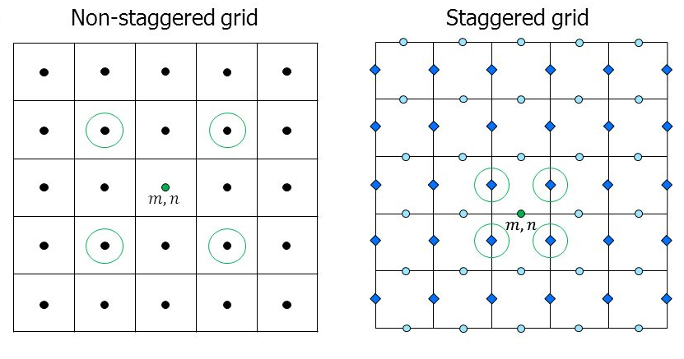
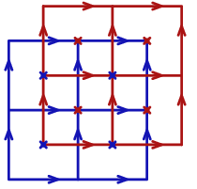

Triangular Grid
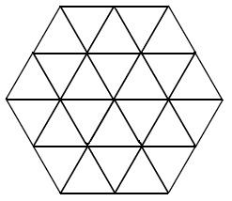
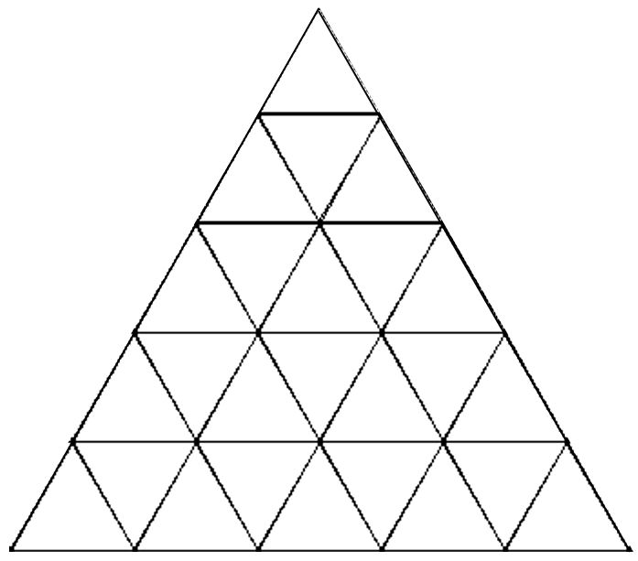

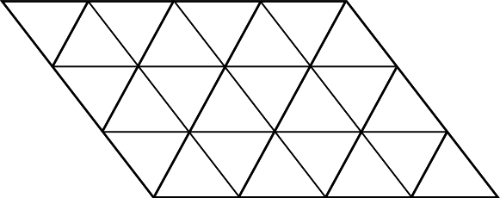

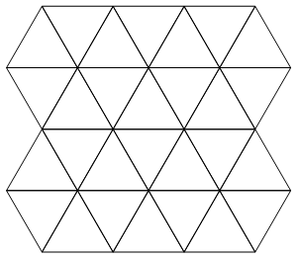
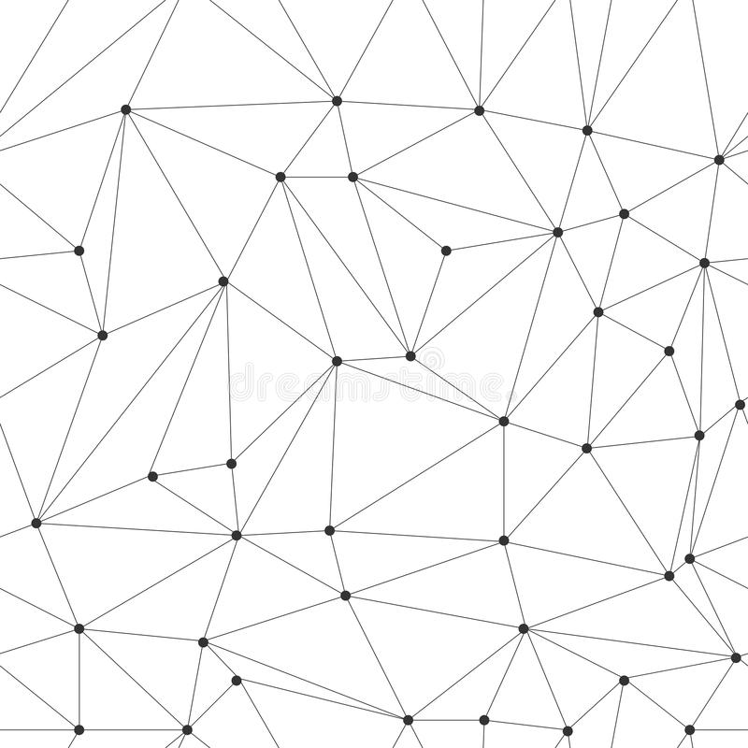
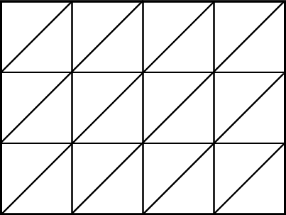

Rectangular grids:
- Indices are known explicitly
- Location of the nodes are known explicitly
- Indices conform to memory, they can be iterated conveniently
- Easy to decompose to patches with rectangular cross sections

Non-rectangular grids
- Indies do not always conform to memory
- Decomposition requires more complicated algorithms
- Location of the grid points are more complicated to obtain

Decisions:
- Let the grid decide how it stores indices and updates fields
- The grid should be able to provide the location of the fields given their indices
- The grid should be able to correspond locations to indices
- The grid should be able to interpolate fields, for example for post processing, or to calculate the fields on points not directly located on a grid node
- The grid should be able to plot itself

