Nima Naimi

EE442 – Digital Signal Processing

Final Exam

**Problem 1**

* 1. The filter used is the hamming window because of its minimum stopband attenuation of 53dB
  2. The order of the filter is 133 (calculated using the window’s transition bandwidth equation)



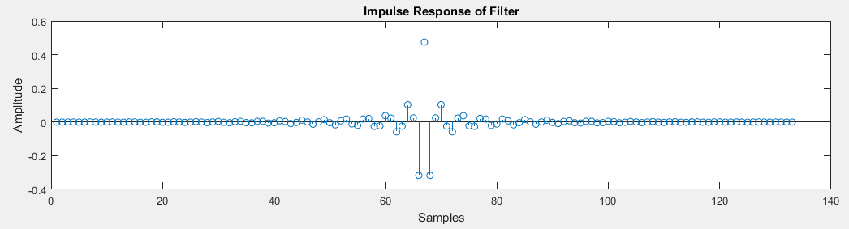



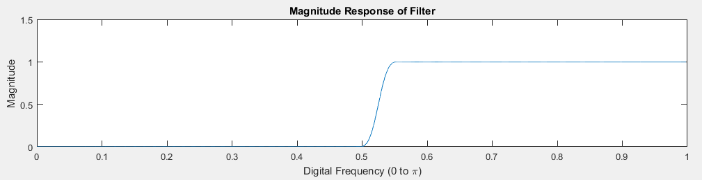

1. Stopband attenuation is 54.85dB and passband ripple is under 0.03dB, which meets the specification

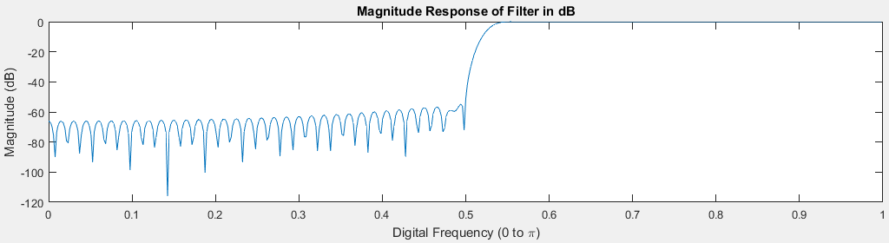

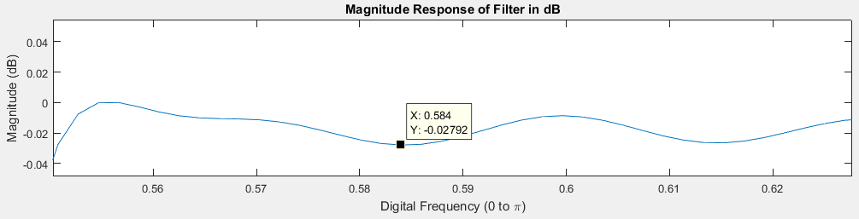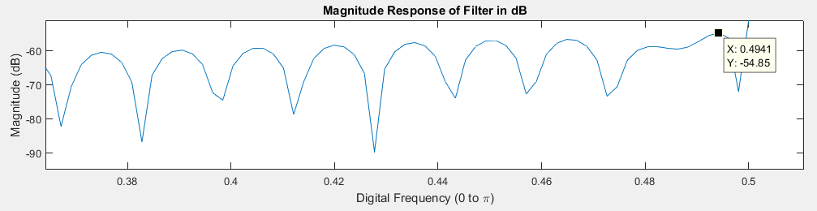

1. The order of the filter is 84, calculated using MATLAB’s firpmord function

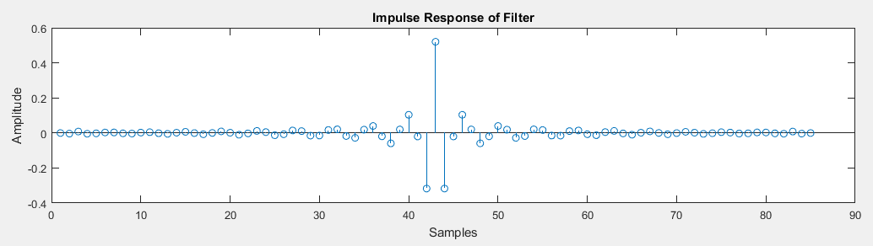



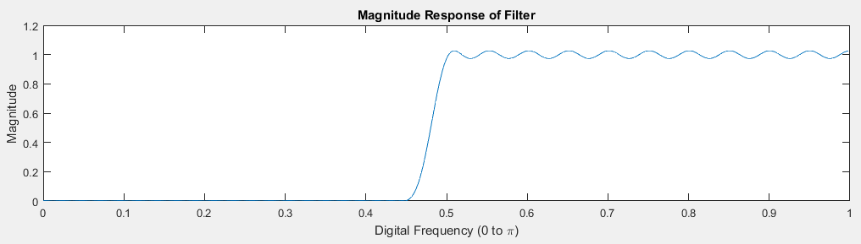

1. Stopband attenuation is 53.92dB and passband ripple is 0.4628 which meets the specification

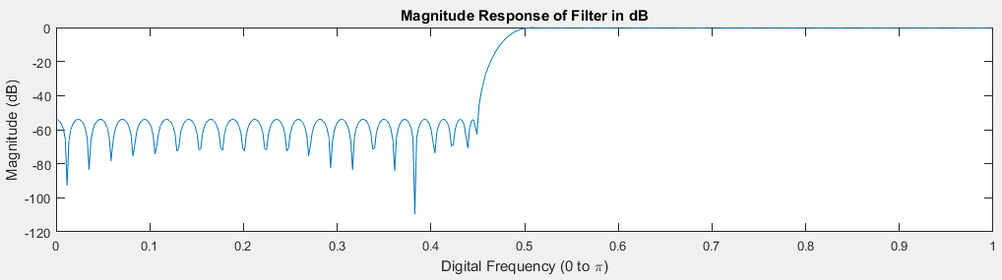

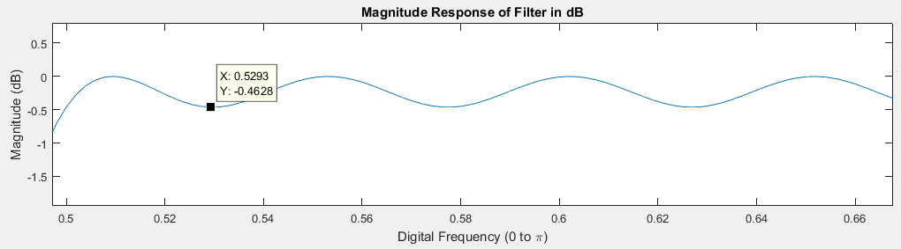

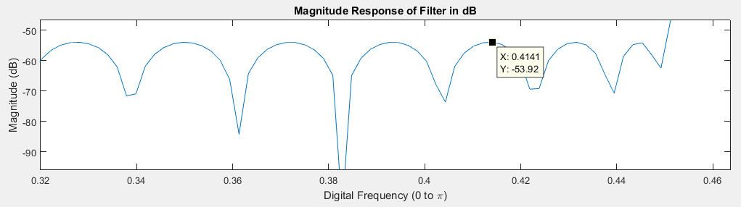

1. The Parks-Mclellan filter has a much smaller order while still achieving the minimum specification requirements, but it does have a much higher passband ripple than the hamming window

**Problem 3**

1. The order of the filter is 7 (calculated using MATLAB’s buttord function)
2. The transfer function is found using MATLAB’s filt function:

0.008718 + 3.203e-07 z^-1 + 0.06103 z^-2 + 1.922e-06 z^-3 + 0.1831 z^-4 + 4.804e-06 z^ -5 + 0.3051 z^-6 + 6.406e-06 z^-7 + 0.3051 z^-8 + 4.804e-06 z^-9 + 0.1831 z^-10 + 1.922e-06 z^-11 + 0.06103 z^-12 + 3.203e-07 z^-13 + 0.008718 z^-14

----------------------------------------------------------------------------------------

1 + 1.636e-05 z^-1 - 0.7648 z^-2 - 6.015e-06 z^-3 + 1.149 z^-4 + 1.114e-05 z^-5 - 0.4996 z^-6 - 2.29e-06 z^-7 + 0.2814 z^-8 + 1.409e-06 z^-9 - 0.06145 z^-10 - 1.241e-07 z^-11 + 0.0126 z^-12 + 1.853e-08 z^-13 - 0.0007911 z^-14





1. 7.



1. The signal, y[n], was filtered using the Butterworth bandstop filter, causing the 2.8 KHz sinusoidal signal to be attenuated. The other sinusoidal signals passed, as they were not within the bandstop region of the filter.